Exercises on Religion Using the 2014 Pew Religious Landscape Survey

Edward Nelson

California State University, Fresno

Table of Contents

Preface 4
Part 1 – Religion and Measurement
Exercise 1 – Measuring Religious Preference 6
Exercise 2 – Measuring Religiosity 13
Exercise 3 – Measuring Religious Beliefs 18
Exercise 4 – Measuring Religious Behavior 25
Part 2 – Religion and Social Issues
Exercise 5 – Two-Variable Analysis of Religion and How People Feel About
Same-Sex Marriage 32
Exercise 6 – Three-Variable Analysis of Religion and How People Feel About
Same-Sex Marriage 44
Exercise 7 – Two-Variable Analysis of Religion and How People Feel About
Environmental Laws and Regulations 49
Exercise 8 – Three-Variable Analysis of Religion and How People Feel About
Environmental Laws and Regulations 61
Part 3 – Religious Mobility
Exercise 9 – Comparing the Religious Group in Which Respondents Were Raised
with Their Current Religious Preference to See How Much Mobility
There is Into and Out of Different Religious Groups 69
Exercise 10 – Developing an Overall Measure of Religious Mobility and Looking to
See Where People Go When They Leave Their Religious Groups 77
Exercise 11 – Comparing Religious Mobility for Men and Women for Different
Age Categories 82
Part 4 – Religious Similarity and Dissimilarity Between Respondents and Their Spouses
or Partners
Exercise 12 – Religious Similarity and Dissimilarity Between Respondents and
Their Spouses or Partners 89
Exercise 13 – Developing an Overall Measure of Religious Similarity and Dissimilarity
Between Respondents and Their Spouses or Partners for Different
Religious Groups 97
Exercise 14 – Exploring Whether Religious Similarity Varies by Sex 102
Part 4 – Comparing Religious Groups
Exercise 15 – Introduction to Comparison of Religious Groups 107
Exercise 16 – Comparing the Religiosity of the Two Religious Groups Selected 116
Exercise 17 – Comparing the Religious Beliefs of the Two Religious Groups Selected 123
Exercise 18 – Comparing the Religious Behavior of the Two Religious Groups
Selected 132
Exercise 19 – Comparing the Political Party Preference and Political Views of the
Two Religious Groups Selected 139
Exercise 20 – Comparing Opinions on Homosexuality, Same-Sex Marriage, Abortion,
and Environmental Laws and Regulations of the Two Religious Groups
Selected 146
Appendix A – Notes on the Data Set 153
Appendix B – Notes for the Instructor 157

Preface

These exercises were written for courses that include a component on religion as well as for courses that introduce quantitative analysis. The Pew Research Center has conducted a number of surveys that deal with religion. Two of these surveys are the Religious Landscape Surveys conducted in 2007 and then repeated in 2014. They were very large telephone surveys of about 35,000 adults in the United States. These exercises use a subset of the 2014 survey which I have named Pew_2014_Religious_Landscape_ Survey_subset_for_classes.sav.
I use SPSS as the statistical package for these exercises. However, they could be converted to SAS, Stata, or any other package you prefer. The statistical tools used are relatively simple – percentages, crosstabulation, Chi Square, and measures of association (i.e., Cramer's V and Kendall's tau-c).
There are two appendices that you might want to look at. One is notes on using the data set for these exercises and the other is notes to the instructors.
You have permission to use these exercises and to revise them to fit your needs. I would be interested in hearing about your experiences using the exercises. If you find any errors, please email me and I will correct them. For any other information or questions, please contact me at ednelson@csufresno.edu.

Part 1 – Religion and Measurement

Exercise 1 – Measuring Religious Preference

Goal of Exercise
The goal of this exercise is to provide an introduction to measurement which is an integral part of any research design. In this exercise we're going to focus on measuring religious preference. In Exercise 2 we'll look at measuring religiosity which refers to how religious people are.

Part I—Concepts
We use concepts all the time. We all know what a book is. But when we use the word “book” we may not be talking about a particular book we’re reading. We could be talking about books in general. In other words, we’re talking about the concept to which we have given the name “book.” There are many different types of books – paperback, hardback, small, large, short, long, and so on. But they all have one thing in common – they all belong to the category “book.”
Let's look at some other examples. Religious preference refers to the religion with which people identify. Some people say they are Lutheran; others say they are Roman Catholic; still others say they are Muslim; and others say they have no religious preference. Religiosity is another concept which refers to the degree of attachment that individuals have to their religious preference. It’s different than religious preference. Religiosity and religious preference are both concepts.
In other words, a concept is an abstract idea. There are the abstract ideas of book, religiosity, religious preference, and many others. Since concepts are abstract ideas and not directly observable, we must select measures or indicants of these concepts. We call this process measurement.

Part II – The Data Set We'll be Using
The Pew Research Center has conducted a number of surveys that deal with religion. Two of these surveys are the Religious Landscape Surveys conducted in 2007 and then repeated in 2014. They were very large telephone surveys of about 35,000 adults in the United States. For more information about the surveys, go to their website.
We'll be using a subset of the 2014 survey in this exercise which I have named Pew_2014_Religious_Landscape_ Survey_subset_for_classes.sav. For the purposes of these exercises I selected a subset of variables from the complete data set. I recoded some of the variables, created a few new variables, and renamed the variables to make them easier to use. There is a weight variable which should always be used so that the sample will better represent the population from which the sample was selected. To open the data set in SPSS, just double click on the file name. Your instructor will tell you where the file is located.

Part III – Measuring Religious Preference
Religious preference refers to the religion with which respondents identify. The Pew survey asked "What is your present religion, if any? Are you Protestant, Roman Catholic, Mormon, Orthodox such as Greek or Russian Orthodox, Jewish, Muslim, Buddhist, Hindu, atheist, agnostic, something else, or nothing in particular?"
Now that you have opened the data set, run a frequency distribution for the variable R1 which is the name of the variable. The variable name starts with the letter R which tells you that this variable describes religious preference. There are seven variables in this category named R1 to R7. We're going to look at most of them in this exercise. Some of you have used SPSS, the statistical package we're using, and know how to get a frequency distribution. Others of you are new to SPSS. There is a tutorial that you can use to learn how to get a frequency distribution. The tutorial is freely available on the Social Science Research and Instructional Center's website. Frequency distributions are covered in Chapter 4 of the tutorial.
It's very easy to get frequency distributions. Once you have opened the data set in SPSS, look on the menu bar at the top and click on "Analyze." This will open a drop-down menu. Click on "Descriptive Statistics" and then on "Frequencies." You screen should look like Figure 1-1.
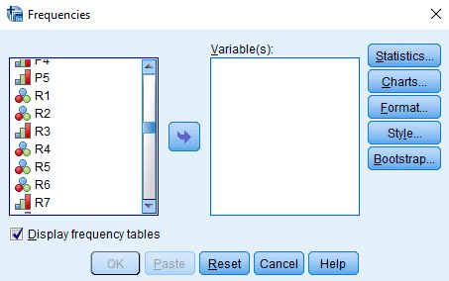
Figure 1-1

Notice that the list of all the variables is in the pane on the left. I scrolled down to the variables that start with R (i.e., R1 through R7). Select R1 by clicking on it and then click on the arrow pointing to the right. This will move R1 into the "Variable(s)" box. Your screen should look like Figure 1-2.
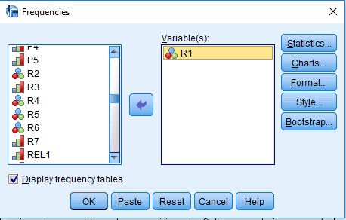
Figure 1-2

Now all you have to do is to click on "OK" to get your frequency distribution. Your screen should look like Figure 1-3. Note that I have only displayed the top part of the distribution because it's a very large table.
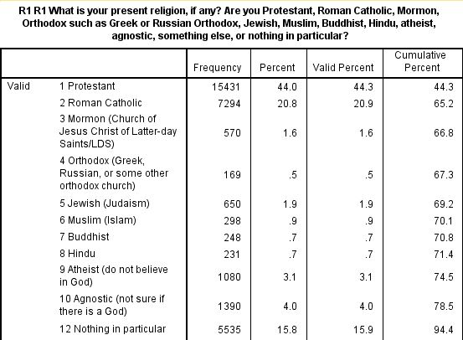
Figure 1-3

Take a few minutes to familiarize yourself with the information in the table.
- The first column is the value and the value label. The value "1" refers to all people who answered Protestant.
- The second column is the number of respondents who said they were Protestants (15,431).
- The third column converts the frequencies to percents. Notice that there are two types of missing information – responses that were uninterpretable and those who said they didn't know or refused to answer. The percent column converts the frequency to a percent by dividing the frequency (15,431) by the total number of cases including those with missing values (35,071). Carry out the computation for yourself and convince yourself that it is 44.0%.
- The fourth column converts the frequencies to valid percents by dividing the frequency (15,431) by the number of cases with valid information (34,846). In other words, it excludes the cases with missing information (225) from the denominator when computing the percent. Carry out the computation for yourself and convince yourself that it is 44.3%. This is called the valid percent. The more missing information there is in the distribution, the greater could be the difference between the percent and the valid percent. Normally we want to use the valid percents when describing the frequency distribution.
- The fifth column is the cumulative percent. Recall that the first twelve categories in the distribution were listed in Figure 1-3. The cumulative percent for this twelfth category is 94.4%. In other words, 94.4% of the cases with valid information selected one of the categories included in the first twelve categories. You can see where this comes from if you add up the valid percents for the first twelve categories.
Now it's your turn. The second category in the distribution is Roman Catholic.
- What is the value for this category?
- How many respondents said they were Roman Catholic?
- What is the percent for this category? What does this mean?
- What is the valid percent for this category? What does this mean?
- Why aren't the percent and valid percents the same?
- What is the cumulative percent for this category? What does this mean?

Part IV – Measuring Religious Preference for Protestants
One problem with the first question is that over 15,000 respondents said they were Protestant. We know there are many different types of Protestants so we might want to break Protestants down more finely. To do this the Pew survey asked another question – "As far as your present religion, what denomination or church, if any, do you identify with most closely? Just stop me when I get to the right one. Are you Baptist, Methodist, Lutheran, Presbyterian, Pentecostal, Episcopalian or Anglican, Church of Christ or Disciples of Christ, Congregational or United Church of Christ, Holiness, Reformed, Church of God, nondenominational or independent church, something else, or none in particular?" Run a frequency distribution for R2 which is the name of this variable.
This question was only asked of those who said they were Protestant in R1. Notice that the number of cases with valid information was 15,403 and that there were 28 respondents who said they didn't know or refused to answer. If you add these two numbers together, you get 15,431 which is the number who said Protestant in R1. Those who didn't say they were Protestant in the previous question are included in the category that is labeled "system missing."
The large number of categories in R2 makes it difficult to interpret. R6 is an attempt to reduce the number of categories making it easier to interpret. Run a frequency distribution for R6. Notice that this variable combines many of the volunteered responses for R2 into two other categories – other Protestant religions and responses that were so nonspecific that they were impossible to recode. Respondents who were not Protestants were assigned the value "0."
Now it's your turn. Write a paragraph describing what the frequency distribution for R6 tells you about religion in the U.S. Be sure to answer the following questions. Use the valid percents.
- What percent of adults are Protestant? Not Protestant?
- What is the largest Protestant denomination? What percent fall in that category?
- What is the second largest Protestant denomination? What percent fall in that category?
- Which Protestant denominations have less than 1% of all Protestants?

Part V – Another Way to Measure Religious Preference
Run a frequency distribution for R4. Notice that this time Protestants are broken down by both denomination (e.g., Lutheran, Presbyterians, Methodist) and by religious tradition. Religious tradition is divided into three categories.
- Evangelical Protestant tradition
- Mainline Protestant tradition
- Historically Black Protestant tradition
To find out what the Pew Center means by these traditions, read the following Pew reports:
- Chapter 1 of the full report for the 2014 Religious Landscape Survey on "The Changing Religious Composition of the U.S. Population" and
- Appendix B to this report on "Classification of Protestant Denominations."
For more information on the difference between the evangelical and the mainline Protestant traditions, read the article by John Green in the PBS Frontline article on "Evangelicals v. Mainline Protestants." For a history of the black church, read Marilyn Mellowes' article on "The Black Church."
Now it's your turn again. Write a paragraph explaining in your own words what is meant by these three religious traditions – the Evangelical Protestant tradition, the Mainline Protestant tradition, and the Historically Black Protestant tradition.
The problem with R4 is that there are so many categories that it's hard to interpret. Run a frequency distribution for R5 which breaks Protestants down into these three religious traditions but does not include denomination. Notice that it also includes non-Protestant religions. Write another paragraph describing religion in the U.S. using R5. Be sure to consider the following questions. Use the valid percents.
- What are the five largest religious groups in R5? Note that this table includes the religiously unaffiliated as a group. What are the percents for each of these groups?
- What percent of adults are Christian? Non-Christian? For this question, be sure to also include Orthodox Christians, Jehovah's Witness, Mormon, and Other Christian as Christian when you compute the percent of adults who are Christian.
- Which non-Christian group is the largest? What is the percent for that group?

Part VI – Other Dimensions of Religious Preference
There are two other dimensions of religious preference considered in the Pew Survey. Go back and review the Green article in Part 5. The third belief that Green lists defining Evangelical Christians is the belief that "individuals must accept salvation for themselves…. Sometimes that's referred to as a born-again experience." The Pew Survey asked respondents, "would you describe yourself as a "born-again" or evangelical Christian, or not?" The name of this variable is R3. Note that this question was not asked of respondents who self-identified as a non-Christian. This would include the following categories – Jewish, Muslim, Buddhist, Hindu, other world religions, other faiths, and unaffiliated.
Run a frequency distribution for R3. Write a paragraph describing what this distribution tells you about Evangelical Christians (or born-again Christians) in the U.S. Be sure to consider what percent of Christians consider themselves born-again? Not born-again?
Just because a person self-identifies with a particular religious group does not mean that they are a member of a church or house of worship. The Pew survey asked respondents "are you personally a member of a local (synagogue; mosque; temple) or other house of worship, or not?" The name of this variable is R7. Run a frequency distribution for R7. Compare the percent who said they belong to a church or house of worship with the percent that identified with some (any) religion. Be sure to cite the valid percents in your answer. What does this tell you about religion in the U.S.?

Part VII – Conclusion
Clearly there are different ways to measure religious preference. Typically, there isn't just one way to measure something. When you read social science research reports be sure to pay attention to the way things are measured.
The next exercise focuses on measuring a different concept – religiosity – which refers to how religious a person is. Religious preference or identification and religiosity are two different concepts.

Exercise 2 – Measuring Religiosity

Goal of Exercise
The goal of this exercise is to provide an introduction to measurement which is an integral part of any research design. In this exercise we're going to focus on measuring religiosity. In Exercise 3 we'll look at measuring religious beliefs.

Part I—Concepts

We use concepts all the time. We all know what a book is. But when we use the word “book” we may not be talking about a particular book we’re reading. We could be talking about books in general. In other words, we’re talking about the concept to which we have given the name “book.” There are many different types of books – paperback, hardback, small, large, short, long, and so on. But they all have one thing in common – they all belong to the category “book.”
Let’s look at some other examples. Religious preference refers to the religion with which people identify. Some people say they are Lutheran; others say they are Roman Catholic; still others say they are Muslim; and others say they have no religious preference. Religiosity is another concept which refers to the degree of attachment that individuals have to their religious preference. It’s different than religious preference. Religiosity and religious preference are both concepts.
In other words, a concept is an abstract idea. There are the abstract ideas of book, religiosity, religious preference, and many others. Since concepts are abstract ideas and not directly observable, we must select measures or indicants of these concepts. We call this process measurement.

Part II – The Data Set We'll be Using
The Pew Research Center has conducted a number of surveys that deal with religion. Two of these surveys are the Religious Landscape Surveys conducted in 2007 and then repeated in 2014. They were very large telephone surveys of about 35,000 adults in the United States. For more information about the surveys, go to their website.
We'll be using a subset of the 2014 survey in this exercise which I have named Pew_2014_Religious_Landscape_ Survey_subset_for_classes.sav. For the purposes of these exercises I selected a subset of variables from the complete data set. I recoded some of the variables, created a few new variables, and renamed the variables to make them easier for students to use. There is a weight variable which should always be used so that the sample will better represent the population from which the sample was selected. To open the data set in SPSS, just double click on the file name. Your instructor will tell you where the file is located.

Part III – Measuring Religiosity Using Attendance at Religious Services
Religiosity refers to how religious people say they are. The Pew survey asked three questions that can be used to measure religiosity. One question asked how often respondents attend religious services. Another question asked how important religion is in their lives. And still another asked how often respondents say they pray.
Let's start with attendance at religious services. The Pew survey asked the following question – "Aside from weddings and funerals, how often do you attend religious services... more than once a week, once a week, once or twice a month, a few times a year, seldom, or never?"
Now that you have opened the data set, run a frequency distribution for the variable REL1 which is the name of this variable. The variable name starts with the letter REL which tells you that this variable describes religiosity. There are three variables in this category named REL1 to REL3. We're going to look at all of them in this exercise. Some of you have used SPSS, the statistical package we're using, and know how to get a frequency distribution. Others of you are new to SPSS. There is a tutorial that you can use to learn how to get a frequency distribution. The tutorial is freely available on the Social Science Research and Instructional Center's website. Frequency distributions are covered in Chapter 4.
It's very easy to get frequency distributions. Once you have opened the data set in SPSS, look on the menu bar at the top and click on "Analyze." This will open a drop-down menu. Click on "Descriptive Statistics" and then on "Frequencies." You screen should look like Figure 2-1.
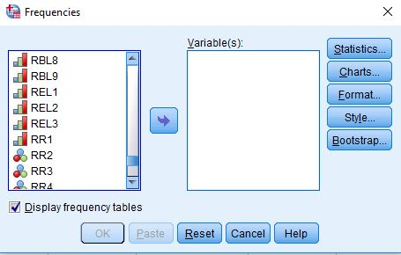
Figure 2-1
Notice that the list of all variables is in the pane on the left. I scrolled down to the variables that start with REL (i.e., REL1 through REL3). Select REL1 by clicking on it and then click on the arrow pointing to the right. This will move REL1 into the "Variable(s)" box. Your screen should look like Figure 2-2.
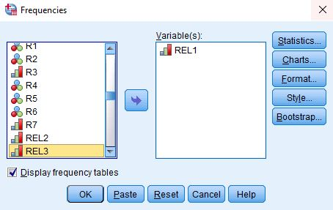
Figure 2-2
Now all you have to do is to click on "OK" to get your frequency distribution. Your screen should look like Figure 2-3.
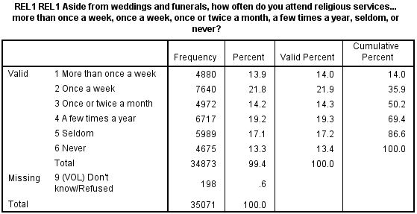
Figure 2-3
Take a few minutes to familiarize yourself with the information in the table.
· The first column is the value and the value label. The value "1" refers to all people who said they attended religious services more than once a week.
· The second column is the number of respondents who said they attended more than once a week (4,880).
· The third column converts the frequencies to percents. Notice that there is a code (9) for those who said they didn't know or refused to answer. The percent column converts the frequency to a percent by dividing the frequency (4,880) by the total number of cases including those with missing values (35,071). Carry out the computation for yourself and convince yourself that it is 13.9%.
· The fourth column converts the frequencies to valid percents by dividing the frequency (4,880) by the number of cases with valid information (34,873). In other words, it excludes the cases with missing information (198) from the denominator when computing the percent. Carry out the computation for yourself and convince yourself that it is 14.0%. This is called the valid percent. The more missing information there is in the distribution, the greater could be the difference between the percent and the valid percent. Normally we want to use the valid percents when describing the frequency distribution.
· The fifth column is the cumulative percent. Look at the cumulative percent for the second category (attended once a week). This tells you that 35.9% attended more than once a week or once a week. Another way to say this is that 35.9% attended at least once a week. You can see where this comes from if you add up the valid percents for the first two categories.
Now it's your turn. The third category in the distribution is for those who attended once or twice a month.
· What is the value for this category?
· How many respondents said they attended once or twice a month?
· What is the percent for this category? What does this mean?
· What is the valid percent for this category? What does this mean?
· Why aren't the percent and valid percents the same?
· What is the cumulative percent for this category? What does this mean?

Part IV – Measuring Religiosity Using Importance of Religion
Often there's more than one way to measure a concept and that's certainly the case for religiosity. The Pew survey also asked about the importance of religion in the respondent's life. Here's the question – "How important is religion in your life – very important, somewhat important, not too important, or not at all important?"
The name of this variable in the Pew data set is REL2. Run a frequency distribution for REL2. Write a paragraph describing what this frequency distribution tells you about religiosity in the U.S. Be sure to answer the following questions. Use the valid percents.
· What percent of adults feel that religion is very important in their lives?
· What percent of adults think that religion is at least somewhat important? How did you arrive at your answer?
· Based on the frequency distribution, how important do you think religion is to adults? Use the percents in the table to justify your answer.

Part V – Another Way to Measure Religiosity – How Often Respondents Pray
Another way that religiosity is often measured is by asking respondents how often they pray. Here's the question that was asked in the Pew survey – "People practice their religion in different ways. Outside of attending religious services, do you pray several times a day, once a day, a few times a week, once a week, a few times a month, seldom, or never?"
The name of this variable is REL3. Run a frequency distribution for REL3. Write a paragraph describing what this frequency distribution tells you about religiosity in the U.S. Be sure to answer the following questions. Use the valid percents.
· What percent of adults say they pray several times a day?
· What percent of adults say they pray once a day?
· What percent of adults say they pray less than once a day? How did you arrive at your answer?

Part VI – Putting All This Information Together
Write a paragraph using all three measures to describe religiosity in the U.S. Think carefully about how you are going to use all this information to describe religiosity. Use the valid percents from the three frequency distributions to support your answer.
The next exercise focusing on measuring religious beliefs, still another dimension of religion.

Exercise 3 – Measuring Religious Beliefs

Goal of Exercise
The goal of this exercise is to provide an introduction to measurement which is an integral part of any research design. In this exercise we're going to focus on measuring religious beliefs. In Exercise 4 we'll look at measuring religious behavior.

Part I—Concepts
We use concepts all the time. We all know what a book is. But when we use the word “book” we may not be talking about a particular book we’re reading. We could be talking about books in general. In other words, we’re talking about the concept to which we have given the name “book.” There are many different types of books – paperback, hardback, small, large, short, long, and so on. But they all have one thing in common – they all belong to the category “book.”
Let’s look at some other examples. Religious preference refers to the religion with which people identify. Some people say they are Lutheran; others say they are Roman Catholic; still others say they are Muslim; and others say they have no religious preference. Religiosity is another concept which refers to the degree of attachment that individuals have to their religious preference. It’s different than religious preference. Religiosity and religious preference are both concepts.
In other words, a concept is an abstract idea. There are the abstract ideas of book, religiosity, religious preference, and many others. Since concepts are abstract ideas and not directly observable, we must select measures or indicants of these concepts. We call this process measurement.

Part II – The Data Set We'll be Using
The Pew Research Center has conducted a number of surveys that deal with religion. Two of these surveys are the Religious Landscape Surveys conducted in 2007 and then repeated in 2014. They were very large telephone surveys of about 35,000 adults in the United States. For more information about the surveys, go to their website.
We'll be using a subset of the 2014 survey in this exercise which I have named Pew_2014_Religious_Landscape_ Survey_subset_for_classes.sav. For the purposes of these exercises I selected a subset of variables from the complete data set. I recoded some of the variables, created a few new variables, and renamed the variables to make them easier for students to use. There is a weight variable which should always be used so that the sample will better represent the population from which the sample was selected. To open the data set in SPSS, just double click on the file name. Your instructor will tell you where the file is located.

Part III – Measuring Religious Beliefs – Belief in God
There is a wide variety of religious beliefs. In this exercise we'll focus on the following:
- belief in God,
- belief in heaven and hell,
- beliefs about the sacred books of a person's religion,
- complaints about religion, and
- positive views of religion.
In this part of the exercise, I'll show you how to analyze one of these beliefs and then you can practice on the others. Let's start with belief in God. The Pew survey asked, "Do you believe in God or a universal spirit?" This was followed by "How certain are you about this belief? Are you absolutely certain, fairly certain, not too certain, or not at all certain?" The names of these variables are RBL1 and RBL2.
Now that you have opened the data set, run a frequency distribution for variables RBL1 and RBL2. The variable name starts with the letters RBL which tells you that this variable describes religious beliefs. Some of you have used SPSS, the statistical package we're using, and know how to get a frequency distribution. Others of you are new to SPSS. There is a tutorial that you can use to learn how to get a frequency distribution. The tutorial is freely available on the Social Science Research and Instructional Center's website. Frequency distributions are covered in Chapter 4.
It's very easy to get frequency distributions. Once you have opened the data set in SPSS, look on the menu bar at the top and click on "Analyze." This will open a drop-down menu. Click on "Descriptive Statistics" and then on "Frequencies." You screen should look like Figure 3-1.
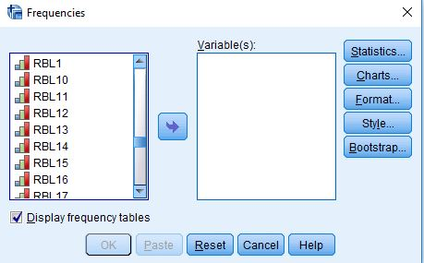
Figure 3-1
Notice that the list of all variables is in the pane on the left. I scrolled down to the variables that start with RBL. There are 21 of these variables but we're not going to look at all of them in this exercise. Select RBL1 and RBL2 by clicking on each one and then clicking on the arrow pointing to the right. This will move RBL1 and RBL2 into the "Variable(s)" box. Your screen should look like Figure 3-2.
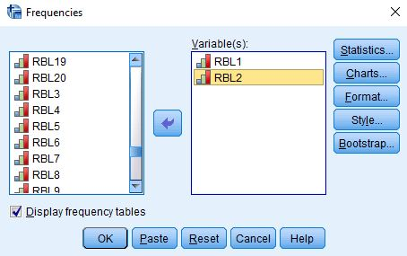
Figure 3-2
Now all you have to do is to click on "OK" to get your frequency distribution. Your screen should look like Figure 3-3.
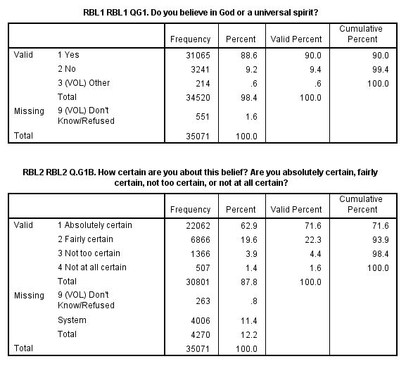
Figure 3-3
Take a few minutes to familiarize yourself with the information in the table.
- The first column is the value and the value label. The value "1" in the first table refers to all people who answered "Yes" – they believed in God.
- The second column is the number of respondents who said they believed in God (31,065).
- The third column converts the frequencies to percents. To compute the percent for those who answered "Yes" to RBL1, you would divide the frequency (31,065) by the total number of cases including those with missing values (35,071). Carry out the computation and convince yourself that it is 88.6%.
  - The fourth column converts the frequencies to valid percents by dividing the frequency by the number of cases with valid information. Notice that in RBL1 some of the respondents said they didn't know if they believed in God and others refused to answer the question. This is what we refer to as missing data and they are coded "9." To compute the valid percent for those who answered "Yes," you would divide 31,065 by 34,520. In other words, it excludes the cases with missing information (551) from the denominator when computing the percent. Carry out the computation and convince yourself that it is 90.0%. This is called the valid percent. The more missing information there is in the distribution, the greater could be the difference between the percent and the valid percent. Normally we want to use the valid percents when describing the frequency distribution.
  - For the second variable, RBL2, there are two types of missing data. Some said they didn't know or refused to answer the question and they are coded "9." But there's a second type of missing data that is labelled "System." What does that mean? The second question is a follow-up to the first question. It asks how certain respondents are about their belief in God. It wouldn't make any sense to ask this follow-up question to respondents who didn't answer "Yes" – they believed in God, to the first question. Anyone who answered anything other than "Yes" to the first question is assigned a system missing code for the second question. To verify this, add up the number of respondents who didn't answer "Yes" to the first question (i.e., 3,241 + 214 + 551) which equals 4,006. That's the number of respondents who are given the system missing code in the second question. So to get the valid percent for those who are absolutely certain there is a God, you would divide 22,062 by 30,801. In other words, you would exclude those with missing information (263 + 4,006 which equals 4,270). Convince yourself that this equals 71.6%.
- The fifth column is the cumulative percent. The cumulative percent for the second category of RBL2 is 93.9%. In other words, 93.9% of the cases with valid information said they were either absolutely certain or fairly certain that there is a God. You can see where this comes from if you add up the valid percents for the first two categories of RBL2.

Part IV – Measuring Religious Beliefs – Belief in Heaven and Hell
Now were going to look at a different type of religious belief – whether or not respondents believe in heaven and hell. The Pew survey asked, "Do you think there is a heaven, where people who have lived good lives are eternally rewarded?" and "Do you believe there is a hell, where people who have lived bad lives are eternally punished?" These variables are named RBL4 and RBL5.
Run frequency distributions for these two questions and answer the following questions.
- How many respondents believe in a heaven? in a hell?
- What is the percent who believe in a heaven? in a hell?
- What is the valid percent who believe in a heaven? in a hell?
- Why aren't the percents and the valid percents the same?
- Do more people believe in a heaven or a hell? What is the difference between the two valid percents?

Part V – Measuring Religious Beliefs – Beliefs about the Sacred Books of a Person's Religion
This time let's look at beliefs about the sacred books of a person's religion. For example, for Christians that would be the Bible and for Muslims that would be the Koran (Quran). The Pew survey asked "Which comes closest to your view? Sacred text is the word of God OR sacred text is a book written by men and is not the word of God?" This is what is referred to as a forced-choice question. The respondent is asked to choose the response that comes closest to their own view. Notice that some respondents volunteered other responses (coded 3) and some said they didn't know or refused to answer (coded 9). Since there were so few respondents that gave another response, I defined this as a missing value along with those who said they didn’t know and refused to answer. Run a frequency distribution for RBL6 which is the name of this variable.
- What percent felt that that their sacred text was the word of God?
- What percent felt that it was not the word of God?
This question was followed up by another question which asked, "And would you say? Sacred text is to be taken literally, word for word OR not everything in the sacred text should be taken literally, word for word?" For Christians, the sacred text is the Bible. Some Christians believe that the Bible is to be taken literally. For example, they would say that the first two chapters in Genesis (the first book in the Bible) describe literally how the world was created. This is the basis for the disagreement over evolution and what should be taught in public schools (i.e., creationism or evolution). Run a frequency distribution for RBL7, the name of this variable.
- There are three missing data codes for this variable. Some respondents volunteered another answer (coded 3); some said they didn't know or refused to answer (coded 9); and others are coded system missing. How many are coded system missing?
- Now see if you can figure out where that number comes from. Look back at RBL6 and figure out which frequencies you have to add up to equal the number that are coded system missing.
  - Now create your own frequency distribution which has the following categories: Sacred text is the word of God and is to be taken literally; Sacred text is the word of God and is not to be taken literally; Sacred text is not the word of God.

Part VI -- Measuring Religious Beliefs – Complaints about Religion
Interviews with members of different religious groups have shown that there are three common complaints about religion.
- They focus too much on rules (RBL15).
- They are too concerned with money and power (RBL16).
- They are too involved with politics (RBL17).
Run frequency distributions for these three variables. What percent of respondents agree with each of these complaints? Notice that for each of these variables respondents who said they didn't know or refused to answer were defined as missing data (coded 9).
One of the problems with this analysis is that we don't know whether these are isolated complaints or whether some respondents agree with more than one complaint. It would be interesting to know how many complaints each respondent agrees with. SPSS has a way to do this.
What we're going to do is to use the compute function in SPSS to count the number of complaints with which respondents agree. Click on "Transform" in the menu bar at the top of the SPSS screen. (See Chapter 3, Transforming Data, in the online SPSS book cited on page 1 of this exercise.) Now click on "Compute Variable" in the drop-down menu and enter COMPLAINTS in the TARGET VARIABLE box. COMPLAINTS is the new variable we are going to compute and will be the number of complaints that respondents agree with. In the "Numeric Expression" box we're going to write the formula for the new variable COMPLAINTS. The variables in the data set are listed in the left-hand pane. Click on RBL15 and move it to the "Numeric Expression" box by clicking on the arrow pointing to the right just to the left of the box. Now click on the + sign. Go back to the list of variables and click on RBL16 and then on the arrow pointing to the right. Now click on the + sign again. Finally, go back to the list of variables and click on RBL17 and then on the arrow pointing to the right. Your formula should read RBL15 + RBL16 + RBL17. If you think it would be easier, you could manually enter this into the "Numeric Expression" box but be sure you don't make an error. Now click on OK at the bottom of the SPSS screen and SPSS will create the new variable. To see what it looks like, run a frequency distribution for COMPLAINTS.
- What percent agree with all three complaints? Note that "1" is the code for agree and "2" is the code for disagree. So you are summing up 1's and 2's.
- What percent disagree with all three complaints?
- Notice that there are a number of respondents with system missing codes. SPSS will code this new variable as system missing if it has missing data in any of the three variables that we sum. How many system missing cases are there and what percent is this of all the cases?
- What does all this tell you about complaints that respondents have about religion?

Part VII – Measuring Religious Beliefs – Positive Beliefs about Religion
The Pew survey didn't just ask about complaints about religion. They also asked about the positive contributions that religion makes to society. These include the following.
- They protect and strengthen morality in society (RBL18).
- They bring people together and strengthen community bonds (RBL19).
- They help the poor and needy (RBL20).
Use the compute function in SPSS to create a new variable called CONTRIBUTIONS which will be the sum of the three variables above. Then run a frequency distribution for CONTRIBUTIONS.
- What percent agree with all three contributions? Note that "1" is the code for agree and "2" is the code for disagree. So you are summing up 1's and 2's.
- What percent disagree with all three contributions?
- Notice that there are a number of respondents with system missing codes. SPSS will code this new variable as system missing if it has missing data in any of the three variables that we sum. How many system missing cases are there and what percent is this of all the cases?
- What does all this tell you about the contributions that respondents think religion makes to society?

Part VIII – Conclusions
Write two or three paragraphs that summarize what you have learned about religious beliefs in the United States. Use the valid percents from the frequency distributions in your answer.
In the next exercise we're going to focus on measuring religious behavior.

Exercise 4 – Measuring Religious Behavior

Goal of Exercise
The goal of this exercise is to provide an introduction to measurement which is an integral part of any research design. In this exercise we're going to focus on measuring religious behavior.

Part I—Concepts

We use concepts all the time. We all know what a book is. But when we use the word “book” we may not be talking about a particular book we’re reading. We could be talking about books in general. In other words, we’re talking about the concept to which we have given the name “book.” There are many different types of books – paperback, hardback, small, large, short, long, and so on. But they all have one thing in common – they all belong to the category “book.”
Let’s look at some other examples. Religious preference refers to the religion with which people identify. Some people say they are Lutheran; others say they are Roman Catholic; still others say they are Muslim; and others say they have no religious preference. Religiosity is another concept which refers to the degree of attachment that individuals have to their religious preference. It’s different than religious preference. Religiosity and religious preference are both concepts.
In other words, a concept is an abstract idea. There are the abstract ideas of book, religiosity, religious preference, and many others. Since concepts are abstract ideas and not directly observable, we must select measures or indicants of these concepts. We call this process measurement.

Part II – The Data Set We'll be Using

The Pew Research Center has conducted a number of surveys that deal with religion. Two of these surveys are the Religious Landscape Surveys conducted in 2007 and then repeated in 2014. They were very large telephone surveys of about 35,000 adults in the United States. For more information about the surveys, go to their website.
We'll be using a subset of the 2014 survey in this exercise which I have named Pew_2014_Religious_Landscape_ Survey_subset_for_classes.sav. For the purposes of these exercises I selected a subset of variables from the complete data set. I recoded some of the variables, created a few new variables, and renamed the variables to make them easier for students to use. There is a weight variable which should always be used so that the sample will better represent the population from which the sample was selected. To open the data set in SPSS, just double click on the file name. Your instructor will tell you where the file is located.

Part III – Measuring Religious Behavior – Participation in Religious Groups

There are many different types of religious behavior. In this exercise we'll focus on the following:
- participating in prayer, scripture study, or religious education groups (RBH1),
- reading scripture outside of religious services (RBH2),
- sharing one's faith with non-believers or people from other religious backgrounds (RBH5),
- doing volunteer work as part of one's church or religious organization (RBH7), and
- sharing one's faith with their children (RBH8, RBH9, and RBH10).
In the first part of the exercise, I'll show you how to analyze one type of religious behavior then you can practice on the others. Let's start with participation in different types of religious groups. The Pew survey asked, "How often do you…participate in prayer groups, scripture study groups or religious education programs?" The name of this variable is RBH1.
Now that you have opened the data set, run a frequency distribution for the variable RBH1. The variable name starts with the letters RBH which tells you that this variable describes religious behavior. Some of you have used SPSS, the statistical package we're using, and know how to get a frequency distribution. Others of you are new to SPSS. There is a tutorial that you can use to learn how to get a frequency distribution. The tutorial is freely available on the Social Science Research and Instructional Center's website. Frequency distributions are covered in Chapter 4.
It's very easy to get frequency distributions. Once you have opened the data set in SPSS, look on the menu bar at the top and click on "Analyze." This will open a drop-down menu. Click on "Descriptive Statistics" and then on "Frequencies." You screen should look like Figure 4-1.
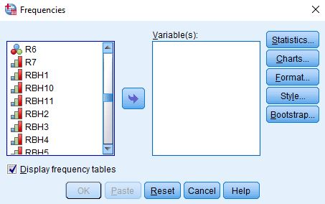
Figure 4-1
Notice that the list of all variables is in the pane on the left. I scrolled down to the variables that start with RBH. There are 11 of these variables but we're not going to look at all of them in this exercise. Select RBH1 by clicking on the variable name and then clicking on the arrow pointing to the right. This will move RBH1 into the "Variable(s)" box. Your screen should look like Figure 4-2.
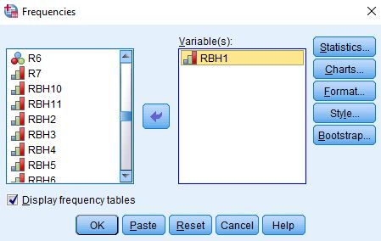
Figure 4-2
Now all you have to do is to click on "OK" to get your frequency distribution. Your screen should look like Figure 4-3.
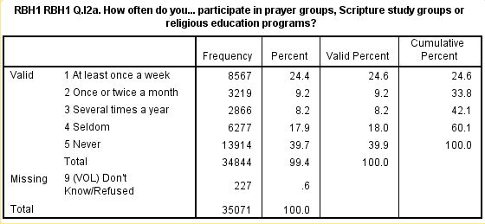
Figure 4-3
Take a few minutes to familiarize yourself with the information in the table.
- The first column is the value and the value label. The value "1" in the first table refers to all people who said they participated at least once a week.
- The second column is the number of respondents who said they participated at least once a week (8,567).
- The third column converts the frequencies to percents. To compute the percent for those who participated at least once a week, you would divide the frequency (8,567) by the total number of cases including those with missing values (35,071). Carry out the computation and convince yourself that it is 24.4%.
- The fourth column converts the frequencies to valid percents by dividing the frequency by the number of cases with valid information. There is one missing value code for this variable. Those who said they didn't know or refused to answer (227) which were coded "9." To compute the valid percent for those who answered at least once a week, you would divide 8,567 by 34,844. In other words, it excludes the cases with missing information (227) from the denominator when computing the percent. Carry out the computation and convince yourself that it is 24.6%. This is called the valid percent. The more missing information there is in the distribution, the greater could be the difference between the percent and the valid percent. Normally we want to use the valid percents when describing the frequency distribution.
- The fifth column is the cumulative percent. The cumulative percent for the second category of RBH1 is 33.8%. In other words, 33.8% of the cases with valid information said they participated in this type of religious groups at least once or twice a month. You can see where this comes from if you add up the valid percents for the first two categories of RBH1.

Part IV – Measuring Religious Behavior – Reading Scripture

Now were going to look at a different type of religious behavior – reading scripture. The Pew survey asked, "How often do you…read scripture outside of religious services?" This variable is named RBH2.
Run a frequency distribution for RBH2 and answer the following questions.
- How many respondents read scripture once or twice a month?
- What is the percent who read scripture once or twice a month?
- What is the valid percent who read scripture once or twice a month?
- Why aren't the percents and the valid percents the same?
- What is the percent who read scripture at least once or twice a month?

Part V – Measuring Religious Behavior – Sharing One's Faith

This time let's look at behavior that involves sharing one's faith with others. The Pew survey asked, "How often do you …share your faith with non-believers or people from other religious backgrounds?" The name of this variable is RBH5. Run a frequency distribution for RBH5.
Notice that this variable has two types of missing data. Some respondents said they didn't know or refused to answer the question and are coded "9." Other respondents are given a code of "system missing". To see what system missing means, run a frequency distribution for R5 which is one of the variables that describes religious preference. You'll see that there are 8,005 respondents who said they had no religious preference and 225 that said they didn't know or refused to answer the question on religious preference. If you add these two numbers, you get 8,229 which is the number of "system missing" values in RBH5. In other words, RBH5 wasn't asked of respondents who didn't give a religious preference to the earlier question. They are given a "system missing" code.
Using the information from the frequency distribution for RBH5, answer the following questions.
- What percent said they shared their faith at least once a week?
- What percent said they shared their faith once or twice a month?
- What percent said they shared their faith at least once or twice a month?
- What percent said they never shared their faith?
- What does this tell you about the willingness of those with a religious preference to share their faith?

Part VI -- Measuring Religious Behavior – Performing Volunteer Work for a Church or Religious Organization

Churches are typically volunteer organizations. They depend on volunteers to carry out their work. The Pew survey asked, "Thinking specifically about just the past week, that is the past seven days – did you yourself happen to do any volunteer work in the last seven days, or not?" If they responded that they did, they were asked if this volunteer work was done mainly through church or other religious organizations or if it was done mainly through non-religious organizations. Some respondents volunteered that it was done through both. Run a frequency distribution for this variable which is named RBH7.
- What percent volunteered through either a religious organization or a non-religious organization?
- What percent of all respondents did volunteer work though a religious organization? Note that those who did volunteer work through both a religious organization and in other ways should also be counted as having volunteered through a religious organization.
- What percent did not volunteer at all?

Part VII – Measuring Religious Behavior – Activities with Children

The Pew survey also asked about activities that the respondent did with their children under the age of 18. The question asked, "Please tell me if you do any of the following with [your child/any of your children]." The question included three different types of religious activities:
- Praying or reading scripture with children (RBH8).
- Sending children to Sunday school or another religious education program (RBH9).
- Home schooling or sending children to a religious school instead of a public school (RBH10).

Respondents answered yes (1) or no (2) to each of these three questions.
Run a frequency distribution for these three variables. It important to note that these questions were only asked of respondents who currently had a child under the age of 18 living at home.
We're going to start by selecting out respondents who answered all three questions. Click on "Data" in the menu bar at the top of the SPSS screen. Now click on "Select Cases" in the drop-down menu and select "If condition is specified" in the option on the right. (See Chapter 3, Transforming Data, in the online SPSS book cited on page 1 of this exercise.) Now click on the blue button just below this option. Copy the following statement and paste it into the box to the right of the arrow.
RBH8 <= 2 & RBH9 <= 2 & RBH10 <= 2
This statement tells SPSS to select out only those cases for which the respondents choose the yes (1) or the no (2) response for all three variables. Click on "Continue" and then on "OK."
Now that we have selected out the cases for which there was a valid response to all three questions, let's count the number of times the respondent said they engaged in these activities with their children. Click on "Transform" in the menu bar at the top of the SPSS screen. This will be the second row at the top of the screen. Now click on "Count Values within Cases" in the drop-down menu and enter ACTIVITIES_WITH_CHILDREN in the "Target Variable" box. Then select RBH8 and RBH9 and RBH10 and move them to the "Numeric Expression" box by clicking on each variable and then clicking on the arrow pointing to the right which is just to the left of the box. Now click on the "Define Values" button just below this box. Enter the value "1" in the "Value" box and then click on the "Add" button to move the value to the big box on the right. Finally, click on "Continue" and then on "OK." This will create a new variable that is the number of activities that respondents engaged in with their children.
Run a frequency distribution for the variable you just created and answer the following questions.
- What percent of respondents engaged in none of these activities with their children?
- What percent of respondents engaged in all three of these activities with their children?
- What percent of respondents engaged in two or more of these activities with their children?
- What is the total number of cases in these tables? Explain which cases are included in this total.

Part VIII – Conclusions

Write two or three paragraphs that summarize what you have learned about religious behavior in the United States. Use the valid percents from the frequency distributions in your answer.
The next set of exercises focus on the relationship between religion and how respondents feel about two social issues – same-sex marriage and environment laws and regulations. We'll use both two-variable (i.e., bivariate) analysis and three-variable (i.e., multivariate) analysis.

Part 2 – Religion and Social Issues

Exercise 5 – Two-Variable Analysis of Religion and How People Feel

About Same-Sex Marriage

Goal of Exercise
All research starts with a question. The question we're going to explore in this exercise is why people have different opinions about same-sex marriage. Some people favor same-sex marriage while others oppose it. We'll use two-variable crosstabulations, percentages, Chi Square, and measures of association as our statistical tools. In the Exercise 6) we'll expand our analysis and use three-variable tables.

Part I – The Data Set We'll be Using

The Pew Research Center has conducted a number of surveys that deal with religion. Two of these surveys are the Religious Landscape Surveys conducted in 2007 and then repeated in 2014. They were very large telephone surveys of about 35,000 adults in the United States. For more information about the surveys, go to their website.
We'll be using a subset of the 2014 survey in this exercise which I have named Pew_2014_Religious_Landscape_ Survey_subset_for_classes.sav. For the purposes of these exercises I selected a subset of variables from the complete data set. I recoded some of the variables, created a few new variables, and renamed the variables to make them easier for students to use. There is a weight variable which should always be used so that the sample will better represent the population from which the sample was selected. To open the data set in SPSS, just double click on the file name. Your instructor will tell you where the file is located.

Part II – Same-Sex Marriage
The Pew survey asked respondents "Do you strongly favor, favor, oppose, or strongly oppose allowing gays and lesbians to marry legally?" Let's start by finding out how respondents answered this question. If you haven't opened the data set yet, open it now. Run a frequency distribution for the variable SS1 which is the name of the variable. The variable name starts with the letters SS which tells you that this variable describes how people feel about same-sex marriage. Some of you have used SPSS, the statistical package we're using, and know how to get a frequency distribution. Others of you are new to SPSS. There is a tutorial that you can use to learn how to get a frequency distribution. The tutorial is freely available on the Social Science Research and Instructional Center's website. Frequency distributions are covered in Chapter 4.
It's very easy to get frequency distributions. Once you have opened the data set in SPSS, look on the menu bar at the top and click on "Analyze." This will open a drop-down menu. Click on "Descriptive Statistics" and then on "Frequencies." You screen should look like Figure 5-1.
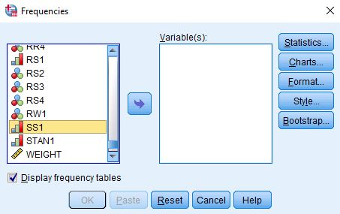
Figure 5-1
Notice that the list of all variables is in the pane on the left. I scrolled down to the variable that starts with SS. Select SS1 by clicking on it and then click on the arrow pointing to the right. This will move SS1 into the "Variable(s)" box. Your screen should look like Figure 5-2.
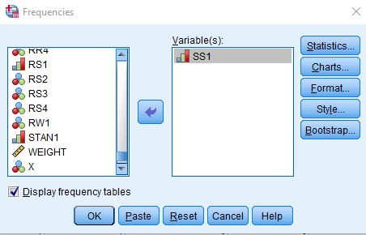
Figure 5-2
Now all you have to do is click on "OK" to get your frequency distribution. Your screen should look like Figure 5-3.
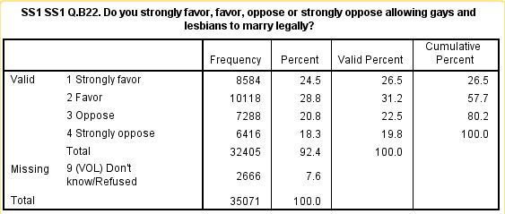
Figure 5-3
Take a few minutes to familiarize yourself with the information in the table.
- The first column is the value and the value label. The value "1" refers to all people who said they strongly favored allowing gays and lesbians to marry legally.
- The second column is the number of respondents who said they were strongly in favor of same-sex marriage (8,584).
- The third column converts the frequencies to percents. Notice that some respondents said they didn't know or refused to answer this question. This is called missing data because we don't know how they feel about same-sex marriage. These respondents are given a missing code which for this variable is the value "9". The percent column converts the frequency to a percent by dividing the frequency (8,584) by the total number of cases including those with missing values (35,071). Carry out the computation for yourself and convince yourself that it is 24.5%.
- The fourth column converts the frequencies to valid percents by dividing the frequency (8,584) by the number of cases with valid information (32,405). In other words, it excludes the cases with missing information (2,666) from the denominator when computing the percent. Carry out the computation for yourself and convince yourself that it is 26.5%. This is called the valid percent. The more missing information there is in the distribution, the greater could be the difference between the percent and the valid percent. Normally we want to use the valid percents when describing the frequency distribution.
- The fifth column is the cumulative percent. The second category (2) is for those who said they favored same-sex marriage. Suppose we wanted to know what percent either strongly favored or just favored same sex-marriage. The cumulative percent for the second category is 57.7%. In other words, 57.7% of the cases with valid information selected either categories 1 or 2. You can see where this comes from if you add up the valid percents for the first two categories.

Now it's your turn. The third category in the distribution is for those that opposed same-sex marriage.
- What is the value for this category?
- How many respondents said they opposed same-sex marriage?
- What is the percent for this category? What does this mean?
- What is the valid percent for this category? What does this mean?
- Why aren't the percent and valid percents the same?
- What is the cumulative percent for this category? What does this mean?

Part III – Religious Preference and Attitudes towards Same-Sex Marriage
Now let's turn to the question of why some people favor and others oppose same-sex marriage. We're going to focus on various dimensions of religion in our exploration of this question.
Our starting point will be religious preference. The Pew survey asked "What is your present religion, if any? Are you Protestant, Roman Catholic, Mormon, Orthodox such as Greek or Russian Orthodox, Jewish, Muslim, Buddhist, Hindu, atheist, agnostic, something else, or nothing in particular?" This is variable R1 in the data set.
One problem with this variable is that over 15,000 respondents said they were Protestant. We know there are many different types of Protestants so we might want to break Protestants down more finely. To do this the Pew survey asked another question – "As far as your present religion, what denomination or church, if any, do you identify with most closely? Just stop me when I get to the right one. Are you Baptist, Methodist, Lutheran, Presbyterian, Pentecostal, Episcopalian or Anglican, Church of Christ or Disciples of Christ, Congregational or United Church of Christ, Holiness, Reformed, Church of God, nondenominational or independent church, something else, or none in particular?" This is variable R2.
One of the problems with R2 is that there are so many categories. The Pew survey dealt with this problem by classifying Protestants into the following three religious traditions. This is variable R5.
- Evangelical Protestant tradition
- Mainline Protestant tradition
- Historically Black Protestant tradition

- To find out what the Pew Center means by these traditions, read the following Pew reports:
  - Chapter 1 of the full report for the 2014 Religious Landscape Survey on "The Changing Religious Composition of the U.S. Population" and
  - Appendix B to this report on "Classification of Protestant Denominations."

For more information on the difference between the evangelical and the mainline Protestant traditions, read the article by John Green in the PBS Frontline article on "Evangelicals v. Mainline Protestants." For a history of the black church, read Marilyn Mellowes' article on "The Black Church."
Now it's your turn again. Run a frequency distribution for R5 and use the information in this table to answer the following questions. Be sure to use the valid percents.
- What are the five largest religious groups in R5? Note that this table includes the religiously unaffiliated as a group. What are the percents for each of these groups?
- What percent of adults are Christian? Non-Christian? For this question be sure to also include Orthodox Christians, Jehovah's Witness, Mormon, and Other Christian as Christian when you compute the percent of adults who are Christian.
- Which non-Christian group is the largest? What is the percent for that group?
Now that we have figured out how to measure religious preference, let's see if religious preference helps us explain why some people favor and others oppose same-sex marriage. This represents a shift from what we typically call univariate (i.e., one-variable) analysis to bivariate (i.e., two-variable) analysis. Frequency distributions look at variables one at a time. Now we are going to look at the relationship between two variables – religious preference which is R5 and how people feel about same sex marriage which is SS1. Crosstabulation looks at variables two at a time.
The statistical tools that we're going to use to explore the relationship between R5 and SS1 are crosstabulation, Chi Square, and measures of association. We're not going to go into a lot of detail about these tools. Your instructor will provide that information. We will talk briefly about how to get SPSS to compute them and how to interpret them.
Before we look at the relationship between variables, we need to talk about independent and dependent variables. The dependent variable is whatever you are trying to explain. In our case, that would be how people feel about same-sex marriage (SS1). The independent variable is some variable that you think might help explain why some people favor and others oppose same-sex marriage. In our case, that would be religious preference (R5).
To run a crosstabulation in SPSS click on "Analyze" in the menu bar at the top of the screen. Now click on "Descriptive Statistics" in the drop-down menu and then on "Crosstabs." (See Chapter 5, Cross Tabulations, in the online SPSS book cited on page 1 of this exercise.) Your screen should look like Figure 5-4.
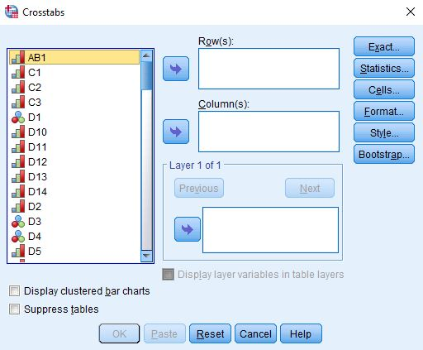
Figure 5-4
You're going to put your two variables (i.e., R5 and SS1) in the "Row(s)" and "Column(s)" boxes by clicking on the variable in the left-hand pane to select it and then clicking on the arrow that points to the right. When you do that, the arrow will change so it points left. If you click on it again, it will move the variable back to the left-hand pane. That way you can correct errors you would make when you select the wrong variable.
But which variable goes in which box? Typically, we put the independent variable in the column box and the dependent variable in the row box. But since there are so many categories in our independent variable, that's going to create a table that has so many columns that it's difficult to read and copy into your report. So in this case, we're going to put R5 in the row box and SS1 in the column box. We're also going to click on the "Cells" box and check the box for the "Row" percents. If your independent variable is in the rows, then you want to use the row percents. If it is in the columns, then you want to use the column percents. Your screens should look like Figure 5-5 and 5-6.

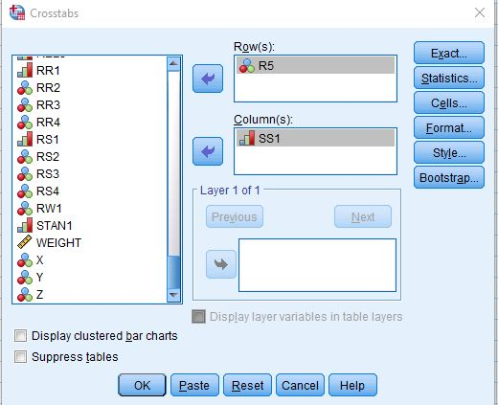
Figure 5-5
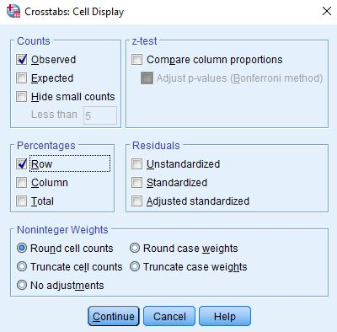
Figure 5-6

To get the table, click on "Continue" and then on "OK." Your screen should look like Figure 5-7. This is a big table so I'm only showing the top part of the output.
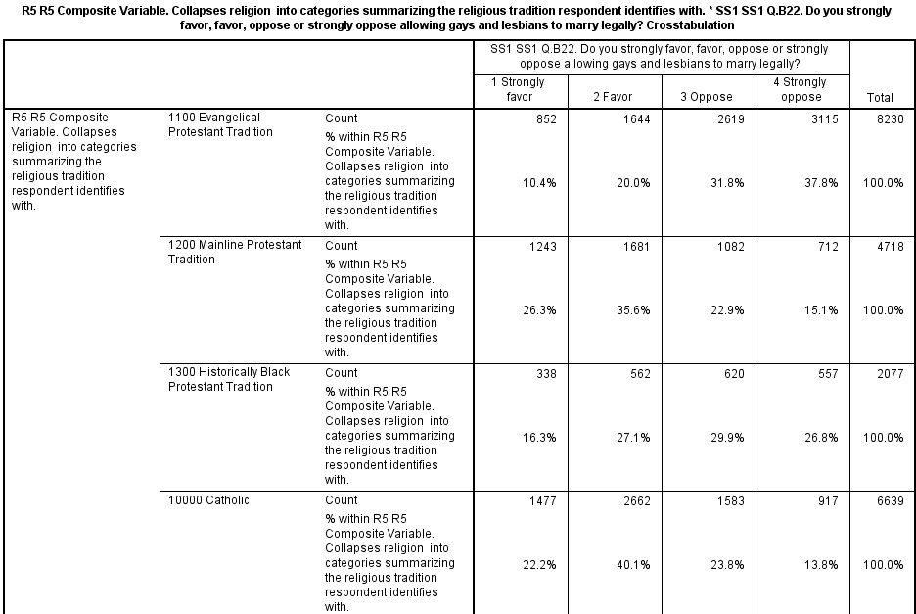
Figure 5-7
There are two numbers in each cell of the table. The top number is the number of cases in each cell and the bottom number is the row percent. Notice that the row percents add across by row to 100. Since the percent sum across to 100, you want to compare the percents down. Always compare the percents in the direction opposite to the way they sum to 100. This part of the table shows you that 26% of Mainline Protestants and 22% of Roman Catholics strongly favor same-sex marriage but only 10% of Evangelical Protestants and 16% of Historically Black Protestants strongly favor it. If we add the percent that strongly favor and favor same-sex marriage, we see that 62% of Mainline Protestants and 62% of Roman Catholics favor (i.e., either strongly favor or favor) same-sex marriage but only 30% of Evangelical Protestants and 43% of Historically Black Protestants favor it. That's quite a difference.
Write a paragraph that summarizes the relationship between religious preference and attitudes toward same-sex marriage in the full table. Be sure to answer the following questions.
- Which religions are most likely to favor same-sex marriage?
- Which religions are least likely to favor same-sex marriage?
- Write two sentences that summarize this pattern. The first sentence should describe the pattern in words without using the percents. The second sentence should use the percents to illustrate the pattern. Don't just read back each percent. Rather summarize the pattern using the percents to illustrate that pattern.
Earlier we said we were also going to use Chi Square and a measure of association in our exploration of this relationship. Chi Square is a test of significance that tests the null hypothesis that the two variables are unrelated to each other. In statistical speak, we would say that the null hypothesis is that the variables are statistically independent. Chi Square tests this null hypothesis and tells you whether you should reject or not reject it. If you can reject it, then you have evidence that the two variables are related to each other. If you can't reject it, then you don't have any evidence of such a relationship.
A measure of association is a statistic that measures the strength of the relationship. The Chi Square test doesn't tell you anything about the strength of the relationship. You need a measure of association to do that. There are many different measures of association. Cramer's V is a measure that you can use when one or both of your variables are nominal variables. A nominal variable is one in which the categories have no inherent order. R5 is a nominal variable since the different religious groups could be listed in any order.
To get Chi Square and Cramer's V click on the "Statistics" button and then click on the boxes for both Chi Square and Cramer's V. You screen should look like Figure 5-8.
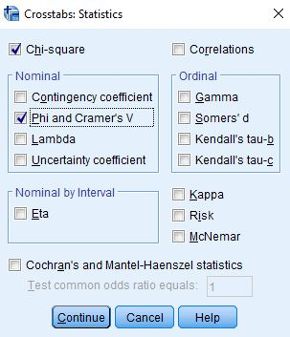
Figure 5-8
Now the question is how to interpret Chi Square and Cramer's V. To interpret Chi Square look at the first row for "Pearson Chi Square" and the column for "Asymptotic Significance." In your output, it should read ".000". This is the probability that you would be wrong if you rejected the null hypothesis. It's actually not 0, but rather it is less than (<) .0005 since it's a rounded value. That tells you that it's very unlikely that this is a chance relationship. There probably is some relationship between these two variables. Our rule is to reject the null hypothesis when the significance value is < .05. In other words, when the probability of being wrong is less than five out of one hundred.
To interpret Cramer's V look at the value which should be .269 in your table. Think of a continuum from 0 (no relationship) to 1 (strongest possible relationship). Measures of association are most useful when comparing tables to see which table has the stronger or weaker relationship.

Part IV – Born-Again Christians and Attitudes toward Same-Sex Marriage
You probably have heard the term "Evangelical Christians" and perhaps have wondered what it meant. In Part 1 of this exercise I asked you read a short article by John Green on the difference between the Evangelical and the Mainline Protestant traditions. In this article Green lists four defining beliefs of an Evangelical Christian.
- The belief that the Bible is inerrant (i.e., without error).
- The belief that the "only way to salvation is through belief in Jesus Christ."
- The belief that one must have had a "born-again experience."
- The belief in proselytization or spreading the word.
The Pew survey includes a question on the third belief. It asked, "Would you describe yourself as a 'born-again' or evangelical Christian, or not?" This is variable R3. Clearly this question only makes sense for respondents who view themselves as Christians. Consequently, Pew only asked this question of those who said they were Christian. Run a frequency distribution for R3 and write a sentence or two describing what the distribution tells you. Note that there are 10,294 cases listed as system missing. Those are the non-Christians that were not asked this question.
Now we're ready to look at the crosstabulation of R3 and SS1 to see if born-again or Evangelical Christians are more or less likely to favor or oppose same-sex marriage. This time put the dependent variable (SS1) in the row and the independent variable (R3) in the column. This is the more traditional way of setting up a crosstabulation. This means you will want to get the columns percents this time. Remember the rule -- if your independent variable is in the rows, then you want to use the row percents; if it is in the columns, then you want to use the column percents. Tell SPSS to compute Chi Square. For our measure of association, this time use Kendall's tau-c. Tau-c is used when both of your variables are ordinal. Ordinal means that the categories have an inherent order to them. In other words, they are ordered from high to low or from low to high.
Write a paragraph describing the relationship between having had a born-again experience and attitudes toward same-sex marriage. Use the column percents in your answer. Remember that since the column percents sum down to 100, you will compare the percents straight across. Use Chi Square and Kendall's tau-c to help you interpret the table. Like Cramer's V, tau-c varies from 0 (no relationship) to 1 (strongest possible relationship). Unlike V, tau-c can be either positive or negative. However, for this exercise ignore the sign when you interpret tau-c.

Part V – Biblical Literalism and Attitudes toward Same-Sex Marriage
Another way we can classify individuals is the way they view the sacred texts of their religion. Do they see these texts as the literal word of God or do they feel that they should not be taken literally? Additionally, some may view them as books written by humans and not by God. The Pew survey asked "Which comes closest to your view? Sacred text is the word of God OR sacred text is a book written by men and is not the word of God?" This is variable RBL6. A follow up question asked "And would you say? Sacred text is to be taken literally, word for word OR not everything in the sacred text should be taken literally, word for word?" This is variable RBL7. The term "sacred text" was replaced with the name of the sacred text for the respondent's religion (i.e., the Bible or the Torah or the Koran or the Holy Scripture).
Run frequency distributions for RBL6 and RBL7. I created a variable that is a composite of these two variables and called it RBL7R1. Run a frequency distribution for RBL7R1. Now let's look carefully and see how that composite variable was created. Value 1 in RBL7R1 is for respondents who said their sacred text is the literal word of God (see value 1 in RBL7). Value 2 is for respondents who said their sacred text is the non-literal word of God (see value 2 in RBL7). And value 3 is for those who said their sacred text is not the word of God (see value 2 in RBL6). The missing value of 9 is for those who had missing information on RBL6 or RBL7.
What we're interested in is whether respondents think their sacred text should be taken literally word for word. Often literalists say the word of God is inerrant. That means that it is without error. Look back at the article by John Green in the PBS Frontline article on "Evangelicals v. Mainline Protestants." Notice that this is one of the beliefs that Green says is central to Evangelical Protestants. So I combined values 2 and 3 in RBL7R1 and created a new variable called RBL7R2. Run a frequency distribution for RBL7R2 and make sure you understand how it was created out of RBL7R1.
Now we're ready to see whether biblical literalism is related to how respondents feel about same-sex marriage. Let's limit our analysis to Christians. Click on "Data" in the menu bar at the top of the SPSS screen. This will be the second row at the top of the screen. Now click on "Select Cases" in the drop-down menu. Your screen should look like Figure 5-9.
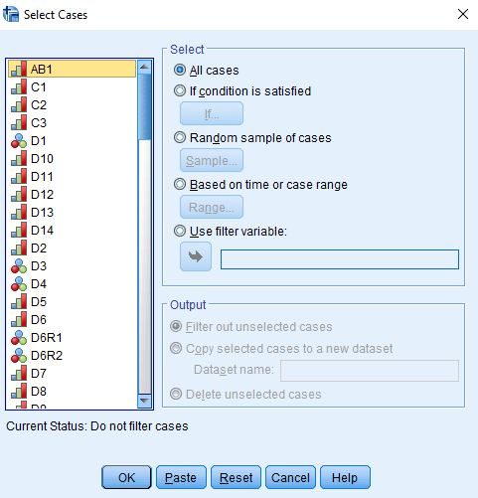
Figure 5-9
Select "If condition is specified" in the option on the right by clicking on the circle. (See Chapter 3, Transforming Data, in the online SPSS book cited on page 1 of this exercise.) Now click on the blue button just below this option. We want to select those cases for which the variable R5 is less than 50000. If you run a frequency distribution for R5 you'll see that Christians have codes less than 50000. Copy the following statement and paste it into the box to the right of the arrow.
R5 < 50000
Your screen should look like Figure 5-10.
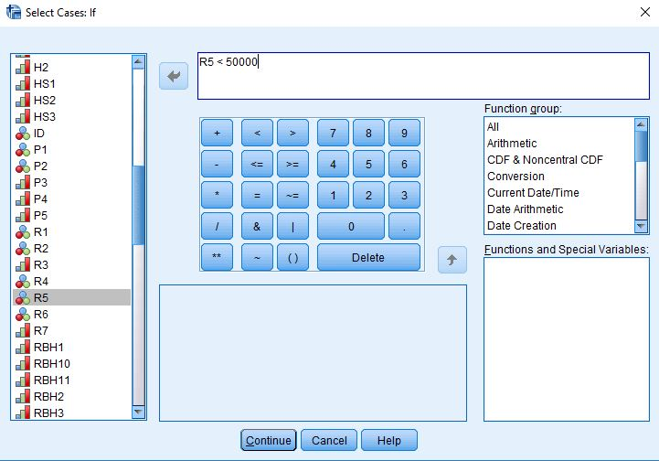
Figure 5-10
If you rerun the frequency distribution for R5 you should see only the Christians in the output.
Now run the crosstab for RBL7R2 and SS1 being sure to get the correct percents, Chi Square, and Kendall's tau-c. Think carefully about which variable should be your independent and dependent variables and put the independent variable in the columns. Write one or two paragraphs explaining what the relationship is between these two variables. The first part of your answer should explain in words (without using the percents) what the relationship is and the second part should use the percents to illustrate the relationship. Be sure to also use Chi Square and Kendall's tau-c in your answer.

Part VI – Using a Typology of Christians to Further Explore Attitudes toward Same-Sex Marriage
In the previous two parts of this exercise we looked at two defining beliefs of Evangelical Christians – the belief that one must have had a born-again experience (R3) and the belief that the Bible is the literal word of God (REL7R2). Now let's combine these two beliefs. Run a frequency distribution for RBL21. This variable is a typology of Christian beliefs combining R3 and RBL7R2. Your analysis will automatically be limited to Christians since non-Christians are defined as missing data.
Run the crosstab for RBL21 and SS1 being sure to get the correct percents, Chi Square, and Kendall's tau-c. Think carefully about which variable should be your independent and dependent variables and put the independent variable in the columns. Write one or two paragraphs explaining what the relationship is between these two variables. The first part of your answer should explain in words (without using the percents) what the relationship is and the second part should use the percents to illustrate the relationship. Be sure to also use Chi Square and Kendall's tau-c in your answer.

Part VII – Religiosity and Attitudes toward Same-Sex Marriage
Still another dimension of religion is religiosity which refers to the strength of a person's attachment to their religious preference. This describes how religious a person is. There are three commonly used measures of religiosity – how often a person attends religious services, how important they say religion is to them, and how often they pray.
The Pew survey asked, "Aside from weddings and funerals, how often do you attend religious services … more than once a week, once a week, once or twice a month, a few times a year, seldom, or never?" This is REL1.
They also asked, "How important is religion in your life – very important, somewhat important, not too important, or not at all important?" This is REL2.
Finally, Pew asked "People practice their religion in different ways. Outside of attending religious services, do you pray – several times a day, once a day, a few times a week, once a week, seldom, or never?" This is REL3.
Run three crosstabs to show the relationship between each of these variables and how people feel about same-sex marriage. Don't limit your analysis to Christians for part 7. To make sure you are using the full data set, click on "Data" and then on "Select Cases." Select the "All cases" option and then click on "OK."
Think carefully about which variables should be your independent and dependent variables and put the independent variable in the columns. For each crosstab, write one or two paragraphs explaining what the relationship is between these two variables. The first part of your answer should explain in words (without using the percents) what the relationship is and the second part should use the percents to illustrate the relationship. Be sure to also use Chi Square and Kendall's tau-c in your answer.
Now reread your answers and write another paragraph comparing the relationships you just described. Did you find the same relationship for all three measures of religiosity or were they different? What does this tell you about the relationship between religiosity and how respondents feel about same-sex marriage?

Part VIII – Conclusions
Write one or two paragraphs summarizing what you learned about religion and attitudes toward same-sex marriage. Be sure to consider what you discovered in each of the first seven parts of this exercise.
In the next exercise we're going to add other variables into the analysis which is commonly referred to as multivariate (i.e., more than two variables) analysis.

Exercise 6 – Three-Variable Analysis of Religion and How People Feel

About Same-Sex Marriage

Goal of Exercise

The goal of this exercise is to introduce three-variable (i.e., multivariate) data analysis. In Exercise 5) we explored the relationship between religiosity and how people felt about same-sex marriage. We discovered that those who were more religious were more likely to oppose same-sex marriage. In this exercise we'll consider whether this relationship might be spurious. We'll use three-variable crosstabulations, percentages, Chi Square, and measures of association as our statistical tools.

Part I – The Data Set We'll be Using
The Pew Research Center has conducted a number of surveys that deal with religion. Two of these surveys are the Religious Landscape Surveys conducted in 2007 and then repeated in 2014. They were very large telephone surveys of about 35,000 adults in the United States. For more information about the surveys, go to their website.
We'll be using a subset of the 2014 survey in this exercise which I have named Pew_2014_Religious_Landscape_ Survey_subset_for_classes.sav. For the purposes of these exercises I selected a subset of variables from the complete data set. I recoded some of the variables, created a few new variables, and renamed the variables to make them easier for students to use. There is a weight variable which should always be used so that the sample will better represent the population from which the sample was selected. To open the data set in SPSS, just double click on the file name. Your instructor will tell you where the file is located.

Part II – Same-Sex Marriage
The Pew survey asked respondents "do you strongly favor, favor, oppose, or strongly oppose allowing gays and lesbians to marry legally?" Let's start by finding out how respondents answered this question. If you haven't opened the data set yet, open it now. Run a frequency distribution for the variable SS1 which is the name of the variable. The variable name starts with the letters SS which tells you that this variable describes how people feel about same-sex marriage. Some of you have used SPSS, the statistical package we're using, and know how to get a frequency distribution. Others of you are new to SPSS. There is a tutorial that you can use to learn how to get a frequency distribution. The tutorial is freely available on the Social Science Research and Instructional Center's website. Frequency distributions are covered in Chapter 4.
It's easy to get frequency distributions. Once you have opened the data set in SPSS, look on the menu bar at the top and click on "Analyze." This will open a drop-down menu. Click on "Descriptive Statistics" and then on "Frequencies." Notice that the list of all variables is in the pane on the left. Select SS1 by clicking on it and then click on the arrow pointing to the right. This will move SS1 into the "Variable(s)" box. Now all you have to do is click on "OK" to get your frequency distribution.
The frequency distribution tells you how respondents answered this question. The difference between the percents and valid percents in the table is important. Percents are based on everyone in the sample while valid percents are based on only those who gave a valid answer. For various reasons, some respondents have missing data. Missing data for this variable refers to respondents who said they didn't know or refused to answer the question. For this variable, these respondents were given the value of "9". Valid percents are computed by removing these respondents from the base for the percent. To make sure you understand the difference between percents and valid percents, answer the following questions.
- What is the percent for those who strongly favor same-sex marriage? What does this mean?
- What is the valid percent for this category? What does this mean?
- Why aren't the percents and valid percents the same?

Part III – Religiosity and Attitudes toward Same-Sex Marriage

In the Exercise 5 we explored the relationship between religiosity and how people felt about same-sex marriage. Religiosity refers to the strength of a person's attachment to their religious preference. In other words, it describes how religious a person is. There are three commonly used measures of religiosity – how often a person attends religious services, how important they say religion is to them, and how often they pray. We're going to use the respondent's self-identified importance of religion in this exercise. The Pew survey asked, "How important is religion in your life – very important, somewhat important, not too important, or not at all important?" This is called REL2 in the data set.
Run a crosstabulation showing the relationship between REL2 and SS1. (See Chapter 5, Cross Tabulations, in the online SPSS book cited on page 1 of this exercise.) You're going to put your two variables (i.e., REL2 and SS1) in the "Row(s)" and "Column(s)" boxes by clicking on the variable in the left-hand pane to select it and then clicking on the arrow that points to the right. When you do that, the arrow will change so it points left. If you click on it again, it will move the variable back to the left-hand pane. That way you can correct errors you would make when you select the wrong variable.
But which variable goes in which box? Typically, we put the independent variable in the column box and the dependent variable in the row box. So we're going to put SS1 in the row box and REL2 in the column box. We're also going to click on the "Cells" box and check the box for the "Column" percents. If your independent variable is in the columns, then you want to use the column percents. If it is in the rows, then you want to use the row percents. To get the table, click on "Continue" and then on "OK."
There are two numbers in each cell of the table. The top number is the number of cases in each cell and the bottom number is the column percent. Notice that the column percents add down by column to 100. Since the percents sum down to 100, you want to compare the percents straight across. Always compare the percents in the direction opposite to the way they sum to 100.
We're going to use Chi Square to help us interpret the table. Chi Square is a test of significance that tests the null hypothesis that the two variables are unrelated to each other. In statistical speak, we would say that the null hypothesis is that the variables are statistically independent. Chi Square tests this null hypothesis and tells you whether you should reject it or not reject it. If you can reject it, then you have evidence that the two variables are related to each other. If you can't reject it, then you don't have any evidence of a relationship.
We're also going to use a measure of association. A measure of association is a statistic that measures the strength of the relationship. The Chi Square test doesn't tell you anything about the strength of the relationship. You need a measure of association to do that. There are many different measures of association. Kendall's tau-c is used when both of your variables are ordinal. Ordinal means that the categories have an inherent order to them. In other words, they are ordered from high to low or from low to high.
To get Chi Square and Kendall's tau-c click on the "Statistics" button and then click on the boxes for both Chi Square and Kendall's tau-c. Click on "Continue" and then on "OK" to get the table.
Now the question is how to interpret Chi Square and Kendall's tau-c. To interpret Chi Square look at the first row for "Pearson Chi Square" and the column for "Asymptotic Significance." In your output, it should read ".000". This is the probability that you would be wrong if you rejected the null hypothesis. It's actually not 0, but rather it is less than (<) .0005 since it's a rounded value. That tells you that it's very unlikely that this is a chance relationship. There probably is some relationship between these two variables. Our rule is to reject the null hypothesis when the significance value is < .05. In other words, when the probability of being wrong is less than five out of one hundred.
To interpret Kendall's tau-c look at the value in your table. Think of a continuum from 0 (no relationship) to 1 (strongest possible relationship). Tau-c varies from 0 to 1 and can be either positive or negative. However, for this exercise ignore the sign when you interpret tau-c. Measures of association are useful when comparing tables to see which table has the stronger or weaker relationship.
Write a paragraph that summarizes the relationship between religiosity and attitudes toward same-sex marriage. Be sure to answer the following questions and to use the valid percents.
- Were people who felt that religion was important to them more or less likely to favor same-sex marriage than those who felt religion was not important? Use the column percents to illustrate your answer.
- What does the Chi Square test tell you about this relationship?
- What does Kendall's tau-c tell you about the relationship?

Part IV – Spuriousness due to Sex
At this point we have only considered two variables. We need to consider other variables that might be related to religiosity and attitudes toward same-sex marriage. For example, sex may be related to both these variables. Women may be more likely to favor same-sex marriage and women may also be more likely to feel that their religion is important to them. This raises the possibility that the relationship between self-reported strength of religion and how one feels about same-sex marriage might be due to sex. In other words, it may be spurious due to sex.
Let’s check to see if sex is related to both our independent and dependent variables. This is important because the relationship can only be spurious if the third variable (sex) is related to both your independent and dependent variables. Use CROSSTABS to get two tables – one table should cross tabulate D14 (sex) and REL2 and the other table should cross tabulate D14 and SS1. Be sure to get the percents, Chi Square, and Kendall's tau-c. If sex is related to both variables, then we need to check further to see if the original relationship between religiosity and how people feel about same-sex marriage is spurious as a result of sex.
Write a paragraph describing the relationship between sex and your independent and dependent variables. Remember to use the percents, Chi Square, and Kendall's tau-c in your answer.
Since sex is related to both variables, we need to check on the possibility that the relationship between strength of religion and how people feel about same-sex marriage is due to the effect of sex on that relationship? What we can do is to separate males and females into two tables and look at the relationship between strength of religion and attitudes toward same-sex marriage separately for men and for women. In effect, we are holding sex constant. We can do that in SPSS by getting a crosstab with REL2 in the column (our independent variable), SS1 in the row (our dependent variable), and D14 in the third box down in SPSS. (See Chapter 8 on Multivariate Analysis in the online SPSS book mentioned on page 1 of this exercise.) In this case, sex is the variable we are holding constant and is often called the control variable.
Check to see what happens to the relationship between importance of religion and opinion on same-sex marriage when we hold sex constant. If the original relationship is spurious, then it either ought to go away or to decrease substantially for both males and females. So look carefully at the two tables (i.e., one table for males and the other table for females). But how can we tell if the relationship goes away or decreases for both males and females? One clue will be the percent differences. Compare the percent differences between those who are more religious and those who are less religious for males and then for females with the percent differences in the original two-variable table. Did the percent difference stay about the same or did they decrease substantially? Another clue is your measure of association. Did Kendall's tau-c stay about the same or did they decrease substantially from that in the original two-variable table?
If the relationship had been due to sex, then the relationship between importance of religion and opinion on same-sex marriage would have disappeared or decreased substantially for both males and females when we took out the effect of sex by holding it constant. In other words, the relationship would be spurious. Spurious means that there is a statistical relationship, but not a causal relationship. It important to note that just because a relationship is not spurious due to sex doesn’t mean that it is not spurious at all. It might be spurious due to some other variable such as age.
Write a paragraph describing the relationship between religiosity and attitudes toward same sex-marriage for men and then write a second paragraph describing the relationship for females. Now write a third paragraph discussing whether this relationship is spurious due to sex. Be sure to describe how you came to your conclusion. Remember to use the percents, Chi Square, and Kendall's tau-c in your answer.

Part V – Spuriousness due to Age
Now let's see if the relationship is spurious due to age. Run a frequency distribution for D6 which is the name of the variable for age. Notice that there are a large number of categories. To reduce the number of categories I recoded D6 into two new variables – D6R1 and D6R2. Both of these variables recode age into different sets of four categories. We're going to use D6R2 in this part of the exercise.
Follow the same steps that you used in Part 4.
- Crosstabulate D6R2 and SS1 and then run another crosstabulation for D6R2 and REL2 to see if your control variable (i.e., recoded age) is related to both your independent and dependent variables.
- Run a three-variable table with REL2 as your independent variable, SS1 as your dependent variable, and D6R2 as your control variable.
- Write a paragraph describing the relationship between religiosity and attitudes toward same sex-marriage for each category of your control variable (age). Since there are four categories for age, that means you will have four paragraphs.
- Now write a fifth paragraph discussing whether this relationship is spurious due to age. Be sure to describe how you came to your conclusion. Remember to use the percents, Chi Square, and Kendall's tau-c in your answer.

Part VI — Conclusions
Summarize what you learned in this exercise. Was the relationship spurious when you controlled for sex? Was it spurious when you controlled for age? What does it mean to say a relationship is spurious?
The next exercise focuses on the relationship religion and how respondents feel about environmental laws and regulations.

Exercise 7 – Two-Variable Analysis of Religion and How People
Feel About Environmental Laws and Regulations

Goal of Exercise

All research starts with a question. The question we're going to explore in this exercise is why some people feel that strict environmental laws and regulations cost jobs and hurt the economy and other feel that they are worth the cost. We'll use two-variable crosstabulations, percentages, Chi Square, and measures of association as our statistical tools. In Exercise 8 we'll expand our analysis and use three-variable tables.

Part I – The Data Set We'll be Using

The Pew Research Center has conducted a number of surveys that deal with religion. Two of these surveys are the Religious Landscape Surveys conducted in 2007 and then repeated in 2014. They were very large telephone surveys of about 35,000 adults in the United States. For more information about the surveys, go to their website.
We'll be using a subset of the 2014 survey in this exercise which I have named Pew_2014_Religious_Landscape_ Survey_subset_for_classes.sav. For the purposes of these exercises I selected a subset of variables from the complete data set. I recoded some of the variables, created a few new variables, and renamed the variables to make them easier for students to use. There is a weight variable which should always be used so that the sample will better represent the population from which the sample was selected. To open the data set in SPSS, just double click on the file name. Your instructor will tell you where the file is located.

Part II – Environmental Laws and Regulations and Their Effect on the Economy

The Pew survey asked respondents to choose between two claims. The first claim is that "stricter environmental laws and regulations cost too many jobs and hurt the economy" while the second claim is that "stricter environmental laws and regulations are worth the cost." Respondents were asked to choose the claim that comes closest to their own opinion. Let's start by finding out how respondents answered this question. If you haven't opened the data set yet, open it now. Run a frequency distribution for the variable ENV1 which is the name of the variable. The variable name starts with the letters ENV which tells you that this variable describes how people feel about environmental laws and regulations. Some of you have used SPSS, the statistical package we're using, and know how to get a frequency distribution. Others of you are new to SPSS. There is a tutorial that you can use to learn how to get a frequency distribution. The tutorial is freely available on the Social Science Research and Instructional Center's website. Frequency distributions are covered in Chapter 4.
It's very easy to get frequency distributions. Once you have opened the data set in SPSS, look on the menu bar at the top and click on "Analyze." This will open a drop-down menu. Click on "Descriptive Statistics" and then on "Frequencies." You screen should look like Figure 7-1.
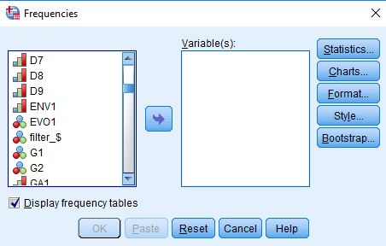
Figure 7-1
Notice that the list of all variables is in the pane on the left. I scrolled down to the variable that starts with ENV1. Select ENV1 by clicking on it and then click on the arrow pointing to the right. This will move ENV1 into the "Variable(s)" box. Your screen should look like Figure 7-2.
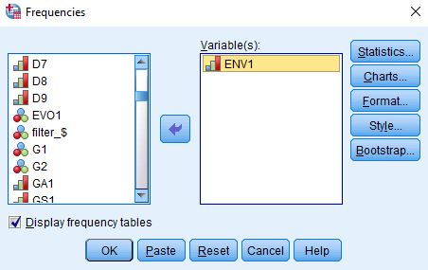
Figure 7-2
Now all you have to do is click on "OK" to get your frequency distribution. Your screen should look like Figure 7-3.
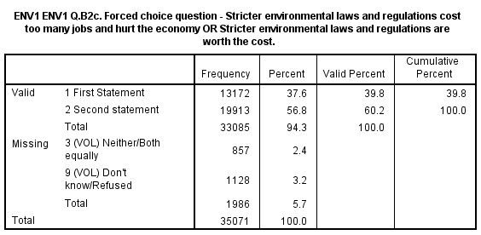
Figure 7-3
Take a few minutes to familiarize yourself with the information in the table.
- The first column is the value and the value label. The value "1" refers to all people who chose the first statement.
- The second column is the number of respondents who chose that statement (13,172).
- The third column converts the frequencies to percents. Notice that some respondents said they didn't know or refused to answer this question and others volunteered that they agreed with both or neither of these claims. These are called missing data because we don't know how they feel about environmental laws and regulations. These respondents are given missing codes which for this variable are the value "3" and "9". The percent column converts the frequency to a percent by dividing the frequency (13,172) by the total number of cases including those with missing values (35,071). Carry out the computation for yourself and convince yourself that it is 37.6%.
- The fourth column converts the frequencies to valid percents by dividing the frequency (13,172) by the number of cases with valid information (33,085). In other words, it excludes the cases with missing information (1,986) from the denominator when computing the percent. Carry out the computation for yourself and convince yourself that it is 39.8%. This is called the valid percent. The more missing information there is in the distribution, the greater could be the difference between the percent and the valid percent. Normally we want to use the valid percents when describing the frequency distribution.
- The fifth column is the cumulative percent which isn't very helpful for this variable because there are only two categories.
Now it's your turn. The second category in the distribution is for those who chose the second claim.
- What is the value for this category?
- How many respondents chose the second claim?
- What is the percent for this category? What does this mean?
- What is the valid percent for this category? What does this mean?
- Why aren't the percent and valid percents the same?

Part III – Religious Preference and Attitudes towards the Environment
Now let's turn to the question of why people have different feelings about environmental laws and regulations. We're going to focus on various dimensions of religion in our exploration of this question.
Our starting point will be religious preference. The Pew survey asked "What is your present religion, if any? Are you Protestant, Roman Catholic, Mormon, Orthodox such as Greek or Russian Orthodox, Jewish, Muslim, Buddhist, Hindu, atheist, agnostic, something else, or nothing in particular?" This is variable R1 in the data set.
One problem with this variable is that over 15,000 respondents said they were Protestant. We know there are many different types of Protestants so we might want to break Protestants down more finely. To do this the Pew survey asked another question – "As far as your present religion, what denomination or church, if any, do you identify with most closely? Just stop me when I get to the right one. Are you Baptist, Methodist, Lutheran, Presbyterian, Pentecostal, Episcopalian or Anglican, Church of Christ or Disciples of Christ, Congregational or United Church of Christ, Holiness, Reformed, Church of God, nondenominational or independent church, something else, or none in particular?" This is variable R2.
One of the problems with R2 is that there are so many categories. The Pew survey dealt with this problem by classifying Protestants into the following three religious traditions. This is variable R5.
- Evangelical Protestant tradition
- Mainline Protestant tradition
- Historically Black Protestant tradition
To find out what the Pew Center means by these traditions, read the following Pew reports:
- Chapter 1 of the full report for the 2014 Religious Landscape Survey on "The Changing Religious Composition of the U.S. Population" and
- Appendix B to this report on "Classification of Protestant Denominations."
For more information on the difference between the evangelical and the mainline Protestant traditions, read the article by John Green in the PBS Frontline article on "Evangelicals v. Mainline Protestants." For a history of the black church, read Marilyn Mellowes' article on "The Black Church."
Now it's your turn again. Run a frequency distribution for R5 and use the information in this table to answer the following questions. Be sure to use the valid percents.
- What are the five largest religious groups in R5? Note that this table includes the religiously unaffiliated as a group. What are the percents for each of these groups?
- What percent of adults are Christian? Non-Christian? For this question, be sure to also include Orthodox Christians, Jehovah's Witness, Mormon, and Other Christian as Christian when you compute the percent of adults who are Christian.
- Which non-Christian group is the largest? What is the percent for that group?
Now that we have figured out how to measure religious preference, let's see if religious preference helps us explain why people have different feelings about environmental laws and regulations. This represents a shift from what we typically call univariate (i.e., one-variable) analysis to bivariate (i.e., two-variable) analysis. Frequency distributions look at variables one at a time. Now we are going to look at the relationship between two variables – religious preference which is R5 and how people feel about environmental laws and regulations which is ENV1. Crosstabulation looks at variables two at a time.
The statistical tools that we're going to use to explore the relationship between R5 and ENV1 are crosstabulation, Chi Square, and measures of association. We're not going to go into a lot of detail about these tools. Your instructor will provide that information. We will talk briefly about how to get SPSS to compute them and how to interpret them.
Before we look at the relationship between these variables, we need to talk about independent and dependent variables. The dependent variable is whatever you are trying to explain. In our case, that would be how people feel about environmental laws and regulations (ENV1). The independent variable is some variable that you think might help explain why people have different feelings about environmental laws and regulations. In our case, that would be religious preference (R5).
To run a crosstabulation in SPSS click on "Analyze" in the menu bar at the top of the screen. Now click on "Descriptive Statistics" in the drop-down menu and then on "Crosstabs." (See Chapter 5, Cross Tabulations, in the online SPSS book cited on page 1 of this exercise.) Your screen should look like Figure 7-4.
Figure 7-4
You're going to put your two variables (i.e., R5 and ENV1) in the "Row(s)" and "Column(s)" boxes by clicking on the variable in the left-hand pane to select it and then clicking on the arrow that points to the right. When you do that, the arrow will change so it points left. If you click on it again, it will move the variable back to the left-hand pane. That way you can correct errors you would make when you select the wrong variable.
But which variable goes in which box? Typically, we put the independent variable in the column box and the dependent variable in the row box. But since there are so many categories in our independent variable, that's going to create a table that has so many columns that it's difficult to read and copy into your report. So in this case, we're going to put R5 in the row box and ENV1 in the column box. We're also going to click on the "Cells" box and check the box for the "Row" percents. If your independent variable is in the rows, then you want to use the row percents. If it is in the columns, then you want to use the column percents. Your screens should look like Figure7- 5 and 7-6.

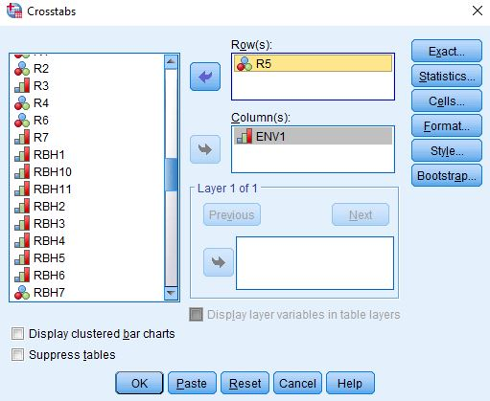
Figure 7-5
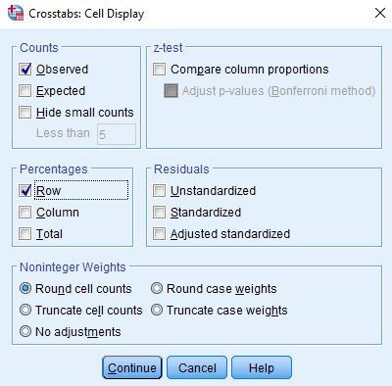
Figure 7-6
To get the table, click on "Continue" and then on "OK." Your screen should look like Figure 7-7. This is a big table so I'm only showing the top part of the output.
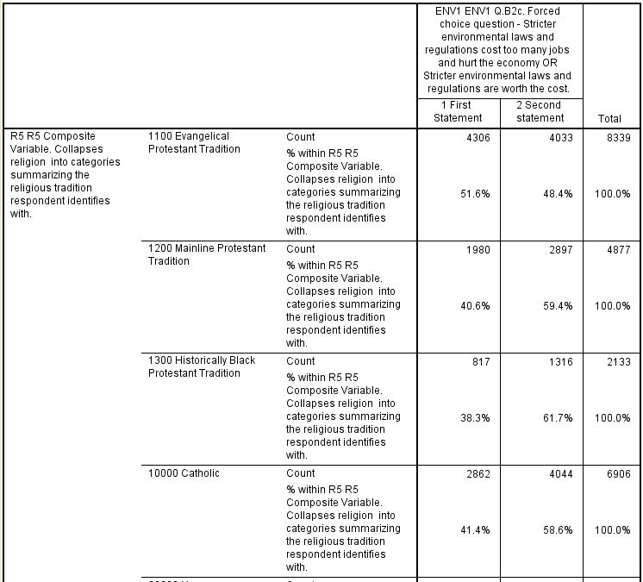
Figure 7-7
There are two numbers in each cell of the table. The top number is the number of cases in each cell and the bottom number is the row percent. Notice that the row percents add across by row to 100. Since the percent sum across to 100, you want to compare the percents down. Always compare the percents in the direction opposite to the way they sum to 100. This part of the table shows you that 52% of Evangelical Protestants but only 41% of Mainline Protestants, 38% of Historically Black Protestants, and 41% of Roman Catholics said that stricter environmental laws and regulations cost too many jobs and hurt the economy. That's quite a difference.
Write a paragraph that summarizes the relationship between religious preference and attitudes toward environmental laws and regulations in the full table. Be sure to answer the following questions.
- Which religions are most likely to think that environmental laws and regulations cost too many jobs and hurt the economy?
- Which religions are least likely to feel this way?
- Write two sentences that summarize this pattern. The first sentence should describe the pattern in words without using the percents. The second sentence should use the percents to illustrate the pattern. Don't just read back each percent. Rather summarize the pattern using the percents to illustrate that pattern.

Earlier we said we were also going to use Chi Square and a measure of association in our exploration of this relationship. Chi Square is a test of significance that tests the null hypothesis that the two variables are unrelated to each other. In statistical speak, we would say that the null hypothesis is that the variables are statistically independent. Chi Square tests this null hypothesis and tells you whether you should reject or not reject it. If you can reject it, then you have evidence that the two variables are related to each other. If you can't reject it, then you don't have any evidence of such a relationship.
A measure of association is a statistic that measures the strength of the relationship. The Chi Square test doesn't tell you anything about the strength of the relationship. You need a measure of association to do that. There are many different measures of association. Cramer's V is a measure that you can use when one or both of your variables are nominal variables. A nominal variable is one in which the categories have no inherent order. R5 is a nominal variable since the different religious groups could be listed in any order.
To get Chi Square and Cramer's V click on the "Statistics" button and then click on the boxes for both Chi Square and Cramer's V. You screen should look like Figure 7-8.
Figure 7-8
Now the question is how to interpret Chi Square and Cramer's V. To interpret Chi Square look at the first row for "Pearson Chi Square" and the column for "Asymptotic Significance." In your output, it should read ".000". This is the probability that you would be wrong if you rejected the null hypothesis. It's actually not 0, but rather it is less than (<) .0005 since it's a rounded value. That tells you that it's very unlikely that this is a chance relationship. There probably is some relationship between these two variables. Our rule is to reject the null hypothesis when the significance value is < .05. In other words, when the probability of being wrong is less than five out of one hundred.
To interpret Cramer's V look at the value which should be .188 in your table. Think of a continuum from 0 (no relationship) to 1 (strongest possible relationship). Measures of association are useful when comparing tables to see which table has the stronger or weaker relationship.

Part IV – Born-Again Christians and Attitudes toward Environmental Laws and Regulations

You probably have heard the term "Evangelical Christians" and perhaps have wondered what it meant. In Part 3 of this exercise I asked you read an article by John Green on the differences between the Evangelical and the Mainline Protestant traditions. In this article Green lists four defining beliefs of an Evangelical Christian.
- The belief that the Bible is inerrant (i.e., without error).
- The belief that the "only way to salvation is through belief in Jesus Christ."
- The belief that one must have had a "born-again experience."
- The belief in proselytization or spreading the word.

The Pew survey includes a question on the third belief. It asked, "would you describe yourself as a 'born-again' or evangelical Christian, or not?" This is variable R3. Clearly this question only makes sense for respondents who view themselves as Christians. Consequently, Pew only asked this question of those who said they were Christian. Run a frequency distribution for R3 and write a sentence or two describing what the distribution tells you. Note that there are 10,294 cases listed as system missing. Those are the non-Christians that were not asked this question and those who didn't answer the question.
Now we're ready to look at the crosstabulation of R3 and ENV1 to see if born-again or Evangelical Christians are more or less likely to think that environmental laws and regulations cost jobs and harm the economy. This time put the dependent variable (ENV1) in the row and the independent variable (R3) in the column. This is the more traditional way of setting up a crosstabulation. This means you will want to get the columns percents this time. Remember the rule -- if your independent variable is in the rows, then you want to use the row percents; if it is in the columns, then you want to use the column percents. Tell SPSS to compute Chi Square. For our measure of association, this time use Kendall's tau-c. Tau-c is used when both of your variables are ordinal. Ordinal means that the categories have an inherent order to them. In other words, they are ordered from high to low or from low to high. Dichotomies are always considered ordinal.
Write a paragraph describing the relationship between having had a born-again experience and attitudes toward environmental laws and regulations. Use the column percents in your answer. Remember that since the column percents sum down to 100, you will compare the percents straight across. Use Chi Square and Kendall's tau-c to help you interpret the table. Like Cramer's V, tau-c varies from 0 (no relationship) to 1 (strongest possible relationship). Unlike V, tau-c can be either positive or negative. However, for this exercise ignore the sign when you interpret tau-c.

Part V – Biblical Literalism and Attitudes toward Environmental Laws and Regulations

Another way we can classify individuals is the way they view the sacred texts of their religion. Do they see these texts as the literal word of God or do they feel that they should not be taken literally? Additionally, some may view them as books written by humans and not by God. The Pew survey asked "Which comes closest to your view? Sacred text is the word of God OR sacred text is a book written by men and is not the word of God?" This is variable RBL6. A follow up question asked "And would you say? Sacred text is to be taken literally, word for word OR not everything in the sacred text should be taken literally, word for word?" This is variable RBL7. The term "sacred text" was replaced with the name of the sacred text for the respondent's religion (i.e., the Bible or the Torah or the Koran or the Holy Scripture).
Run frequency distributions for RBL6 and RBL7. I created a variable that is a composite of these two variables and called it RBL7R1. Run a frequency distribution for RBL7R1. Now let's look carefully at how that composite variable was created. Value 1 in RBL7R1 is for respondents who said their sacred text is the literal word of God (see value 1 in RBL7). Value 2 is for respondents who said their sacred text is the non-literal word of God (see value 2 in RBL7). And value 3 is for those who said their sacred text is not the word of God (see value 3 in RBL6). The missing value of 9 is for those who had missing information on RBL6 and RBL7.
What we're interested in is whether respondents think their sacred text should be taken literally word for word. Often literalists say the word of God is inerrant. That means that it is without error. Look back at the article by John Green in the PBS Frontline article on "Evangelicals v. Mainline Protestants." Notice that this is one of the beliefs that Green says is central to Evangelical Protestants. So I combined values 2 and 3 in RBL7R1 and created a new variable called RBL7R2. Run a frequency distribution for RBL7R2 and make sure you understand how it was created out of RBL7R1.
Now we're ready to see whether biblical literalism is related to how respondents feel about environmental laws and regulations. Let's limit our analysis to Christians. Click on "Data" in the menu bar at the top of the SPSS screen. This will be the second row at the top of the screen. Now click on "Select Cases" in the drop-down menu. Your screen should look like Figure 7-9.
Figure 7-9
Select "If condition is specified" in the option on the right by clicking on the circle. (See Chapter 3, Transforming Data, in the online SPSS book cited on page 1 of this exercise.) Now click on the blue button just below this option. We want to select those cases for which the variable R5 is less than 50000. If you run a frequency distribution for R5 you'll see that Christians have codes less than 50000. Copy the following statement and paste it into the box to the right of the arrow.
R5 < 50000
Your screen should look like Figure 7-10.
Figure 7-10
If you rerun the frequency distribution for R5 you should see only Christians in the output.
Now run the crosstab for RBL7R2 and ENV1 being sure to get the correct percents, Chi Square, and Kendall's tau-c. Think carefully about which variable should be your independent and dependent variables and put the independent variable in the columns. Write one or two paragraphs explaining what the relationship is between these two variables. The first part of your answer should explain in words (without using the percents) what the relationship is and the second part should use the percents to illustrate the relationship. Be sure to also use Chi Square and Kendall's tau-c in your answer.

Part VI – Using a Typology of Christians to Further Explore Attitudes toward Environmental Laws and Regulations

In the last two parts of this exercise we looked at two defining beliefs of Evangelical Christians – the belief that one must have had a born-again experience (R3) and the belief that the Bible is the literal word of God (REL7R2). Now let's combine these two beliefs. Run a frequency distribution for RBL21. This variable is a typology of Christian beliefs combining R3 and REL7R2. Your analysis will automatically be limited to Christians since non-Christians are defined as missing data.
Run the crosstab for RBL21 and ENV1 being sure to get the correct percents, Chi Square, and Kendall's tau-c. Think carefully about which variable should be your independent and dependent variables and put the independent variable in the columns. Write one or two paragraphs explaining what the relationship is between these two variables. The first part of your answer should explain in words (without using the percents) what the relationship is and the second part should use the percents to illustrate the relationship. Be sure to also use Chi Square and Kendall's tau-c in your answer.

Part VII – Religiosity and Attitudes toward Environmental Laws and Regulations

Still another dimension of religion is religiosity which refers to the strength of a person's attachment to their religious preference. This describes how religious a person is. There are three commonly used measures of religiosity – how often a person attends religious services, how important they say religion is to them, and how often they pray.
The Pew survey asked, "Aside from weddings and funerals, how often do you attend religious services … more than once a week, once a week, once or twice a month, a few times a year, seldom, or never?" This is REL1.
They also asked, "How important is religion in your life – very important, somewhat important, not too important, or not at all important?" This is REL2.
Finally, Pew asked "People practice their religion in different ways. Outside of attending religious services, do you pray – several times a day, once a day, a few times a week, once a week, seldom, or never?" This is REL3.
Run three crosstabs to show the relationship between each of these variables and how people feel about environmental laws and regulations. Don't limit your analysis to Christians for part 7. To make sure you are using the full data set, click on "Data" and then on "Select Cases." Select the "All cases" option and then click on "OK."
Think carefully about which variables should be your independent and dependent variables and put the independent variable in the columns. For each crosstab, write one or two paragraphs explaining what the relationship is between these two variables. The first part of your answer should explain in words (without using the percents) what the relationship is and the second part should use the percents to illustrate the relationship. Be sure to also use Chi Square and Kendall's tau-c in your answer.
Now reread your answers and write another paragraph comparing the relationships you just described. Did you find the same relationship for all three measures of religiosity or were they different? What does this tell you about the relationship between religiosity and how respondents feel about environmental laws and regulations?

Part VIII – Conclusions

Write one or two paragraphs summarizing what you learned about religion and attitudes toward environmental laws and regulations. Be sure to consider what you discovered in each of the first seven parts of this exercise.
In the next exercise we're going to add other variables into the analysis which is commonly referred to as multivariate (i.e., more than two variables) analysis.

Exercise 8 – Three-Variable Analysis of Religion and How People Feel About Environmental Laws and Regulations

Goal of Exercise

The goal of this exercise is to introduce three-variable (i.e., multivariate) data analysis. In Exercise 7) we explored the relationship between religion and how people felt about environmental laws and regulations. We discovered that Christians who were more literal in their reading of the Bible were more likely to think that stricter environmental laws and regulations hurt the economy. In this exercise we're going to elaborate this relationship by controlling for other variables. We'll use three-variable crosstabulations, percentages, Chi Square, and measures of association as our statistical tools.

Part I – The Data Set We'll be Using

The Pew Research Center has conducted a number of surveys that deal with religion. Two of these surveys are the Religious Landscape Surveys conducted in 2007 and then repeated in 2014. They were very large telephone surveys of about 35,000 adults in the United States. For more information about the surveys, go to their website.
We'll be using a subset of the 2014 survey in this exercise which I have named Pew_2014_Religious_Landscape_ Survey_subset_for_classes.sav. For the purposes of these exercises I selected a subset of variables from the complete data set. I recoded some of the variables, created a few new variables, and renamed the variables to make them easier for students to use. There is a weight variable which should always be used so that the sample will better represent the population from which the sample was selected. To open the data set in SPSS, just double click on the file name. Your instructor will tell you where the file is located.

Part II – Environmental Laws and Regulations

The Pew survey asked respondents to choose between two claims. The first claim is that "stricter environmental laws and regulations cost too many jobs and hurt the economy" while the second claim is that "stricter environmental laws and regulations are worth the cost." Respondents were asked to choose the claim that comes closest to their own opinion. Let's start by finding out how respondents answered this question. If you haven't opened the data set yet, open it now. Run a frequency distribution for the variable ENV1 which is the name of the variable. The variable name starts with the letters ENV which tells you that this variable describes how people feel environmental laws and regulations. Some of you have used SPSS, the statistical package we're using, and know how to get a frequency distribution. Others of you are new to SPSS. There is a tutorial that you can use to learn how to get a frequency distribution. The tutorial is freely available on the Social Science Research and Instructional Center's website. Frequency distributions are covered in Chapter 4.
It's easy to get frequency distributions. Once you have opened the data set in SPSS, look on the menu bar at the top and click on "Analyze." This will open a drop-down menu. Click on "Descriptive Statistics" and then on "Frequencies." Notice that the list of all variables is in the pane on the left. Select ENV1 by clicking on it and then click on the arrow pointing to the right. This will move ENV1 into the "Variable(s)" box. Now all you have to do is click on "OK" to get your frequency distribution.
The frequency distribution tells you how respondents answered this question. The difference between the percents and valid percents in the table is important. Percents are based on everyone in the sample while valid percents are based on only those who gave a valid answer. Notice that some respondents said they didn't know or refused to answer this question and others volunteered that they agreed with both or neither of these claims. These are called missing data because we don't know how they feel about environmental laws and regulations. These respondents are given missing codes which for this variable are the value "3" and "9". Valid percents are computed by removing these respondents from the base for the percent. To make sure you understand the difference between the percents and the valid percents, answer the following questions.
- What is the percent for those who think that stricter environmental laws and regulations cost too many jobs and harm the economy? What does this mean?
- What is the valid percent for this category? What does this mean?
- Why aren't the percents and valid percents the same?

Part III – Biblical Literalism and Environmental Laws and Regulations

In Exercise 7 we explored the relationship between religion and how people felt about environmental laws and regulations. One of the ways we can classify individuals is the way they view the sacred texts of their religion. Do they see these texts as the literal world of God or do they feel that they should not be taken literally? Additionally, some may view them as books written by humans and not by God. The Pew survey asked "Which comes closest to your view? Sacred text is the word of God OR sacred text is a book written by men and is not the word of God?" This is variable RBL6. A follow up question asked, "And would you say? Sacred text is to be taken literally, word for word OR not everything in the sacred text should be taken literally, word for word?" This is variable RBL7. The term "sacred text" was replaced with the name of the sacred text for the respondent's religion (i.e., the Bible or the Torah or the Koran or the Holy Scripture).
Run frequency distributions for RBL6 and RBL7. I created a variable that is a composite of these two variables and called it RBL7R1. Run a frequency distribution for RBL7R1. Now let's look carefully at how that composite variable was created. Value 1 in RBL7R1 is for respondents who said their sacred text is the literal word of God (see value 1 in RBL7). Value 2 is for respondents who said their sacred text is the non-literal word of God (see value 2 in RBL7). And value 3 is for those who said their sacred text is not the word of God (see value 2 in RBL6). The missing value of 9 is for those who had missing information on RBL6 and RBL7.
What we're interested in is whether respondents think their sacred text should be taken literally word for word. Often literalists say the word of God is inerrant. That means that it is without error. So I combined values 2 and 3 in RBL7R1 and created a new variable called RBL7R2. Run a frequency distribution for RBL7R2 and make sure you understand how it was created out of RBL7R1.
Let's limit our analysis to respondents who identified their religious preference as Christian. We need to select out those respondents and limit our analysis to them. To do this, click on "Data" in the menu bar at the top of the screen and then click on "Select Cases" in the drop-down menu. (See Chapter 3, Transforming Data in the online SPSS book cited on page 1 of this exercise.) Select "if condition is satisfied" by clicking on its circle and then click on the "if" button below. Enter the specification for the cases you want to select. Your specification should read "R5 < 50000". Don't enter the quotation marks. Now click on "Continue" and then on "OK". To make sure you did this correctly, run a frequency distribution for R5. This time you should only see categories for Christians and values less than 50,000. If you made a mistake, you'll need to do it again. You should also notice that some of the cases (i.e., the non-Christians) in the data window have been lined out.
Run a crosstabulation showing the relationship between RBL7R2 and ENV1 being sure to get the correct percents, Chi Square, and Kendall's tau-c. (See Chapter 5, Cross Tabulations in the online SPSS book cited on page 1 of this exercise.) You're going to put your two variables (i.e., RBL7R2 and ENV1) in the "Row(s)" and "Column(s)" boxes by clicking on the variable in the left-hand pane to select it and then clicking on the arrow that points to the right. When you do that, the arrow will change so it points left. If you click on it again, it will move the variable back to the left-hand pane. That way you can correct errors you might make when you select the wrong variable.
But which variable goes in which box? Typically, we put the independent variable in the column box and the dependent variable in the row box. So we're going to put ENV1 in the row box andRBL7R2in the column box. We're also going to click on the "Cells" box and check the box for the "Column" percents. If your independent variable is in the columns, then you want to use the column percents. If it is in the rows, then you want to use the row percents. To get the table, click on "Continue" and then on "OK."
There are two numbers in each cell of the table. The top number is the number of cases in each cell and the bottom number is the column percent. Notice that the column percents add down by column to 100. Since the percents sum down to 100, you want to compare the percents straight across. Always compare the percents in the direction opposite to the way they sum to 100.
We're going to use Chi Square to help us interpret the table. Chi Square is a test of significance that tests the null hypothesis that the two variables are unrelated to each other. In statistical speak, we would say that the null hypothesis is that the variables are statistically independent. Chi Square tests this null hypothesis and tells you whether you should reject or not reject it. If you can reject it, then you have evidence that the two variables are related to each other. If you can't reject it, then you don't have any evidence of a relationship.
We're also going to use a measure of association. A measure of association is a statistic that measures the strength of the relationship. The Chi Square test doesn't tell you anything about the strength of the relationship. You need a measure of association to do that. There are many different measures of association. Kendall's tau-c is used when both of your variables are ordinal. Ordinal means that the categories have an inherent order to them. In other words, they are ordered from high to low or from low to high.
To get Chi Square and Kendall's tau-c click on the "Statistics" button and then click on the boxes for both Chi Square and Kendall's tau-c. Click on "Continue" and then on "OK" to get the table.
Now the question is how to interpret Chi Square and Kendall's tau-c. To interpret Chi Square look at the first row for "Pearson Chi Square" and the column for "Asymptotic Significance." In your output, it should read ".000". This is the probability that you would be wrong if you rejected the null hypothesis. It's actually not 0, but rather it is less than (<) .0005 since it's a rounded value. That tells you that it's very unlikely that this is a chance relationship. There probably is some relationship between these two variables. Our rule is to reject the null hypothesis when the significance value is < .05. In other words, when the probability of being wrong is less than five out of one hundred.
To interpret Kendall's tau-c look at the value in your table. Think of a continuum from 0 (no relationship) to 1 (strongest possible relationship). Measures of association are useful when comparing tables to see which table has the stronger or weaker relationship. Tau-c varies from 0 (no relationship) to 1 (strongest possible relationship). Tau-c can be either positive or negative. However, for this exercise ignore the sign when you interpret tau-c.
Write a paragraph that summarizes the relationship between biblical literalism and attitudes toward environmental laws and regulations. Write one or two paragraphs explaining what the relationship is between these two variables. The first part of your answer should explain in words (without using the percents) what the relationship is and the second part should use the percents to illustrate the relationship. Be sure to also use Chi Square and Kendall's tau-c in your answer. Make sure that you answer the following questions and use the valid percents.
- Were people who are biblical literalists more or less likely to think that stricter environmental laws and regulations harm the economy? Use the column percents to illustrate your answer.
- What does the Chi Square test tell you about this relationship?
- What does Kendall's tau-c tell you about the relationship?

Part IV – Spuriousness due to Age

At this point we have only considered two variables. We need to consider other variables that might be related to both biblical literalism and attitudes toward environmental laws and regulations. For example, age may be related to both these variables. Older respondents may be more likely to be biblical literalists and to think that stricter environmental laws and regulations harm the economy. This raises the possibility that the relationship between biblical literalism and how one feels about environmental laws and regulations might be due to age. In other words, it may be spurious due to age.
Let’s check to see if age is related to both our independent and dependent variables. This is important because the relationship can only be spurious if the third variable (age) is related to both your independent and dependent variables. Use CROSSTABS to get two tables – one table should cross tabulate D6R2 (recoded age) and RBL7R2 (biblical literalism) and the other table should cross tabulate D6R2 and ENV1. Limit your analysis to Christians. Be sure to get the percents, Chi Square, and Kendall's tau-c. If age is related to both variables, then we need to check further to see if the original relationship between biblical literalism and how people feel about environmental laws and regulations is spurious as a result of age.
Write a paragraph describing the relationship between age and your independent and dependent variables. Remember to use the percents, Chi Square, and Kendall's tau-c in your answer.
Since age is related to both variables, we need to check on the possibility that the relationship between biblical literalism and how people feel about environmental laws and regulations is due to the effect of age on that relationship? What we're going to do is separate respondents into different age categories and then look at the relationship between biblical literalism and attitudes toward environmental laws and regulations separately for each age category. In effect, we're going to see what happens then we hold age constant. We can do that in SPSS by running a crosstab with RBL7R2 in the column (our independent variable), ENV1 in the row (our dependent variable), and D6R2 in the third box down in SPSS. (See Chapter 8, Multivariate Analysis, in the online SPSS book mentioned on page 1 of this exercise.) In this case, age is the variable we are holding constant and is often called the control variable.
If the original relationship is spurious, then it either ought to go away or decrease substantially for all four age categories. Look carefully at the four tables (i.e., one table for each age category). How can we tell if the relationship goes away or decreases for each age category? One clue will be the percent differences. Compare the percent differences between those who are biblical literalists and those who are not for each of the four age categories with the percent difference in the original two-variable table. Did the percent differences stay about the same or did they decrease substantially? Another clue is your measure of association. Did Kendall's tau-c stay about the same or did they decrease substantially from that in the original two-variable table?
If the relationship had been due to age, then the relationship between biblical literalism and opinion on environmental laws and regulations would have disappeared or decreased substantially for all age categories. In other words, the relationship would be spurious. Spurious means that there is a statistical relationship, but not a causal relationship. It's important to note that just because a relationship is not spurious due to sex doesn’t mean that it is not spurious at all. It might be spurious due to some other variable.
Write a paragraph describing the relationship between biblical literalism and attitudes toward environmental laws and regulations for each age category. Now write another paragraph discussing whether this relationship is spurious due to age. Be sure to describe how you came to your conclusion. Remember to use the percents, Chi Square, and Kendall's tau-c in your answer.

Part V – Another Use of Control Variables

This process of introducing other variables is often called elaboration. We are elaborating our two-variable analysis by introducing another variable into the analysis. This is also referred to as multivariate analysis. One reason to introduce other variables into the analysis is to check for spuriousness as we did in Part 4.
It's possible that the relationship between two variables is different for some categories of individuals than it is for other categories. We know from Part 3 that biblical literalists are more likely to think that strict environmental laws and regulations harm the economy. We also know that individuals belong to many different religions. Run a frequency distribution for R5 which is religious preference. The four categories with the most cases are Evangelical Protestants (value 1), Mainline Protestants (value 2), Historically Black Protestants (value 3), and Roman Catholics (value 4). To find out what the Pew Center means by these traditions, read the following Pew reports:
- Chapter 1 of the full report for the 2014 Religious Landscape Survey on "The Changing Religious Composition of the U.S. Population" and
- Appendix B to this report on "Classification of Protestant Denominations."
For more information on the difference between the evangelical and the mainline Protestant traditions, read the article by John Green in the PBS Frontline article on "Evangelicals v. Mainline Protestants." For a history of the black church, read Marilyn Mellowes' article on "The Black Church."
Let's see if the relationship between biblical literalism (RBL7R2) and opinion on environmental laws and regulations (ENV1) is the same for Evangelical Protestants, Mainline Protestants, Historically Black Protestants, and Roman Catholics. To do this we're going to select out only these four groups. Click on "Data" in the menu bar at the top of the screen and then click on "Select Cases" in the drop-down menu. Select "if condition is satisfied" by clicking on its circle and then click on the "if" button below. Enter the specification for the cases you want to select. Your specification should read "R5 < 20000". Don't enter the quotation marks. Now click on "Continue" and then on "OK". To make sure you did this correctly, run a frequency distribution for R5. This time you should only see the four categories for Evangelical Protestants, Mainline Protestants, Historically Black Protestants, and Roman Catholics. If you made a mistake, you'll need to do it again. You should also notice that other religious groups in the data window have been lined out.
Now run a three-variable table with biblical literalism (RBL7R2) as your independent variable, opinion on environmental laws and regulations (ENV1) as your dependent variable, and religious preference (R5) as your control variable. Since you have selected out only those in the first four preference categories, you should only see these respondents in your table.
Compare the percent differences for each religious category. Look to see they changed drastically for any of these categories. You should find one of the religious categories for which the percent difference decreased sharply. Look also at the values for tau-c for these different religious groups. That same religious category will have a much lower value for tau-c. This is called specification because you have specified the conditions under which the relationship is either much stronger or much weaker.

Part VI — Conclusions

Summarize what you learned in this exercise. Was the relationship between biblical literalism and how people felt about environmental laws and regulations spurious when you controlled for age? What happened when you controlled for religious preference? Why is it important to introduce other variables into the analysis?
The next set of exercises focus on religious mobility by comparing the religious group in which respondents were raised with their current religious preference to see how much mobility there is into and out of different religious groups.

Part 3 – Religious Mobility

Exercise 9 – Comparing the Religious Group in which Respondents We're Raised with Their Current Religious Preference to See How Much Mobility There is Into and Out of Different Religious Groups

Goal of Exercise

The goal of this exercise is to explore religious mobility. We'll compare the religion in which respondents were raised with their current religious preference to see how much mobility there is into and out of different religious groups. In Exercise 10 we'll develop an overall measure of religious mobility and look to see where people go when they leave their religious group.

Part I – The Data Set We'll be Using

The Pew Research Center has conducted a number of surveys that deal with religion. Two of these surveys are the Religious Landscape Surveys conducted in 2007 and then repeated in 2014. They were very large telephone surveys of about 35,000 adults in the United States. For more information about the surveys, go to their website.
We'll be using a subset of the 2014 survey in this exercise which I have named Pew_2014_Religious_Landscape_ Survey_subset_for_classes.sav. For the purposes of these exercises I selected a subset of variables from the complete data set. I recoded some of the variables, created a few new variables, and renamed the variables to make them easier for students to use. There is a weight variable which should always be used so that the sample will better represent the population from which the sample was selected. To open the data set in SPSS, just double click on the file name. Your instructor will tell you where the file is located.

Part II – Measuring Religious Preference

Religious preference refers to the religion with which respondents identify. The Pew survey asked "What is your present religion, if any? Are you Protestant, Roman Catholic, Mormon, Orthodox such as Greek or Russian Orthodox, Jewish, Muslim, Buddhist, Hindu, atheist, agnostic, something else, or nothing in particular?"
Now that you have opened the data set, run a frequency distribution for the variable R1 which is the name of the variable. The variable name starts with the letter R which tells you that this variable describes religious preference. Some of you have used SPSS, the statistical package we're using, and know how to get a frequency distribution. Others of you are new to SPSS. There is a tutorial that you can use to learn how to get a frequency distribution. The tutorial is freely available on the Social Science Research and Instructional Center's website. Frequency distributions are covered in Chapter 4.
It's very easy to get frequency distributions. Once you have opened the data set in SPSS, look on the menu bar at the top and click on "Analyze." This will open a drop-down menu. Click on "Descriptive Statistics" and then on "Frequencies." You screen should look like Figure 9-1.
Figure 9-1
Notice that the list of all variables is in the pane on the left. I scrolled down to the variables that start with R (i.e., R1 through R7). Select R1 by clicking on it and then click on the arrow pointing to the right. This will move R1 into the "Variable(s)" box. Your screen should look like Figure 9-2.
Figure 9-2
Now all you have to do is to click on "OK" to get your frequency distribution. (Don't include this table in your paper.) Your screen should look like Figure 9-3. Note that I have only displayed the top part of the distribution because it's a very large table.
Figure 9-3
Take a few minutes to familiarize yourself with the information in the table.
- The first column is the value and the value label. The value "1" refers to all people who answered Protestant.
- The second column is the number of respondents who said they were Protestants (15,431).
- The third column converts the frequencies to percents. Notice that there are two types of missing information – responses that were uninterpretable and those who said they didn't know or refused to answer. The percent column converts the frequency to a percent by dividing the frequency (15,431) by the total number of cases including those with missing values (35,071). Carry out the computation for yourself and convince yourself that it is 44.0%.
- The fourth column converts the frequencies to valid percents by dividing the frequency (15,431) by the number of cases with valid information (34,846). In other words, it excludes the cases with missing information (225) from the denominator when computing the percent. Carry out the computation for yourself and convince yourself that it is 44.3%. This is called the valid percent. The more missing information there is in the distribution, the greater could be the difference between the percent and the valid percent. Normally we want to use the valid percents when describing the frequency distribution.
- The fifth column is the cumulative percent. Recall that the first twelve categories in the distribution were listed in Figure 3. The cumulative percent for this twelfth category is 94.4%. In other words, 94.4% of the cases with valid information selected one of the categories included in the first twelve categories. You can see where this comes from if you add up the valid percents for the first twelve categories.
Now it's your turn. The second category in the distribution is Roman Catholic.
- What is the value for this category?
- How many respondents said they were Roman Catholic?
- What is the percent for this category? What does this mean?
- What is the valid percent for this category? What does this mean?
- Why aren't the percent and valid percents the same?
- What is the cumulative percent for this category? What does this mean?

Part III – Measuring Religious Preference for Protestants

One problem with the first question is that over 15,000 respondents said they were Protestant. We know there are many different types of Protestants so we might want to break Protestants down more finely. To do this the Pew survey asked another question – "As far as your present religion, what denomination or church, if any, do you identify with most closely? Just stop me when I get to the right one. Are you Baptist, Methodist, Lutheran, Presbyterian, Pentecostal, Episcopalian or Anglican, Church of Christ or Disciples of Christ, Congregational or United Church of Christ, Holiness, Reformed, Church of God, nondenominational or independent church, something else, or none in particular?"
Run a frequency distribution for R2 which is the name of this variable. (Don't include this table in your paper.)
This question was only asked of those who said they were Protestant in R1. Notice that the number of cases with valid information was 15,403 and that there were 28 respondents who said they didn't know or refused to answer. If you add these two numbers together, you get 15,431 which is the number who said Protestant in R1. Those who didn't say they were Protestant in the previous question are included in the category that is labeled "system missing."
The large number of categories in R2 makes it difficult to interpret. R5 is an attempt to reduce the number of categories. Run a frequency distribution for R5. (Include this table in your paper.) Notice that this time Protestants are broken down by religious tradition. Religious tradition is divided into three categories.
- Evangelical Protestant tradition
- Mainline Protestant tradition
- Historically Black Protestant tradition
To find out what the Pew Center means by these traditions, read the following Pew reports:
Chapter 1 of the full report for the 2014 Religious Landscape Survey on "The Changing Religious Composition of the U.S. Population" and Appendix B to this report on "Classification of Protestant Denominations."
For more information on the difference between the evangelical and the mainline Protestant traditions, read the article by John Green in the PBS Frontline article on "Evangelicals v. Mainline Protestants." For a history of the black church, read Marilyn Mellowes' article on "The Black Church."
Now it's your turn again. Write a paragraph explaining in your own words what is meant by these three religious traditions – the Evangelical Protestant tradition, the Mainline Protestant tradition, and the Historically Black Protestant tradition. Study the frequency distribution carefully and be sure to answer the following questions. Use the valid percents.
- What are the five largest religious groups in R5? Note that this table includes the religiously unaffiliated as a group. What are the percents for each of these groups?
- What percent of adults are Christian? Non-Christian? For this question, be sure to also include Orthodox Christians, Jehovah's Witness, Mormon, and Other Christian as Christian when you compute the percent of adults who are Christian.
- Which non-Christian group is the largest? What is the percent for that group?

Part IV – Exploring Religious Mobility

We'll going to compare the religion in which respondents were raised with their current religious preference to see how much mobility there is both into and out of different religious groups. You already looked at the frequency distribution for R5 which describes respondent's current religious preference. The variable RR3 refers to the religion in which respondents were raised. The letters RR stand for "religion raised."
The Pew survey asked, "Thinking about when you were a child, in what religion were you raised, if any? Were you Protestant, Roman Catholic, Mormon, Orthodox such as Greek or Russian Orthodox, Jewish, Muslim, Buddhist, Hindu, atheist, agnostic, something else, or nothing in particular?" The respondents' answers to this question were recoded into the same categories as R5.
Now that we have figured out how to measure both current religious preference and the religious preference in which respondents were raised, let's turn to the question of religious mobility. This represents a shift from what we typically call univariate (i.e., one-variable) analysis to bivariate (i.e., two-variable) analysis. Frequency distributions look at variables one at a time. Now we are going to look at the relationship between two variables – religious preference in which one was raised (RR3) and current preference (R5). Crosstabulation looks at variables two at a time.
The statistical tools that we're going to use to explore the relationship between R5 and RR3 are crosstabulation, Chi Square, and measures of association. We're not going to go into a lot of detail about these tools. Your instructor will provide that information. We will talk briefly about how to get SPSS to compute them and how to interpret them.
Before we look at the relationship between variables, we need to talk about independent and dependent variables. The dependent variable is whatever you are trying to explain. In our case, that would be respondent's current religious preference (R5). The independent variable is the religion in which they were raised (RR3). We want to see whether the religious preference in which people are raised helps explain their current religious preference. Another way to look at this is to ask if the religious preference in which people are raised helps us predict current religious preference.
To run a crosstabulation in SPSS click on "Analyze" in the menu bar at the top of the screen. Now click on "Descriptive Statistics" in the drop-down menu and then on "Crosstabs." (See Chapter 5, Cross Tabulations, in the online SPSS book cited on page 1 of this exercise.) Your screen should look like Figure 9-4.
Figure 9-4
You're going to put your two variables (i.e., R5 and RR3) in the "Row(s)" and "Column(s)" boxes by clicking on the variable in the left-hand pane to select it and then clicking on the arrow that points to the right. When you do that, the arrow will change so it points left. If you click on it again, it will move the variable back to the left-hand pane. That way you can correct errors you would make when you select the wrong variable.
But which variable goes in which box? Typically, we put the independent variable in the column box and the dependent variable in the row box. So in this case, we're going to put RR3 in the column box and R5 in the row box. We're also going to click on the "Cells" box and check the box for "Column" percents. If your independent variable is in the columns, then you want to use the column percents. If it's in the rows, then you want to use the row percents. Your screens should look like Figures 9-5 and 9- 6.
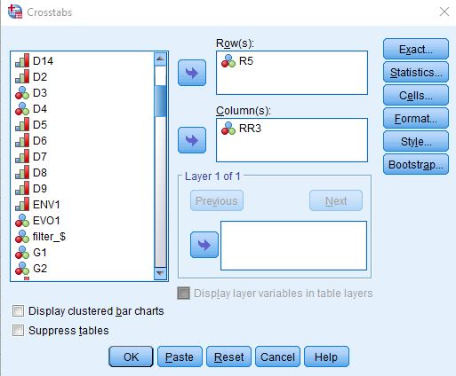
Figure 9-5
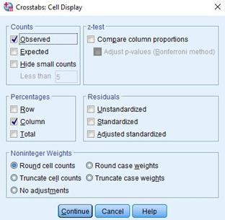
Figure 9-6
To get the table, click on "Continue" and then on "OK." Your screen should look like Figure 9-7. This is a big table so I'm only showing the top left part of the output.
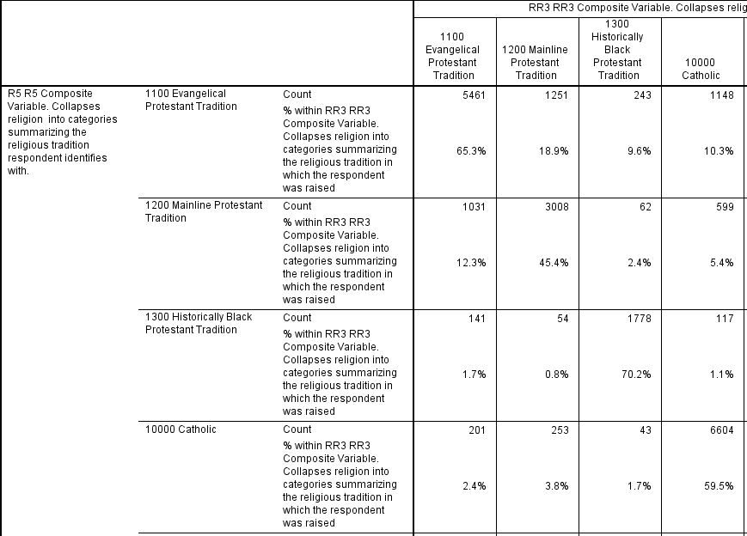
Figure 9-7
There are two numbers in each cell of the table. The top number is the number of cases in each cell and the bottom number is the column percent. Notice that the column percents add down by column to 100. Since the percent sum down to 100, you want to compare the percents across. Always compare the percents in the direction opposite to the way they sum to 100. This part of the table shows you that 65% of those who were raised Evangelical Protestant are still Evangelical today and that 45% of those raised Mainline Protestant are still Mainline today.
This table is too large to conveniently print out or to copy into your paper so you will need to refer to the table in SPSS. You're going to fill in the information in Figure 9-8 below by referring to the table in SPSS.
What we want to know is the percent of respondents who were raised in each religious category that are still in that category today and the percent that have moved out of that category.

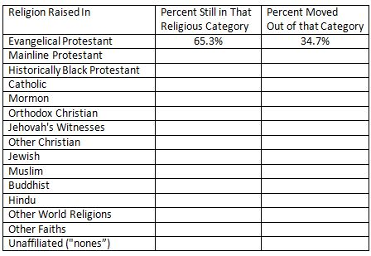
Figure 9-8
I filled in the first row for you so you would have an example to work from. Notice that the second and third columns sum across to 100%.
Now that you have the data, write a paragraph or two describing religious mobility. To help you write your paragraph(s), consider the following questions.
- Which religious groups have more than 50% out-mobility? Out-mobility refers to those who have left the religion in which they were raised.
- Which religious groups have at least 60% staying in the religious group in which they were raised?
- Look at those who grew up unaffiliated without any religious preference. What percent of that group are still unaffiliated and what percent now have a religious preference?

Part V – Conclusions

Write a summary of what you learned about religious mobility. Which religious groups have the most and the least mobility? What does this tell you about religious mobility in the United States?
In the next exercise we'll develop an overall measure of religious mobility and look to see where people go when they leave their religious group.

Exercise 10 – Developing an Overall Measure of Religious Mobility and Looking to See Where People Go When
They Leave Their Religious Group

Goal of Exercise

The goal of this exercise is to explore religious mobility. We'll develop an overall measure of religious mobility and look to see where people go when they leave their religious group. In Exercise 11 we'll compare out-mobility for men and women and for different age categories. Out-mobility refers to those who have left the religion in which they were raised.

Part I – The Data Set We'll be Using

The Pew Research Center has conducted a number of surveys that deal with religion. Two of these surveys are the Religious Landscape Surveys conducted in 2007 and then repeated in 2014. They were very large telephone surveys of about 35,000 adults in the United States. For more information about the surveys, go to their website.
We'll be using a subset of the 2014 survey in this exercise which I have named Pew_2014_Religious_Landscape_ Survey_subset_for_classes.sav. For the purposes of these exercises I selected a subset of variables from the complete data set. I recoded some of the variables, created a few new variables, and renamed the variables to make them easier for students to use. There is a weight variable which should always be used so that the sample will better represent the population from which the sample was selected. To open the data set in SPSS, just double click on the file name. Your instructor will tell you where the file is located.
Some of you have used SPSS, the statistical package we're using, and know how to get a frequency distribution. Others of you are new to SPSS. There is a tutorial that you can use to learn how to get a frequency distribution. The tutorial is freely available on the Social Science Research and Instructional Center's website. Crosstabulations are covered in Chapter 5.

Part II – Developing a Measure of Religious Mobility

We'll start by looking at the relationship between the religion in which people were raised and their current religious preference. Put the independent variable (RR3) in the columns and the dependent variable (R5) in the rows. We're not going to need the column percents this time. All we need is the observed counts which you get by default. Your output should look like Figure 10-1. This is a large table so we're just showing the top left part of the table.

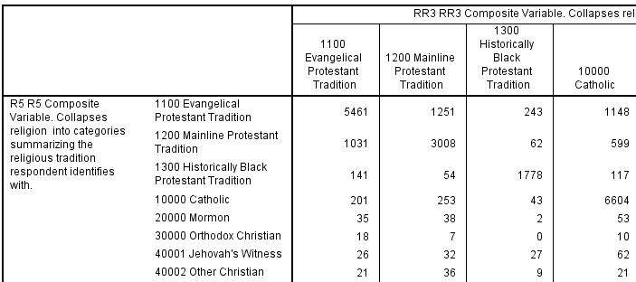
Figure 10-1
The upper-left cell represents the respondents who grew up Evangelical Protestant and are still Evangelical Protestant. In other words, they have remained in that same religious group. There are 5,461 of them. Moving over one column to the right we have the Mainline Protestants. Look for the number (3,008) of Mainline Protestants who have remained Mainline Protestant. Do this for each religious group in the table. Fill in the appropriate number of cases in Figure 10-2 for all religious groups.
Now add up the number of respondents who remained in the religious group in which they were raised (i.e., the number who were not religiously mobile found in column two of Figure 10-2). The last thing to do is to divide the number of respondents who were not religiously mobile by the total number of cases in the table which is 34,711 and convert that to a percent. To get the percent that were religiously mobile, just subtract that value from 100.

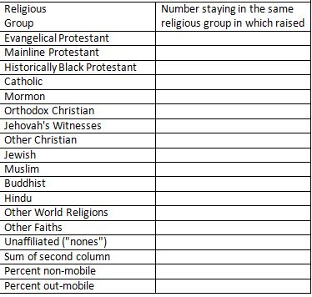
Figure 10-2

Part III – Mobility from One Religious Group to Another Religious Group

Let's look more carefully at religious mobility. Instead of just looking at overall out-mobility, let's look at where people go when they leave their religion. Copy by hand the number of cases in each cell into Figure 10-3.
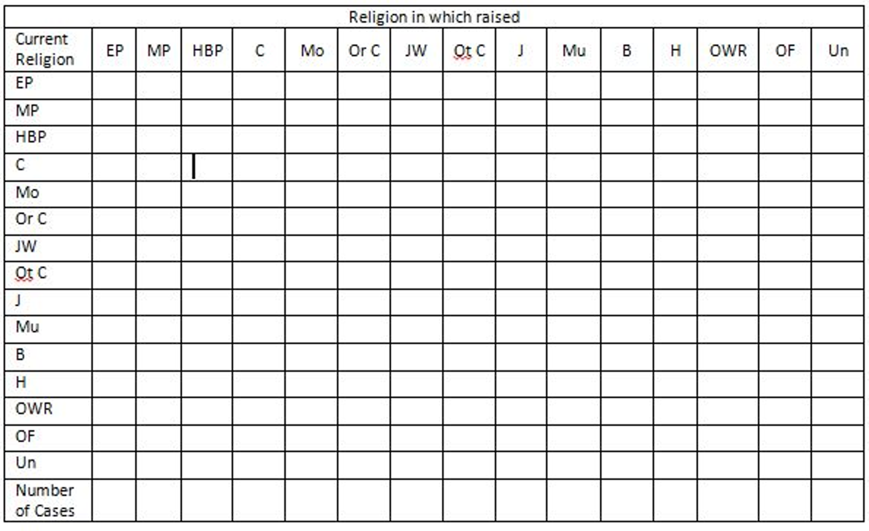
Figure 10-3
What do Figures 10-2 and 10-3 tell us about religious mobility in the United States? From Figure 10-2 we can calculate the percent of all adults that are religiously mobile. That is, they have moved from one religious group to another group.
What can we learn from Figure 10-3? When people leave their religious group, where are they most likely to go? The first eight religious categories are different types of Christians. The last seven categories are different types of non-Christians.
Let's start with mobility from Christian groups to non-Christian groups. How much of this type of mobility is there? (Hint: For each of the eight categories of Christians, you'll have to add up the number of cases that moved from a Christian category to a non-Christian category and then divide that sum by the number of cases in all eight Christian categories.)

Now let's look at other types of mobility.
- How much mobility is there from non-Christian groups to Christian groups?
- The four largest Christian groups are Evangelical Protestants, Mainline Protestants, Historically Black Protestants, and Catholics. Let's look at each of these groups separately.
- Evangelical Protestants
  - What percent go to Mainline Protestant groups?
  - What percent go to Historically Black Protestant groups?
  - What percent go to Catholics?
  - What percent become religiously unaffiliated?
- Mainline Protestants
  - What percent go to Evangelical Protestant groups?
  - What percent go to Historically Black Protestant groups?
  - What percent go to Catholics?
  - What percent become religiously unaffiliated?
- Historically Black Protestants
  - What percent go to Evangelical Protestant groups?
  - What percent go to Mainline Protestant groups?
  - What percent go to Catholics?
  - What percent become religiously unaffiliated?
- Catholics
  - What percent go to Evangelical Protestant groups?
  - What percent go to Mainline Protestant groups?
  - What percent go to Historically Black Protestant groups?
  - What percent become religiously unaffiliated?

Part IV – Conclusions

Now let's put all this together. Write one or two paragraphs summarizing what you learned about religious mobility. Don't just read back the percents from above. Rather, discuss the main conclusions that you can draw from these data.
The next exercise compares religious mobility for men and women and for different age categories.

Exercise 11 – Comparing Religious Mobility for Men and Women
and for Different Age Categories

Goal of Exercise

The goal of this exercise is to explore religious mobility. We'll develop an overall measure of religious mobility and compare out-mobility for men and women and for different age categories. Out-mobility refers to those who have left the religion in which they were raised.

Part I – The Data Set We'll be Using

The Pew Research Center has conducted a number of surveys that deal with religion. Two of these surveys are the Religious Landscape Surveys conducted in 2007 and then repeated in 2014. They were very large telephone surveys of about 35,000 adults in the United States. For more information about the surveys, go to their website.
We'll be using a subset of the 2014 survey in this exercise which I have named Pew_2014_Religious_Landscape_ Survey_subset_for_classes.sav. For the purposes of these exercises I selected a subset of variables from the complete data set. I recoded some of the variables, created a few new variables, and renamed the variables to make them easier for students to use. There is a weight variable which should always be used so that the sample will better represent the population from which the sample was selected. To open the data set in SPSS, just double click on the file name. Your instructor will tell you where the file is located.
Some of you have used SPSS, the statistical package we're using, and know how to get a frequency distribution. Others of you are new to SPSS. There is a tutorial that you can use to learn how to get a frequency distribution. The tutorial is freely available on the Social Science Research and Instructional Center's website. Crosstabulations are covered in Chapter 5.

Part II – Developing a Measure of Religious Mobility

In Exercise 10 we looked at the relationship between the religion in which people were raised and their current religious preference. Let's run that crosstab now. Put the independent variable (RR3) in the columns and the dependent variable (R5) in the rows. You won't need the column percents this time. All you need is the observed counts which you get by default. Your output should look like Figure 11-1. This is a large table so we're just showing the top left part of the table.
Figure 11-1
The upper-left cell represents the respondents who grew up Evangelical Protestant and are still Evangelical Protestant. In other words, they have remained in that same religious group. There are 5,461 of them. Moving over one column to the right we have the Mainline Protestants. Look for the number of Mainline Protestants who have remained Mainline Protestant. Do this for each religious group in the table. Fill in the appropriate number of cases in Figure11-2.
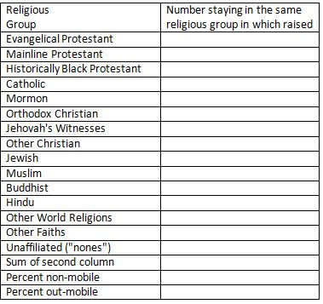
Figure 11-2
Now add up all these numbers. This is the number of respondents who remained in the religious group in which they were raised. The last thing to do is to divide the number of respondents who were not religiously mobile by the total number of cases in the table (34,711) and convert that to a percent. To get the percent that were religiously mobile, just subtract that value from 100.

Part III – Comparing Religious Mobility for Men and Women

Now that we have a measure of religious mobility for our sample of adults, let's compare mobility for men and women. That means that you will need to run a three-variable table that controls for sex. Put your independent variable (RR3) in the column and your dependent variable (R5) in the row as you did in Part 2. Put your control variable (D14) in the big box just below the column box. Copy by hand the observed counts (i.e., frequencies) into figures 11-3 and 11-4 below.
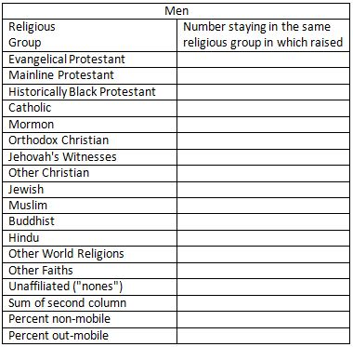
Figure 11-3
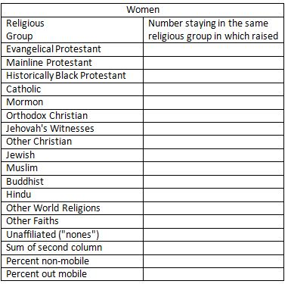
Figure 11-4
Compute the percent of men and women who were religiously mobile and non-mobile.
Write a paragraph comparing mobility for men and for women. Was there more mobility for men or for women? Were they only slightly different or quite different? Which percents did you use to compare mobility rates?

Part IV – Comparing Religious Mobility for Age Groups

Now let's compare mobility for different age groups. As you did in Part 3, you will need to run a three-variable table that controls for age. Put your independent variable (RR3) in the column and your dependent variable (R5) in the row as you did in Parts 2 and 3. This time put your control variable (D6R2) in the big box just below the column box. Copy by hand the observed counts (i.e., frequencies) into the tables below
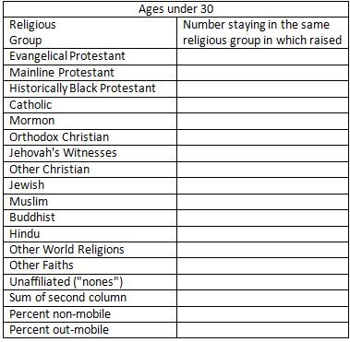
Figure 11-5
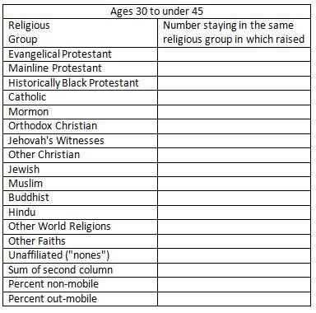
Figure 11-6
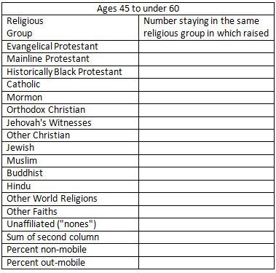
Figure 11-7
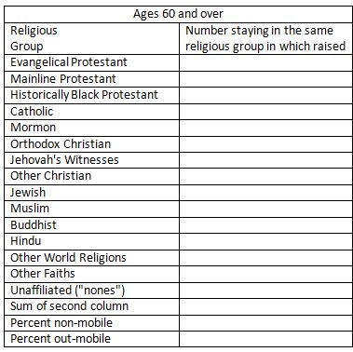
Figure 11-8
Write a paragraph comparing mobility for the four age groups. Was there more mobility for younger respondents or for older respondents? Were they only slightly different or quite different? Which percents did you use to compare mobility rates?

Part V – Conclusions

Write one or two paragraphs summarizing what you learned about religious mobility. Use the relevant percents from above in your answer.
The next set of exercises focus on the similarity and dissimilarity between respondents and their spouses or partners.

Part 4 – Religious Similarity and Dissimilarity Between
Respondents and Their Spouses or Partners

Exercise 12 – Comparing Religious Similarity and Dissimilarity between Respondents and Their Spouses or Partners
for Different Religious Groups

Goal of Exercise

The goal of this exercise is to explore religious similarity and dissimilarity between respondents and their spouses or partners. We'll compare the respondent's religious preference with spouse's or partner's preference. In Exercise 13 we'll develop an overall measure of religious similarity and look more closely at respondents who are not similar to their spouses and partners in religious preference.

Part I – The Data Set We'll be Using

The Pew Research Center has conducted a number of surveys that deal with religion. Two of these surveys are the Religious Landscape Surveys conducted in 2007 and then repeated in 2014. They were very large telephone surveys of about 35,000 adults in the United States. For more information about the surveys, go to their website.
We'll be using a subset of the 2014 survey in this exercise which I have named Pew_2014_Religious_Landscape_ Survey_subset_for_classes.sav. For the purposes of these exercises I selected a subset of variables from the complete data set. I recoded some of the variables, created a few new variables, and renamed the variables to make them easier for students to use. There is a weight variable which should always be used so that the sample will better represent the population from which the sample was selected. To open the data set in SPSS, just double click on the file name. Your instructor will tell you where the file is located.

Part II – Measuring Religious Preference

Religious preference refers to the religion with which respondents and their spouses/partners identify. The Pew survey asked, "What is your present religion, if any? Are you Protestant, Roman Catholic, Mormon, Orthodox such as Greek or Russian Orthodox, Jewish, Muslim, Buddhist, Hindu, atheist, agnostic, something else, or nothing in particular?" The same question was asked about their spouse or partner.
Now that you have opened the data set, run a frequency distribution for the variable R1 which is the name of one of the variables we will be using. The variable name starts with the letter R which tells you that this variable describes the respondent's religious preference. Some of you have used SPSS, the statistical package we're using, and know how to get a frequency distribution. Others of you are new to SPSS. There is a tutorial that you can use to learn how to get a frequency distribution. The tutorial is freely available on the Social Science Research and Instructional Center's website. Frequency distributions are covered in Chapter 4.
It's very easy to get frequency distributions. Once you have opened the data set in SPSS, look on the menu bar at the top and click on "Analyze." This will open a drop-down menu. Click on "Descriptive Statistics" and then on "Frequencies." You screen should look like Figure 12-1.
Figure 12-1
Notice that the list of all variables is in the pane on the left. I scrolled down to the variables that start with R (i.e., R1 through R7). Select R1 by clicking on it and then click on the arrow pointing to the right. This will move R1 into the "Variable(s)" box. Your screen should look like Figure 12-2.
Figure 12-2
Now all you have to do is to click on "OK" to get your frequency distribution. (Don't include this table in your paper.) Your screen should look like Figure 12-3. Note that I have only displayed the top part of the table because it's very large.
Figure 12-3
Take a few minutes to familiarize yourself with the information in the table.
- The first column is the value and the value label. The value "1" refers to all people who answered Protestant.
- The second column is the number of respondents who said they were Protestants (15,431).
- The third column converts the frequencies to percents. Notice that there are two types of missing information – responses that were uninterpretable and those who said they didn't know or refused to answer. The percent column converts the frequency to a percent by dividing the frequency (15,431) by the total number of cases including those with missing values (35,071). Carry out the computation for yourself and convince yourself that it is 44.0%.
- The fourth column converts the frequencies to valid percents by dividing the frequency (15,431) by the number of cases with valid information (34,846). In other words, it excludes the cases with missing information (225) from the denominator when computing the percent. Carry out the computation for yourself and convince yourself that it is 44.3%. This is called the valid percent. The more missing information there is in the distribution, the greater could be the difference between the percent and the valid percent. Normally we want to use the valid percents when describing the frequency distribution.
- The fifth column is the cumulative percent. Recall that the first twelve categories in the distribution were listed in Figure 12-3. The cumulative percent for this twelfth category is 94.4%. In other words, 94.4% of the cases with valid information selected one of the categories included in the first twelve categories. You can see where this comes from if you add up the valid percents for the first twelve categories.
Now it's your turn. The second category in the distribution is Roman Catholic.
- What is the value for this category?
- How many respondents said they were Roman Catholic?
- What is the percent for this category? What does this mean?
- What is the valid percent for this category? What does this mean?
- Why aren't the percent and valid percents the same?
- What is the cumulative percent for this category? What does this mean?

Part III – Measuring Religious Preference for Protestants

One problem with the first question is that over 15,000 respondents said they were Protestant. We know there are many different types of Protestants so we might want to break Protestants down more finely. To do this the Pew survey asked another question – "As far as your present religion, what denomination or church, if any, do you identify with most closely? Just stop me when I get to the right one. Are you Baptist, Methodist, Lutheran, Presbyterian, Pentecostal, Episcopalian or Anglican, Church of Christ or Disciples of Christ, Congregational or United Church of Christ, Holiness, Reformed, Church of God, nondenominational or independent church, something else, or none in particular?"
Run a frequency distribution for R2 which is the name of this variable. (Don't include this table in your paper.)
This question was only asked of those who said they were Protestant in R1. Notice that the number of cases with valid information was 15,403 and that there were 28 respondents who said they didn't know or refused to answer. If you add these two numbers together, you get 15,431 which is the number who said Protestant in R1. Those who didn't say they were Protestant in the previous question are included in the category that is labeled "system missing."
The large number of categories in R2 makes it difficult to interpret. R5 is an attempt to reduce the number of categories. Run a frequency distribution for R5. (Include this table in your paper.) Notice that this time Protestants are broken down by religious tradition. Religious tradition is divided into three categories.
- Evangelical Protestant tradition
- Mainline Protestant tradition
- Historically Black Protestant tradition
To find out what the Pew Center means by these traditions, read the following Pew reports:
- Chapter 1 of the full report for the 2014 Religious Landscape Survey on "The Changing Religious Composition of the U.S. Population" and
- Appendix B to this report on "Classification of Protestant Denominations."
For more information on the difference between the evangelical and the mainline Protestant traditions, read the article by John Green in the PBS Frontline article on "Evangelicals v. Mainline Protestants." For a history of the black church, read Marilyn Mellowes' article on "The Black Church."
Now it's your turn again. Write a paragraph explaining in your own words what is meant by these three religious traditions – the Evangelical Protestant tradition, the Mainline Protestant tradition, and the Historically Black Protestant tradition. Study the frequency distribution carefully and be sure to answer the following questions. Use the valid percents.
- What are the five largest religious groups in R5? Note that this table includes the religiously unaffiliated as a group. What are the percents for each of these groups?
- What percent of adults are Christian? Non-Christian? For this question be sure to also include Orthodox Christians, Jehovah's Witness, Mormon, and Other Christian as Christian when you compute the percent of adults who are Christian.
- Which non-Christian group is the largest? What is the percent for that group?

Part IV – Exploring Religious Similarity and Dissimilarity between Respondent and Spouse

We'll going to compare the respondent's religious preference with the religious preference of their spouse or partner. You already looked at the frequency distribution for R5 which describes respondent's current religious preference. The variable RS3 refers to the religion of the respondent's spouse or partner. Respondents who are not married or living with a partner are treated as missing data for RS3 and not included in the frequency distribution. The letters RS stand for "spouses and partners religious preference."
Now that we have figured out how to measure religious preference, let's turn to the question of the similarity and dissimilarity of respondent's religious preference and the preference of their spouse or partner. This represents a shift from what we typically call univariate (i.e., one-variable) analysis to bivariate (i.e., two-variable) analysis. Frequency distributions look at variables one at a time. Now we are going to look at the relationship between two variables – respondent's religious preference (R5) and spouse's or partner's preference (RS3). Crosstabulation looks at variables two at a time.
The statistical tools that we're going to use to explore the relationship between R5 and RR3 are crosstabulation and percents. We're not going to go into a lot of detail about these tools. Your instructor will provide that information. We will talk briefly about how to get SPSS to compute them and how to interpret them.
Before we look at the relationship between variables, let's talk about independent and dependent variables. Typically, the dependent variable is whatever you are trying to explain and the independent variable is some variable that you think will help you explain the variation in the dependent variable. So if you were looking at the relationship between religious preference and how people felt about social issues such as abortion or same-sex marriage, you would want to use religious preference as the independent variable and opinion on abortion or same-sex marriage as your dependent variable since you are trying to explain why people have different opinions on these issues. But in this exercise we're trying to measure the similarity or dissimilarity between the religious preference of the respondent and their spouse or partner. So we don't need to decide which is the independent and dependent variable.
To run a crosstabulation in SPSS click on "Analyze" in the menu bar at the top of the screen. Now click on "Descriptive Statistics" in the drop-down menu and then on "Crosstabs." (See Chapter 5, Cross Tabulations, in the online SPSS book cited on page 1 of this exercise.) Your screen should look like Figure 12-4.
Figure 12-4
You're going to put your two variables (i.e., R5 and RS3) in the "Row(s)" and "Column(s)" boxes by clicking on the variable in the left-hand pane to select it and then clicking on the arrow that points to the right. When you do that, the arrow will change so it points left. If you click on it again, it will move the variable back to the left-hand pane. That way you can correct errors you would make when you select the wrong variable.
But which variable goes in which box? Typically, we put the independent variable in the column box and the dependent variable in the row box. But we just decided that we didn't need to designate independent and dependent variables in this case. In order to standardize our tables so they will look similar, we're going to put R5 in the column box and RS3 in the row box. We're also going to click on the "Cells" box and check the box for "Column" percents. Your screens should look like Figure 12-5 and 12-6.

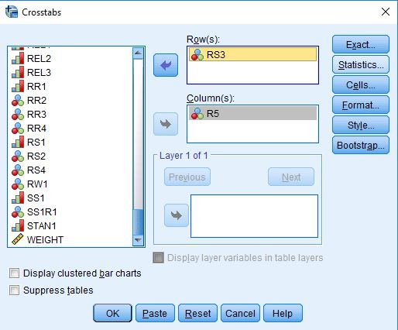
Figure 12-5
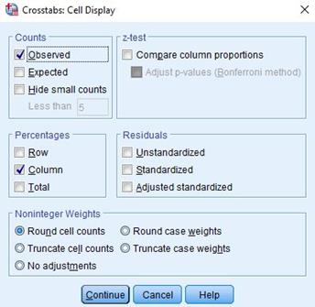
Figure 12-6
To get the table, click on "Continue" and then on "OK." Your screen should look like Figure 12-7. This is a big table so I'm only showing the top left part of the output.
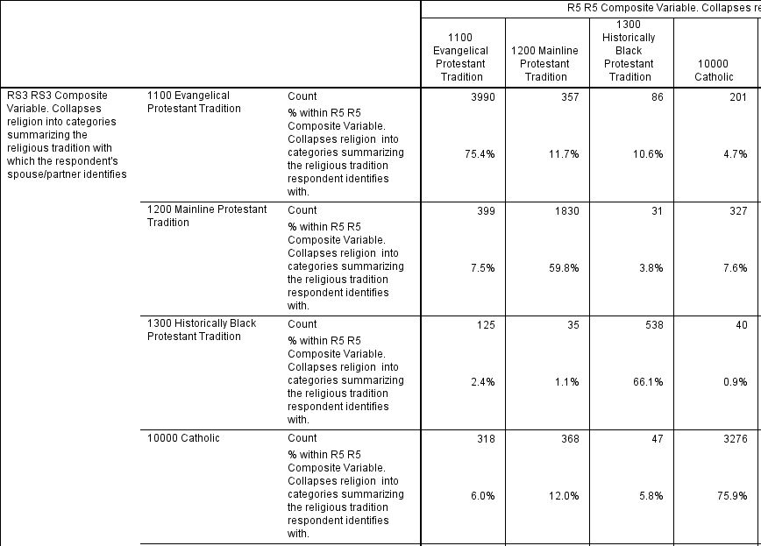
Figure 12-7
There are two numbers in each cell of the table. The top number is the number of cases in each cell and the bottom number is the column percent. Notice that the column percents add down by column to 100. Since the percents sum down to 100, you want to compare the percents across. Always compare the percents in the direction opposite to the way they sum to 100. This part of the table shows you that 75% of respondents who are Evangelical Protestant are either married to living with someone who is also Evangelical Protestant and that 60% of those who are Mainline Protestant are married to or living with someone who is Mainline Protestant.
This table is too large to conveniently print out or to copy into your paper so you will need to refer to the table in SPSS. You're going to fill in the information in the table below by referring to the table in the SPSS output.
What we want to know is the percent of respondents in each religious category that are married to or living with someone in that same category and the percent that are married to or living with someone in another religious category. You can get the percent married to or living with someone in the same religious table from the table in SDA and then get the percent married to or living with someone in another religious category by subtracting that percent from 100.
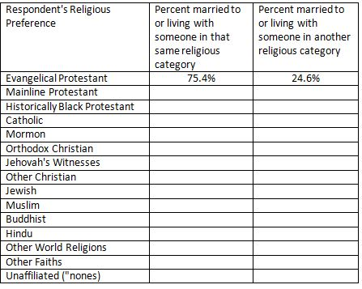
Figure 12-8
I filled in the first row for you so you would have an example to work from. Notice that the second and third columns sum across to 100%.
Now that you have the data, write a paragraph or two describing the similarity and dissimilarity between respondent's religious preference and that of their spouse or partner. To help you write your paragraph(s), consider the following questions.
- Which religious groups show more similarity than dissimilarity? Which groups have the greatest similarity?
- Which religious groups are more dissimilar than similar? Which groups have the greatest dissimilarity?
- Look at those who are unaffiliated without any religious preference. What percent of that group are married to or living with someone who is also unaffiliated?

Part V – Conclusions

Write a summary of what you learned about the similarity and dissimilarity of religious preference for respondents and their spouses or partners. Which religious groups have the most and the least similarity? What does this tell you about religious similarity and dissimilarity for respondents and their spouses and partners in the United States?

Exercise 13 – Developing an Overall Measure of Religious Similarity and Exploring Religious Similarity and Dissimilarity Between
Respondents and Their Spouses or Partners
for Different Religious Groups

Goal of Exercise

The goal of this exercise is to explore religious similarity and dissimilarity between respondents and their spouses or partners. We'll develop an overall measure of religious similarity and look more closely at respondents who are not similar to their spouses and partners in religious preference. In Exercise 14 we'll look to see whether similarity and dissimilarity varies by sex and age.

Part I – The Data Set We'll be Using

The Pew Research Center has conducted a number of surveys that deal with religion. Two of these surveys are the Religious Landscape Surveys conducted in 2007 and then repeated in 2014. They were very large telephone surveys of about 35,000 adults in the United States. For more information about the surveys, go to their website.
We'll be using a subset of the 2014 survey in this exercise which I have named Pew_2014_Religious_Landscape_ Survey_subset_for_classes.sav. For the purposes of these exercises I selected a subset of variables from the complete data set. I recoded some of the variables, created a few new variables, and renamed the variables to make them easier for students to use. There is a weight variable which should always be used so that the sample will better represent the population from which the sample was selected. To open the data set in SPSS, just double click on the file name. Your instructor will tell you where the file is located.
Some of you have used SPSS, the statistical package we're using, and know how to get a frequency distribution. Others of you are new to SPSS. There is a tutorial that you can use to learn how to get a frequency distribution. The tutorial is freely available on the Social Science Research and Instructional Center's website. Crosstabulations are covered in Chapter 5.

Part II – Developing a Measure of Religious Similarity and Dissimilarity

In Exercise 12 we looked at the relationship between the respondents' religious preference and the preference of their spouse or partner. Let's run that crosstab now. Put R5 in the columns and RS3 in the rows. Don't ask for percents this time. You'll get the observed frequencies by default and that's all that you will need. Your output should look like Figure 13-1. This is a large table so we're just showing the top left part of the table.
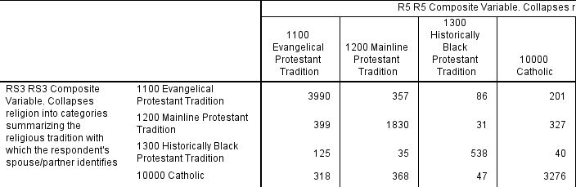
Figure 13-1
The upper-left cell represents the respondents who are Evangelical Protestant and whose spouse or partner are also Evangelical Protestant. In other words, they have the same religious preference as their spouse or partner. There are 3,990 of them. Moving over one column to the right we have the Mainline Protestants. Look for the number (1,830) of Mainline Protestants whose spouse or partner are also Mainline Protestant. Do this for each religious group in the table. Fill in the appropriate number of cases in Figure 13-2 for all religious groups.
Now add up all these numbers. That is the number of respondents whose spouse or partner has the same religious preference. The last thing to do is to divide the number of respondents who are religiously similar to their spouse or partner by the total number of cases in the table (19,127) and convert that to a percent. To get the percent that were religiously dissimilar, just subtract that value from 100.

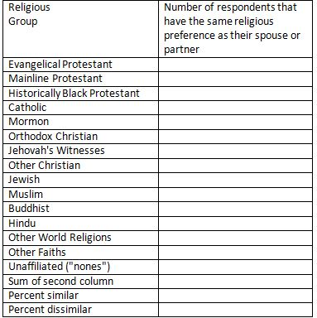
Figure 13-2

Part III – Exploring Religious Dissimilarity

Instead of just looking at similarity and dissimilarity, let's look more closely at couples who are dissimilar. Rerun the table that you ran in part 2. This time ask for the column percents. Copy by hand the column percents into the table below.
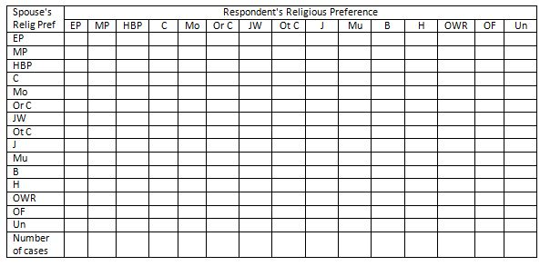
Figure 13-3
What do Figures 13-2 and 13-3 tell us about religious similarity and dissimilarity in the United States? Figure 13-2 shows the percent of couples that are similar in terms of their religious preference. That is, the respondents and their spouses and partners have the same religious preference.
But what about couples who are dissimilar in their religious preferences? What can we learn from Figure 13-3 that might help us answer this question? Consider the following questions and write a paragraph answering each question.
- The first eight religious categories are different types of Christians. The last seven categories are different types of non-Christians. How much similarity is there for Christian groups compared to non-Christian groups? (Hint: Think about how you will answer this question. Can you compute two different measures of similarity – one for Christians and another for non-Christians?)
- The four largest Christian groups are Evangelical Protestants, Mainline Protestants, Historically Black Protestants, and Catholics. Let's look at each of these groups separately.
- Evangelical Protestants
  - What percent of Evangelical Protestants marry someone who belongs to a Mainline Protestant group?
  - What percent of Evangelical Protestants marry someone who belongs to a Historically Black Protestant group?
  - What percent of Evangelical Protestants marry someone who is Catholic?
  - What percent of Evangelical Protestants marry someone who is religiously unaffiliated?
- Mainline Protestants
  - What percent of Mainline Protestants marry someone who belongs to an Evangelical Protestant group?
  - What percent of Mainline Protestants marry someone who belongs to a Historically Black Protestant group?
  - What percent of Mainline Protestants marry someone who is Catholic?
  - What percent of Mainline Protestants marry someone who is religiously unaffiliated?
- ​​​​​​​​​​​​​​Historically Black Protestants
  - ​​​​​​​What percent of Historically Black Protestants marry someone who belongs to an Evangelical Protestant group?
  - What percent of Historically Black Protestants marry someone who belongs to a Mainline Protestant group?
  - What percent of Historically Black Protestants marry someone who is Catholic?
  - What percent of Historically Black Protestants marry someone who is religiously unaffiliated?
- ​​​​​​​Catholics
  - ​​​​​​​What percent of Catholics marry someone who belongs to an Evangelical Protestant group?
  - What percent of Catholics marry someone who belongs to a Mainline Protestant group?
  - What percent of Catholics marry someone who belongs to a Historically Black Protestant group?
  - ​​​​​​​What percent of Catholics marry someone who is religiously unaffiliated?

Part IV – Conclusions

Now let's put all this together. Write one or two paragraphs summarizing what you learned about religious similarity and dissimilarity. Don't just read back the percents from the tables. Rather, discuss the conclusions that you can draw from these data.
The next exercise compares men and women to see whether religious similarity varies by sex.

Exercise 14 – Exploring Whether Religious Similarity
Varies by Sex

Goal of Exercise

The goal of this exercise is to explore similarity and dissimilarity between respondents and their spouses or partners in terms of religious preference. We'll look to see whether similarity varies by sex.

Part I – The Data Set We'll be Using

The Pew Research Center has conducted a number of surveys that deal with religion. Two of these surveys are the Religious Landscape Surveys conducted in 2007 and then repeated in 2014. They were very large telephone surveys of about 35,000 adults in the United States. For more information about the surveys, go to their website.
We'll be using a subset of the 2014 survey in this exercise which I have named Pew_2014_Religious_Landscape_ Survey_subset_for_classes.sav. For the purposes of these exercises I selected a subset of variables from the complete data set. I recoded some of the variables, created a few new variables, and renamed the variables to make them easier for students to use. There is a weight variable which should always be used so that the sample will better represent the population from which the sample was selected. To open the data set in SPSS, just double click on the file name. Your instructor will tell you where the file is located.
Some of you have used SPSS, the statistical package we're using, and know how to get a frequency distribution. Others of you are new to SPSS. There is a tutorial that you can use to learn how to get a frequency distribution. The tutorial is freely available on the Social Science Research and Instructional Center's website. Crosstabulations are covered in Chapter 5.

Part II – Developing a Measure of Religious Similarity and Dissimilarity

In Exercise 13 we looked at the relationship between the respondent's religious preference and that of their spouse or partner and developed a measure of religious similarity and dissimilarity. To do that we ran a crosstab of respondent's religious preference (R5) and spouse's or partner's preference (RS3). Let's run that crosstab now. Put R5 in the columns and RS3 in the rows. Don't ask for percents this time. You'll get the observed frequencies by default and that's all that you will need. Your output should look like Figure 14-1. This is a large table so we're just showing the top left part of the table.
Figure 14-1
The upper-left cell represents the respondents who are Evangelical Protestant and whose spouse or partner are also Evangelical Protestant. In other words, they have the same religious preference as their spouse or partner. There are 3,990 of them. Moving over one column to the right we have the Mainline Protestants. Look for the number (1,830) of Mainline Protestants whose spouse or partner is also Mainline Protestant. Do this for each religious group in the table. Fill in the appropriate number of cases in Figure 14-2 for all religious groups.
Now add up all these numbers. That is the number of respondents whose spouse or partner has the same religious preference. The last thing to do is to divide the number of respondents who are religiously similar to their spouse or partner by the total number of cases in the table (19,127) and convert that to a percent. To get the percent that were religiously dissimilar, just subtract that value from 100.
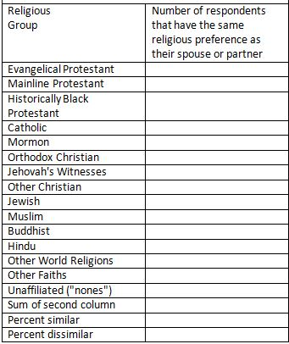
Figure 14-2

Part III – Comparing Religious Mobility for Men and Women

Now that we have a measure of religious similarity for our sample of adults, let's compare similarity for men and women. That means that you will need to run a three-variable table that controls for sex. Put R5 in the column and RS3 in the row as you did in Part 2. Put your control variable (D14) in the big box just below the column box. Copy by hand the frequencies into the tables on the next page.
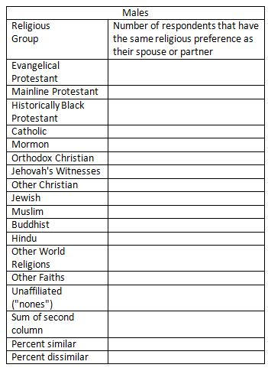
Figure 14-3
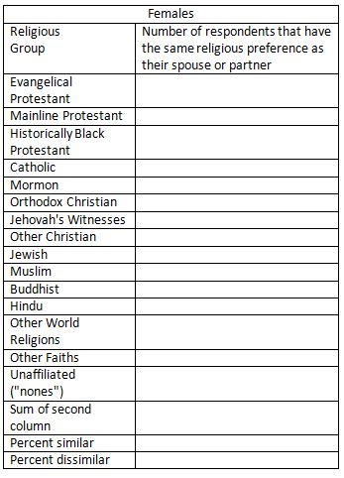
Figure 14-4
Write a paragraph comparing religious similarity for men and for women. Was there more similarity for men or for women? Were they only slightly different or quite different?

Part IV – Conclusions

Write one or two paragraphs summarizing what you learned about religious similarity and dissimilarity for respondents and their spouses and partners.

Part 5 – Comparing Religious Groups

Exercise 15 – Introduction to Comparison of Religious Groups

Goal of Exercise

The goal of this exercise is to introduce a series of exercises in which you will compare two religious groups of your choice. In this introduction we'll help you choose the two groups you will compare and show you how to select out respondents in those two religious groups. In Exercise 16 we'll compare the two groups you chose in terms of religiosity (i.e., how religious people are).

Part I—Concepts

We use concepts all the time. We all know what a book is. But when we use the word “book” we may not be talking about a particular book we’re reading. We could be talking about books in general. In other words, we’re talking about the concept to which we have given the name “book.” There are many different types of books – paperback, hardback, small, large, short, long, and so on. But they all have one thing in common – they all belong to the category “book.”
Let’s look at some other examples. Religious preference refers to the religion with which people identify. Some people say they are Lutheran; others say they are Roman Catholic; still others say they are Muslim; and others say they have no religious preference. Religiosity is another concept which refers to the degree of attachment that individuals have to their religious preference. It’s different than religious preference. Religiosity and religious preference are both concepts.
In other words, a concept is an abstract idea. There are the abstract ideas of book, religiosity, religious preference, and many others. Since concepts are abstract ideas and not directly observable, we must select measures or indicants of these concepts. We call this process measurement.

Part II – The Data Set We'll be Using

The Pew Research Center has conducted a number of surveys that deal with religion. Two of these surveys are the Religious Landscape Surveys conducted in 2007 and then repeated in 2014. They were very large telephone surveys of about 35,000 adults in the United States. For more information about the surveys, go to their website.
We'll be using a subset of the 2014 survey in this exercise which I have named Pew_2014_Religious_Landscape_ Survey_subset_for_classes.sav. For the purposes of these exercises I selected a subset of variables from the complete data set. I recoded some of the variables, created a few new variables, and renamed the variables to make them easier for students to use. There is a weight variable which should always be used so that the sample will better represent the population from which the sample was selected. To open the data set in SPSS, just double click on the file name. Your instructor will tell you where the file is located.

Part III – Measuring Religious Preference

Religious preference refers to the religion with which respondents identify. The Pew survey asked "What is your present religion, if any? Are you Protestant, Roman Catholic, Mormon, Orthodox such as Greek or Russian Orthodox, Jewish, Muslim, Buddhist, Hindu, atheist, agnostic, something else, or nothing in particular?"
Now that you have opened the data set, run a frequency distribution for the variable R1 which is the name of the variable. The variable name starts with the letter R which tells you that this variable describes religious preference. There are seven variables in this category named R1 to R7. We're going to look at some of them in this exercise. Some of you have used SPSS, the statistical package we're using, and know how to get a frequency distribution. Others of you are new to SPSS. There is a tutorial that you can use to learn how to get a frequency distribution. The tutorial is freely available on the Social Science Research and Instructional Center's website. Frequency distributions are covered in Chapter 4.
It's very easy to get frequency distributions. Once you have opened the data set in SPSS, look on the menu bar at the top and click on "Analyze." This will open a drop-down menu. Click on "Descriptive Statistics" and then on "Frequencies." You screen should look like Figure 15-1.
Figure 15-1
Notice that the list of all the variables is in the pane on the left. I scrolled down to the variables that start with R (i.e., R1 through R7). Select R1 by clicking on it and then click on the arrow pointing to the right. This will move R1 into the "Variable(s)" box. Your screen should look like Figure 15-2.
Figure 15-2
Now all you have to do is to click on "OK" to get your frequency distribution. Your screen should look like Figure 15-3. Note that I have only displayed the top part of the distribution because it's a very large table.
Figure 15-3
Take a few minutes to familiarize yourself with the information in the table.
- The first column is the value and the value label. The value "1" refers to all people who answered Protestant.
- The second column is the number of respondents who said they were Protestants (15,431).
- The third column converts the frequencies to percents. Notice that there are two types of missing information – responses that were uninterpretable and those who said they didn't know or refused to answer. The percent column converts the frequency to a percent by dividing the frequency (15,431) by the total number of cases including those with missing values (35,071). Carry out the computation for yourself and convince yourself that it is 44.0%.
- The fourth column converts the frequencies to valid percents by dividing the frequency (15,431) by the number of cases with valid information (34,846). In other words, it excludes the cases with missing information (225) from the denominator when computing the percent. Carry out the computation for yourself and convince yourself that it is 44.3%. This is called the valid percent. The more missing information there is in the distribution, the greater could be the difference between the percent and the valid percent. Normally we want to use the valid percents when describing the frequency distribution.
- The fifth column is the cumulative percent. Recall that the first twelve categories in the distribution were listed in Figure 3. The cumulative percent for this twelfth category is 94.4%. In other words, 94.4% of the cases with valid information selected one of the categories included in the first twelve categories. You can see where this comes from if you add up the valid percents for the first twelve categories.
Now it's your turn. The second category in the distribution is Roman Catholic.
- What is the value for this category?
- How many respondents said they were Roman Catholic?
- What is the percent for this category? What does this mean?
- What is the valid percent for this category? What does this mean?
- Why aren't the percent and valid percents the same?
- What is the cumulative percent for this category? What does this mean?

Part IV – Measuring Religious Preference for Protestants

One problem with the first question is that over 15,000 respondents said they were Protestant. We know there are many different types of Protestants so we might want to break Protestants down more finely. To do this the Pew survey asked another question – "As far as your present religion, what denomination or church, if any, do you identify with most closely? Just stop me when I get to the right one. Are you Baptist, Methodist, Lutheran, Presbyterian, Pentecostal, Episcopalian or Anglican, Church of Christ or Disciples of Christ, Congregational or United Church of Christ, Holiness, Reformed, Church of God, nondenominational or independent church, something else, or none in particular?" Run a frequency distribution for R2 which is the name of this variable.
This question was only asked of those who said they were Protestant in R1. Notice that the number of cases with valid information was 15,403 and that there were 28 respondents who said they didn't know or refused to answer. If you add these two numbers together, you get 15,431 which is the number who said Protestant in R1. Those who didn't say they were Protestant in the previous question are included in the category that is labeled "system missing."
The large number of categories in R2 makes it difficult to interpret. R6 is an attempt to reduce the number of categories making it easier to interpret. Run a frequency distribution for R6. Notice that this variable combines many of the volunteered responses for R2 into two other categories – other Protestant religions and responses that were so nonspecific that they were impossible to recode. Respondents who were not Protestants were assigned the value "0."
Now it's your turn. Write a paragraph describing what the frequency distribution for R6 tells you about religion in the U.S. Be sure to answer the following questions. Use the valid percents.
- What percent of adults are Protestant? Not Protestant?
- What is the largest Protestant denomination? What percent fall in that category?
- What is the second largest Protestant denomination? What percent fall in that category?
- Which Protestant denominations have less than 1% of all Protestants?

Part V – Another Way to Measure Religious Preference

Run a frequency distribution for R4. Notice that this time Protestants are broken down by both denomination (e.g., Lutheran, Presbyterians, Methodist) and by religious tradition. Religious tradition is divided into three categories.
- Evangelical Protestant tradition
- Mainline Protestant tradition
- Historically Black Protestant tradition
To find out what the Pew Center means by these traditions, read the following Pew reports:
- Chapter 1 of the full report for the 2014 Religious Landscape Survey on "The Changing Religious Composition of the U.S. Population" and
- Appendix B to this report on "Classification of Protestant Denominations."
For more information on the difference between the evangelical and the mainline Protestant traditions, read the article by John Green in the PBS Frontline article on "Evangelicals v. Mainline Protestants." For a history of the black church, read Marilyn Mellowes' article on "The Black Church."
Now it's your turn again. Write a paragraph explaining in your own words what is meant by these three religious traditions – the Evangelical Protestant tradition, the Mainline Protestant tradition, and the Historically Black Protestant tradition.
The problem with R4 is that there are so many categories that it's hard to interpret. Run a frequency distribution for R5 which breaks Protestants down into these three religious traditions but does not include denomination. Notice that it also includes non-Protestant religions. Write another paragraph describing religion in the U.S. using R5. Be sure to consider the following questions. Use the valid percents.
- What are the five largest religious groups in R5? Note that this table includes the religiously unaffiliated as a group. What are the percents for each of these groups?
- What percent of adults are Christian? Non-Christian? For this question be sure to also include Orthodox Christians, Jehovah's Witness, Mormon, and Other Christian as Christian when you compute the percent of adults who are Christian.
- Which non-Christian group is the largest? What is the percent for that group?

Part VI – Choosing the Two Religions to Compare

You're going to choose two religions which you will compare in subsequent exercises. There are several ways you can do this.
- You could compare your own religious group with another religious group of your choice. If you don't have a religious preference, you could select "nothing in particular" to compare with another group. For example, you could compare Lutherans with those who have no religious preference (i.e., nothing in particular).
- You could compare two religious groups that you are interested in. For example, you could compare Catholics with Lutherans.
- Instead of comparing two religious groups, you could compare two religious traditions such as the Mainline Protestant tradition and the Evangelical Protestant tradition.
- You could compare a Christian group with a non-Christian group. For example, you could compare Catholics with Muslims.
- You could compare two non-Christian groups. For example, you could compare Muslims and Buddhists.
You want to compare two groups that have enough cases to make the comparisons meaningful. Don't select groups that have fewer than 150 cases in them. If you're having trouble selecting two religious groups, talk with your instructor who will help you. In the next section, I'm going to work through several examples.

Part VII – Example
One of the things we know about religion is that there are many different religious denominations or groups. In Part 5 of this exercise you read several articles on different Protestant religious traditions – Mainline, Evangelical, and Historically Black traditions. Consider Lutherans for example. Open Appendix B on "Classification of Protestant Denominations" and scroll down to the "Detailed Summary of Protestant Denominations by Tradition and Family." Under Lutheran you will see a listing of Lutheran denominations that are in the Mainline and Evangelical traditions. This is what you should see.

Lutheran in the evangelical tradition

Lutheran Church-Missouri Synod
Lutheran Church-Wisconsin Synod
Lutheran Brethren
Church of the Lutheran Confession
Free Lutheran
Apostolic Lutheran Church in America
Lutheran Congregations in Mission for Christ
North American Lutheran Church
Lutheran Church of the Reformation
Conservative Lutheran
Ethnic Lutheran (if born again)
Lutheran, ambiguous affiliation (if born again)
Lutheran, not further specified (if born again)

Lutheran in the mainline tradition

Evangelical Lutheran Church in America
American Lutheran Church/Lutheran Church in America
Ethnic Lutheran (if not born again)
Lutheran, ambiguous affiliation (if not born again)
Lutheran, not further specified (if not born again"
Let's assume that you are interested in Lutherans and want to compare these two different religious traditions. How do you go about selecting Lutherans in these two traditions from the entire data set? In this example, you would use variable R4. Lutherans in the Evangelical Protestant Tradition are coded "4" and Lutherans in the Mainline Protestant Tradition are coded "37." If your frequency distribution for R4 doesn't show the numerical codes, go back and read footnote 37 in this exercise and rerun the frequency distribution.
What we're going to do is to select out respondents who are coded either "4" or "37" on R4. Click on "Data" in the menu bar at the top of the SPSS screen. This will be the second row at the top of the screen. Now click on "Select Cases" in the drop-down menu and select "If condition is specified" in the option on the right. (See Chapter 3, Transforming Data, in the online SPSS book cited on page 1 of this exercise.) Your screen should look like Figure 15-4.
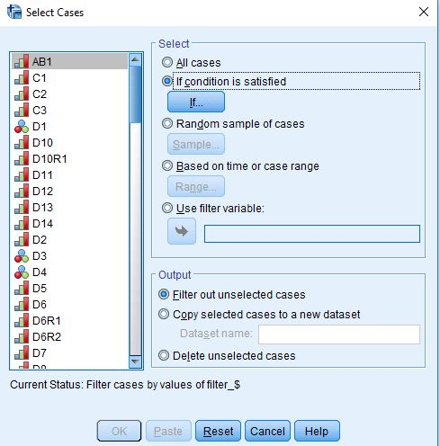
Figure 15-4
Now click on the blue button just below this option. Copy the following statement and paste it into the box to the right of the arrow or enter it manually.
R4 = 4 | R4 = 37
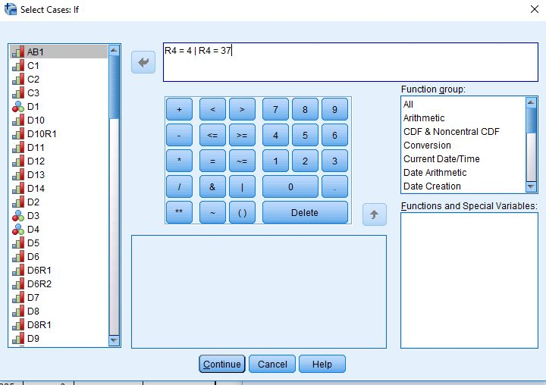
Figure 15-5
Your screen should look like Figure 15-5. This statement tells SPSS to select out only those cases which are coded "4" or "37" on R4. The vertical line is the code for "or." Click on "Continue" and then on "OK." Run the frequency distribution for R4 again and this time you should only see Lutherans in these two traditions. You should see 514 and 728 cases in these two traditions so you know you have enough cases for your comparisons.

Part VIII – Some Other Examples

I'll work several more examples. Let's say that you want to compare all Protestants with all Catholics. This time we would want to use R1 and select out all Protestants (code 1) and all Catholics (code 2). So you would follow the instructions in Part 7 but this time paste the following in the box.
R1 = 1 | R1 = 2
What if you wanted to compare all Baptists with all Pentecostals? To do this, use R2 and paste the following into the box.
R2 = 1 | R2 = 5
What if you wanted to compare all Muslims with all Buddhists? To do this, use R5 and paste the following into the box.
R5 = 60000 | R5 = 70000

Part IX – Now It's Your Turn

Decide which two religious groups you want to compare and select out the respondents for these two groups. Run the frequency distribution for the variable you used to select out these respondents to see if you did it correctly. If you did, you're ready to proceed to the subsequent exercises in this series.
In the next set of exercises you'll compare the two religious groups you chose on a number of different dimensions of religion.

Exercise 16 – Comparing the Religiosity of the
Two Religious Groups Selected

Goal of Exercise

The goal of this exercise is to compare two religious groups of your choice in terms of religiosity (i.e., how religious people are). Exercise 15 guided you through the process of choosing the two religious groups to compare and selecting out respondents in those two groups. In Exercise 17 we'll compare the two religious groups you chose in terms of religious beliefs.

Part I—Concepts

We use concepts all the time. We all know what a book is. But when we use the word “book” we may not be talking about a particular book we’re reading. We could be talking about books in general. In other words, we’re talking about the concept to which we have given the name “book.” There are many different types of books – paperback, hardback, small, large, short, long, and so on. But they all have one thing in common – they all belong to the category “book.”
Let’s look at some other examples. Religious preference refers to the religion with which people identify. Some people say they are Lutheran; others say they are Roman Catholic; still others say they are Muslim; and others say they have no religious preference. Religiosity is another concept which refers to the degree of attachment that individuals have to their religious preference. It’s different than religious preference. Religiosity and religious preference are both concepts.
In other words, a concept is an abstract idea. There are the abstract ideas of book, religiosity, religious preference, and many others. Since concepts are abstract ideas and not directly observable, we must select measures or indicants of these concepts. We call this process measurement.

Part II – The Data Set We'll be Using

The Pew Research Center has conducted a number of surveys that deal with religion. Two of these surveys are the Religious Landscape Surveys conducted in 2007 and then repeated in 2014. They were very large telephone surveys of about 35,000 adults in the United States. For more information about the surveys, go to their website.
We'll be using a subset of the 2014 survey in this exercise which I have named Pew_2014_Religious_Landscape_ Survey_subset_for_classes.sav. For the purposes of these exercises I selected a subset of variables from the complete data set. I recoded some of the variables, created a few new variables, and renamed the variables to make them easier for students to use. There is a weight variable which should always be used so that the sample will better represent the population from which the sample was selected. To open the data set in SPSS, just double click on the file name. Your instructor will tell you where the file is located.

Part III – Choosing the Two Religions to Compare

In this exercise you're going to choose two religious groups which you will compare. There are several ways you can do this.
- You could compare your own religious group with another religious group of your choice. If you don't have a religious preference, you could select "nothing in particular" to compare with another group. For example, you could compare Lutherans with those who have no religious preference (i.e., nothing in particular).
- You could compare two religious groups that you are interested in. For example, you could compare Catholics with Lutherans.
- Instead of comparing two religious groups, you could compare two religious traditions such as the Mainline Protestant tradition and the Evangelical Protestant tradition.
- You could compare a Christian group with a non-Christian group. For example, you could compare Catholics with Muslims.
- You could compare two non-Christian groups. For example, you could compare Muslims and Buddhists.
You want to compare two groups that have enough cases to make the comparisons meaningful. Don't select groups that have fewer than 150 cases in them.
Review Exercise 15 to learn more about choosing the religious groups you will compare and how to select out respondents in those two groups. In the rest of this exercise, I'm going to assume that you know how to do this. If you're having trouble, talk with your instructor who will help you.

Part IV – Measuring Religiosity

We want to compare our two religious groups to see if respondents in one group are more religious than the other. Religiosity refers to how religious people say they are. The Pew survey asked three questions that can be used to measure religiosity. One question asked how often respondents attend religious services. Another question asked how important religion is in their lives. And still another asked how often respondents say they pray.
Let's start with attendance at religious services. The Pew survey asked the following question – "Aside from weddings and funerals, how often do you attend religious services... more than once a week, once a week, once or twice a month, a few times a year, seldom, or never?" The name of this variable is REL1.
Often there's more than one way to measure a concept and that's certainly the case for religiosity. The Pew survey also asked about the importance of religion in the respondent's life. Here's the question – "How important is religion in your life – very important, somewhat important, not too important, or not at all important?" The name of this variable is REL2.
Another way that religiosity is often measured is by asking respondents how often they pray. Here's the question that was asked in the Pew survey – "People practice their religion in different ways. Outside of attending religious services, do you pray several times a day, once a day, a few times a week, once a week, a few times a month, seldom, or never?" The name of this variable is REL3.
Run frequency distributions for all three variables. Some of you have used SPSS, the statistical package we're using, and know how to get a frequency distribution. Others of you are new to SPSS. There is a tutorial that you can use to learn how to get a frequency distribution. The tutorial is freely available on the Social Science Research and Instructional Center's website. Frequency distributions are covered in Chapter 4.
Write a paragraph or two describing what these distributions tell you about religiosity in the U.S. Be sure to use the valid percents in your answer. If you need more information on getting the frequency distributions in SPSS and interpreting them, review Exercise 15.

Part V – Comparing the Two Religious Groups

Now we're going to compare the two religious groups that you chose in Exercise_1CR. This represents a shift from what we typically call univariate (i.e., one-variable) analysis to bivariate (i.e., two-variable) analysis. Frequency distributions look at variables one at a time. Crosstabulation looks at variables two at a time.
The statistical tools that we're going to use are crosstabulation, Chi Square, and measures of association. We're not going to go into a lot of detail about these tools. Your instructor will provide that information. We will talk briefly about how to get SPSS to compute them and how to interpret them.
Before we use crosstabulation we need to talk about independent and dependent variables. The dependent variable is whatever you are trying to explain. In our case, that would be how religious people are. The independent variable is some variable that you think might help explain why some people are more religious than others. In our case, that would be whichever variable we used to select the two religious groups we want to compare.
To run a crosstabulation in SPSS click on "Analyze" in the menu bar at the top of the screen. Now click on "Descriptive Statistics" in the drop-down menu and then on "Crosstabs." (See Chapter 5, Cross Tabulations, in the online SPSS book mentioned earlier.) Your screen should look like Figure 16-1.
Figure 16-1
As an example, I'm going to compare Lutherans in the Evangelical Tradition with Lutherans in the Mainline Tradition and use REL1 as my measure of religiosity. In order to do this I selected all respondents who were value 4 (i.e., Lutherans in the Evangelical Tradition) and value 37 (Lutherans in the Mainline Tradition) on variable R4. (See Exercise 15 for an explanation of how to select out particular respondents.)
To make sure that I did this correctly, I ran a frequency distribution for R4. It should only include respondents in those two religious groups which is what the SPSS output shows in Figure 16-2.
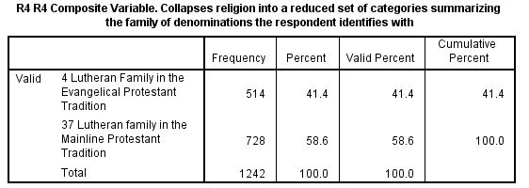
Figure 16-2
To run a crosstabulation, you're going to put your variables in the "Row(s)" and "Column(s)" boxes by clicking on the variable in the left-hand pane to select it and then clicking on the arrow that points to the right. When you do that, the arrow will change so it points left. If you click on it again, it will move the variable back to the left-hand pane. That way you can correct errors you would make when you select the wrong variable.
But which variable goes in which box? We're going to put the independent variable in the column box and the dependent variables in the row box. Since we're trying to explain why some people are more religious than others, we'll put our measure of religiosity (i.e. REL1) in the rows and whichever variable you used to select the two religions in the columns. In my example, that would be R4. Your screen should look like Figure 16-3.
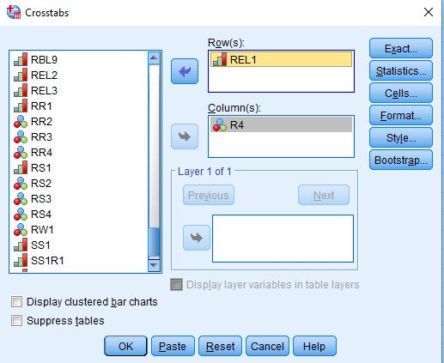
Figure 16-3
Since your independent variable is in the columns, you want the column percents so click on the "Cells" button and check the box for the "Column" percents and then click on "Continue." Now click on the "Statistics" button and check the boxes for Chi Square and Kendall's tau-c and then click on "Continue." (We'll discuss these statistics in a little bit.) Your screens should look like Figure 16-4 and 16- 5.
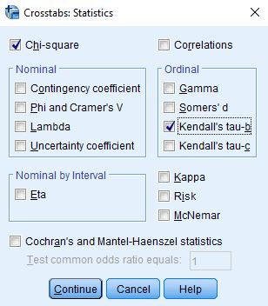
Figure 16-4
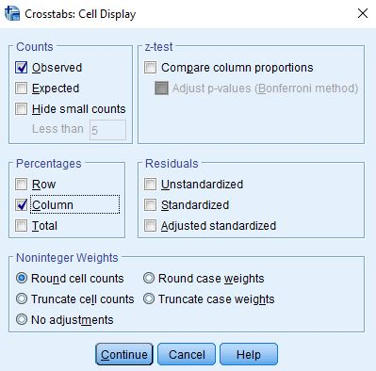
Figure 16-5
Now all you have to do is to click on "OK" and you should see your output. Since the column percents sum down to 100, you should compare the percents straight across. Always compare the percents in the direction opposite to the way they sum to 100.
How would you describe your findings in a report? Think of writing two sentences. The first sentence should describe the pattern without using numbers. The second sentence should use the percents to illustrate the pattern. So you might write something like this. "Evangelical Lutherans attend church more frequently than Mainline Lutherans while Mainline Lutherans attend less frequently. For example, 46.0% of Evangelical Lutherans attend church at least once a week while only 26.3% of Mainline Lutherans attend that often."
What about Chi Square? Chi Square is a test of significance that tests the null hypothesis that the two variables are unrelated to each other. In statistical speak, we would say that the null hypothesis is that the variables are statistically independent. Chi Square tests this null hypothesis and tells you whether you should reject or not reject it. If you can reject it, then you have evidence that the two variables are related to each other. If you can't reject it, then you don't have any evidence of such a relationship.
To interpret Chi Square in your output, look at the first row for "Pearson Chi Square" and the column for "Asymptotic Significance." In your output, it should read ".000". This is the probability that you would be wrong if you rejected the null hypothesis. It's actually not 0, but rather it is less than (<) .0005 since it's a rounded value. That tells you that it's very unlikely that this is a chance relationship. There probably is some relationship between these two variables. Our rule is to reject the null hypothesis when the significance value is < .05. In other words, when the probability of being wrong is less than five out of one hundred.
A measure of association is a statistic that measures the strength of the relationship. The Chi Square test doesn't tell you anything about the strength of the relationship. You need a measure of association to do that. There are many different measures of association. For our measure of association, we used Kendall's tau-c. Tau-c can be used when both of your variables are ordinal. Ordinal means that the categories have an inherent order to them. In other words, they are ordered from high to low or from low to high. In our example, tau-c is .207 which means that there is a weak relationship between the two variables. Measures of association are most useful for comparing the strength of the relationship in two or more tables.

Part VI – Now It's Your Turn

Decide which two religious groups you want to compare and select out the respondents in these two groups. Check to make sure that you did this correctly by running a frequency distribution for the variable you used to select out the two groups. Run the appropriate crosstabs to see if the two religions differ in terms of religiosity. Instead of only using REL1 as your measure of religiosity, use all three measures – REL1, REL2, and REL3. This will give you three separate tables. Be sure to get the column percents, Chi Square, and Kendall's tau-c for all three crosstabs.
Write one paragraph describing your findings for each of the three measures of religiosity. Follow the approach I described above by writing two sentences. The first sentence should describe the pattern without using numbers. The second sentence should use the percents to illustrate the pattern. Be sure to use the column percents, Chi Square, and Kendall's tau-c in your answer. Are the findings consistent for all three measures of religiosity?

Exercise 17 – Comparing the Religious Beliefs of the Two Religious Groups Selected

Goal of Exercise

The goal of this exercise is to compare two religious groups of your choice in terms of religious beliefs. Exercise 15 guided you through the process of choosing the two religious groups to compare and selecting out respondents in those two groups. In Exercise 18 we'll compare the two groups you chose in terms of religious behavior.

Part I—Concepts

We use concepts all the time. We all know what a book is. But when we use the word “book” we may not be talking about a particular book we’re reading. We could be talking about books in general. In other words, we’re talking about the concept to which we have given the name “book.” There are many different types of books – paperback, hardback, small, large, short, long, and so on. But they all have one thing in common – they all belong to the category “book.”
Let’s look at some other examples. Religious preference refers to the religion with which people identify. Some people say they are Lutheran; others say they are Roman Catholic; still others say they are Muslim; and others say they have no religious preference. Religiosity is another concept which refers to the degree of attachment that individuals have to their religious preference. It’s different than religious preference. Every religion has certain beliefs that are central to their religion. These include, for example, beliefs about God, beliefs about life after death, and beliefs about the sacred books of their religion. Religiosity, religious preference, and religious beliefs are all concepts.
In other words, a concept is an abstract idea. There are the abstract ideas of book, religiosity, religious preference, religious beliefs, and many others. Since concepts are abstract ideas and not directly observable, we must select measures or indicants of these concepts. We call this process measurement.

Part II – The Data Set We'll be Using

The Pew Research Center has conducted a number of surveys that deal with religion. Two of these surveys are the Religious Landscape Surveys conducted in 2007 and then repeated in 2014. They were very large telephone surveys of about 35,000 adults in the United States. For more information about the surveys, go to their website.
We'll be using a subset of the 2014 survey in this exercise which I have named Pew_2014_Religious_Landscape_ Survey_subset_for_classes.sav. For the purposes of these exercises I selected a subset of variables from the complete data set. I recoded some of the variables, created a few new variables, and renamed the variables to make them easier for students to use. There is a weight variable which should always be used so that the sample will better represent the population from which the sample was selected. To open the data set in SPSS, just double click on the file name. Your instructor will tell you where the file is located.

Part III – Choosing the Two Religious Groups to Compare

Note: If you have already chosen the two religious groups you want to compare, you can skip this part of the exercise and proceed to part 4.
In this exercise you're going to choose two religious groups which you will compare. There are several ways you can do this.
- You could compare your own religious group with another religious group of your choice. If you don't have a religious preference, you could select "nothing in particular" to compare with another group. For example, you could compare Lutherans with those who have no religious preference (i.e., nothing in particular).
- You could compare two religious groups that you are interested in. For example, you could compare Catholics with Lutherans.
- Instead of comparing two religious groups, you could compare two religious traditions such as the Mainline Protestant tradition and the Evangelical Protestant tradition.
- You could compare a Christian group with a non-Christian group. For example, you could compare Catholics with Muslims.
- You could compare two non-Christian groups. For example, you could compare Muslims and Buddhists.
You want to compare two religious groups that have enough cases to make the comparisons meaningful. Don't select groups that have fewer than 150 cases in them.
Review Exercise 15 to learn more about choosing the religious groups you will compare and how to select out respondents in those two groups. In the rest of this exercise, I'm going to assume that you know how to do this. If you're having trouble, talk with your instructor who will help you.

Part IV – Measuring Religious Beliefs

We want to compare our two religious groups to see if respondents in one group hold different religious beliefs than respondents in the other group. There are many different beliefs that are central to religions. The Pew survey asked about a number of these beliefs. We're going to look at questions about God, life after death, and the sacred books of a person's religion.
Let's start with beliefs about God. The Pew survey asked, "Do you believe in God or a universal spirit?" This was followed by "How certain are you about this belief? Are you absolutely certain, fairly certain, not too certain, or not at all certain?" The names of these variables are RBL1 and RBL2.
The survey also included questions about life after death. The Pew survey asked, "Do you think there is a heaven, where people who have lived good lives are eternally rewarded?" and "Do you believe there is a hell, where people who have lived bad lives are eternally punished?" These variables are named RBL4 and RBL5.
Let's also look at beliefs about the sacred books of a person's religion. For example, for Christians that would be the Bible and for Muslims that would be the Koran. The Pew survey asked, "Which comes closest to your view? Sacred text is the word of God OR sacred text is a book written by men and is not the word of God?" This is what is referred to as a forced-choice question. The respondent is asked to choose the response that comes closest to their own view. This variable is named RBL6.
This question was followed up by another question which asked "And would you say? Sacred text is to be taken literally, word for word OR not everything in the sacred text should be taken literally, word for word?" For Christians, the sacred text is the Bible. Some Christians believe that the Bible is to be taken literally. For example, they would say that the first two chapters in Genesis (the first book in the Bible) describe literally how the world was created. This is the basis for the disagreement over evolution and what should be taught in public schools (i.e., creationism or evolution). This variable is named RBL7.
Run frequency distributions for all six variables. Some of you have used SPSS, the statistical package we're using, and know how to get a frequency distribution. Others of you are new to SPSS. There is a tutorial that you can use to learn how to get a frequency distribution. The tutorial is freely available on the Social Science Research and Instructional Center's website. Frequency distributions are covered in Chapter 4. You could also review Exercise 15. It goes into more detail on how to get and interpret frequency distributions.

Part V – Interpreting Frequency Distributions

Your frequency distributions for RBL1 and RBL2 should look like this.
Figure 17-1
Take a few minutes to familiarize yourself with the information in the table. It's particularly important to understand the difference between the percent and the valid percent columns.
The percent column converts the frequencies to percents. To compute the percent for those who answered "Yes" to RBL1, you would divide the frequency (31,065) by the total number of cases including those with missing values (35,071). Carry out the computation and convince yourself that it is 88.6%.
The valid percent column converts the frequencies to valid percents by dividing the frequency by the number of cases with valid information. Notice that in RBL1 some of the respondents said they didn't know if they believed in God and others refused to answer the question. This is what we refer to as missing data and they are coded "9." To compute the valid percent for those who answered "Yes," you would divide 31,065 by 34,520. In other words, it excludes the cases with missing information (551) from the denominator when computing the percent. Carry out the computation and convince yourself that it is 90.0%. This is called the valid percent. The more missing information there is in the distribution, the greater could be the difference between the percent and the valid percent. Normally we want to use the valid percents when describing the frequency distribution.
For the second variable, RBL2, there are two types of missing data. Some said they didn't know or refused to answer the question and they are coded "9." But there's a second type of missing data that is labelled "System." What does that mean? The second question is a follow-up to the first question. It asks how certain respondents are about their belief in God. It wouldn't make any sense to ask this follow-up question to respondents who didn't answer "Yes" – they believed in God, to the first question. Anyone who answered anything other than "Yes" to the first question is assigned a system missing code for the second question. To verify this, add up the number of respondents who didn't answer "Yes" to the first question (i.e., 3,241 + 214 + 551) which equals 4,006. That's the number of respondents who are given the system missing code in the second question. So to get the valid percent for those who are absolutely certain there is a God, you would divide 22,062 by 30,801. In other words, you would exclude those with missing information (263 + 4,006 which equals 4,270). Convince yourself that this equals 71.6%.
Write a paragraph describing respondents' beliefs about God. Be sure to use the valid percents in your answer. Keep in mind that when we talk about beliefs in God, we're referring to the God of many different religions.
Now look at the frequency distributions for RBL4 and RBL5. What do these distributions tell you about respondents' beliefs in a heaven and a hell? Again, be sure to use the valid percents.
Finally, look at the frequency distributions for RBL6 and RBL7. Note that those who said that the sacred text of their religion was the word of God in RBL6 were asked the following follow up question. "And would you say? Sacred text is to be taken literally, word for word OR not everything in the sacred text should be taken literally, word for word?" Be sure to use the valid percents. Keep in mind that the sacred text that respondents are referring to depends on their religion.

Part VI – Comparing the Two Religions

Now we're going to compare the two religious groups that you chose earlier. This represents a shift from what we typically call univariate (i.e., one-variable) analysis to bivariate (i.e., two-variable) analysis. Frequency distributions look at variables one at a time. Crosstabulation looks at variables two at a time.
The statistical tools that we're going to use are crosstabulation, Chi Square, and measures of association. We're not going to go into a lot of detail about these tools. Your instructor will provide that information. We will talk briefly about how to get SPSS to compute them and how to interpret them.
Before we use crosstabulation we need to talk about independent and dependent variables. The dependent variable is whatever you are trying to explain. In our case, that would be respondents' religious beliefs. The independent variable is some variable that you think might help explain why some people have difference beliefs than others. In our case, that would be whichever variable we used to select the two religions we want to compare.
To run a crosstabulation in SPSS click on "Analyze" in the menu bar at the top of the screen. Now click on "Descriptive Statistics" in the drop-down menu and then on "Crosstabs." (See Chapter 5, Cross Tabulations, in the online SPSS book mentioned earlier.) Your screen should look like Figure 17-2.
Figure 17-2
As an example, I'm going to compare Lutherans in the Evangelical Tradition with Lutherans in the Mainline Tradition and use RBL1 as my measure of religious beliefs. In order to do this I selected all respondents who were value 4 (i.e., Lutherans in the Evangelical Tradition) and value 37 (Lutherans in the Mainline Tradition) on variable R4. (See Exercise 15 for an explanation of how to select out particular respondents.)
To make sure that I did this correctly, I ran a frequency distribution for R4. It should only include respondents in those two religious groups which is what the SPSS output shows in Figure 17-3.
Figure 17-3
To run a crosstabulation, you're going to put your variables in the "Row(s)" and "Column(s)" boxes by clicking on the variable in the left-hand pane to select it and then clicking on the arrow that points to the right. When you do that, the arrow will change so it points left. If you click on it again, it will move the variable back to the left-hand pane. That way you can correct errors you would make when you select the wrong variable.
But which variable goes in which box? We're going to put the independent variable in the column box and the dependent variables in the row box. Since we're trying to explain why some people hold different beliefs about God, we'll put RBL1 in the rows and whichever variable you used to select the two religions in the columns. In my example, that would be R4. Your screen should look like Figure 17-4.
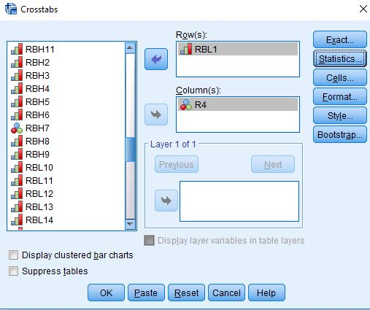
Figure 17-4
Since your independent variable is in the columns, you want the column percents so click on the "Cells" button and check the box for the "Column" percents and then click on "Continue." Now click on the "Statistics" button and check the boxes for Chi Square and Kendall's tau-c and then click on "Continue." (We'll discuss these statistics in a little bit.) Your screens should look like Figure 17-5 and 17-6.
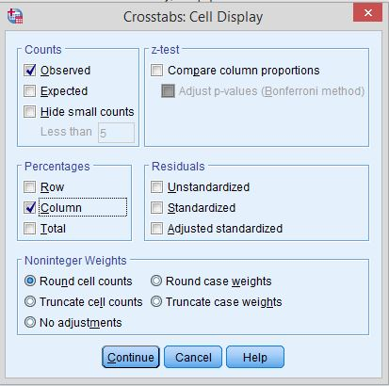
Figure 17-5
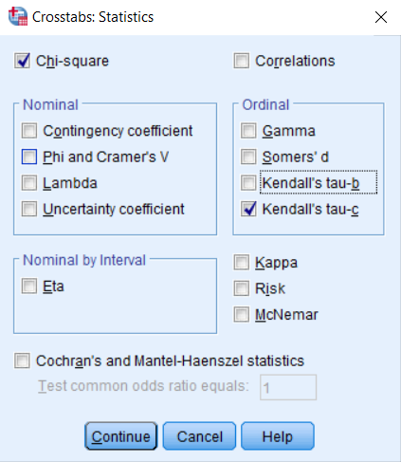
Figure 17-6
Now all you have to do is to click on "OK" and you should see your output. Since the column percents sum down to 100, you should compare the percents straight across. Always compare the percents in the direction opposite to the way they sum to 100.
How would you describe your findings in a report? Think of writing two sentences. The first sentence should describe the pattern without using numbers. The second sentence should use the percents to illustrate the pattern. So you might write something like this. "There is very little difference between Evangelical Lutherans and Mainline Lutherans in their belief in God. For example, 100.0% of Evangelical Lutherans believe in God and 98.3% of Mainline Lutherans also believe in God."
What about Chi Square? Chi Square is a test of significance that tests the null hypothesis that the two variables are unrelated to each other. In statistical speak, we would say that the null hypothesis is that the variables are statistically independent. Chi Square tests this null hypothesis and tells you whether you should reject or not reject it. If you can reject it, then you have evidence that the two variables are related to each other. If you can't reject it, then you don't have any evidence of such a relationship.
To interpret Chi Square in your output, look at the first row for "Pearson Chi Square" and the column for "Asymptotic Significance." In your output, it should read ".013". This is the probability that you would be wrong if you rejected the null hypothesis. This tells you that it's unlikely that this is a chance relationship. There probably is some relationship between these two variables. Our rule is to reject the null hypothesis when the significance value is < .05. In other words, when the probability of being wrong is less than five out of one hundred. Even though the percent difference is very small (i.e., 100.0% – 98.3% or 1.7%), it's still statistically significant. In other words, it's probably not a chance difference. This is due to the large number of cases we have to compare. There were 513 Evangelical Lutherans and 718 Mainline Lutherans in our table. With such large numbers of cases, even small differences can be statistically significant.
A measure of association is a statistic that measures the strength of the relationship. The Chi Square test doesn't tell you anything about the strength of the relationship. You need a measure of association to do that. There are many different measures of association. For our measure of association, we used Kendall's tau-c. Tau-c can be used when both of your variables are ordinal. Ordinal means that the categories have an inherent order to them. In other words, they are ordered from high to low or from low to high. In our example, tau-c is .016 which means that there is virtually no relationship between the two variables. Just because our Chi Square is significant doesn't mean that it is a strong relationship. Measures of association are most useful for comparing the strength of the relationship in two or more tables.

Part VII – Now It's Your Turn

Decide which two religious groups you want to compare and select out the respondents in these two groups. Check to make sure that you did this correctly by running a frequency distribution for the variable you used to select out the two religions. Run the appropriate crosstabs to see if the two religions differ in terms of their beliefs. Use the variables for which you created frequency distributions in part 5 (i.e., RBL1, RBL2, RBL4, RBL5, RBL6, and RBL7. This will give you six separate tables. Be sure to get the column percents, Chi Square, and Kendall's tau-c for all three crosstabs.
Write one paragraph describing your findings for each of these six tables. Follow the approach I described above by writing two sentences. The first sentence should describe the pattern without using numbers. The second sentence should use the percents to illustrate the pattern. Be sure to use the column percents, Chi Square, and Kendall's tau-c in your answer.

Exercise 18 – Comparing the Religious Behavior of the
Two Religious Groups Selected

Goal of Exercise

The goal of this exercise is to compare two religious groups of your choice in terms of religious behavior. Exercise 15 guided you through the process of choosing the two religious groups to compare and selecting out respondents in those two groups. In Exercise 19 we'll compare the two groups you chose in terms of political behavior.

Part I—Concepts

We use concepts all the time. We all know what a book is. But when we use the word “book” we may not be talking about a particular book we’re reading. We could be talking about books in general. In other words, we’re talking about the concept to which we have given the name “book.” There are many different types of books – paperback, hardback, small, large, short, long, and so on. But they all have one thing in common – they all belong to the category “book.”
Let’s look at some other examples. Religious preference refers to the religion with which people identify. Some people say they are Lutheran; others say they are Roman Catholic; still others say they are Muslim; and others say they have no religious preference. Religiosity is another concept which refers to the degree of attachment that individuals have to their religious preference. It’s different than religious preference. Every religion has certain beliefs that are central to their religion. Religions also differ in terms of religiously motivated behaviors. Religiosity, religious preference, religious beliefs, and religious behavior are all concepts.
In other words, a concept is an abstract idea. There are the abstract ideas of book, religiosity, religious preference, religious beliefs, religious behavior, and many others. Since concepts are abstract ideas and not directly observable, we must select measures or indicants of these concepts. We call this process measurement.

Part II – The Data Set We'll be Using

The Pew Research Center has conducted a number of surveys that deal with religion. Two of these surveys are the Religious Landscape Surveys conducted in 2007 and then repeated in 2014. They were very large telephone surveys of about 35,000 adults in the United States. For more information about the surveys, go to their website.
We'll be using a subset of the 2014 survey in this exercise which I have named Pew_2014_Religious_Landscape_ Survey_subset_for_classes.sav. For the purposes of these exercises I selected a subset of variables from the complete data set. I recoded some of the variables, created a few new variables, and renamed the variables to make them easier for students to use. There is a weight variable which should always be used so that the sample will better represent the population from which the sample was selected. To open the data set in SPSS, just double click on the file name. Your instructor will tell you where the file is located.

Part III – Choosing the Two Religions to Compare

In this exercise you're going to choose two religious groups which you will compare. There are several ways you can do this.
- You could compare your own religious group with another religious group of your choice. If you don't have a religious preference, you could select "nothing in particular" to compare with another group. For example, you could compare Lutherans with those who have no religious preference (i.e., nothing in particular).
- You could compare two religious groups that you are interested in. For example, you could compare Catholics with Lutherans.
- Instead of comparing two religious groups, you could compare two religious traditions such as the Mainline Protestant tradition and the Evangelical Protestant tradition.
- You could compare a Christian group with a non-Christian group. For example, you could compare Catholics with Muslims.
- You could compare two non-Christian groups. For example, you could compare Muslims and Buddhists.
You want to compare two religious groups that have enough cases to make the comparisons meaningful. Don't select groups that have fewer than 150 cases in them.
Review Exercise 15 to learn more about choosing the religious groups you will compare and how to select out respondents in those two groups. In the rest of this exercise, I'm going to assume that you know how to do this. If you're having trouble, talk with your instructor who will help you.

Part IV – Measuring Religious Behavior

We want to compare our two religious groups to see if respondents differ in terms of religiously motivated behavior. The Pew survey asked several questions that can be used to measure religious behavior. These include how often respondents participated in religious activities, how often they read scripture, and how often they shared their faith.
Let's start with participation in religious activities. The Pew Survey asked, "How often do you…participate in prayer groups, scripture study groups or religious education programs?" The name of this variable is RBH1.
Often there's more than one way to measure a concept and that's certainly the case for religious behavior. The Pew survey also asked, "How often do you…read scripture outside of religious services?" This variable is named RBH2.
We can also look at behavior that involves sharing one's faith with others. The Pew survey asked, "How often do you …share your faith with non-believers or people from other religious backgrounds?" The name of this variable is RBH5.
Run frequency distributions for all three variables. Some of you have used SPSS, the statistical package we're using, and know how to get a frequency distribution. Others of you are new to SPSS. There is a tutorial that you can use to learn how to get a frequency distribution. The tutorial is freely available on the Social Science Research and Instructional Center's website. Frequency distributions are covered in Chapter 4.
Write a paragraph or two describing what these distributions tell you about these types of religious behavior in the U.S. Be sure to use the valid percents in your answer. If you need more information on getting the frequency distributions in SPSS and interpreting them, review Exercise 15.

Part V – Comparing the Two Religions

Now we're going to compare the two religious groups that you chose in Exercise 15. This represents a shift from what we typically call univariate (i.e., one-variable) analysis to bivariate (i.e., two-variable) analysis. Frequency distributions look at variables one at a time. Crosstabulation looks at variables two at a time.
The statistical tools that we're going to use are crosstabulation, Chi Square, and measures of association. We're not going to go into a lot of detail about these tools. Your instructor will provide that information. We will talk briefly about how to get SPSS to compute them and how to interpret them.
Before we use crosstabulation we need to talk about independent and dependent variables. The dependent variable is whatever you are trying to explain. In our case, that would be religiously motivated behavior. The independent variable is some variable that you think might help explain why some people engage in certain types of religious behavior more frequently than others. In our case, that would be whichever variable we used to select the two religious groups we want to compare.
To run a crosstabulation in SPSS click on "Analyze" in the menu bar at the top of the screen. Now click on "Descriptive Statistics" in the drop-down menu and then on "Crosstabs." (See Chapter 5, Cross Tabulations, in the online SPSS book mentioned earlier.) Your screen should look like Figure 18-1.
Figure 18-1
As an example, I'm going to compare Lutherans in the Evangelical Tradition with Lutherans in the Mainline Tradition and use RBH1 as my measure of religious behavior. In order to do this I selected all respondents who were value 4 (i.e., Lutherans in the Evangelical Tradition) and value 37 (Lutherans in the Mainline Tradition) on variable R4. (See Exercise 15 for an explanation of how to select out particular respondents.)
To make sure that I did this correctly, I ran a frequency distribution for R4. It should only include respondents in those two religious groups which is what the SPSS output shows in Figure 18-2.
Figure 18-2
To run a crosstabulation, you're going to put your variables in the "Row(s)" and "Column(s)" boxes by clicking on the variable in the left-hand pane to select it and then clicking on the arrow that points to the right. When you do that, the arrow will change so it points left. If you click on it again, it will move the variable back to the left-hand pane. That way you can correct errors you would make when you select the wrong variable.
But which variable goes in which box? We're going to put the independent variable in the column box and the dependent variables in the row box. Since we're trying to explain why some people engage in certain types of religious behavior more frequently than others, we'll put our measure of religious behavior (i.e., RBH1) in the rows and whichever variable you used to select the two religions in the columns. In my example, that would be R4. Your screen should look like Figure 18-3.
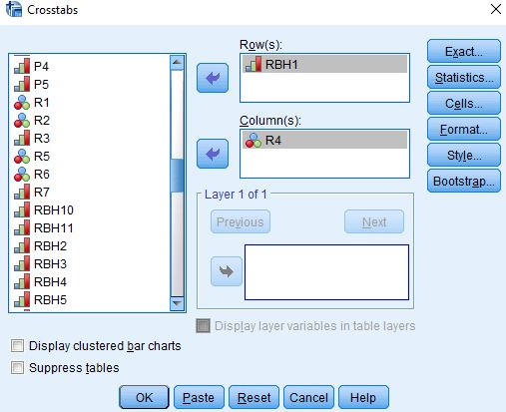
Figure 18-3
Since your independent variable is in the columns, you want the column percents so click on the "Cells" button and check the box for the "Column" percents and then click on "Continue." Now click on the "Statistics" button and check the boxes for Chi Square and Kendall's tau-c and then click on "Continue." (We'll discuss these statistics in a little bit.) Your screens should look like Figure 18-4 and 18-5.
Figure 18-4
Figure 18-5
Now all you have to do is to click on "OK" and you should see your output. Since the column percents sum down to 100, you should compare the percents straight across. Always compare the percents in the direction opposite to the way they sum to 100.
How would you describe your findings in a report? Think of writing two sentences. The first sentence should describe the pattern without using numbers. The second sentence should use the percents to illustrate the pattern. So you might write something like this. "Evangelical Lutherans participate in certain types of religious groups more frequently than Mainline Lutherans while Mainline Lutherans participate less frequently. For example, 22.7% of Evangelical Lutherans participate at least once a week while only 12.1% of Mainline Lutherans participate that often."
What about Chi Square? Chi Square is a test of significance that tests the null hypothesis that the two variables are unrelated to each other. In statistical speak, we would say that the null hypothesis is that the variables are statistically independent. Chi Square tests this null hypothesis and tells you whether you should reject or not reject it. If you can reject it, then you have evidence that the two variables are related to each other. If you can't reject it, then you don't have any evidence of such a relationship.
To interpret Chi Square in your output, look at the first row for "Pearson Chi Square" and the column for "Asymptotic Significance." In your output, it should read ".000". This is the probability that you would be wrong if you rejected the null hypothesis. It's actually not 0, but rather it is less than (<) .0005 since it's a rounded value. That tells you that it's very unlikely that this is a chance relationship. There probably is some relationship between these two variables. Our rule is to reject the null hypothesis when the significance value is < .05. In other words, when the probability of being wrong is less than five out of one hundred.
A measure of association is a statistic that measures the strength of the relationship. The Chi Square test doesn't tell you anything about the strength of the relationship. You need a measure of association to do that. There are many different measures of association. For our measure of association, we used Kendall's tau-c. Tau-c can be used when both of your variables are ordinal. Ordinal means that the categories have an inherent order to them. In other words, they are ordered from high to low or from low to high. In our example, tau-c is .197 which means that there is a weak relationship between the two variables. Measures of association are most useful for comparing the strength of the relationship in two or more tables.

Part VII – Now It's Your Turn

Decide which two religious groups you want to compare and select out the respondents in these two groups. Check to make sure that you did this correctly by running a frequency distribution for the variable you used to select out the two religions. Run the appropriate crosstabs to see if the two groups differ in terms of religious behavior. Use RBH1, RBH2, and RBH5 as your measures of religious behavior. This will give you three separate tables. Be sure to get the column percents, Chi Square, and Kendall's tau-c for all three crosstabs.
Write one paragraph describing your findings for each of the three measures of religious behavior. Follow the approach I described above by writing two sentences. The first sentence should describe the pattern without using numbers. The second sentence should use the percents to illustrate the pattern. Be sure to use the column percents, Chi Square, and Kendall's tau-c in your answer.

Exercise 19 – Comparing Political Party Preference and Political Views
of the Two Religious Groups Selected

Goal of Exercise

The goal of this exercise is to compare two religious groups of your choice in terms of political behavior. Exercise 15 guided you through the process of choosing the two religious groups to compare and selecting out respondents in those two groups. In Exercise 20 we'll compare the two groups you chose in terms of how people feel about social issues.

Part I—Concepts

We use concepts all the time. We all know what a book is. But when we use the word “book” we may not be talking about a particular book we’re reading. We could be talking about books in general. In other words, we’re talking about the concept to which we have given the name “book.” There are many different types of books – paperback, hardback, small, large, short, long, and so on. But they all have one thing in common – they all belong to the category “book.”
Let’s look at some other examples. Religious preference refers to the religion with which people identify. Some people say they are Lutheran; others say they are Roman Catholic; still others say they are Muslim; and others say they have no religious preference. Religiosity is another concept which refers to the degree of attachment that individuals have to their religious preference. It’s different than religious preference. Every religion has certain beliefs that are central to their religion. Religions also differ in terms of religiously motivated behaviors. Religiosity, religious preference, religious beliefs, and religious behavior are all concepts.
These concepts focus on religion. Other concepts deal with political behavior. Political party preference refers to the political party with which people identify. Some identify with the Democratic Party; others with the Republican Party; others say they are independent; and still others identify with a third party. Political views is another concept that refers to whether people see themselves as liberal or conservative or somewhere in between.
In other words, a concept is an abstract idea. There are the abstract ideas of book, religiosity, religious preference, religious beliefs, religious behavior, political party preference, political views, and many others. Since concepts are abstract ideas and not directly observable, we must select measures or indicants of these concepts. We call this process measurement.

Part II – The Data Set We'll be Using

The Pew Research Center has conducted a number of surveys that deal with religion. Two of these surveys are the Religious Landscape Surveys conducted in 2007 and then repeated in 2014. They were very large telephone surveys of about 35,000 adults in the United States. For more information about the surveys, go to their website.
We'll be using a subset of the 2014 survey in this exercise which I have named Pew_2014_Religious_Landscape_ Survey_subset_for_classes.sav. For the purposes of these exercises I selected a subset of variables from the complete data set. I recoded some of the variables, created a few new variables, and renamed the variables to make them easier for students to use. There is a weight variable which should always be used so that the sample will better represent the population from which the sample was selected. To open the data set in SPSS, just double click on the file name. Your instructor will tell you where the file is located.

Part III – Choosing the Two Religions to Compare

In this exercise you're going to choose two religious groups which you will compare. There are several ways you can do this.
- You could compare your own religious group with another religious group of your choice. If you don't have a religious preference, you could select "nothing in particular" to compare with another group. For example, you could compare Lutherans with those who have no religious preference (i.e., nothing in particular).
- You could compare two religious groups that you are interested in. For example, you could compare Catholics with Lutherans.
- Instead of comparing two religious groups, you could compare two religious traditions such as the Mainline Protestant tradition and the Evangelical Protestant tradition.
- You could compare a Christian group with a non-Christian group. For example, you could compare Catholics with Muslims.
- You could compare two non-Christian groups. For example, you could compare Muslims and Buddhists.
You want to compare two religious groups that have enough cases to make the comparisons meaningful. Don't select groups that have fewer than 150 cases in them.
Review Exercise 15 to learn more about choosing the religious groups you will compare and how to select out respondents in those two groups. In the rest of this exercise, I'm going to assume that you know how to do this. If you're having trouble, talk with your instructor who will help you.

Part IV – Measuring Political Behavior

We want to compare our two religious groups to see if respondents differ in terms of political behavior. The Pew survey asked several questions that can be used to measure political behavior. These include political party preference and political views.
Let's start with political party preference. The Pew survey asked, "In politics today, do you consider yourself a Republican, Democrat, or Independent?" This variable is named P2. This was followed by another question asked of anyone who didn't choose one of the two main parties in politics today – Republican or Democrat. The question asked, "As of today do you lean more towards the Republican Party or more to the Democratic Party?" The name of this variable is P3. These two variables were then combined into another variable named P4. We're going to use P4 as our measure of political party preference in this exercise.
We can also look at the political views of individuals. The Pew Survey asked, "In general, would you describe your political views as very conservative, conservative, moderate, liberal, or very liberal?" The name of this variable is P5.
Run frequency distributions for P4 and P5. Some of you have used SPSS, the statistical package we're using, and know how to get a frequency distribution. Others of you are new to SPSS. There is a tutorial that you can use to learn how to get a frequency distribution. The tutorial is freely available on the Social Science Research and Instructional Center's website. Frequency distributions are covered in Chapter 4.
Write a paragraph or two describing what these distributions tell you about political party preference and political views in the U.S. Be sure to use the valid percents in your answer. If you need more information on getting the frequency distributions in SPSS and interpreting them, review Exercise 15.

Part V – Comparing the Two Religious Groups

Now we're going to compare the two religious groups that you chose in Exercise 15. This represents a shift from what we typically call univariate (i.e., one-variable) analysis to bivariate (i.e., two-variable) analysis. Frequency distributions look at variables one at a time. Crosstabulation looks at variables two at a time.
The statistical tools that we're going to use are crosstabulation, Chi Square, and measures of association. We're not going to go into a lot of detail about these tools. Your instructor will provide that information. We will talk briefly about how to get SPSS to compute them and how to interpret them.
Before we use crosstabulation we need to talk about independent and dependent variables. The dependent variable is whatever you are trying to explain. In our case, that would be political party preference. The independent variable is some variable that you think might help explain why some people are more likely to identify with a particular political party. In our case, that would be whichever variable we used to select the two religions we want to compare.
To run a crosstabulation in SPSS click on "Analyze" in the menu bar at the top of the screen. Now click on "Descriptive Statistics" in the drop-down menu and then on "Crosstabs." (See Chapter 5, Cross Tabulations, in the online SPSS book mentioned earlier.) Your screen should look like Figure 19-1.
Figure 19-1
As an example, I'm going to compare Lutherans in the Evangelical Tradition with Lutherans in the Mainline Tradition and use RBH1 as my measure of religious behavior. In order to do this I selected all respondents who were value 4 (i.e., Lutherans in the Evangelical Tradition) and value 37 (Lutherans in the Mainline Tradition) on variable R4. (See Exercise 15 for an explanation of how to select out particular respondents.)
To make sure that I did this correctly, I ran a frequency distribution for R4. It should only include respondents in those two religious groups which is what the SPSS output shows in Figure 19-2.
Figure 19-2
To run a crosstabulation, you're going to put your variables in the "Row(s)" and "Column(s)" boxes by clicking on the variable in the left-hand pane to select it and then clicking on the arrow that points to the right. When you do that, the arrow will change so it points left. If you click on it again, it will move the variable back to the left-hand pane. That way you can correct errors you would make when you select the wrong variable.
But which variable goes in which box? We're going to put the independent variable in the column box and the dependent variable in the row box. Since we're trying to explain why some people are more likely to identify with a particular political party, we'll put our measure of political behavior (i.e., P4) in the rows and whichever variable you used to select the two religions in the columns. In my example, that would be R4. Your screen should look like Figure 19-3.
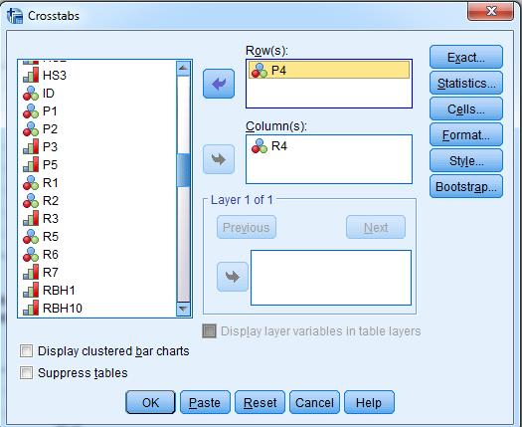
Figure 19-3
Since your independent variable is in the columns, you want the column percents so click on the "Cells" button and check the box for the "Column" percents and then click on "Continue." Now click on the "Statistics" button and check the boxes for Chi Square and Kendall's tau-c and then click on "Continue." (We'll discuss these statistics in a little bit.) Your screens should look like Figure 19-4 and 19-5.
Figure 19-4
Figure 19-5
Now all you have to do is to click on "OK" and you should see your output. Since the column percents sum down to 100, you should compare the percents straight across. Always compare the percents in the direction opposite to the way they sum to 100.
How would you describe your findings in a report? Think of writing two sentences. The first sentence should describe the pattern without using numbers. The second sentence should use the percents to illustrate the pattern. So you might write something like this. "Evangelical Lutherans are more likely to identify with the Republican Party while Mainline Lutherans are more likely to identify with the Democratic Party. For example, 61.1% of Evangelical Lutherans identified with Republican Party or leaned toward the Republicans, while only 45.7% of Mainline Lutherans identified or leaned toward the Republican Party. However, 44.0% of Mainline Lutherans identified or leaned toward the Democratic Party compared to only 28.9% of Evangelical Lutherans. Approximately equal percents of Mainline and Evangelical Lutherans were true independents who didn't lean either way."
What about Chi Square? Chi Square is a test of significance that tests the null hypothesis that the two variables are unrelated to each other. In statistical speak, we would say that the null hypothesis is that the variables are statistically independent. Chi Square tests this null hypothesis and tells you whether you should reject or not reject it. If you can reject it, then you have evidence that the two variables are related to each other. If you can't reject it, then you don't have any evidence of such a relationship.
To interpret Chi Square in your output, look at the first row for "Pearson Chi Square" and the column for "Asymptotic Significance." In your output, it should read ".000". This is the probability that you would be wrong if you rejected the null hypothesis. It's actually not 0, but rather it is less than (<) .0005 since it's a rounded value. That tells you that it's very unlikely that this is a chance relationship. There probably is some relationship between these two variables. Our rule is to reject the null hypothesis when the significance value is < .05. In other words, when the probability of being wrong is less than five out of one hundred.
A measure of association is a statistic that measures the strength of the relationship. The Chi Square test doesn't tell you anything about the strength of the relationship. You need a measure of association to do that. There are many different measures of association. For our measure of association, we used Kendall's tau-c. Tau-c can be used when both of your variables are ordinal. Ordinal means that the categories have an inherent order to them. In other words, they are ordered from high to low or from low to high. In our example, tau-c is .189 which means that there is a weak relationship between the two variables. Measures of association are most useful for comparing the strength of the relationship in two or more tables.

Part VII – Now It's Your Turn

Decide which two religious groups you want to compare and select out the respondents in these two groups. Check to make sure that you did this correctly by running a frequency distribution for the variable you used to select out the two religions. Run the appropriate crosstab to see if the two religions differ in terms of political behavior. Use P5 as your measures of political behavior. Be sure to get the column percents, Chi Square, and Kendall's tau-c.
Write one paragraph describing your findings. Follow the approach I described above by writing two sentences. The first sentence should describe the pattern without using numbers. The second sentence should use the percents to illustrate the pattern. Be sure to use the column percents, Chi Square, and Kendall's tau-c in your answer.

Exercise 20 – Comparing Opinion on Homosexuality, Same-Sex Marriage, Abortion, and Environmental Laws and Regulations of the
Two Religious Groups Selected

Goal of Exercise

The goal of this exercise is to compare two religious groups of your choice in terms of their views on social issues. Exercise 15 guided you through the process of choosing the two religious groups to compare and selecting out respondents in those two groups. In the previous exercises we compared these two groups on various aspects of religion and political behavior.

Part I—Concepts

We use concepts all the time. We all know what a book is. But when we use the word “book” we may not be talking about a particular book we’re reading. We could be talking about books in general. In other words, we’re talking about the concept to which we have given the name “book.” There are many different types of books – paperback, hardback, small, large, short, long, and so on. But they all have one thing in common – they all belong to the category “book.”
Let’s look at some other examples. Religious preference refers to the religion with which people identify. Some people say they are Lutheran; others say they are Roman Catholic; still others say they are Muslim; and others say they have no religious preference. Religiosity is another concept which refers to the degree of attachment that individuals have to their religious preference. It’s different than religious preference. Every religion has certain beliefs that are central to their religion. Religions also differ in terms of religiously motivated behaviors. Religiosity, religious preference, religious beliefs, and religious behavior are all concepts.
These concepts focus on religion. Other concepts deal with political behavior. Political party preference refers to the political party with which people identify. Some identify with the Democratic Party; others with the Republican Party; others say they are independent; and still others identify with a third party. Political views is another concept that refers to whether people see themselves as liberal or conservative or somewhere in between. Still other concepts focus on how people view social issues such as same-sex marriage, abortion, and the environment.
In other words, a concept is an abstract idea. There are the abstract ideas of book, religiosity, religious preference, religious beliefs, religious behavior, political party preference, political views, views on social issues, and many others. Since concepts are abstract ideas and not directly observable, we must select measures or indicants of these concepts. We call this process measurement.

Part II – The Data Set We'll be Using

The Pew Research Center has conducted a number of surveys that deal with religion. Two of these surveys are the Religious Landscape Surveys conducted in 2007 and then repeated in 2014. They were very large telephone surveys of about 35,000 adults in the United States. For more information about the surveys, go to their website.
We'll be using a subset of the 2014 survey in this exercise which I have named Pew_2014_Religious_Landscape_ Survey_subset_for_classes.sav. For the purposes of these exercises I selected a subset of variables from the complete data set. I recoded some of the variables, created a few new variables, and renamed the variables to make them easier for students to use. There is a weight variable which should always be used so that the sample will better represent the population from which the sample was selected. To open the data set in SPSS, just double click on the file name. Your instructor will tell you where the file is located.

Part III – Choosing the Two Religious Groups to Compare

In this exercise you're going to choose two religious groups which you will compare. There are several ways you can do this.
- You could compare your own religious group with another religious group of your choice. If you don't have a religious preference, you could select "nothing in particular" to compare with another group. For example, you could compare Lutherans with those who have no religious preference (i.e., nothing in particular).
- You could compare two religious groups that you are interested in. For example, you could compare Catholics with Lutherans.
- Instead of comparing two religious groups, you could compare two religious traditions such as the Mainline Protestant tradition and the Evangelical Protestant tradition.
- You could compare a Christian group with a non-Christian group. For example, you could compare Catholics with Muslims.
- You could compare two non-Christian groups. For example, you could compare Muslims and Buddhists.
You want to compare two religious groups that have enough cases to make the comparisons meaningful. Don't select groups that have fewer than 150 cases in them.
Review Exercise 15 to learn more about choosing the religious groups you will compare and how to select out respondents in those two groups. In the rest of this exercise, I'm going to assume that you know how to do this. If you're having trouble, talk with your instructor who will help you.

Part IV – Measuring Views on Social Issues

We want to compare our two religious groups to see if respondents differ in the way they view social issues. The Pew survey asked several questions that can be used to measure how people feel about various issues. These include homosexuality, same-sex marriage, abortion, and the environment.
Let's start with homosexuality and same-sex marriage. The Pew survey asked, "For each pair [of statements], tell me whether the FIRST statement or the SECOND statement comes closer to your own views — even if neither is exactly right. Homosexuality should be accepted by society OR Homosexuality should be discouraged by society." This is often called a forced-choice question since respondents are asked to choose the statement that is closest to their own views. The name of this variable is H1. The Pew survey also asked, "Do you strongly favor, favor, oppose, or strongly oppose allowing gays and lesbians to marry legally?" This variable is named SS1.
The Pew survey asked about people's views on abortion. The question read, "Do you think abortion should be legal in all cases, legal in most cases, illegal in most cases, or illegal in all cases?" The name of this variable is AB1.
They also asked a question about how people felt about environmental laws and regulations. This was also a forced-choice question in which respondents were asked which of the following statements was closest to their views – "Stricter environmental laws and regulations cost too many jobs and hurt the economy OR Stricter environmental laws and regulations are worth the cost." The name of this variable is ENV1.
Run frequency distributions for H1, SS1, AB1, and ENV1. Some of you have used SPSS, the statistical package we're using, and know how to get a frequency distribution. Others of you are new to SPSS. There is a tutorial that you can use to learn how to get a frequency distribution. The tutorial is freely available on the Social Science Research and Instructional Center's website. Frequency distributions are covered in Chapter 4.
Write a paragraph or two describing what these distributions tell you about how respondents feel about these social issues. Be sure to use the valid percents in your answer. If you need more information on getting the frequency distributions in SPSS and interpreting them, review Exercise 15.

Part V – Comparing the Two Religious Groups

Now we're going to compare the two religious groups that you chose in Exercise 15. This represents a shift from what we typically call univariate (i.e., one-variable) analysis to bivariate (i.e., two-variable) analysis. Frequency distributions look at variables one at a time. Crosstabulation looks at variables two at a time.
The statistical tools that we're going to use are crosstabulation, Chi Square, and measures of association. We're not going to go into a lot of detail about these tools. Your instructor will provide that information. We will talk briefly about how to get SPSS to compute them and how to interpret them.
Before we use crosstabulation we need to talk about independent and dependent variables. The dependent variable is whatever you are trying to explain. In our case, that would be respondent's views on social issues. The independent variable is some variable that you think might help explain why some people are more likely to hold certain views than other individuals. In our case, that would be whichever variable we used to select the two religions we want to compare.
To run a crosstabulation in SPSS click on "Analyze" in the menu bar at the top of the screen. Now click on "Descriptive Statistics" in the drop-down menu and then on "Crosstabs." (See Chapter 5, Cross Tabulations, in the online SPSS book mentioned earlier.) Your screen should look like Figure 20-1.
Figure 20-1
As an example, I'm going to compare Lutherans in the Evangelical Tradition with Lutherans in the Mainline Tradition and use RBH1 as my measure of religious behavior. In order to do this I selected all respondents who were value 4 (i.e., Lutherans in the Evangelical Tradition) and value 37 (Lutherans in the Mainline Tradition) on variable R4. (See Exercise 15 for an explanation of how to select out particular respondents.)
To make sure that I did this correctly, I ran a frequency distribution for R4. It should only include respondents in those two religious groups which is what the SPSS output shows in Figure 20-2.
Figure 20-2
To run a crosstabulation, you're going to put your variables in the "Row(s)" and "Column(s)" boxes by clicking on the variable in the left-hand pane to select it and then clicking on the arrow that points to the right. When you do that, the arrow will change so it points left. If you click on it again, it will move the variable back to the left-hand pane. That way you can correct errors you would make when you select the wrong variable.
But which variable goes in which box? We're going to put the independent variable in the column box and the dependent variables in the row box. Since we're trying to explain why some people are more likely to think that homosexuality should be accepted by society and others are more likely to feel it should be discouraged, we'll put H1 in the rows and whichever variable you used to select the two religions in the columns. In my example, that would be R4. Your screen should look like Figure 20-3.
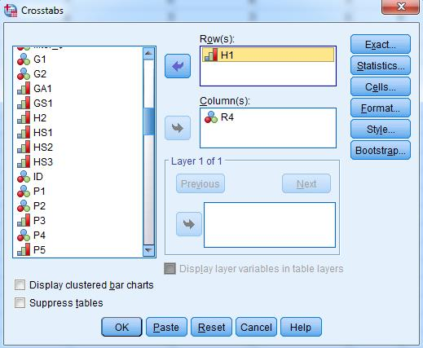
Figure 20-3
Since your independent variable is in the columns, you want the column percents so click on the "Cells" button and check the box for the "Column" percents and then click on "Continue." Now click on the "Statistics" button and check the boxes for Chi Square and Kendall's tau-c and then click on "Continue." (We'll discuss these statistics in a little bit.) Your screens should look like Figure 20-4 and 20-5.
Figure 20-4
Figure 20-5
Now all you have to do is to click on "OK" and you should see your output. Since the column percents sum down to 100, you should compare the percents straight across. Always compare the percents in the direction opposite to the way they sum to 100.
How would you describe your findings in a report? Think of writing two sentences. The first sentence should describe the pattern without using numbers. The second sentence should use the percents to illustrate the pattern. So you might write something like this. "Mainline Lutherans are more likely to feel that homosexuality should be accepted by society while Evangelical Lutherans are more likely to feel it should be discouraged by society. For example, 75.8% of Mainline Lutherans think that homosexuality should be accepted by society while only 57.0% of Evangelical Lutherans feel that way. However, 43.0% of Evangelical Lutherans feel that homosexuality should be discouraged compared to 24.2% of Mainline Lutherans."
What about Chi Square? Chi Square is a test of significance that tests the null hypothesis that the two variables are unrelated to each other. In statistical speak, we would say that the null hypothesis is that the variables are statistically independent. Chi Square tests this null hypothesis and tells you whether you should reject or not reject it. If you can reject it, then you have evidence that the two variables are related to each other. If you can't reject it, then you don't have any evidence of such a relationship.
To interpret Chi Square in your output, look at the first row for "Pearson Chi Square" and the column for "Asymptotic Significance." In your output, it should read ".000". This is the probability that you would be wrong if you rejected the null hypothesis. It's actually not 0, but rather it is less than (<) .0005 since it's a rounded value. That tells you that it's very unlikely that this is a chance relationship. There probably is some relationship between these two variables. Our rule is to reject the null hypothesis when the significance value is < .05. In other words, when the probability of being wrong is less than five out of one hundred.
A measure of association is a statistic that measures the strength of the relationship. The Chi Square test doesn't tell you anything about the strength of the relationship. You need a measure of association to do that. There are many different measures of association. For our measure of association, we used Kendall's tau-c. Tau-c can be used when both of your variables are ordinal. Ordinal means that the categories have an inherent order to them. In other words, they are ordered from high to low or from low to high. In our example, tau-c is -.182 which means that there is a weak relationship between the two variables. Measures of association are most useful for comparing the strength of the relationship in two or more tables.

Part VII – Now It's Your Turn

Decide which two religions you want to compare and select out the respondents in these two religions. Check to make sure that you did this correctly by running a frequency distribution for the variable you used to select out the two religions. Run the appropriate crosstabs to see if the two religions differ in terms of their views on these social issues. Use SS1, AB1, and ENV1 as your measures of views on social issues. This will give you four separate tables. Be sure to get the column percents, Chi Square, and Kendall's tau-c for all three crosstabs.
Write one paragraph describing your findings for each of the two measures of political behavior. Follow the approach I described above by writing two sentences. The first sentence should describe the pattern without using numbers. The second sentence should use the percents to illustrate the pattern. Be sure to use the column percents, Chi Square, and Kendall's tau-c in your answer.

Appendix A – Notes on the Data Set

The data set used in these exercises is a subset of the Pew Religious Landscape Survey conducted in 2014 by the Pew Research Center. The survey was a very large telephone survey of about 35,000 adults living in all 50 states in the U.S. About 60% of all interviews were on cell phones and 40% on landlines. At least 300 interviews were conducted in each state including the District of Columbia. More information about the survey can be found on the Pew website. You will find their website extremely useful. A similar survey of about 35,000 adults was conducted by the Pew Center in 2007.

Selecting the Variables
A subset of variables was selected from the full Pew survey. Some of these variables were created by combining other variables while other variables were recodes of existing variables. Variables were selected that would be most useful for instructional purposes. The full data set can be downloaded from the Pew Center's website. Be sure to read the Dataset Use Agreement before downloading the data set.
Weighting
There is a weight variable (named "weight") that should be used whenever analyzing the data. Weighting adjusts the data so it better represents the population from which the sample was selected.
The survey also includes another set of weights that should be used if you want to focus on specific metropolitan areas. These weights are not included in this subset. If you want to look at certain metropolitan areas you will need to download the full data set from the Pew website.

Renaming Variables
Variables were renamed to make them easier to use. Names consist of a short description of the type of variable and a unique numbering of the variables. Variable names are kept short for convenience sake. Here is a listing of the different types of variables in the dataset.
- AB1 – abortion
- C1 to C3 – various types of changes in the U.S. and whether this was for the better or worse
- D1 to D14 – demographic variables including marital status, race, ethnicity, children, age, cohort, education, citizen, family income, and sex
- ENV1 – environmental laws and regulation
- EVO1 – evolution
- G1 to G2 – geographic region including state and census region
- GA1 – government aid to the poor
- GS1 – size of government
- H1 to H2 – homosexuality and whether they know anyone who is gay or lesbian
- HS1 to HS3 – satisfaction with different areas of life
- ID – unique identification number
- P1 to P5 – political party identification and ideology
- R1 to R7 – religious identification
  - present religion
  - born-again or evangelical Christian
  - religious family including evangelical Protestant tradition, mainline Protestant tradition, historically black Protestant tradition, Catholic, Jewish, Muslim, Buddhist, Hindu, other, atheist, agnostic, nothing in particular; the various Protestant traditions are broken down into their respective denominations (e.g., Lutheran, Methodist)
  - same as above but Protestant traditions are not broken down into their respective denominations
  - Protestant denominations with non-Protestants coded as not Protestant
  - Member of a local house of worship or not
- REL1 to REL3 – religiosity including attendance at worship, importance of religion, and frequency of prayer
- RR1 to RR4 – religion in which raised
- RS1 to RS4 – religion of spouse or partner
- RBH1 to RBH11 – religious behavior including such things as participation in small religious groups and reading of scripture
- RBL1 to RBL21 – religious beliefs including such things as belief in God, view of God, and existence of heaven and hell
- RW1 – what respondents look to for guidance on right and wrong
- STAN1 – absolute standards of right and wrong
- SS1 – same-sex marriage
- WEIGHT variable

Variable Labels
Variable labels always start with the variable name. The rest of the label is the label that Pew used in the full data set. This identifies the question number in the survey and the wording of each question. This is very useful since you can see exactly how the question was asked in the survey. I did some minor editing of the Pew variable labels to make them easier to read.

Composite Variables
Some variables were created by Pew and some I created. These are identified in the variable label as a "composite or a combined variable." Pew created the following variables: R4, R5, R6, RR2, RR3, RR4, RS2, RS3, and RS4. I created the following variables: D10, EVO1, RBH7, P4, and RBL21.
The first three of the variables I created were straight forward combinations of two other variables.
- D10 combines two family income questions into one variable.
- EVO1 combines two questions about evolution into one variable.
- RBH7 combines two questions about volunteering into one variable.
The last two variables I created (P4 and RBL21) requires a little more explanation.
- P2 asked respondents whether they considered themselves to be Republican, Democrat, or Independent. Some respondents added that they had no preference or belonged to another party.
- P3 asked those that responded independent, no preference, belonged to another party, and those that said they didn't know or refused to answer whether they leaned more to the Republican or Democratic Party.
- I combined these two variables into another variable (P4). This variable classifies respondents as Republican, lean Republican, Independent, lean Democrat, and Democrat. Independents consist of those who said they were Independent in P2 and didn't lean either way in P3.
- Some of the exercises look at two defining beliefs of Evangelical Christians – the belief that one must have had a born-again experience (R3) and the belief that the Bible is the literal word of God (RBL7R2). RBL21 combines these two beliefs into a typology of Christian beliefs. Your analysis will automatically be limited to Christians since non-Christians are defined as missing data.

Recoded Variables
Several variables were recoded to make them easier to use. These include RBL7R1, RBL7R2, D6R1, D7R2, D8R1, and D10R1. The R toward the end of the variable name indicates that it is a recoded variable and the number at the very end of the name distinguishes between the first and second recodes.

Missing Values
I created missing values for all variables that had any missing information. I used the following rules to create the missing values.
- Don't know and refused were always defined as missing values.
- In variables C1 to C3 respondents were asked if various changes were for the better or for the worse. Some said that the changes were mixed and I assigned them a missing value.
- Several variables were forced choice questions where the respondents were asked to choose the statement that was closest to their view. Some said both or neither and I assigned them a missing value.
- Some responses were uncodeable and I assigned them a missing value.

Levels of Measurement
Variables are often labelled as nominal, ordinal, interval, and ratio based on a classification scheme developed by S. S. Stevens. The variables in this subset are all nominal or ordinal level measurement. There are no interval or ratio level measures. This, of course, limits the type of statistical analysis you can do with these variables. If you want a series of exercises that include interval and ratio level variables, I created three sets of exercises using the General Social Survey. These use SPSS, PSPP, and SDA (Survey Documentation and Analysis) as the statistical package for analysis. You can find these exercises on the Social Science Research and Instructional Council's website.

Statistical Package Used
I use SPSS as the statistical package for these exercises. There are other statistical packages that you might use including SAS, Stata, R, and others. You can convert the data set to other formats as you wish.

Appendix B – Notes for the Instructor

The data set used in these exercises is a subset of the Pew Religious Landscape Survey conducted in 2014 by the Pew Research Center. The survey was a very large telephone survey of about 35,000 adults living in all 50 states in the U.S. About 60% of all interviews were on cell phones and 40% on landlines. At least 300 interviews were conducted in each state including the District of Columbia. More information about the survey can be found on the Pew website. A similar survey of about 35,000 adults was conducted by the Pew Center in 2007 but we will be using the 2014 Pew survey in these exercises.

Instructional Exercises

I created five sets of instructional exercises.
- Exercises 1 to 4 focus on measurement.
  - Exercise 1 – measuring religious preference.
  - Exercise 2 – measuring religiosity.
  - Exercise 3 – measuring religious beliefs.
  - Exercise 4 – measuring religious behavior.
- Exercises 5 to 8 focus on the relationship of various dimensions of religion and social issues.
  - Exercise 5 – two-variable analysis of religion and attitudes toward same-sex marriage.
  - Exercise 6 – three-variable analysis of religion and attitudes toward same-sex marriage.
  - Exercise 7 – two-variable analysis of religion and attitudes toward environmental laws and regulations.
  - Exercise 8 – three-variable analysis of religion and attitudes toward environmental laws and regulations.
- Exercises 9 to 11 compare the religion in which the respondent was raised to the respondent's current religious preference in order to measure religious mobility.
  - Exercise 9 – compares the religion in which respondents were raised with their current religious preference.
  - Exercise 10 – develops an overall measure of religious mobility and looks to see where people go when they leave their religious group.
  - Exercise 11 – develops an overall measure of religious mobility and looks to see whether mobility varies by sex and age.
- Exercises 12 to 14 compare the religious preference of respondents with the preference of their spouse or partner.
  - Exercise 12 – compares the respondent's religious preference with spouse's or partner's preference.
  - Exercise 13 – develops an overall measure of religious similarity and looks more closely at respondents who are not similar to their spouses and partners in religious preference.
  - Exercise 14 – looks to see whether similarity and dissimilarity varies by sex.
- Exercises 15 to 20 compare two religious groups of the student's choice.
  - Exercise 15 – an introduction to this series.
  - Exercise 16 – compares the religiosity (i.e., how religious people are) of the two religious groups the students chose.
  - Exercise 17 – compares the religious beliefs of the two religious groups the students chose.
  - Exercise 18 – compares the religious behavior of the two religious groups the students chose.
  - Exercise 19 – compares the political party preference and political views of the two religious groups the students chose.
  - Exercise 20 – compares opinions on homosexuality, same-sex marriage, abortion, and environmental laws and regulations of the two religious groups the students chose.

Statistical Analysis

I used SPSS as the statistical package for these exercises. However, they could be converted to SAS, Stata, or any other package you prefer. The statistical tools used are relatively simple – percentages, crosstabulation, Chi Square, and measures of association. I used two measures of association – Cramer's V and Kendall's tau-c. Cramer's V is the appropriate measure of association for nominal variables and Kendall's tau-c for ordinal variables. SPSS computes other measures of association so it would be easy to modify the exercises to use your favorite measure.
If you are looking for exercises that cover a broader range of statistical tools, I have written three sets of exercises for an introductory statistics class. One set uses SPSS; another set uses PSPP, and the third set uses SDA (Survey Documentation and Analysis). I have also written a series of exercises for an introductory research methods class that uses SDA (Survey Documentation and Analysis).
John Korey and I have written an online introduction to SPSS which is freely available on our website. I referred students to appropriate chapters in the book in these exercises. This book includes all the statistical procedures in SPSS that you are likely to use in undergraduate courses.
I show students how to use SPSS to compute the statistics they use in these exercises and provide information on how to interpret them. I do not explain how to compute them nor do I discuss the assumptions that underlie each statistic. If you want to cover this in the exercises, you will need to add that information.
There are some things that you ought to discuss with students before assigning these exercises.
- Students need to understand the difference between nominal and ordinal measures for some of the exercises. In a crosstabulation, if either variable is nominal, then V should be used. If both variables are ordinal, then tau-c should be used.
- Students also need to understand that dichotomous variables are always treated as ordinal.
- Cramer's V is always positive while Kendall's tau-c can be either positive or negative. I would tell the students to ignore the sign of tau-c. That's because the sign depends on how the variables are coded. For example, sex is a dichotomy in the data set and therefore should be treated as ordinal. It doesn't matter whether males are coded 1 and females are coded 2 or if females are coded 1 and males coded 2. The value of tau-c will be the same although the sign of tau-c will change.
- Students need to understand the difference between independent and dependent variables for exercises that include crosstabulation. I discuss this in the exercises but it will need to be reinforced in class.
- With a sample this large, it's important to keep in mind that the larger the sample, the easier it is to get a significant Chi Square. That makes measures of association even more critical.

Notes about Specific Exercises
- Measurement exercises – These exercises are limited to frequency distributions. The focus is on how to measure different religious concepts. All four exercises include screen captures to help students learn SPSS. Exercise 4 introduces both the select cases and the count functions in SPSS.
- Social issue exercises (i.e., same-sex marriage and environmental laws and regulations)
  - Exercises 5 and 6 focus on the relationship between religion and attitudes toward same-sex marriage. The first exercise uses frequency distributions and two-variable tables. The second exercise uses frequency distributions and three-variable tables and also discusses spuriousness.
  - Exercises 7 and 8 focus on the relationship between religion and how respondents feel about environmental laws and regulations. The third exercise uses frequency distributions and two-variable tables. The fourth exercise uses frequency distributions and three-variable tables and also discusses spuriousness and specification.
- Religion in which raised – Exercises 9 to 11 use frequency distributions and crosstabulation to discuss religious mobility.
- Religion of respondent and religion of spouse or partner – Exercises 12 to 14 use crosstabulation to compare the religious preference of the respondents and that of their spouse or partner and to develop a measure of similarity and dissimilarity.
- Comparing religious groups – Exercises 15 to 20 compare two religious groups of the student's choice. They use frequency distributions, crosstabulations, percents, Chi Square, and Kendall's tau-c as the measure of association. Exercise 15 explains how to choose the two religious groups to compare and how to select out the respondents in these two groups. It should be used prior to any of the other exercises in this set. There is considerable repetition in Exercises 16 through 20 so you can select which comparisons you want students to make. If you use more than one of these five exercises, you will want to eliminate some of the repetitious material.

Screen Captures
Screen captures are used in some of the exercises to help students learn how to use SPSS. There is also a SPSS tutorial that is freely available to help students. I refer students to different parts of this book in these exercises.

Suggestions on Using the Exercises
There are many ways to use these exercises in your classes. Here are just some of the ways.
- If you want to introduce students to frequency distributions and two-variable crosstabulations, you could one of Exercises 1 to 4 and either Exercise 5 or 7.
- If you want to add three-variable crosstabulations, you could use Exercise 6 or 8.
- If you want to include other types of analysis, consider using Exercises 9 to 11 on religious mobility or Exercises 12 to 14 on religious similarity and dissimilarity.
- Exercises 15 to 20 allow students to choose two religious groups and compare them using various dimension of religion.

Permission to Edit Exercises

I have tried to make the exercises as independent of each other as possible so you could use whichever exercise you want without having to use all the exercises in the series. This means that there is considerable repetition across the exercises. You have permission to edit the exercises in any way you want. You can delete material that is too repetitious, add material of your own, and combine exercises. I would like to hear from you about your experiences using the exercises. If you find any errors, please let me know so I can correct them.

Contacting the Author

If you would like to contact me, please email me at ednelson@csufresno.edu. I’m Professor Emeritus at California State University, Fresno in the Sociology department. I taught research methods, statistics, and critical thinking before retiring and now teach a critical thinking course part time.

This assumes that the proper associations have been set up on your computer so the computer knows that .sav files are SPSS data files.
SPSS allows you to change the way your output is displayed. You can change these preferences by clicking on "Edit" in the menu bar at the top of the screen and then clicking on "Options" and finally on the "Output" tab. Under "Variables in item labels shown as", select "Names and Labels" and then under "Variable values in item labels shown as", select "Values and Labels." Then click on "OK." You can also try out other options.
This assumes that the proper associations have been set up on your computer so the computer knows that .sav files are SPSS data files.
SPSS allows you to change the way your output is displayed. You can change these preferences by clicking on "Edit" in the menu bar at the top of the screen and then clicking on "Options" and finally on the "Output" tab. Under "Variables in item labels shown as" select "Names and Labels" and then under "Variable values in item labels shown as" select "Values and Labels." Then click on "OK." You can also try out other options.
This assumes that the proper associations have been set up on your computer so the computer knows that .sav files are SPSS data files.
SPSS allows you to change the way your output is displayed. You can change these preferences by clicking on "Edit" in the menu bar at the top of the screen and then clicking on "Options" and finally on the "Output" tab. Under "Variables in item labels shown as" select "Names and Labels" and then under "Variable values in item labels shown as" select "Values and Labels." Then click on "OK." You can also try out other options.
There is a slight discrepancy here. When you add 263 and 4,006 you actually get 4,269 and not 4,270. You're off by one. That's due to the way the data are weighted and is nothing to worry about.
Be sure to use the valid percents in answering these questions.
This assumes that the proper associations have been set up on your computer so the computer knows that .sav files are SPSS data files
SPSS allows you to change the way your output is displayed. You can change these preferences by clicking on "Edit" in the menu bar at the top of the screen and then clicking on "Options" and finally on the "Output" tab. Under "Variables in item labels shown as" select "Names and Labels" and then under "Variable values in item labels shown as" select "Values and Labels." Then click on "OK." You can also try out other options.
Be sure to use the valid percents in answering these questions
This assumes that the proper associations have been set up on your computer so the computer knows that .sav files are SPSS data files.
SPSS allows you to change the way your output is displayed. You can change these preferences by clicking on "Edit" in the menu bar at the top of the screen and then clicking on "Options" and finally on the "Output" tab. Under "Variables in item labels shown as" select "Names and Labels" and then under "Variable values in item labels shown as" select "Values and Labels." Then click on "OK." You can also try out other options.
The "R" indicates that it is a recoded or composite variable and the "1" indicates that it is the first recoded or composite variable. The second recoded or composite variable would be "R2".
This assumes that the proper associations have been set up on your computer so the computer knows that .sav files are SPSS data files.
SPSS allows you to change the way your output is displayed. You can change these preferences by clicking on "Edit" in the menu bar at the top of the screen and then clicking on "Options" and finally on the "Output" tab. Under "Variables in item labels shown as" select "Names and Labels" and then under "Variable values in item labels shown as" select "Values and Labels." Then click on "OK." You can also try out other options.
The percent difference refers to the difference between the percents for those who say religion is important and those who say it's not important. For example, subtract the percent of those for whom religion is important that favor same-sex marriage from the percent of those for whom it's not important that favor same-sex marriage. It doesn't matter which percent you subtract from the other percent as long as you are consistent.
The "R" indicates that it is a recoded or composite variable and the "1" indicates that it is the first recoded or composite variable. The second recoded or composite variable would be "R2".
This assumes that the proper associations have been set up on your computer so the computer knows that .sav files are SPSS data files
SPSS allows you to change the way your output is displayed. You can change these preferences by clicking on "Edit" in the menu bar at the top of the screen and then clicking on "Options" and finally on the "Output" tab. Under "Variables in item labels shown as" select "Names and Labels" and then under "Variable values in item labels shown as" select "Values and Labels." Then click on "OK." You can also try out other options
The "R" indicates that it is a recoded or composite variable and the "1" indicates that it is the first recoded or composite variable. The second recoded or composite variable would be "R2".
This assumes that the proper associations have been set up on your computer so the computer knows that .sav files are SPSS data files.
SPSS allows you to change the way your output is displayed. You can change these preferences by clicking on "Edit" in the menu bar at the top of the screen and then clicking on "Options" and finally on the "Output" tab. Under "Variables in item labels shown as" select "Names and Labels" and then under "Variable values in item labels shown as" select "Values and Labels." Then click on "OK." You can also try out other options.
The "R" indicates that it is a recoded or composite variable and the "1" indicates that it is the first recoded or composite variable. The second recoded or composite variable would be "R2".
The percent difference refers to the difference between the percents for the biblical literalists and the non-literalists. For example, subtract the percent of literalists who chose the first claim from the percent of non-literalists who chose that claim. It doesn't matter which percent you subtract from the other percent as long as you are consistent.
This assumes that the proper associations have been set up on your computer so the computer knows that .sav files are SPSS data files.
SPSS allows you to change the way your output is displayed. You can change these preferences by clicking on "Edit" in the menu bar at the top of the screen and then clicking on "Options" and finally on the "Output" tab. Under "Variables in item labels shown as" select "Names and Labels" and then under "Variable values in item labels shown as" select "Values and Labels." Then click on "OK." You can also try out other options.
This assumes that the proper associations have been set up on your computer so the computer knows that .sav files are SPSS data files.
The religious groupings are abbreviated by using the first one or two letters of the religious group. See Figure 10-2 for a list of these groups.
This assumes that the proper associations have been set up on your computer so the computer knows that .sav files are SPSS data files.
This assumes that the proper associations have been set up on your computer so the computer knows that .sav files are SPSS data files.
SPSS allows you to change the way your output is displayed. You can change these preferences by clicking on "Edit" in the menu bar at the top of the screen and then clicking on "Options" and finally on the "Output" tab. Under "Variables in item labels shown as" select "Names and Labels" and then under "Variable values in item labels shown as" select "Values and Labels." Then click on "OK." You can also try out other options.
This assumes that the proper associations have been set up on your computer so the computer knows that .sav files are SPSS data files.
The religious groupings are abbreviated by using the first two letters of the religious group. See Table 1 for a list of these groups.
This assumes that the proper associations have been set up on your computer so the computer knows that .sav files are SPSS data files.
This assumes that the proper associations have been set up on your computer so the computer knows that .sav files are SPSS data files.
SPSS allows you to change the way your output is displayed. You can change these preferences by clicking on "Edit" in the menu bar at the top of the screen and then clicking on "Options" and finally on the "Output" tab. Under "Variables in item labels shown as" select "Names and Labels" and then under "Variable values in item labels shown as" select "Values and Labels." Then click on "OK." You can also try out other options.
This assumes that the proper associations have been set up on your computer so the computer knows that .sav files are SPSS data files.
SPSS allows you to change the way your output is displayed. You can change these preferences by clicking on "Edit" in the menu bar at the top of the screen and then clicking on "Options" and finally on the "Output" tab. Under "Variables in item labels shown as" select "Names and Labels" and then under "Variable values in item labels shown as" select "Values and Labels." Then click on "OK." You can also try out other options.
Exercise_1CR discusses what we mean by these different religious traditions and gives you links to articles providing more information.
This assumes that the proper associations have been set up on your computer so the computer knows that .sav files are SPSS data files
SPSS allows you to change the way your output is displayed. You can change these preferences by clicking on "Edit" in the menu bar at the top of the screen and then clicking on "Options" and finally on the "Output" tab. Under "Variables in item labels shown as" select "Names and Labels" and then under "Variable values in item labels shown as" select "Values and Labels." Then click on "OK." You can also try out other options.
There is a slight discrepancy here. When you add 263 and 4,006 you actually get 4,269 and not 4,270. You're off by one. That's due to the way the data are weighted and is nothing to worry about.
Exercise 15 discusses what we mean by these different religious traditions and gives you links to articles providing more information.
This assumes that the proper associations have been set up on your computer so the computer knows that .sav files are SPSS data files.
SPSS allows you to change the way your output is displayed. You can change these preferences by clicking on "Edit" in the menu bar at the top of the screen and then clicking on "Options" and finally on the "Output" tab. Under "Variables in item labels shown as" select "Names and Labels" and then under "Variable values in item labels shown as" select "Values and Labels." Then click on "OK." You can also try out other options.
Exercise 15 discusses what we mean by these different religious traditions and gives you links to articles providing more information.
This assumes that the proper associations have been set up on your computer so the computer knows that .sav files are SPSS data files.
SPSS allows you to change the way your output is displayed. You can change these preferences by clicking on "Edit" in the menu bar at the top of the screen and then clicking on "Options" and finally on the "Output" tab. Under "Variables in item labels shown as" select "Names and Labels" and then under "Variable values in item labels shown as" select "Values and Labels." Then click on "OK." You can also try out other options.
Exercise 15 discusses what we mean by these different religious traditions and gives you links to articles providing more information.
Exercise 15 discusses what we mean by these different religious traditions and gives you links to articles providing more information.
This assumes that the proper associations have been set up on your computer so the computer knows that .sav files are SPSS data files.
SPSS allows you to change the way your output is displayed. You can change these preferences by clicking on "Edit" in the menu bar at the top of the screen and then clicking on "Options" and finally on the "Output" tab. Under "Variables in item labels shown as" select "Names and Labels" and then under "Variable values in item labels shown as" select "Values and Labels." Then click on "OK." You can also try out other options.
Exercise 15 discusses what we mean by these different religious traditions and gives you links to articles providing more information.
Exercise 15 discusses what we mean by these different religious traditions and gives you links to articles providing more information.
Not all of these statistics are used in each exercise.

