Exercises for Critical Thinking

Edward Nelson

California State University, Fresno

2020

Table of Contents

Page

Preface 3
Exercise 1 – Questions are Important! 5
Exercise 2 – Scientific Approach 7
Exercise 3 – Inductive and Deductive Approaches to Research 10
Exercise 4 – Concepts and Variables 13
Exercise 5 – Theories and Hypotheses 16
Exercise 6 – Sampling 18
Exercise 7 – Arguments 22
Exercise 8 – Deductive and Nondeductive Arguments 25
Exercise 9 – Evaluating Arguments 28
Exercise 10 – Causality and Causal Arguments 35
Exercise 11 – Testing Causal Claims with Experimental Design 37
Exercise 12 – Testing Causal Claims with Survey Design 40
Exercise 13 – Introduction to Survey Data Analysis 44
Exercise 14 – Bivariate (Two-Variable) Data Analysis 47
Exercise 15 – Multivariate (Three or More Variables) Data Analysis 53
Exercise 16 – Errors in Critical Thinking 58
Appendix A – Introduction to Survey Documentation and Analysis (SDA) 61
Appendix B – Writing Research Reports 67

Exercises for Critical Thinking
Edward Nelson, California State University, Fresno

Preface

I taught in the Department of Sociology at California State University, Fresno for many years before retiring a few years ago and taught critical thinking, research methods, and statistics. Over the years I developed a framework for my critical thinking course which I want to share in the hope that it will be useful.
My critical thinking course is made up of five sections.
- Questions and the scientific method. Everything starts with a question. Being able to craft a good question is essential. Once the questions are formed, then and only then, should we begin to think about how to answer these questions. There are many ways that people attempt to answer questions, but the method we're going to use in these exercises is the scientific method. So, the first part of the course focuses on the scientific method and discusses the following.
  - Defining the scientific method
  - Deductive and inductive approaches
  - Concepts and variables
  - Measurement
  - Theory
  - Hypotheses
  - Sampling
- In order to answer our questions, we develop an argument. So, the second section of the course looks at argumentation and includes the following.
  - Defining an argument
  - Different types of arguments
  - Evaluating arguments
- The scientific method focuses on questions of causality so that's the third section of the course.
  - Causal arguments and causal claims
  - Causal diagrams
  - Establishing causality
  - Testing causal claims with experimental design and with survey design
- Once we develop our causal argument, it's time to test our causal claims. In my course we use survey design. Survey design can be thought of as an approximation of experimental design. In this fourth section of the course, the focus is on analyzing data to test hypotheses that flow from our causal argument. Topics include the following.
  - Measurement
  - Bivariate and multivariate analysis
  - Crosstabulation
  - Spuriousness
  - Writing research reports
- We conclude with a discussion of common errors that people make when formulating their arguments. These include the following. This is, of course, only a partial list.
  - Appeal to inappropriate authority
  - Gambler's fallacy
  - Slippery slope
  - Straw man
  - Denying the antecedent
  - Affirming the consequent
- There are two appendices at the end of this series of exercises.
  - The first is a short introduction to Survey Documentation and Analysis (SDA), the statistical program we use in Exercises 14 and 15.
  - The second is a discussion of how to write research papers.
Over the years I found my favorite texts.
- I found two excellent discussions of the scientific method. For years I used Thomas J. Sullivan's short text, Applied Sociology – Research and Critical Thinking (Macmillan Publishing, 1992). Eventually it went out of print so I had to look for another text. Fortunately, I found an excellent replacement, Making Sense of the Social World – Methods of Investigation by Daniel F. Chambliss and Russel K. Schutt (Sage, 2019). This series of exercises could be used as a replacement for these texts which would reduce the costs of books for students.
- For the section on argumentation, I use The Elements of Reasoning by Ronald Munson and Andrew Black (Cengage Learning, 2017).
I make extensive use of these books in these exercises. I try to credit the authors whenever I make use of their treatment of the scientific method and argumentation.
There are several ways you could utilize these exercises. Each of the exercises is independent of the other exercises which means that you could pick and choose whichever exercises you want to use. I suggest that if you plan to use Exercise 15 on multivariate analysis, that you also use Exercise 14 on bivariate analysis. If you want to adopt the structure of my course, you could use the exercises in their entirety. You may want to add or delete material from these exercises. You have permission to use these exercises and make changes, additions, and deletions as you think best. All I ask is that you cite the original source.
There is an additional set of resources that you might find helpful. They include instructions for papers that I used in my class using a data-driven approach and several data sets that I previously used.
If you would like to contact me (Edward Nelson), please email me at ednelson@csufresno.edu. I’m Professor Emeritus at California State University, Fresno in the Sociology department. Now that I'm retired, I teach a critical thinking course part time. If you find any errors, please let me know so I can correct them. Please feel free to contact me with any questions or problems you may have when using the exercises.

Exercises for Critical Thinking
Edward Nelson, California State University, Fresno

Exercise 1
Questions are Important!

Everything starts with a question. The most common types of questions are why and how questions. Here are a few examples of why questions.
- Why do some people decide to go to college and others don't?
- Why do some vote for the Democratic candidate for president and others for the Republican candidate and still others don't vote at all?
- Why are some people in favor of gun control and others oppose it?
How questions are often more policy oriented. Here are some examples of how questions.
- How can we reduce violent crime?
- How could the police respond to domestic violence calls to increase the likelihood that it would not occur again?
- If we were the campaign manager for a candidate, how could we convince people to vote for our candidate?
We need to learn how to formulate good research questions. Let’s start by looking at some examples of poor questions. Why are these poor questions?
- Women are more likely than men to vote Democrat in presidential elections. This one is easy. It’s not a question. It’s actually a hypothesis which we'll discuss in Exercise 5.
- Why are women more likely than men to vote Democrat in presidential elections? This one is a little more difficult. We want to start with the more general question such as why some people vote Democrat and others vote Republican? Then we would consider possible answers to this question. One of these answers might be that gender influences voting. Since science is empirical, we would start by looking at data to see if, in fact, gender is related to voting and we would discover that in most recent presidential elections women are more likely to vote Democrat. This would lead us to ask why women are more likely than men to vote Democrat. But we would start our study with the more general question.
- Why aren't people more like me? This question is vague and is focused on a particular individual.
What are the characteristics of a good research question?
- We start by looking at general questions such as what influences voting or why do some people favor same-sex marriage and others oppose it. As our study progresses, we move to more focused questions such as why women are more likely to vote Democrat than men.
- We focus on questions that ask about behavior, attitudes, and opinions.
- Good questions are clearly stated. Questions such as what about voting aren’t clear and therefore aren’t useful.
- As with everything we write, we want to make sure that we use correct spelling and good grammar. So proofread everything you write including your questions.
There are many ways that people go about trying to answer questions. Some rely on their religious or family traditions while others follow what those in authority (e.g., religious, family, government) tell them. Still others rely on their common sense or intuition. In these exercises we're to going to use the scientific method to answer our questions.
But keep in mind that science can't answer all questions. Science wouldn't be very helpful in determining if there is a god or the meaning of life. Science would be able to help us determine why people vote the way they do or why people choose to go to college.

Assignment

- Write two questions that could be answered using the scientific approach. Don't use questions that were discussed in this exercise.
- Write two questions that couldn't be answered using the scientific approach. Again, don't use questions that were discussed in this exercise.

Next Exercise
Exercise 2 will focus on the scientific approach – what it is and what it isn't.

Exercises for Critical Thinking
Edward Nelson, California State University, Fresno

Exercise 2
Scientific Approach

Everything starts with a question. Once we have a well-formulated question, we can turn our attention to how we're going to answer that question. The approach we're going to use in these exercises is based on the scientific method. So, the first thing we have to do is review what the scientific method is and what it isn't.
Thomas Sullivan says the "Science is a method of obtaining knowledge about the world though systematic observations." There are two important points in this definition. First, science is one way we can learn more about our world. Second, the way we gain this knowledge is through systematic observations.
Sullivan goes on to discuss the five characteristics of the scientific method.
"First, all scientific knowledge is based on observations." Typically we refer to these observations as data. Science is not based on our opinions. Rather, it is based on data that we collect.
"Second, scientific knowledge is based on systematic observation." One example of systematic observations is the Minneapolis Domestic Violence Experiment. The question that guided their research was what is the most effective way that the police could "reduce domestic violence." They compared three ways the police could respond to a domestic violence incident – arrest, mediation or advice, and separation. The method of response was randomly determined for each incident and recurrences were tracked over a six-month period. Compare this to another approach based on anecdotal data. What if we based our analysis on reports from friends and friends of friends? This would be a purely volunteer sample and a good example of anecdotal data which would be unsystematic.
"A third characteristic of scientific knowledge is that it focuses on causation." Science is primarily interested in identifying the factors that lead to something happening. For example, social scientists are interested in determining why people vote the way they do and why some choose not to vote. It's not enough to simply describe how people voted, but we want to go beyond simple description to an analysis of why people vote the way they do.
"Fourth, scientific knowledge is provisional." This means that we don't ever claim to have discovered "the truth." Everything is open to revision based on subsequent research. A very important part of the scientific approach is replication which means repeating or replicating a study with different samples and different locations. For example, the Minneapolis Study of Domestic Violence was replicated in different part so the country and, as you might guess, they didn't always get the same results.
"A fifth and final characteristics of scientific knowledge is that of objectivity." That means that we try to avoid letting our own biases and values affect our research. The operative word here is "tries." No one can ever be completely objective." Sullivan points out that sharing our research findings with others is critical. That way others can evaluate our work and provide checks and balances to our work.

Systematic vs. unsystematic observations
Probably the most critical part of Sullivan's five characteristics is the distinction between systematic and unsystematic observations. Let's consider another example. Every two years in the U.S. we have an election. Every four years we elect a president and congressional and gubernatorial elections are held every two years. How can we tell who’s ahead at any particular point during the campaign?
One way would be for you to poll your family members and friends. However, since your friends and family members are probably similar to yourself, that's not going to give us systematic data. It would be biased data. So we need to look for another method.
A second way would be to put a poll on your website or on Facebook. You'll get a larger sample and it will include people that aren't your friends and family but it will still be unsystematic. It's a volunteer sample and people who volunteer to be part of your sample are usually quite different from those who don't volunteer.
A third way is to select a random sample of registered voters and contact them by telephone, email, or by sending them a letter through the mail. You could also combine different ways of reaching out to your sample. You would want to be sure to provide the poll in different languages since not everyone will be fluent in English. Some will not respond to your initial attempt to reach them so you'll have to make several attempts to contact them. That's why some elections polls are considered to be systematic. This doesn't mean that all election polls are systematic, but it means that good polls are conducted this way.
You can see examples of this type of polling by going to the Fivethirtyeight and Real Clear Politics websites and looking at the many polls that have been conducted asking respondents whether they approve or disapprove of the job that the president has been doing. Each of the dots on the chart shows the result of a particular poll. Think of each dot as a replication. Not all the dots show the same results. This shows the importance of replication. If you want more information on how they created this chart, click on this link.

Assignment

- Write one question that you would like to answer using the scientific approach.
- How could you go about answering this question using the scientific approach?
- What would be an example of how someone (not you) could try to answer this question with a non-scientific approach?

Next Exercise
Exercise 3 will focus on two different approaches to research – the inductive and the deductive approaches.

Exercises for Critical Thinking
Edward Nelson, California State University, Fresno

Exercise 3
Inductive and Deductive Approaches to Research

The goals of science are to produce and test theory where a theory is a systematic attempt to answer a research question. The goal of the inductive approach to research is to produce theory while the goal of the deductive approach is to test theory.
The French sociologist, Emile Durkheim (1858-1917), wanted to discover why some social groups had higher suicide rates than other groups. He argued that both integration and regulation influenced the suicide rate of that group. Barclay Johnson says integration refers to "the degree to which its [the group's] members possess a 'common conscience' of shared beliefs and sentiments, interact with one another, and have a sense of devotion to common goals." Regulation refers to the degree to which the group regulates or controls the behavior of its members. Durkheim argued that extremes of integration and extremes of regulation lead to higher rates of suicide of groups. Thus, groups that had very low or very high levels of integration would have higher suicide rates than groups that were more moderate in integration. And the same relationship would hold for regulation.
Theories need to be tested. Simply because a theory makes sense to us doesn't mean it's true and just because most people believe a theory to be true also doesn't make it true. Durkheim's study of suicide first described his theory and then proceeded to test it using various types of available data. Durkheim was one of the first sociologists to test his theory empirically.
Let's take a closer look at these two approaches to research – inductive and deductive. We're going to use police work and the criminal justice system to illustrate these two approaches.

Inductive Approach to Research
Let's assume that a possible crime has occurred. It could be a homicide or an assault or a burglary or a robbery. How do the police learn of this incident? Typically someone reports it – either the victim or a bystander. The police rarely directly observe it.
Once the police learn of the possible crime, they determine whether it was actually a crime. Consider a possible homicide. It could, in fact, be a homicide but it might also be a suicide or an accident. Once they determine that it is a homicide, they turn their attention to three questions:
- who did it,
- how did they do it, and
- why did they do it?
The police don't call these research questions but that's what they are. Their investigation is an attempt to answer these questions.
How do the police conduct their investigation? They look for data that might help them answer these questions. These might include:
- blood samples,
- DNA,
- fibers,
- fingerprints,
- interviews, and
- other types of data.
As their investigation proceeds, they eventually narrow the list of suspects and then make an arrest.
This is clearly an inductive approach and it's clearly empirical. They start with a set of questions and conduct an investigation to answer these questions. In other words, they produce a theory of the crime. The police wouldn't refer to it this way, but from our perspective that's what it is.
At this point, the process moves from the police to the courts and to the testing of the theory of the crime that the police have developed.

Deductive Approach to Research
The court decides if the evidence is sufficient for there to be a trial. Once the trial begins the prosecution lays out their theory of the crime. Again, this is not what they would call it. But remember that a theory is just a systematic attempt to answer a set of research questions. The prosecution presents its theory of the crime by calling witnesses and asking them questions which they think will support their case. The defense also gets to question the witnesses and attempts to raise doubt in the mind of the jurors.
Then the defense gets to present its case. They call witnesses whom they think will raise doubt in the jurors' minds as to the guilt of the defendant. The prosecution, of course, gets to question these witnesses to counter the defense's case.
After the prosecution and the defense present their cases, each gets to sum up their argument. Then the judge instructs the jurors on how to go about their deliberations. A key point in the judge's instructions is that the jury can find the defendant guilty or not guilty. Notice that it is not guilty or innocent. The judge tells the jury that if they have a reasonable doubt as the defendant's guilt, they must find the defendant not guilty. In other words, reasonable doubt is the key element in deciding on a verdict. Additionally, all jurors must agree on a verdict. If they are not able to all agree on a guilty or not guilty verdict, then they report that they are deadlocked and are unable to reach a verdict and the prosecution must decide whether to retry the defendant.
The jury ultimately becomes the test of the prosecution's theory of the crime. So the role of jury system is to test the prosecution's theory of the crime. Police work is inductive while the jury system is deductive.

Another Example of an Inductive Approach
Daniel Chambliss and Russel Schutt provide another interesting example of an inductive approach. Disaster research studies disasters such as floods, hurricanes, tornados, and fires in an attempt to discover how such disasters affect both individuals and communities. In 1972 a dam broke in West Virginia which caused many deaths and much property damage that resulted in both physical and psychological trauma. Kai Erickson interviewed residents to see how this disaster affected them. What is particularly interesting is the way in which this disaster destroyed communities. From Erickson's work comes a better understanding of trauma and the beginning of an answer to the question: how do disasters affect individuals and communities?

Assignment
For this assignment we're going to focus on the 2020 pandemic caused by the Coronavirus which was a highly infectious virus that spread quickly. This virus caused many millions of deaths worldwide as well as in the U.S. Medical experts advised the public to take several precautions – hand washing, social distancing, and wearing a mask. Wearing masks became a contentious issue with some people objecting to the requirement to wear masks as an affront to their individual liberties. Here's our research question – why are some people more likely to wear a mask than others? Think about the following questions and write a short essay answering each of these three questions.
- How would you use an inductive approach to suggest an answer to this question?
- What might your theory look like? In other word, what would be two factors that might influence mask wearing?
- How would you go about testing your theory?

Next Exercise
Exercise 4 will focus on concepts and variables.

Exercises for Critical Thinking
Edward Nelson, California State University, Fresno

Exercise 4
Concepts and Variables

A concept is an abstract idea to which we assign a short label. A couple examples are religious preference and religiosity. Religious preference refers to the particular religion that a person identifies with while religiosity refers to how religious a person is. Another example of a concept is socioeconomic status which refers to a person's position in a social hierarchy. Still another example is the amount of serious violent crime in communities.
Concepts are the tools that we use to try to answer our research questions. For example, our research question might be, why do some people vote Democrat and others vote Republican in presidential elections? Concepts that we might use to try to answer this question could include religiosity, gender, and race. But we probably wouldn't use concepts such as hair color or weight. Why not? Because some concepts are potentially relevant and others are clearly not relevant. Here's another way to think about this. Imagine that you go to the dentist. When you sit down in the dentist's chair you see various tools that the dentist is going to use. What if you saw a chain saw among these tools? You would be smart if you got up and left because a chain saw is definitely not a relevant or appropriate tool for the dentist to be using.
Concepts must be defined and there are two different types of definitions – conceptual and operational. The conceptual definition explains what you mean by this concept. Religiosity refers to how religious a person is. That's our conceptual definition. But how are we going to measure this concept? That would be our operational definition. What are the operations that we must perform to measure religiosity? Let' see if we can diagram this. We're going to use rectangles to refer to the concept, ovals to refer to the measures, and arrows to connect the concepts and their measures.

Religiosity

Attendance frequency self-rating
at worship of prayer of importance
services of one's religion

In other words, attendance at worship services, frequency of prayer, and self-rating of the importance of one's religion are all measures of how religious a person is. These measures are often referred to as variables.
Let's look at another example. Assume we're going to move to a new state – California, for example. One of the things we want to know about communities in California is how much violent crime there is in that community. Our concept is amount of violent crime in a particular community.
First, we would have to define what we mean by violent crime. A crime is some action that violates a criminal law or statute. What about violent crime? The FBI defines violent crime as homicide, rape, assault, and robbery. So, that's going to be our conceptual definition.
But how are we going to measure the amount of violent crime in communities?
- We would need to know how many violent crimes were committed in each community. The FBI's Uniform Crime Reports provides us with that information. Each community reports the number of homicides, rapes, assaults, and robberies in their jurisdiction to the FBI and that information is compiled and made public. One of the limitations of these data is that they are limited to crimes known to the police.
- But that's not enough. If we compare the number of homicides in Los Angeles with the number of homicides in Fresno, of course, there will be more homicides in LA. It's many times larger than Fresno. So we have to take into account population size. That's readily available on the state's website.
- Next, we would divide the number of violent crimes in a given year by the population size for that year.
- To convert this to a rate we would multiply that fraction by some number which we could call the base. Let's say that we multiply our fraction by 10,000 to give us the violent crime rate for each community. That rate would tell us the number of violent crimes per 10,000 people in the population. Now we could compare these rates to determine which communities had more violent crime. The violent crime rate is our measure of the amount of violent crime in communities. We refer to this violent crime rate as our variable.
So, our diagram would look like this.
Amount of
violent crime

Violent crime
rate

Assignment
Which concepts might we use to try to explain why some people go to college and others don't?
- One of these concepts might be socioeconomic status. How would you define socioeconomic status? How would you measure it?
- Another concept might be the amount of economic resources that the person has available. How would you define this concept and how would you measure it?
- Think of another concept that might be relevant and discuss why you think it could be relevant, how you would define it conceptually, and how you would measure it.

Next Exercise
Exercise 5 will focus on theories and hypotheses.

Exercises for Critical Thinking
Edward Nelson, California State University, Fresno

Exercise 5
Theories and Hypotheses

A theory is a systematic attempt to answer our research questions. The French sociologist, Emile Durkheim (1858-1917), wanted to discover why some social groups had higher suicide rates than other groups. He argued that both integration and regulation influenced the suicide rate of that group. Barclay Johnson says integration refers to "the degree to which its [the group's] members possess a 'common conscience' of shared beliefs and sentiments, interact with one another, and have a sense of devotion to common goals." Regulation refers to the degree to which the group regulates or controls the behavior of its members. Durkheim argued that extremes of integration and extremes of regulation lead to higher rates of suicide of groups. Thus, groups that had very low or very high levels of integration would have higher suicide rates than groups that were more moderate in integration. And the same relationship would hold for regulation.
Daniel Chambliss and Russell Schutt provide us with a summary of another theoretical approach called rational choice theory which suggests that "people's behavior is shaped by calculations of the costs and benefits of their actions." In other words, when presented with a decision as to what to do, people weigh the possible costs against the possible benefits of the various choices they have. This doesn't mean that they sit down and write out the costs and benefits, but rather that they make a rapid calculation in their minds in order to make a decision.
A good example of rational choice theory is the decision whether to vote or not vote in elections. The costs would include the time and effort it takes to vote while the benefits would include doing one's civic duty and possibly influencing the outcome of the election. Another example would be the speed at which one drives on city streets. Costs would include the monetary costs of speeding tickets and benefits would include receiving a reduction in the cost of automobile insurance for having a clean driving record.
Now that we understand what a theory is, let's talk about hypotheses. A hypothesis is a testable statement that specifies the relationships among variables that our theory predicts. In other words, the hypothesis is derived from our theory.
Consider the application of rational choice theory to voting behavior. Our theory suggests that decreasing the costs of voting will increase voting turnout assuming that the benefits remain constant. Lowering the costs of voting could include making it easier to register, voting by mail, increasing the hours that polling places are open, and making election day a national holiday so voters wouldn't have to balance working and voting.
Durkheim's theory of suicide suggests that extremes of integration and regulation lead to higher suicide rates while more moderate levels lead to lower suicide rates. This would be our hypothesis. Hypotheses must be tested. Durkheim tested his theory by comparing the suicide rates of different groups. For example, he argued that Protestants were low in integration and Roman Catholics and Jews were more moderate in integration. If we were to diagram this part of Durkheim's argument, it would look like this.
Protestants Roman Catholics
and Jews
_____________________________________________________________
Low Integration High
Durkheim used available data on suicide and religion to test his hypothesis and the data supported the hypothesis. He derived other hypotheses from his theory and tested those as well. For example, he argued that regulation tended to be low in periods of great economic depression and prosperity and more moderate in more normal economic times. His test of this hypothesis also supported his theory. While these tests didn't prove his theory of suicide, they did support his theory and lend credibility to it.

Assignment
- Construct a theory to explain why some people vote Democrat and others vote Republican in presidential elections. Think about what concepts you would want to use in your theory and how you might measure these concepts.
- Construct two hypotheses that should be true if your theory is true. What types of data might you use to test these hypotheses? If your hypotheses turn out to be supported by the data, what could you conclude about your theory? What would you conclude if your hypotheses turn out to be false?

Next Exercise
Exercise 6 will focus on sampling.

Exercises for Critical Thinking
Edward Nelson, California State University, Fresno

Exercise 6
Sampling
Populations are the complete set of individuals that we want to study. For example, a population might be all the adults that live in the United States at a particular point in time. But populations are often large and it’s too costly and time consuming to carry out a complete enumeration. So, what we do is to select a sample from the population where a sample is a subset of the population. If we wanted to study all the adults in the U.S., we would select a sample of adults and collect data from that sample. Then we would use our sample data to make an inference about our population. That's commonly referred to as statistical inference.
There are many different ways to select samples. Probability samples are samples in which every object in the population has a known, non-zero, chance of being in the sample (i.e., the probability of selection). This isn’t the case for non-probability samples. An example of a non-probability sample is a volunteer sample which you often hear about on radio and television shows and on the internet. You might be invited to go to a website and answer a question such as whether you favor or oppose same-sex marriage. This is a purely volunteer sample and we have no idea of the probability of selection.
The most basic type of probability sample is a simple random sample in which everyone in the population has the same chance of being selected in the sample. If you have a list of all the individuals in your population, it’s easy to select a simple random sample. In this exercise, we're going to a data base that I created. In this hypothetical population there are 100 individuals numbered 1 to 100 (i.e., ID). Individuals in the population are also listed by sex (M for male and F for female) and whether they favor (F for favor) or oppose (O for oppose) same-sex marriage.
To select a simple random sample, all you need to do is to follow these easy steps.
- Number all the individuals from 1 to n where n is the total number of individuals in the population. If your population consists of 100 individuals, then number them from 1 to 100. This is done for you in the data file.
- Select m random numbers where m is the number of individuals in your sample. A set of random numbers has no discernable pattern to it. There are many random number generators on the internet. One of those generators can be found on the Stat Trek website. All you have to do is to enter the minimum value (i.e., 1 for the example above), the maximum number (i.e., 100), and the number of random numbers you want (e.g., 10 if you want a sample of 10 individuals). Note that it also asks if you want to allow duplicate entries. Most of the time you do not, so select “False.” Ignore the “Seed” box. Click on “Calculate” to generate the random numbers.
Write down the 10 random numbers that the generator produced and label this sample 1. Now calculate the percent of respondents in this sample that favored and opposed same-sex marriage.
Repeat this process. All you have to do is click on “Calculate” again. Write down the 10 random numbers and label this sample 2 and calculate the percent of respondents in this sample that favored and opposed same-sex marriage. Notice that the two samples will consist of different individuals although there may be some overlap.
Now repeat this process again and label this sample 3 and again calculate the percent of respondents in this sample that favored and opposed same-sex marriage.
Were the percent of respondents in the three samples that favored and opposed same-sex marriage all the same or different? What does this tell you about sampling?
We know that no sample is ever a perfect representation of the population from which the sample is drawn. This is because every sample contains some amount of sampling error. Sampling error is inevitable. There is always some amount of sampling error present in every sample.
Since we can’t eliminate sampling error, what we do is try to minimize sampling error. One way to do that is to stratify the sample. Notice that in the exercise data base, 50% of the population is male and 50% is female. When we select a simple random sample of 10 individuals from this population, sometimes the sample has 50% male and 50% female and sometimes there are more males than females and other times there are more females than males. Go back and check the three samples that you selected and calculate how many males and females there were in each sample. Were there the same number of males and females or were there more males or more females? You probably didn’t get exactly 50% males and 50% females in all three samples. Although it's possible, it’s not likely.
We can stratify our sample by sex and ensure that the sample has the same percent males and females as does the population. How would we do that? Divide the sample into two groups – all males and all females. Since the population is 50% males and 50% females, we want our sample to be 50% males and 50% females. For a sample of 10 individuals, that means we want our sample to have 5 males and 5 females. That’s easy to do in our exercise data base since the 50 males are listed first (id’s 1 to 50) and the 50 females are listed next (id’s 51 to 100).
Use the same random-number generator that we used earlier. For the males, all you have to do is to enter the minimum value (i.e., 1), the maximum number (i.e., 50), and the number of random numbers you want (e.g., 5). For females, just change the minimum value to 51 and the maximum value to 100 and leave the number of random numbers at 5.
Select three stratified random samples and write down the random numbers for each of the three samples. Calculate how many males and females there were in each sample and write that after the random numbers for each sample. This time there should be exactly 5 males and 5 females in each sample. These are stratified random samples. Since we have made sure that the population and the samples have the same proportion males and females, they are often called proportional stratified random samples.
Stratification will decrease sampling error if the variable that is used to stratify the sample is related to what you want to estimate. In this case, we want to estimate the proportion of the population that favor and oppose same-sex marriage. To do that we select a sample from the population and use the percent of the sample that favors and opposes same-sex marriage as an estimate of the population parameter. Since sex is related to how people feel about same-sex marriage, sampling error will be reduced. In order to stratify a sample, the stratifying variable must be known for each case in the population as it is in this exercise.
Notice that simple random samples and stratified random samples assume that we have a list of the population from which to select our sample. But what if we don’t have such a list? For example, how would we get a sample of high school seniors? There is no list available. But there is a list of all high schools in the United States. So, we could select a sample of high schools and then within each high school in our sample select a sample of seniors. This is called a cluster sample because high schools are the clusters where you find seniors.
As we said earlier, no sample is ever a perfect representation of the population from which the sample is drawn. That’s because every sample contains some amount of sampling error. Sampling error is inevitable. The question then is how can we reduce sampling error?
Stratifying a sample is one way that you can reduce sampling error. This assumes that the variable you are using to stratify the sample is related to whatever you are studying. For example, if you are trying to explain why some people favor same-sex marriage and others oppose it, then you could stratify your sample by sex. Assuming that sex is related to how people feel about same-sex marriage (and it is), this will reduce sampling error.
Another way is to increase the sample size. The larger the sample size, the less the sampling error. A simple random sample of 400 will have half the sampling error that a simple random sample of 100 has. To reduce the amount of sampling error by half for a simple random sample, you have to quadruple the sample size.

Assignment
- What are the possible types of error that might occur in each of the following sampling designs?
  - Drawing a sample of college students attending a college in your area and then generalizing to all college students in the U.S.
  - Drawing a sample of college students in a nearby college by setting up a table near the student union and selecting the first 200 students to visit the table.
  - Drawing a sample of college students in a nearby college by selecting a random sample of students from the registrar's list of all college students in that college. Unfortunately, only 10% of the students selected respond to your survey.
- Using the Survey System, answer the following questions.
  - What is the effect of sample size on sampling error?
    - Assume that you want your confidence interval to be +/- 3%. So, enter 3 in the box for the confidence interval. The confidence interval gives you a range in which it is highly likely that your population parameter falls. Here you are indicating that you want the width of the confidence interval to be +/- 3%.
    - Try it multiple times. Start with your population being 1,000. Then try it for 10,000. Then 100,000. Then 1,000,000. Then 10,000,000. And finally 100,000,000.
    - Don't worry about the confidence level. Leave it at 95%. The confidence level indicates how confident you want to be that your population parameter falls within the confidence interval.
    - What can you conclude?
  - Is there a point of diminishing returns where an increase in sample size doesn’t produce much of a decrease in sampling error? How might you determine this?
- How would you select a sample of Roman Catholics (i.e., those who are members of a Roman Catholic church) from the population of all Roman Catholics in your county? What are some of the problems you might encounter in carrying out your sampling design?

Next Exercise
Exercise 7 will focus on arguments.

Exercises for Critical Thinking
Edward Nelson, California State University, Fresno

Exercise 7
Arguments

An argument consists of a conclusion and at least one premise where premises are the reasons that you think your conclusion is true. Notice the word "think." Arguments have to be evaluated which we'll discuss in Exercise 9.
Here's an example of an argument. " I think we ought to go to the movies tonight for the following reasons. Movies aren't very expensive and there are lots of good movies out now." In this example, our conclusion is that we ought to go to the movies tonight. The premises or reasons that support the conclusion are that movies are not very expensive and there are a lot of good movies available. Our argument has one conclusion and two premises.
Notice that we are making an inference from our two premises to our conclusion. We think our conclusion is true because of our two premises. In order to make our argument clearer, we often add inference indicators that let the reader know that a conclusion or premise is coming. In this argument, "for the following reasons" tells the reader that one or more premises are coming so we could call this a premise indicator. Another premise indicator that is frequently used is "because." Commonly used conclusion indicators are "therefore" and "thus."
Arguments have one and only one final conclusion. In the example above, "we ought to go to the movies tonight" is our final conclusion. We use "final" to distinguish this from another type of conclusion – intermediate conclusions.
Consider the following argument.
¹[People who see a dentist regularly are less likely to have cavities.] Also, ²[people who see a dentist regularly are more likely to discover if they have cancer of the tongue] because ³[the dentist will check their tongue for suspicious looking sores or lesions.] Finally, ⁴[dentists will give you free toothbrushes and toothpaste to use. Therefore, ⁵[you should go to a dentist every six months.]
Notice that I put brackets around each of the five statements that form the argument and numbered them from 1 to 5. This makes it easier to refer to the statements in our argument. I underlined the final conclusion and drew ovals around the premise indicator (i.e., because) and the conclusion indicator (i.e., therefore). This is a helpful practice when you are analyzing an argument.

In this example, our conclusion is that "you should go to a dentist every six months" and there are three premises or reasons.
- People who see a dentist regularly are less likely to have cavities.
- People who see a dentist regularly are more likely to discover if they have cancer of the tongue.
- Dentists will give you free toothbrushes and toothpaste to use.
Statements 1, 2, and 4 are premises that support our conclusion (i.e., statement 5). But we haven't discussed statement 3 – "the dentist will check for suspicious looking sores or lesions." How does that fit into our argument? Statement 3 is actually a premise or reason for statement 2. The reason that people who see dentists are more likely to discover if they have cancer of the tongue is because dentists check for suspicious looking sores or lesions.
A diagram of this argument would look like this.
3
1 + 2 + 4
5
Diagram 1
Statement 3 leads to statement 2 and statements 1, 2, and 4 lead to statement 5.
We could divide our argument into two sub arguments.
- Sub argument 1 – The reasons that you should go to a dentist regularly (i.e., our final conclusion) are because you're less likely to have cavities and because you're more likely to discover if you have cancer of the tongue and because you'll get free toothbrushes and toothpaste. Each of the becauses is a premise or a reason for our conclusion.
- Sub argument 2 – The reason you're more likely to discover if you have cancer of the tongue is because dentists look for suspicious looking sores and lesions.
So we could divide our argument into two sub arguments and diagram them like this.
3 1 + 2 + 4
2 5
Diagram 2
Notice that statement 2 occurs in both sub arguments. That's because it's a conclusion for the first sub argument and a premise in the second sub argument. We call these intermediate conclusions which are both a premise and a conclusion in the sub arguments.
Let's summarize.
- Arguments can have one and only one final conclusion (i.e., statement 5).
- Arguments can have one or more intermediate conclusions (i.e., statement 3) but might not have any intermediate conclusions. If you left statement 3 out of your argument, it would have no intermediate conclusions.
- Arguments must have a least one premise.
Arguments that don't have any intermediate conclusions are called simple arguments and arguments that have at least one intermediate conclusion are called complex arguments. In Exercise 9 we'll focus on evaluating arguments and see that we're going to need to evaluate simple and complex arguments differently.
The main takeaway for now is that complex arguments are made up on two or more simple arguments. Look back at the dentist argument. Diagram 1 is a complex argument since it has one intermediate conclusion and Diagram 2 shows the two simple arguments that make up the complex argument.

Assignment
- Write an argument to support your conclusion that the public should or should not be allowed to purchase assault weapons. Have a least two premises to support your conclusion.
- Now rewrite your argument so that it includes at least one intermediate conclusion.
- Which of your two arguments is a simple argument and which is a complex argument?

Next Exercise
Exercise 8 will focus on deductive and nondeductive arguments.

Exercises for Critical Thinking
Edward Nelson, California State University, Fresno

Exercise 8
Deductive and Nondeductive Arguments
There are several different ways we can classify arguments. Arguments can be either simple or complex. Simple arguments have no intermediate conclusions while complex arguments have at least one intermediate conclusion. An intermediate conclusion is a statement in your argument that is both a premise and a conclusion. An argument can have one and only one final conclusion but can have any number of intermediate conclusions (including zero). If you want to review this, reread Exercise 7.
In this exercise we're going to focus on another way of classifying arguments – deductive and nondeductive. Deductive arguments are either valid or invalid. A valid deductive argument is "one in which there is no possible say for the premises to be true and the conclusion false at the same time." In other words, a valid deductive argument is one in which the "truth of the premises completely guarantees the truth of the conclusion."
Let's look at a couple examples of deductive arguments.
If I score 70% or higher on the exam, then I'll pass.
I scored 75% on the exam.
Therefore, I passed.
Assuming the first two statements (i.e., our premises) are true, then I know that I passed the exam (i.e., our conclusion). Guarantees means that we are 100% certain that our conclusion is true. This would be an example of a valid deductive argument.
Here's another example.
Almost all the students in the class passed the exam.
I am a student in the class.
Therefore, I passed.
Assuming the first two statements are true, I can't be certain that I passed. Almost might include me, but it might not. So the truth of the premises doesn't guarantee the conclusion. This would be an example of an invalid deductive argument.
How do we decide if a deductive argument is valid? Munson and Black suggest that we use a "thought experiment." We try to think of any way that the premises could be true and the conclusion false. If we can think of such a way, then the argument is invalid. If we can't think of any way the premises could be true and the conclusion false, then the argument is valid as far as we can tell. Why do we add the clauses "as far as we can tell?" Because we can't ever be sure that we have thought of everything. That's a limitation of thought experiments.
A nondeductive argument is one which the truth of the premises makes the conclusion "probable or likely." One way to interpret probable in this context is to say that the truth of the premises makes the conclusion more likely than not.
Let's look at a couple examples of nondeductive arguments.
In a recent election poll, 55% of a randomly selected sample of likely voters said they would vote for candidate A if the election was held today.
The margin of error for this poll was +/- 3%
Therefore, candidate A is likely to win if the election was held today.
No sample is ever a perfect representation of the population from which the sample was drawn. There is always some amount of error that is referred to as sampling error. The margin of error refers to the amount of sampling error that we would expect given our sampling design. That means that candidate A's share of the vote should be 55% plus and minus 3% or somewhere between 52% and 58%. That interval from 52% to 58% is often referred to as a confidence interval. Since a candidate who receives 50% plus 1 of the votes in an election is the winner, we would conclude that it is likely that candidate A will win the election. Note that we can't be absolutely certain that A will win; we can only say it is likely that A will win. This would be a successful nondeductive argument.
Now let's assume that instead of 55% of the randomly selected sample of likely voters saying they would vote for candidate A, it was 52%. Since the margin of error was +/- 3%, that means that A's share of the vote should be between 49% and 55%. Now we wouldn't be able to conclude that A was likely to win because A's share might be as low as 49%. That what it means when you hear news reports speak of a statistical tie. This would be an unsuccessful nondeductive argument.
Let's look at another example of a nondeductive argument
I can't find my wallet.
The last time I saw it was this morning.
I searched the house and couldn’t find it.
Smith came by to visit me early in the morning.
Therefore, I think Smith took my wallet.
This is what Munson and Black call a plausibility argument. The four premises that precede the conclusion are meant to increase the likelihood of the conclusion being true. We have to decide if these premises make the conclusion more likely to be true than false. Most everyone has had the experience of losing something, looking unsuccessful for it, and then finding it days or months later. It's very difficult to actually look in every possible place in your home for something lost. Based on these experiences we would probably conclude that this was an unsuccessful nondeductive argument.

Assignment
- Write a deductive argument to support your conclusion that your favorite major league baseball team will win its division this year.
- Write a nondeductive argument to support your conclusion that your favorite baseball team will win the World Series this year.

Next Exercise
Exercise 9 will focus on evaluating arguments.

Exercises for Critical Thinking
Edward Nelson, California State University, Fresno

Exercise 9
Evaluating Arguments

Now that we have discussed what an argument is and considered the different types of arguments, we need to think about how to evaluate arguments. Put simply, what is a good argument and how do we identify good arguments? Keep in mind that deductive arguments can be either valid or invalid and nondeductive arguments are either successful or unsuccessful.
The quality of an argument rests on how we answer two questions.
- Is the argument valid or invalid in the case of a deductive argument or successful or unsuccessful in the case of a nondeductive argument?
- Are the premises true?
Our focus will be on the first of these questions. There's are good reasons for this. If the argument isn't valid or successful, it won't matter whether the premises are true or not. Either way it won't be a good argument. And often we don't have the expertise to decide if the premises are true and therefore, we will have to consult an expert in that area. So, we'll focus on whether the argument is valid or successful. If it is, then we'll need to tackle the question of the truth of the premises. If it isn't valid or successful, then we'll dismiss the argument and not worry about the premises.

Deductive Arguments
A valid deductive argument is "one in which there is no possible way for the premises to be true and the conclusion false at the same time." In other words, a valid deductive argument is one in which the "truth of the premises completely guarantees the truth of the conclusion."
One way to decide if a deductive argument is valid is to use a thought experiment which we discussed in Exercise 8. We try to think of any way that the premises could be true and the conclusion false. If we can think of such a way, then the argument is invalid. If we can't think of any way the premises could be true and the conclusion false, then the argument is valid as far as we can tell. Why do we add the clause "as far as we can tell?" Because we can't ever be sure that we have thought of everything. That's a limitation of thought experiments.
Another way of deciding if a deductive argument is valid is by considering the form of the argument. There are certain argument forms that are always valid and others than are always invalid. We're only going to consider four of these argument forms. – modus ponens, denying the antecedent, modus tollens, and affirming the consequent. Don't worry about these strange names but if you Google them you'll be amazed how many hits you will get.
To provide content to our discussion, we're going to use Durkheim's theory of suicide which we discussed in Exercise 5. Here's a brief review. The French sociologist, Emile Durkheim (1858-1917), wanted to discover why some social groups had higher suicide rates than other groups. He argued that both integration and regulation influenced the group's suicide rate. Barclay Johnson says integration refers to "the degree to which its [the group's] members possess a 'common conscience' of shared beliefs and sentiments, interact with one another, and have a sense of devotion to common goals." Regulation refers to the degree to which the group regulates or controls the behavior of its members. Durkheim argued that extremes of integration and regulation lead to higher rates of suicide. Thus, his hypothesis is that groups with very low or very high levels of integration will have higher suicide rates than groups that with more moderate integration. And the same relationship would hold for regulation.

Modus Ponens
Consider the following deductive argument.
If Durkheim’s theory of suicide is correct, then Protestants will have higher
suicide rates than Catholics and Jews.
Durkheim’s theory of suicide is correct.
Therefore, Protestants will have higher suicide rates than Catholics and Jews.
Assuming the first two premises are correct, then the conclusion will always be true. Whenever we see an argument of this form, we can assume that it is always valid. Notice that this is the way we derive hypotheses from a theory. We ask ourselves, what would I expect if the theory is true? The conclusion to this argument is one of the hypotheses that Durkheim tested. This is the way we go about testing our theories.
The following deductive argument that we considered in Exercise 8 is also an example of modus ponens.
If I score 70% or higher on the exam, then I'll pass.
I scored 75% on the exam.
Therefore, I passed.
Arguments of the form Modus Ponens are always valid.

Denying the Antecedent
Now consider another deductive argument.
If Durkheim’s theory of suicide is correct, then Protestants will have higher
suicide rates than Catholics and Jews.
Durkheim’s theory of suicide is not correct.
Therefore, Protestants will not have higher suicide rates than Catholics and Jews.
The first premise only says that if Durkheim's theory is correct, then Protestants will have higher suicide rates than Catholics and Jews. It doesn't say anything about what we should expect if his theory is not correct.
Consider another example of denying the antecedent.
If Clayton Kershaw (one of the Dodger's best pitchers) is healthy, then the Dodgers will win the National League's baseball pennant.
Kershaw is not healthy.
Therefore, the Dodgers won't win the National League's baseball pennant.
There are many reasons to expect that the Dodgers will win the National League's pennant (e.g., good hitting, other good pitchers). The first premise only says that if Kershaw is healthy, then the Dodgers will win. It says nothing about what will happen if he isn't healthy.
Arguments of the form Denying the Antecedent are always invalid.

Modus Tollens
Consider the following deductive argument.
If Durkheim’s theory of suicide is correct, then Protestants will have higher
suicide rates than Catholics and Jews.
Protestants do not have higher suicide rates than Catholics and Jews.
Therefore, Durkheim's theory of suicide is not correct.

Protestants will have higher suicide rates that Catholics and Jews is the hypothesis we're going to test. We test this hypothesis by obtaining data on the suicide rates of Protestants, Catholics, and Jews. We may have to collect the data ourselves or we might be able to find available data that we can use. Let's assume that the data do not support this hypothesis. We would then conclude that the theory from which this hypothesis was derived must be incorrect.

Arguments of the form Modus Tollens are always valid.

Affirming the Consequent
Consider another deductive argument.
If Durkheim’s theory of suicide is correct, then Protestants will have higher
suicide rates than Catholics and Jews.
Protestants do have higher suicide rates than Catholics and Jews.
Therefore, Durkheim's theory of suicide is correct.

This is a little tricky. You would think that if we tested the hypothesis and it turned out to be true, then we would be able to conclude that our theory was true. But we can't. There might be other theories that would predict the same hypothesis. So if we concluded that Durkheim's theory was correct, we would be committing the fallacy of affirming the consequent. What we can conclude is that our theory is more believable because it withstood one attempt to prove it false.

In other words, you can show that a theory is false but you can't ever prove it to be true. That's what has happened with the many tests of the theory that smoking is one of the causes of lung cancer. We have never been able to disprove this theory but that doesn't mean we can conclude it is true. But after many research studies, we can conclude that it is very believable and we pass laws restricting smoking in public and discouraging people from smoking.

Arguments of the form Affirming the Consequent are always invalid.

Nondeductive Arguments
Nondeductive arguments can be either successful or unsuccessful. We evaluate nondeductive argument using the same two questions that we discussed earlier.
- Is the argument either successful or unsuccessful?
- Are the premises true?
We'll start with the first question. If the argument is unsuccessful, then we don't have to consider the truth of the premises. It won't be a good argument even if the premises are true. If the argument is successful, then we'll deal with the premises. A nondeductive argument is successful if the truth of the premises makes the conclusion more likely to be true than false. Notice that the criterion for the success of a nondeductive argument often shifts in different situations. If you on a jury, the judge will instruct you to return a guilty verdict if you are convinced beyond a reasonable doubt of the defendant's guilt.
There are several different types of nondeductive arguments. Munson and Black list five types of nondeductive arguments: statistical syllogisms, inductive generalizations, causal arguments, arguments by analogy, and plausibility arguments. We're only going to talk about inductive generalizations and plausibility arguments in this exercise. We'll discuss causal arguments in Exercises 10 through 12.

Inductive Generalizations
We often want to make statements about populations which consist of all the objects in which we are interested. Examples of populations include all adults in the U.S., all students in a particular college, all high schools in your state, and all high school seniors in your community. Populations are often quite large and it would be impossible to talk with everyone in the population. So we select a sample which is a subset of the population. Then we make an inference about the population from our sample data. This is usually referred to as statistical inference.
An example of an inductive generalization is found in election polling. Our population might be all registered voters or all likely voters in your state. A sample is selected and respondents are asked who they would vote for if the election were held today. Let's say that 55% say they would vote for candidate A. We know that no sample is a perfect representation of the population because of sampling error. We take sampling error into account by calculating the margin of error. For a sample of 1,000, the sampling error would be around +/- 3%. That means that we can be reasonably confident that the percent of the population that would vote for candidate A is 55% +/- 3% or 52% to 58%. This is an inductive generalization.
But how are we to evaluate this argument? We need to consider several things about this inductive generalization.
- How was the sample selected? Was it a probability sample?
- How was the survey conducted? Did it carefully follow the guidelines for properly conducting a survey?
- What was the response rate (i.e., the percent of the sample who were actually interviewed) of the survey?
- Were the data weighted so they better represent the population from which the sample was selected?
- Was the margin of error reported?
- How were the data analyzed?
- How were the findings presented in the report?
Based on all this information, we would make an assessment as to the success or lack of success of this inductive generalization. As you can see, it's not a simple task but you need to look at the study critically to assess it.

Plausibility Argument
A plausibility argument attempts to make its conclusion plausible or believable by a series of premises. Here's the example we used earlier.
I can't find my wallet.
The last time I saw it was this morning.
I searched the house and couldn’t find it.
Smith came by to visit me early in the morning.
Therefore, Smith took my wallet.
The first four premises are meant to make the conclusion that "Smith took my wallet" plausible where plausible means more likely to be true than not true.
How can we evaluate this argument? Ask yourself how likely it is that Smith took your wallet assuming that all four premises are true. Can we imagine a likely scenario where the premises could be true and the conclusion false? We referred to this in Exercises 8 as a thought experiment. Most of us have lost something, looked extensively for it, and then found it months later. So it's pretty easy to imagine how the premises could be true and the conclusion false.
But let's add another premise. Jones, an acquaintance, reports seeing Smith with your wallet later that day. Does that change our evaluation of this argument? Probably. Now we might conclude that this is a plausible or believable argument.

Assignment
- Consider the following deductive arguments and decide whether they are valid or not. Explain how you decided.
If the weather forecast says there is a less 20% chance of rain today, I won't take an umbrella.
The weather forecast says there is a 5% chance of rain today.
Therefore, I'm not taking an umbrella today.
If Durkheim's theory of suicide is correct, suicide rates will be higher during economic peaks and valleys, than during more normal economic times.
The data show that suicide rates are higher during economic peaks and valleys than during more normal economic times.
Therefore, Durkheim's theory of suicide is correct.
If Durkheim's theory of suicide is correct, suicide rates will be higher in totalitarian societies where regulation is high than in democracies where regulation is more moderate.
There is no difference in suicide rates for totalitarian and democratic societies.
Therefore, Durkheim's theory of suicide is incorrect.

- Consider the following nondeductive arguments and decide whether they are successful or not. Explain how you decided.
Witnesses place Smith at the scene of the homicide.
Other witnesses report that Smith and the victim were arguing before the homicide occurred.
Smith has a record of violent altercations with other people.
Therefore, Smith is guilty of the homicide.
Witnesses place Smith at the scene of the homicide.
Other witnesses report that Smith and the victim were arguing before the homicide occurred.
Smith has a record of violent altercations with other people.
The knife that was used to kill the victim had Smith's DNA on it.
Therefore, Smith is guilty of the homicide.
An election poll of 1,000 randomly selected registered voters found that 51% of those polled said they were going to vote for candidate B.
The margin of error for the poll was +/- 3%.
The poll had a high response rate of 80% where the response rate is the percent of the sample that were actually interviewed.
Therefore, candidate B will probably win the election.

Next Exercise
Exercise 10 will focus on causality and causal arguments.

Exercises for Critical Thinking
Edward Nelson, California State University, Fresno

Exercise 10
Causality and Causal Arguments

Causal arguments are nondeductive arguments. Recall that nondeductive arguments are either successful or unsuccessful. A successful nondeductive argument is one in which the truth of the premises make the conclusion more likely than not.
Ronald Munson and Andrew Black describe a causal explanation as consisting of three parts.
- Causal law(s)
- Set of initial conditions
- Outcome(s)
Here's an example of a causal explanation or causal argument.
- Those with less economic power are more likely to support political parties that attempt to change the status quo, while those with more economic power are more likely to support political parties that attempt to maintain the status quo.
- Family income is an indicant of economic power.
- The Democratic party is more likely to want to change the status quo, while the Republican party is more likely to want to maintain the status quo.
- Therefore, those with less income are more likely to vote Democratic, while those with more income are more likely to vote Republican.
Statement 1 is the causal law or causal principle. Statements 2 and 3 are the initial conditions and statement 4 is the outcome which is the conclusion to the argument.
Every causal argument contains one or more causal claims which need to be tested. Here are some other example of causal claims.
- Smoking leads to or causes lung cancer.
- Family income influences who people vote for.
- Gender influences who people vote for.
- Race influences who people vote for.
In order to show that a variable leads to or influences or causes another variable, we need to meet three criteria.
- There is a statistical relationship between the two variables.
- One of the variables is the cause and the other is the outcome or effect. This is often referred to as causal ordering.
- There are no other alternative explanations for this relationship. The causal explanation is the only explanation. In other words, this relationship is not due to any other variable or variables.
We'll discuss how we can test causal claims using experimental design and survey design in Exercises 11 and 12. The goal of this exercise is to lay the groundwork for testing causal claims.

Causal Diagrams
It's often helpful to create a causal diagram which shows your causal argument visually. Let's say that we want to explain why some people vote for the Democratic candidate for president and others vote for the Republican candidate. Our starting point suggests that family income, gender, and race influence how people vote. We know that we'll have to expand our argument to include other variables such as political party preference, political views, and family influences but let's start by creating a casual diagram that includes only these three variables. Here's what it would look like.

Family Gender Race
income

Voting

Having a visual picture of your causal argument is often helpful.

Assignment
In this assignment, were interested in explaining why some people support gun control and others oppose it.
- What are some possible variables that might explain support for gun control? This could include political factors such as the political party that people identify with and their political views (e.g., liberal, moderate, conservative), their gender, race, and many other concepts.
- Create a causal explanation or argument that attempts to explain why some people favor gun control and others oppose it.
- Create a causal diagram.

Next Exercise
Exercise 11 will focus on testing causal claims with experimental design.

Exercises for Critical Thinking
Edward Nelson, California State University, Fresno

Exercise 11
Testing Causal Claims with Experimental Design

A causal claim is one that suggests that one variable causes or influences or leads to another variable. For example, smoking causes lung cancer is an example of a causal claim. Claims are not necessarily true even if they make sense and have a sound argument to support them. Claims must be tested. This exercise discusses how we can test causal claims using experimental design and the next exercise will focus on using survey design to test causal claims.
In order to show that a variable leads to or influences or causes another variable, we need to meet three criteria.
- There is a statistical relationship between the two variables.
- One of the variables is determined to be the cause and the other to be the outcome or effect. This is often referred to as causal ordering.
- There are no other alternative explanations for this relationship. The causal explanation is the only explanation. In other words, this relationship is not due to any other variable or variables.
Experimental design is one way to test a causal claim. A true experimental design must have three features.
- There must be at least one experimental group and a control group.
- Subjects must be assigned randomly to these groups. This is referred to as randomization.
- Outcomes must be measured.
Let's look at two examples of a true experimental design.
- The Asch experiment was designed to test the effect of peer pressure on conformity. In the original Asch experiment there were eight participants. Only one participant was a true participant while the others were confederates of the experimenter. Participants were asked to compare the length of a line with three alternative lines and indicate which of these three alternative lines matched the length of the original line. Since the three alternative lines were of very different lengths, there was only one clearly correct answer. In the first several trials, the confederates gave the correct answer but in later trials they all gave the same incorrect answer. About a third of the true participants conformed to the clearly wrong answer. There was also a control group where there were no confederates, only the true participant. This demonstrated the effect of peer pressure on conformity.
- Researchers use medical trials to test the effectiveness of new medical treatments and determine if there are negative side effects. In 2020, medical trials were begun to determine the effectiveness of a vaccine for Covid-19. A large sample of volunteers (about 30,000) was selected and a random half of these volunteers were given the vaccine and the other random half were given an injection that consisted of a placebo. This was a double-blind study meaning that neither the volunteers nor the person administering the injections knew whether the injections contained the vaccine or the placebo. Subjects were monitored to determine if they contracted the Coronavirus afterwards.
In both these experiments, subjects were randomly assigned to the experimental and control groups and outcomes were measured afterwards. Thus, these are true experimental designs.
The large majority of studies are not true experiments including most surveys (see Exercise 12) and case studies such as Kai Erickson's study of a community in West Virginia that was destroyed by a flood. Other studies could be classified as quasi-experimental designs since they contain some but not all of the characteristics of a true experimental design.
But how do true experimental designs meet the criteria for establishing cause and effect?
- Experimental and control groups are established so the outcomes of the experiment can be compared for these groups. This allows the researcher to determine if these outcomes are different for some of the groups. In the Asch experiment, they found that true participants were much more likely to conform to the wrong answer when under peer pressure (i.e., experimental group) than without peer pressure (i.e., control group). In the medical trials, those receiving the vaccine could be compared to those receiving placebos to determine if the vaccine was effective.
- The stimulus (e.g., the vaccine) precedes the outcome which shows that if there is a difference between the experimental and control groups, the stimulus could be the cause and not the effect.
- The only systematic difference between the experimental and control groups is that the experimental group received the stimulus while the control group did not. All other differences have been converted to random differences by randomization. This means that if there is a difference in outcomes between these groups, there could only be two explanations – the stimulus produced the difference or it's just random variation. If statistical tests can rule out random variation, we are left with only one possible explanation – the stimulus produced the effect.
Experimental design is the gold standard for testing causal claims.

Assignment
Every four years presidential candidates have one or more debates where moderators ask questions and the candidates answer their questions. The question always arises whether these debates matter. Do they influence voters' decision of whom to vote for?
- Describe how you could set up a true experimental design to test the claim that viewing presidential debates influences voting. Be sure to discuss experimental and control groups, randomization, and outcomes.
- What are some of the problems you might have in carrying out your experimental study?

Next Exercise
Exercise 12 will focus on testing causal claims with survey design.

Exercises for Critical Thinking
Edward Nelson, California State University, Fresno

Exercise 12
Testing Causal Claims with Survey Design

Thomas Sullivan says the "Science is a method of obtaining knowledge about the world though systematic observations." We typically refers to these observations as data. One of the ways we collect data is by carrying out a survey. In surveys we ask people questions and use what they tell us to try to answer our research questions.
One example of a survey is election polls which are common during the months preceding an election. Examples of election polls can be found on RealClear Politics. Another example of a survey that we'll be using in Exercises 14 and 15 is the General Social Survey (GSS). The GSS is a large, national probability sample of adults (18 years and older) living in the United States conducted by the National Opinion Research Center (NORC) at the University of Chicago. The GSS started in 1972 and was conducted annually through 1994 and biannually since then. Many of the questions in the GSS have been repeated from previous years providing important trend data. The most recent GSS was in 2018. The sample size for the 2018 survey was a little more than 2,300 individuals.
Survey researchers typically make a distinction between independent and dependent variables. The dependent variable is whatever you are trying to explain. For example, if we want to explain why some people favor gun control and others oppose it, that would be our dependent variable. The independent variable is some variable that you think might help you explain why some people favor and others oppose gun control. Political party identification, political views (i.e., liberal, moderate, conservative), and gender would be possible independent variables.
Science is particularly interested in exploring causal relationships. In Exercise 11 we explored testing causal claims with experimental design. In this exercise we're going to discuss how we could use survey design to test causal claims.
In order to show that a variable leads to or influences or causes another variable, we need to meet three criteria. Meeting one or two of these criteria doesn't establish causality. We need to meet all three criteria.
- There is a statistical relationship between the two variables.
- One of the variables can be demonstrated to be the cause and the other to be the outcome or effect. This is often referred to as causal ordering.
- There are no other alternative explanations for this relationship. The causal explanation is the only explanation. In other words, this relationship is not due to any other variable or variables.
How does survey design meet these three criteria for establishing cause and effect? Assume that our research question is why some people favor and others oppose gun control and that we think that gender influences how people feel about gun control. In a survey we would ask questions about a person's gender and how they felt about gun control. Then we use that data to test our causal claim.
First, we would determine whether there is a statistical relationship between gender (our independent variable) and opinion about gun control (our dependent variable). We could do that by comparing men and women in terms of their support for gun control. One way would be to construct a crosstabulation of gender and opinion on gun control. That crosstab would look like this.
 | % of males who: | % of females who:
Favored gun control
Opposed gun control
Total | 100% | 100%
Figure 12-1
Here's what the table might look like if the data supported our claim that gender influences opinion on gun control.
 | % of males who: | % of females who:
Favored gun control | 40% | 60%
Opposed gun control | 60% | 40%
Total | 100% | 100%
Figure 12-2
Here's what it might look like if the data did not support our claim.
 | % of males who: | % of females who:
Favored gun control | 50% | 50%
Opposed gun control | 50% | 50%
Total | 100% | 100%
Figure 12-3
In other words, figure 12-2 would show that there is a statistical relationship between gender and opinion on gun control and figure 12-3 would show that there is not a statistical relationship. But that's not enough to demonstrate causality. The second criterion deals with causal ordering. Is gender the possible cause and gun control the possible effect or is gun control the possible cause and gender the possible effect? In other words, a statistical relationship between two variables just tells us that variable X might cause variable Y OR that variable Y might cause variable X. To answer that question, we need to explore the causal ordering of the variables.
To determine causal ordering, we need to consider two questions.
- Are the variables arranged temporally in time? In other words, does one of the variables precede the other in time order? Let's say that you had dinner at a restaurant last night around 6:00 pm. At 8:00 pm you began to feel sick to your stomach. So, you think to yourself, I wonder if what I had for dinner made me sick? That's a possibility. It doesn't demonstrate that what you had for dinner made you sick, but it does raise that possibility in your mind. In this case, event A (i.e., eating dinner out at 6:00 pm) would be the causal variable and event B (getting sick at 8:00 pm) would be the effect. So time order is one way we could determine which is the causal variable. But many variables aren't arranged in a temporal order, so we also need some other way to determine causal ordering.
- Gender and opinion about gun control aren't temporal variables, so how do we determine causal ordering here? Gender is clearly the more fixed or more permanent of these two variables. We can imagine how gender might influence how we feel about things such as gun control, but it's much harder to think of how our opinions about gun control could influence our gender identity. So the relative fixity or permanence of the variables can help us determine causal ordering. As another example, consider income and gun control. We can imagine how income might influence how we feel about gun control but it's much harder to imagine how gun control could influence our income. That's because our income is the more fixed or permanent of the two variables.
Causal order isn't always clear. Consider two other opinion variables – how you feel about the death penalty and how you feel about immigration. There's no way we could determine the causal ordering of these variables. They aren't arranged in any temporal sequence and neither is fixed or permanent. Both can, and often, do change. So, sometimes we aren't able to determine the causal ordering of the variables.
Even if we can demonstrate that there is a statistical relationship between two variables and even if the causal ordering is clear, we still haven't demonstrated a causal connection. Before we can say that there is a causal connection between the variables, we have to show that there is no other alternative explanation. We're going to address this issue in Exercise 15. But, for the moment, just consider how impossible it would be to show that there is no other explanation. How would we ever know? How could we ever be sure that we have considered all possible explanations for the relationship between two variables?
This leads to the conclusion that we can never prove causality with survey data. We can only make it more believable or credible. And that's what we have done with smoking and lung cancer. No amount of survey research can ever prove that smoking causes lung cancer. But all the surveys done to date have supported the causal connection between smoking and lung cancer. So the causal explanation is more believable or credible. As a result of this research, society actively tries to discourage smoking and passes laws governing where people can smoke and who can purchase tobacco products.

Assignment
In Exercise 11 we explored how we could use experimental design to determine whether presidential debates influence how people vote. Every four years presidential candidates have one or more debates where moderators ask questions and the candidates answer their questions. The question is whether these debates matter. Do they influence voters' decision of whom to vote for?
- Describe how you could use survey design to test the claim that viewing presidential debates influences voting.
- What are some of the problems you might have in carrying out your survey?
- What are the limitations of your design for demonstrating cause and effect?

Next Exercise
Exercise 13 is an introduction to survey data analysis.

Exercises for Critical Thinking
Edward Nelson, California State University, Fresno

Exercise 13
Introduction to Survey Data Analysis
There are two principles that we need to discuss before we are ready to analyze survey data. One deals with measurement and is often referred to as levels of measurement. The other deals with different types or levels of analysis.

Levels of Measurements
We use concepts all the time. For example, religiosity is a concept that refers to how religious a person is. It’s different than religious preference which is another concept that refers to the religion with which they identify. Some people say they are Lutheran; others say they are Roman Catholic; still others say they are Muslim; and others say they have no religious preference. Religiosity and religious preference are both concepts.
Concepts are abstract ideas and need to be measured. Commonly used measures of religiosity are frequency of attendance at worship services, how often one prays, and how important people think their religion is to them. These measures are often classified in terms of their levels of measurement. S. S. Stevens described measures as falling into one of four categories – nominal, ordinal, interval, or ratio. Levels of measurement is important when we consider how to analyze our data.

Nominal Measures

A nominal measure is one in which objects (i.e. in our survey, these would be the respondents) are sorted into a set of categories which are qualitatively different from each other. For example, we could classify individuals by their current marital status. Individuals could be married or widowed or divorced or separated or never married. Our categories should be mutually exclusive and exhaustive. Mutually exclusive means that every individual can be sorted into one and only one category. Exhaustive means that every individual can be sorted into a category. We wouldn’t want to use single as one of our categories because some people who are single can also be divorced and therefore could be sorted into more than one category. We wouldn’t want to leave widowed off our list of categories because then we wouldn’t have any place to sort these individuals. The categories in a nominal level measure have no inherent order to them. This means that it wouldn’t matter how we ordered the categories. They could be arranged in any number of different ways.

Ordinal Measures
An ordinal measure is a nominal measure in which the categories are ordered from low to high or from high to low. We could classify individuals in terms of the highest educational degree they achieved. Some individuals did not complete high school; others graduated from high school but didn’t go on to college. Other individuals completed a two-year junior college degree but then stopped college. Still others completed their bachelor’s degree and others went on to graduate work and completed a master’s degree or their doctorate. These categories are ordered from low to high. But notice that while the categories are ordered they lack an equal unit of measurement. That means, for example, that the differences between categories are not necessarily equal.

Interval Measures
An interval measure is an ordinal measure with equal units of measurement. For example, consider temperature measured in degrees Fahrenheit. Now we have equal units of measurement – degrees Fahrenheit. The difference between 20 degrees and 40 degrees is the same as the difference between 70 degrees and 90 degrees. Now the numbers have the properties of real numbers and we can add and subtract them. But notice one thing about the Fahrenheit scale. There is no absolute zero point. There can be both positive and negative temperatures. That means that we can’t compare values by taking their ratios. For example, we can’t divide 80 degrees Fahrenheit by 40 degrees and conclude that 80 is twice as hot at 40. To do that we would need a measure with an absolute zero point. Another example of an interval measure is the amount of yearly profit of businesses. Profit could be either positive or negative. There is no absolute zero point for profit.

Ratio Measures

A ratio measure is an interval measure with an absolute zero point. Consider, for example, the number of years of school completed. This variable has an absolute zero point and all the properties of nominal, ordinal, and interval measures and therefore is a ratio variable.

Notice that level of measurement is itself ordinal since it is ordered from low (nominal) to high (ratio). It’s what we call a cumulative scale. Each level of measurement adds something to the previous level.

Importance of Level of Measurement
One of the things that helps us decide which statistic to use in our analysis is the level of measurement of the variable(s) involved. For example, we might want to describe the central tendency of a distribution. If the variable was nominal, we would use the mode. If it was ordinal, we could use the mode or the median. If it was interval or ratio, we could use the mode or median or mean.

Types or Levels of Data Analysis
Data analysis can be thought of consisting of three different types or levels – univariate, bivariate, and multivariate.

Univariate Data Analysis
Univariate analysis looks at variables one at a time. For example, we could use frequency distributions to describe how respondents to our survey answered questions. We could use graphs to visually display what these frequency distributions looked like. We could use measures of central tendency like the mean, median, and mode to describe the center of the distribution. And we could use measures of variation or dispersion like the standard deviation and the variance to describe the amount of spread in our distribution.

Bivariate Data Analysis
Bivariate analysis looks at variables two at a time. Here we could use two-variable crosstabulations and correlation and regression to describe the relationship between pairs of variables. Exercise 14 will give you some practice in doing bivariate analysis using crosstabulation.

Multivariate Data Analysis
Multivariate analysis looks at sets of three or more variables and analyzes the interrelationships of this set of variables. Exercise 15 will give you some practice in doing multivariate analysis. We'll be using crosstabulation in that exercise but you could also use multivariate correlation and regression.
Assignment
- What level of measurement is each of the following variables and why?
  - Marital status
  - Age
  - Political views – liberal, moderate, conservative
  - Astrological sign
  - Family income
- What level of analysis does each of the following represent and why?
  - Crosstabulation of number of years of school completed and family income
  - Describing the central tendency of family incomes
  - Examining the interrelationships of gender, political party preference, and voting

Next Exercise
Now that we understand these two important principles of data analysis, we're ready to begin analyzing data. Exercise 14 will focus on bivariate analysis.

Exercises for Critical Thinking
Edward Nelson, California State University, Fresno

Exercise 14
Bivariate (Two-Variable) Data Analysis

Bivariate analysis or two-variable analysis explores the relationship between pairs of variables. For example, in 2016 and 2020 election polls showed that individuals with a four-year college degree were more likely to vote for the Democratic candidate for president. Here we are looking at the relationship between education and voting.
There are several statistical techniques that we can use. Generally they fall into two categories – crosstabulation and correlation and regression. Exercises 14 and 15 will use crosstabulation. There are several reasons for this. Crosstabulation requires less knowledge of statistics, is easier to grasp, and easier to understand and present visually.
There are two things that we need in order to carry out our bivariate analysis – data and a statistical program to perform the analysis.
- The data set we're going to use is the General Social Survey (GSS). The GSS is a large, national probability sample of adults (18 years and older) living in the United States conducted by the National Opinion Research Center (NORC) at the University of Chicago. The GSS started in 1972 and was conducted annually through 1994 and biannually since then. Many of the questions in the GSS have been repeated from previous years providing important trend data. The most recent GSS was in 2018. The sample size for the 2018 survey was a little more than 2,300 individuals. One of the advantages of the GSS is that it is freely available on the internet.
- We don't want to do the statistical analysis by hand. That's too time consuming and subject to mistakes. There are many statistical programs available. Some of them like SPSS, SAS, and STATA are subscription based and expensive. If you are on a college campus, your institution might have a site license for some of them meaning that you will be able to use that program for free. But that will vary from campus to campus. Some of these programs like R are free but somewhat difficult to master. Survey Documentation and Analysis (SDA) is a statistical program that is free and available anywhere you have an internet connection. SDA is very easy to learn and the GSS is also freely available in SDA format. So, we're going to use SDA in Exercises 14 and 15.
Let's turn now to the focus of our analysis in these exercises. Every society and every group has to deal with the issue of social control. Societies and groups need to be able to control the behavior of their members. Think about driving your automobile. Your behavior is controlled by traffic laws and enforcement. You must have a driver's license to legally drive. To get that license you need to pass both a written test and a driving test. You have to demonstrate that you understand the laws governing traffic and that you can adequately operate your car. There are several important traffic laws regulating the speed at which you drive. You don't want someone driving 100 miles per hour down your streets.
Parents have to deal with social control issues. There are certain things you want your children to do and other things you don't want them to do. Parents use a number of social control mechanisms to accomplish this. They can both reward their children (e.g., praise) and punish them (e.g., grounding).
Society also controls access to both drugs and alcohol. This is accomplished in several different ways. Access to alcohol and tobacco is controlled by making it illegal for children under a certain age to purchase them. We'll call this the alcohol/tobacco model. On the other hand, there are many drugs like cocaine and LSD which cannot be legally purchased regardless of your age. We'll call this the drug model.
We're going to consider an issue that some of you may never have thought about – controlling the distribution of pornography. We can think of three different models of control for pornography.
- Drug model – pornography is illegal for everyone regardless of their age
- Alcohol/tobacco model – pornography is illegal only for those under the age of 18
- No control model – pornography is legally available for everyone regardless of their age
The GSS included a question on these social control mechanisms in their 2018 survey. That variable is named pornlaw. Here's the question from the GSS.
"Which of these statements comes closest to your feelings about pornography laws: 1. There should be laws against the distribution of pornography whatever the age. 2. There should be laws against the distribution of pornography to persons under 18. 3. There should be no laws forbidding the distribution of pornography."
Concepts are abstract ideas and variables are measures of these concepts. Opinion about the distribution of pornography is our concept and pornlaw is our measure. Here's how this could be diagramed visually.

Opinion about the
distribution of
pornography

pornlaw
Figure 14-1
The other concept that we'll be using is religiosity which refers to how religious a person is. There are several possible measures including attendance at worship services and how strong they consider themselves to be in their religion. These are named attend and reliten in the GSS. Here are the questions from the GSS for these two variables.
- "How often do you attend religious services?" Response categories are several times a day, once a day, several times a week, once a week, less than once a week, and never.
- "Would you call yourself a strong [insert religious preference] or a not very strong [insert religious preference]?" Response categories are strong, somewhat strong (volunteered), not very strong, no religion.
Here's how this could be expressed visually.

Religiosity

attend reliten
Figure 14-2
Now we need to think about what a crosstabulation is and how we're going to construct it. We're going to start with the crosstab of pornlaw by reliten. Notice that we write this dependent variable by independent variable. The dependent variable is how people feel about controlling the distribution of pornography (pornlaw) and the independent variable is the variable we think will help explain why some people prefer one social control mechanism over another (reliten). So we're going to divide our sample into the different categories of our independent variable – strong, somewhat strong, not very strong, and no religion. To make this easier to understand, I'm going to combine somewhat strong, not very strong, and no religion into a single category which means we will now have only two categories – strong and not strong. For the moment don't worry about how I did this. This process is called recoding and we'll come back to it shortly.
Here's what our crosstab will look like.
 | Reliten - strong | Reliten – not strong
Opinion on pornography
Illegal to all
Illegal under 18
Legal to all
Total | 100% | 100%
Figure 14-3
We're going to compare those who are more religious with those who are less religious for each category of pornlaw. It's conventional to put the independent variable in the columns and the dependent in the rows. That's what we have done in our table. That means we want the percents to sum down to 100. Another way to say this is we want the percents to sum to 100 for each category of the independent variable.
Now we want to tell SDA to construct this table for us. The Introduction to SDA at the end of these exercises will show you how to run a crosstabulation in SDA. Here's what you need to do.
- Open SDA and the GSS by clicking on this link.
- In the COLUMN box, enter: reliten (r:1=1-1"strong";2=2-4"not strong") Don't worry about what's inside the parentheses. That's the instructions for recoding reliten. I'm just giving that to you and all you need to do is copy and paste it into the COLUMN box.
- In the ROW box, enter: pornlaw
- In the SELECTION FILTER box, enter: year(2018). This will tell SDA to use only the data from the 2018 GSS.
- Notice that the WEIGHT box is already filled in for you. This will weight the data so it better represents the population of all adults in the U.S.
- Click on OUTPUT OPTIONS and uncheck the box for COLOR CODING
- Click on CHART OPTIONS and then click on the down arrow for TYPE OF CHART and select NO CHART
- There's one other option that is sometimes handy. In the OUTPUT OPTIONS, select QUESTION TEXT. This will show you the wording of the question for each variable.
Your SDA dialog box ought to look like the following.
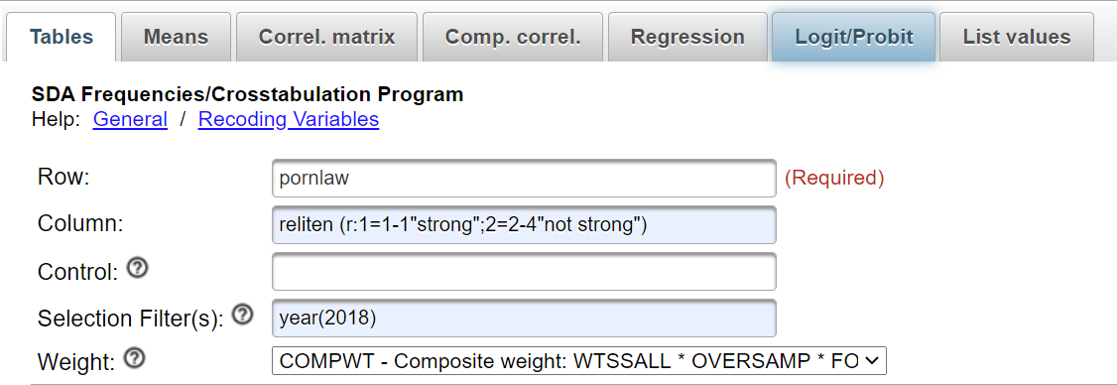
Figure 14-4
Now click on RUN THE TABLE and your crosstab will open in a new window. It should look like the following.
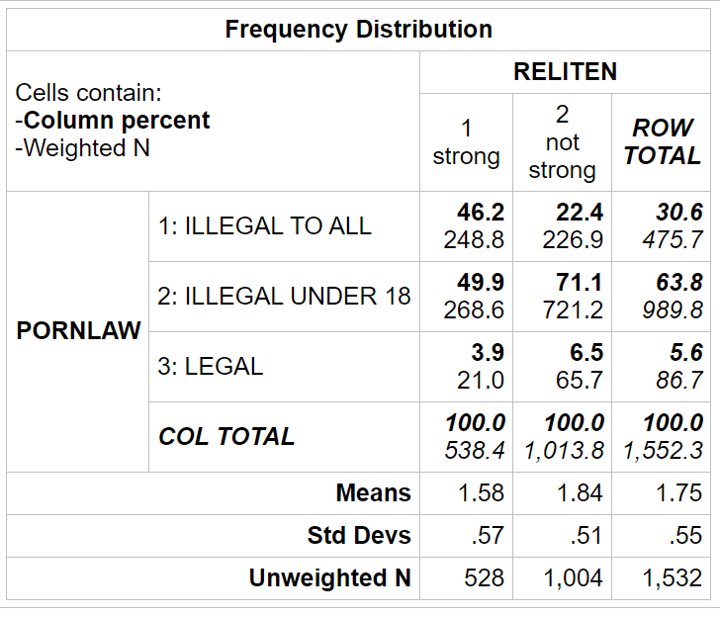
Figure 14-5
Now we need to interpret the output that SDA gives us. Notice that we put our independent variable (reliten) in the column of the table. By default, SDA will compute the column percents which sum down to 100 for each column. That's exactly what we want. If our independent variable is the column variable, then you will always want the column percents which sum down to 100. To interpret these percents, compare the percents straight across. Always compare in the direction opposite to the way the percents sum to 100.
Look at the first row of the table. Approximately 46% of those who are more religious think that pornography should be illegal for everyone regardless of age while only 22% of the less religious feel this way. Clearly those who are more religious want stricter control over the distribution of pornography. Approximately 71% of those who are less religious think pornography ought to be illegal only for those under the age of 18 compared to 50% of the more religious. Those who are less religious want weaker controls over pornography. Very few respondents think pornography ought to be legally available regardless of age. There's a clear relationship between religiosity and how people feel about controlling the distribution of pornography. The more religious want stricter controls while the less religious want looser controls.
Let's review the criteria for demonstrating cause and effect. In order to show that a variable leads to or influences or causes another variable, we need to meet three criteria. Meeting one or two of these criteria doesn't establish causality. We need to meet all three criteria.
- There is a statistical relationship between the two variables.
- One of the variables can be demonstrated to be the cause and the other to be the outcome or effect. This is often referred to as causal ordering.
- There are no other alternative explanations for this relationship. The causal explanation is the only explanation. In other words, this relationship is not due to any other variable or variables.
We have clearly met the first of these criteria. And it seems more reasonable to assume that how religious a person is could be a cause of how they feel about pornography than to assume that feelings about pornography would influence one's religiosity. Religiosity would be the more fixed of these two variables. That leaves the third criterion. How are we going to try to eliminate alternative explanations? That's what we will look at in Exercise 15.

Assignment

We're going to consider two alternative measures of religiosity in the GSS – attendance at worship services (attend) and how strong respondents consider themselves to be in their religion (reliten). Use SDA and the GSS to explore the relationship of attend with pornlaw.
To make the tables easier to interpret, recode attend. I'm going to give you the recode statement. All you need to do is to copy and paste it into the COLUMN box in SDA. Here is the recode statement.
attend (r:1=0-3"seldom or none";2=4-5"sometimes"; 3=6-8"often")

Next Exercise
Exercise 15 will focus on multivariate analysis.

Exercises for Critical Thinking
Edward Nelson, California State University, Fresno

Exercise 15
Multivariate (Three or More Variables) Data Analysis

Let's start by reviewing the criteria for demonstrating cause and effect. In order to show that a variable leads to or influences or causes another variable, we need to meet three criteria. Meeting one or two of these criteria doesn't establish causality. We need to meet all three criteria.
- There is a statistical relationship between the two variables.
- One of the variables can be demonstrated to be the cause and the other to be the outcome or effect. This is often referred to as causal ordering.
- There are no other alternative explanations for this relationship. The causal explanation is the only explanation. In other words, this relationship is not due to any other variable or variables.
In Exercise 14 we considered the relationship between two variables (i.e., bivariate analysis). In this exercise we’re going to add a third variable into the analysis (i.e., multivariate analysis) and consider the possibility that our two-variable relationship might be spurious due to this third variable. Spuriousness means that there is a statistical relationship between two variables, but it is not a causal relationship. The statistical relationship is due to the third variable which we typically call the control variable.
To illustrate the idea of spuriousness, think about children in elementary, middle, and high school. Every year children take standardized tests at the end of the school year to measure their achievement in areas such as mathematics, reading, and science. Do you know that children with small feet score lower on these tests than children with big feet? There is a relationship between children’s foot size and their test scores. There is a clear statistical relationship between these two variables. But is it a causal relationship? Of course not! No parent ever says I hope my kids have big feet so they will do better in school. What we’re saying is that we think this relationship is spurious. There is a statistical relationship but it’s not causal.
But why is this relationship spurious? There must be some third variable that is creating this relationship. One possibility is children’s grade level. Children in lower grades have smaller feet and lower test scores. Children in higher grades have bigger feet and higher test scores. So, the relationship between foot size and test scores might be due to grade level. In other words, it might be spurious due to grade in school.
How are we going to test this hypothesis? What we do is to hold this third variable constant. Let’s say that we have test scores for children in grades 6 through 12. We’ll start with the sixth graders and look at the relationship between foot size and test scores for only the sixth graders. Then we’ll repeat this for the seventh graders and for each successive grade level. If the relationship is spurious due to grade in school, then we ought to find that the relationship between foot size and test scores goes away or is considerably reduced for each grade level. If the relationship is not spurious, then we ought to find that the relationship does not change much for the different grade levels.
In Exercise 14 we explored the relationship between religiosity and how people felt about controlling the distribution of pornography. We showed that there was a relationship between these two variables that clearly met the first of the criteria for establishing cause and effect. We argued that it seems more reasonable to assume that how religious a person is could influence how they feel about pornography than to assume that feelings about pornography would influence one's religiosity. Religiosity would be the more fixed of the variables and, as such, could be the causal variable.
Could this relationship be due to some other variable such that when we controlled or held constant that variable (i.e., our control variable) the original relationship either disappeared or, as is more likely, weakened. For this to occur our control variable would need to be related to both religiosity and how respondents felt about controlling the distribution of pornography.
One possible control variable could be gender. Gender is related to both religiosity and control of pornography. We know from previous research that women are more religious than men. They go to worship services more often and they tell us they are more religious. And we have good reasons to suspect that women are more concerned about pornography than are men. Women are usually the objects of pornography; pornography demeans women.
We can use the 2018 GSS to check on these assumptions. Run a two-variable crosstab for pornlaw by sex and then then another two-variable crosstab for reliten by sex. What did you find? Did you find, as we expected, that women are more religious than men and that women prefer stronger controls over the distribution of pornography. Make sure that you entered year(2018) in the FILTER box and that you used the recode for reliten.
Now that we know that our assumptions are correct, let's rerun the crosstab of pornlaw by reliten but this time control for the variable sex. The Introduction to SDA found at the end of these exercises will tell you how to run a three-variable table. Here's what your SDA dialog box ought to look like.
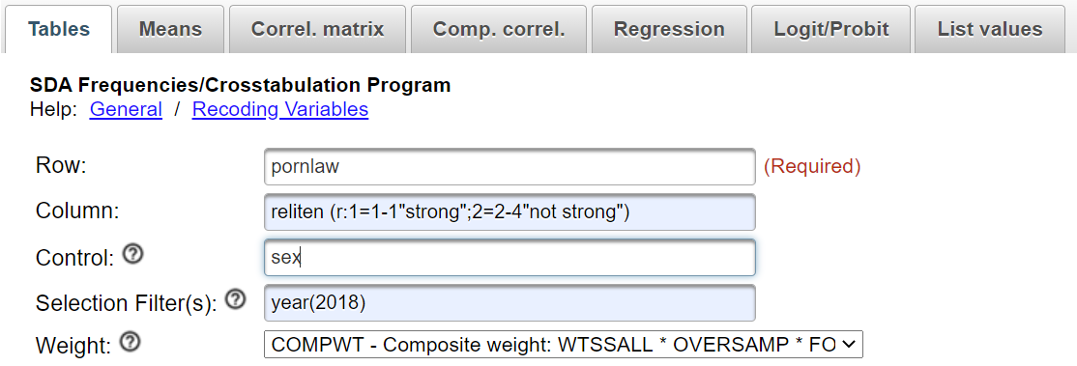
Figure 15-1
The only difference between what you did when you ran the crosstab of pornlaw by reliten in Exercise 14 is the addition of sex in the CONTROL box. When you click on RUN THE TABLE, you should see three tables. The first table will contain only the males; the second table will contain only the females, the third table, will contain all respondents regardless of gender. Here's what you output should look like.
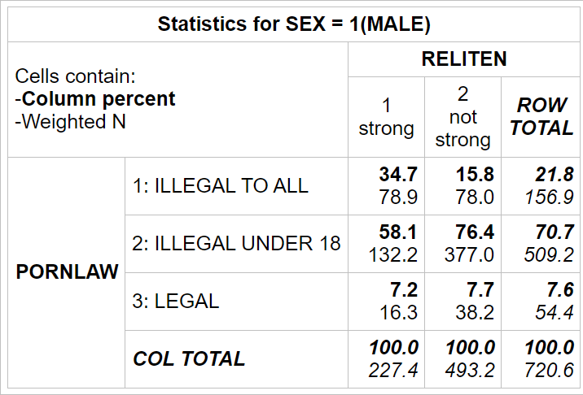
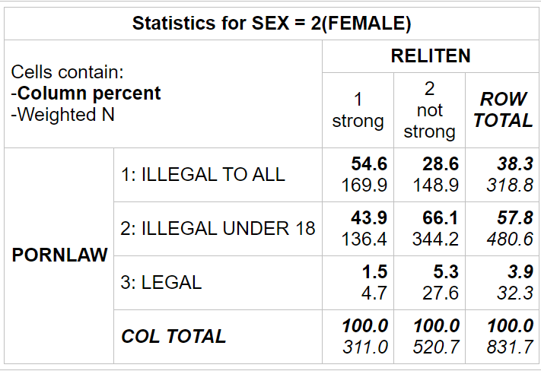
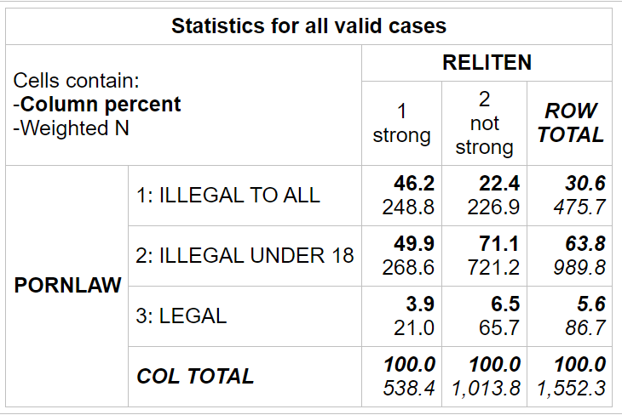
Figure 15-2
If you compare the tables for men and for women, you'll see that they are very similar. The difference between the more religious and the less religious is about 19 percentage points for men and 26 percentage points for women. The relationship is slightly stronger for women than for men but for both men and for women, the more religious prefer stronger controls and the less religious prefer weaker controls.
If the original relationship was spurious, then it either ought to go away or decrease substantially for both males and females. So look carefully at the two tables – one for males and the other for females. But how can we tell if the relationship goes away or decreases markedly for both males and females? Look at the percent differences. Compare the percent differences between those who are more religious (i.e., strong) and those who are less religious (i.e., not strong) for males and then for females with the percent differences in the original two-variable table. Did the percent differences stay about the same or did they decrease substantially?
If the relationship had been due to gender, then the relationship between strength of religion and opinion on pornography laws would have disappeared or decreased substantially for both males and females when we took out the effect of gender by holding it constant. In other words, the relationship would be spurious. Spurious means that there is a statistical relationship, but not a causal relationship.
In our case, the relationship between reliten and pornlaw was about the same for males and for females. So it's not spurious due to gender. It important to note that just because a relationship is not spurious due to gender doesn’t mean that it is not spurious at all. It could be spurious due to some other variable such as age.

Assignment
Recall that we have two different measures of religiosity – reliten and attend. The nice thing about having multiple measures is that you can repeat your analysis using an alternative measure. If you discover the same relationships, you can have more confidence in your findings. So, repeat the analysis we just did using attend as your measure of religiosity. Interpret your findings and decide if you found basically the same relationship. Be sure to use the following recode statement for attend.
attend (r:1=0-3"seldom or none";2=4-5"sometimes"; 3=6-8"often")
- Now that we have explored the relationship between religiosity and how people feel about pornography using two different measures of religiosity, what can we conclude about the causal relationship between religiosity and pornography?
- Can we ever conclusively prove causality? Why or why not?

Next Exercise
Exercise 16 will focus on errors in critical thinking.

Exercises for Critical Thinking
Edward Nelson, California State University, Fresno

Exercise 16
Errors in Critical Thinking

There are many common errors that are relevant for critical thinking. An excellent discussion of many of these errors is Ronald Munson and Andrew Black's, The Elements of Reasoning. This exercise will only discuss six of these errors. You can Google the name of the error and find many more examples.

Appeal to Inappropriate Authority
We often cite experts to support our arguments. We may lack the expertise to evaluate these arguments so it is appropriate to rely on experts. But the question we always have to ask is whether they are truly experts in the area covered in our argument.
For example, famous athletes often appear in advertisements telling us to purchase certain types of products such as automobiles and insurance. They certainly are experts in their athletic sport but they aren't necessarily experts in other areas.
Prosecutors and defense attorneys often rely on expert witnesses in criminal trials. The court has to accept their expertise before they are allowed to testify. A person who is an expert in DNA probably isn't also an expert in facial recognition software.
So we always have to ask if the person is an appropriate or an inappropriate authority.

Gambler's Fallacy
This error occurs when we assume that because something hasn't happened in a long time, it's likely to occur soon. How many times have you been watching a baseball game and heard an announcer say, "This batter has zero hits in his last 21 times at bat. He's due for a hit." In fact, the batter is clearly in a slump and is probably not likely to get a hit in his next at bat.
Or consider someone playing Blackjack at a casino who has a run of really bad luck. The person might reason that after a series of 10 really bad hands, he or she is due to get a good hand so the person doubles the bet. And they lose. That's why it's called the gambler's fallacy. It's why gamblers go broke.

Slippery Slope
Another error is called slippery slope. Have you ever run down a steep hill and noticed that you pick up speed the farther you run and it's hard to stop or even slow down? That's where the name comes from.
An example of this type of error sometimes occurs when we're asked to make an exception to a rule. A teenager might ask for their parents' permission to extend their curfew by 30 minutes for a school event in the evening. The parents refuse and say that if we make an exception this time, we'll have to make an exception the next time. That's the slippery slope.
Or some might argue that abortion should always be illegal. Once we allow abortions in the case of rape, then we will have to allow abortions in other cases as well. That's also the slippery slope.

Straw Man
The straw man error uses an oversimplified or distorted version of someone’s argument in order to defeat it. For example, a person might say that liberals believe in big government – the bigger the better. Another example is the politician who says, "Congressman Smith favors a law that would allow students to have voluntary prayer in public schools every morning. This would result in religion being taught in our public schools and would destroy freedom of religion."
In each of these examples, the person has misrepresented a complex argument by reducing it to a straw man argument in order make is easier to reject that argument.

Denying the Antecedent
We test theories by deriving hypotheses from a theory that should be true if the theory is true. In Exercise 9 we used Durkheim's theory of suicide as an example of denying the antecedent. We considered the following argument.
If Durkheim’s theory of suicide is correct, then Protestants will have higher
suicide rates than Catholics and Jews.
Durkheim’s theory of suicide is not correct.
Therefore, Protestants will not have higher suicide rates than Catholics and Jews.

The hypothesis is that Protestants will have higher suicide rates than Catholics and Jews. If it turns out that Durkheim's theory is not correct, this does not imply that Protestants will not have higher suicide rates. The hypothesis could be true for other reasons than Durkheim's theory of suicide. The premise says that If Durkheim’s theory of suicide is correct, then Protestants will have higher suicide rates than Catholics and Jews. It doesn't say what will be the case if his theory is incorrect.

Affirming the Consequent

We also discussed the fallacy of affirming the consequent in Exercise 9. Consider this deductive argument.
If Durkheim’s theory of suicide is correct, then Protestants will have higher
suicide rates than Catholics and Jews.
Protestants do have higher suicide rates than Catholics and Jews.
Therefore, Durkheim's theory of suicide is correct.

You would think that if we tested the hypothesis and it turned out to be true, then we would be able to conclude that our theory was true. But we can't. There might be other theories that would predict the same hypothesis. So if we concluded that Durkheim's theory was correct, we would be committing the fallacy of affirming the consequent. What we can conclude is that our theory is more believable because it withstood one attempt to prove it false. In other words, you can show that a theory is false but you can't ever prove it to be true.

These certainly aren't the only types of errors we can make but they are some of the more important ones. You can Google "logical fallacies" and fine many more or you can look at Munson and Black's excellent text, The Elements of Reasoning.

Assignment
- Choose two of these errors or fallacies and write your own examples.
- Google "logical fallacies" and find another error or fallacy. Write you own example of this error.

Appendices

There are two appendices at the end of this series of exercises.
- The first is a short introduction to Survey Documentation and Analysis (SDA), the statistical program we use in Exercises 14 and 15.
- The second is a discussion of how to write research papers.

Exercises for Critical Thinking
Edward Nelson, California State University, Fresno

Appendix A
Introduction to Survey Documentation and Analysis (SDA)

Selecting the Data Set to be Analyzed
We’re going to use the General Social Survey (GSS) for Exercises 14 and 15. The GSS is a national probability sample of adults in the United States conducted by the National Opinion Research Center (NORC). The GSS started in 1972 and has been an annual or biannual survey ever since. For this exercise we’re going to use the 2018 GSS. To access the GSS cumulative data file in SDA format click here. SDA stands for Survey Documentation and Analysis. This introduction will tell you most of what you need to know to run SDA. The GSS cumulative data file contains all the data from each GSS survey conducted from 1972 through 2018. We want to use only the data that was collected in the most recent survey in 2018. To select out the 2018 data, enter year(2018) in the SELECTION FILTER(S) box. Your screen should look like Figure 1.
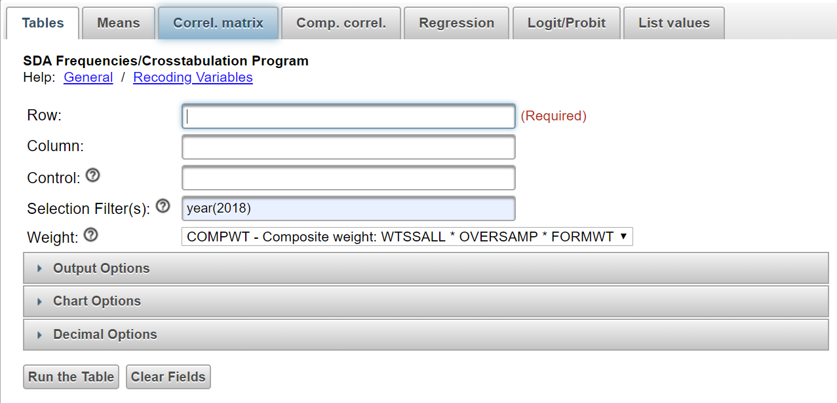
Figure 1
Notice that a weight variable has automatically been entered in the WEIGHT box. This will weight the data so the sample better represents the population from which the sample was selected.
The GSS is an example of a social survey. The investigators selected a sample from the population of all adults in the United States. This particular survey was conducted in 2018 and is a relatively large sample of adults. In a survey we ask respondents questions and use their answers as data for our analysis. The answers to these questions are used as measures of various concepts. In the language of survey research these measures are typically referred to as variables.

Getting a Frequency Distribution
One of the variables in the GSS is the respondent's educational level. Each variable has a name which is degree for this variable. (Variable names will in lower case and will be italicized.) To get a frequency distribution for degree, enter the variable name in the ROW box. Your screen should look like Figure 2.
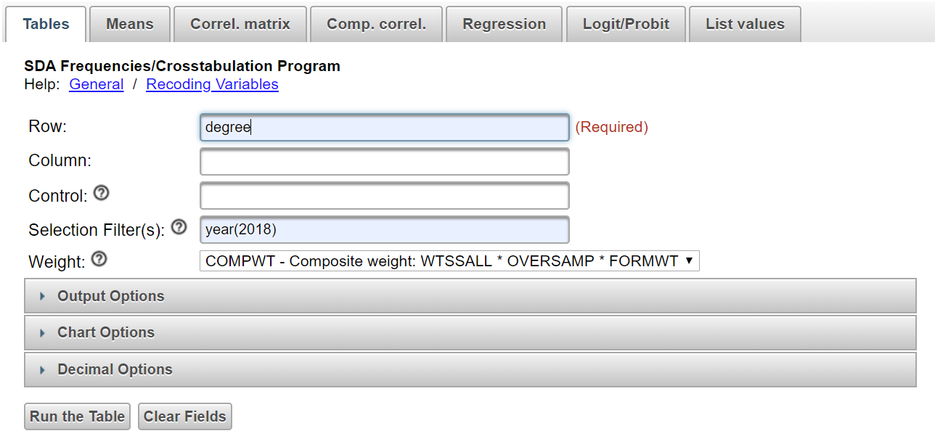
Figure 2
Notice that we have entered year(2018) in the SELECTION FILTER box. SDA will automatically enter the weight variable in the WEIGHT BOX. Click on RUN THE TABLE and your screen should look like Figure 3.
T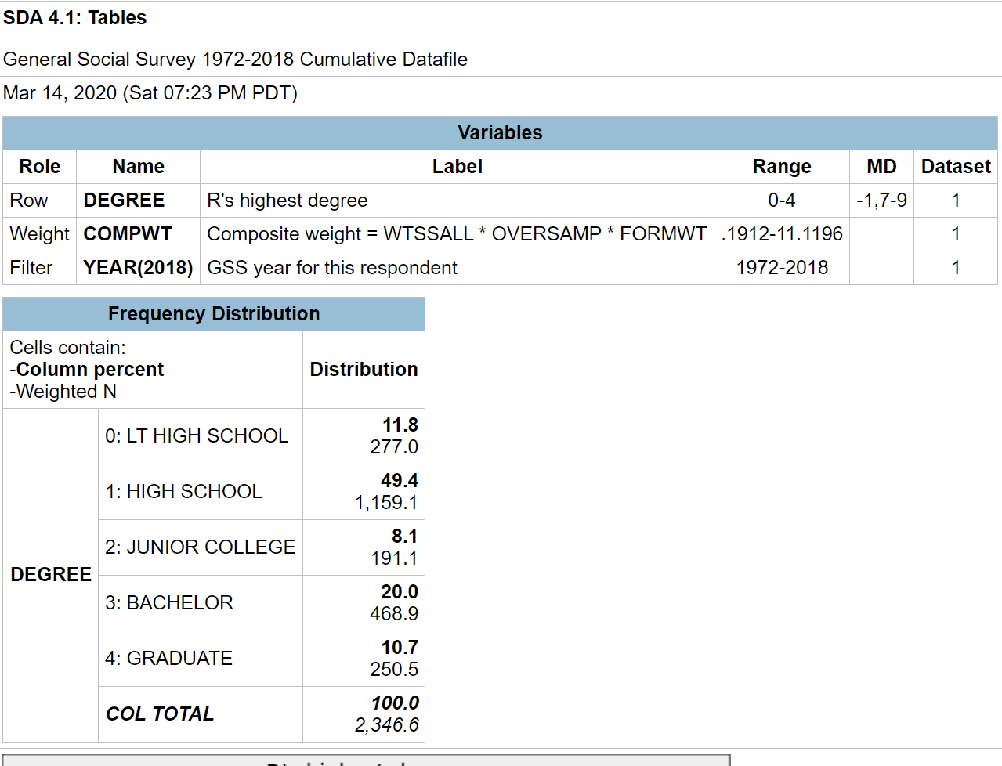
Figure 3

Getting a Crosstab
Now let's get the crosstabulation of degree and grass. Grass is the respondent's answer to the following question: "Do you think the use of marijuana should be made legal or not?"
We'll talk about crosstabulation in these exercises. The purpose of this introduction to SDA is to show you how to use SDA. Look back at Figure 1. Your dependent variable goes in the ROW box and your independent variable in the COLUMN box. You'll want the column percents which is the default in SDA so you don't have to do anything else to get them. Your screen should look like Figure 4.
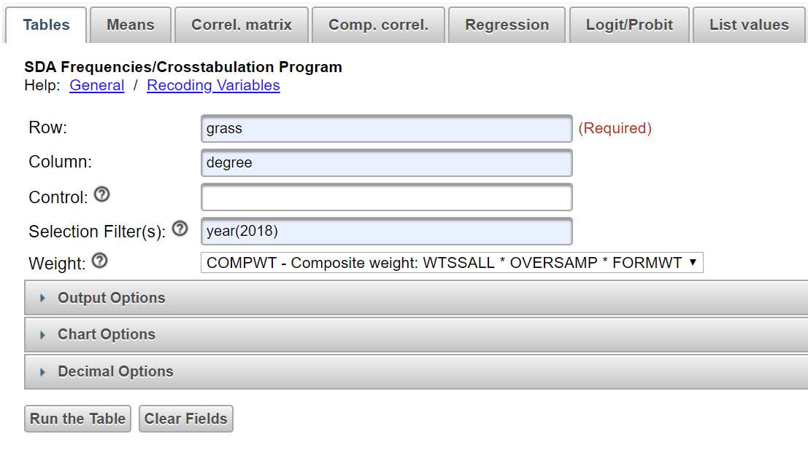
Figure 4
Click on RUN THE TABLE and your screen should look like Figure 5.
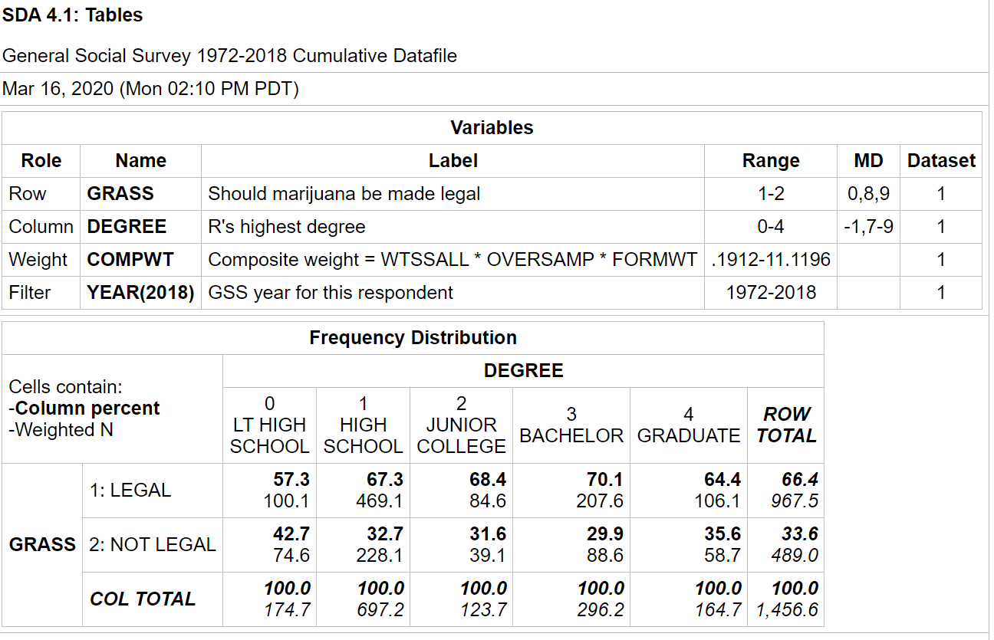
Figure 5
There are a couple options that you will want to change.
- SDA uses something called "color coding" which we won't be using in these exercises. You can turn it off if you wish by clicking on OUTPUT OPTIONS and then unchecking the box for COLOR CODING.
- Under CHART OPTIONS, change the TYPE OF CHART to NO CHART.

Recoding
Often we want to combine categories of a variable. Run a frequency distribution for the variable partyid. Your output ought to look like this.
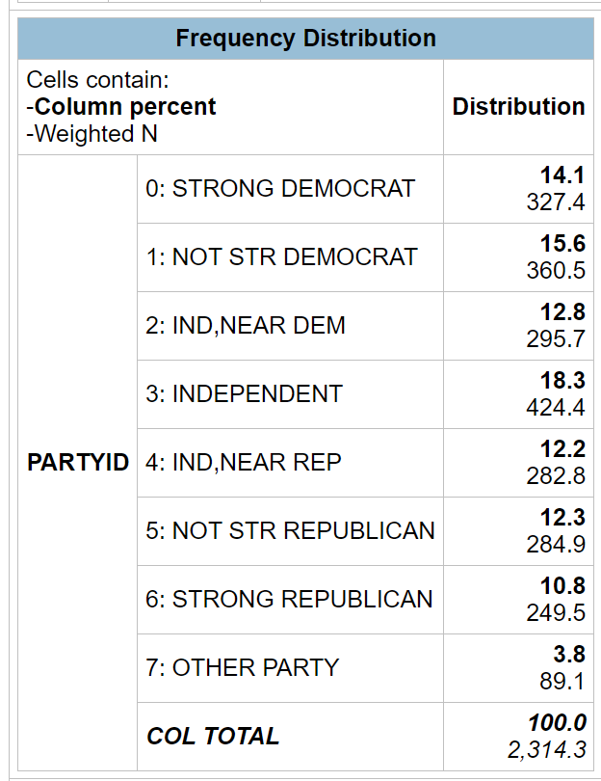
Figure 6
Let's say we want to combine categories 0 through 2 into one category and assign it a value of 1 and give it the label "Democrat." Then we'll combine categories 4 through 6 into another category and give it a value of 3 and the label "Republican." We'll change category 3 to the value of 2 and give it the label "Independent." Additionally, we want to omit category 7 from our analysis. Here's the way you will accomplish this.
- First you enter r: after the variable name. The r stands for recode.
- Then you indicate the new value you want to assign to the first category which is 1.
- Then you put the values that you are combining which are 0-2 for the first category. These values must be separated by a dash (i.e., hyphen). The hyphen must always be used even if there is only one value for that category.
- This is followed by the label you want to assign to this category enclosed in double quotation marks which is “Democrat” for the first category. This is free form meaning you can put what you want for the label.
- This is separated from another recode category by a semi-colon.
- Finally, the entire recode specification is in parentheses.
- To omit the value 7, just leave it out of the recode statement.
- So your recode statement will be the following:
partyid (r:1=0-2"Democrat";2=3-3"independent";3=4-6"Republican")
It can be tricky to write these recode statements properly, so in these exercises I'll give you the recode statement and all you have to is copy and paste it into the appropriate box in SDA.

Exercises for Critical Thinking
Edward Nelson, California State University, Fresno

Appendix B
Writing Research Reports

This chapter will focus on how to write research reports including:
- how to organize your report,
- creating tables,
- whether to use footnotes or endnotes,
- citing articles, papers, and other materials,
- plagiarism,
- proofreading, and
- other guides to writing reports.

An Outline of your Research Report
In Exercises 14 and 15 we discussed how to use SDA to analyze your data. We talked about using SDA to analyze the relationship between pairs of variables and extending our analysis to include sets of three or more variables. Now we need to think about how to write a research report so that others may read it and learn from our analysis. This report might be for a class you are taking, or it might be a paper that you are submitting to a research conference. If you are going to submit your paper to a journal for possible publication, you need to look carefully at the instructions that all journals provide on preparing a manuscript for publication.
Here's an outline for your report. Don't think that this is the only way you can organize your report, but this is one way to do it.
- Title page including your name, date, and class or institutional affiliation.
- Abstract – An abstract is a short summary of what you did in the paper and the major findings of your analysis. Abstracts are really short, so you need to be succinct. It should be less than 200 words or even shorter depending on the requirements of your professor or the research conference to which you are submitting your paper.
- Table of contents (optional).
- Body of the paper.
  - An introduction to the paper which explains why you wrote the report and provides an introduction to the topic of the paper.
  - Your review of the literature that summarizes what others discovered about this topic. Virtually everything you might do has been written about by others. You should review the relevant literature and summarize what others have found. You don't want to simply list the relevant literature and consider the articles and books one by one. Rather you want to summarize what others have done and look for themes around which you can organize your literature review. If you are having trouble finding relevant literature, go to the library at your university or a nearby university and talk with a reference librarian. They are trained in searching for relevant literature and will be able to help you.
  - The methodology of your study.
    - If you collected your own data, discuss how you chose your sample, how you measured the concepts, and how you collected your data.
    - If you used an existing data set, discuss the sampling, measurement, and data collection used in that study. Studies that are part of data archives such as the Inter-university for Political and Social Research at the University of Michigan and the Roper Center for Public Opinion Research at Cornell University provide good summaries for all data sets that are housed at their archive.
  - Theory and Hypotheses – If you are using a theoretical perspective and/or testing hypotheses, describe the theory and state the hypotheses you plan to test. Be sure to cite supporting literature that form the basis for your theory and hypotheses.
  - Empirical findings and interpretation – What are the empirical findings that came out of your data analysis and what did they tell you? If you are testing hypotheses, did your analysis support your hypotheses? Remember that you are telling a story. Start simple and build up. That means starting by looking at variables one at a time (i.e., univariate analysis), then proceeding to relationships between pairs of variables (i.e., bivariate analysis), and then looking at sets of three or more variables (i.e., multivariate analysis) to consider such things as spuriousness.
  - Conclusions and summary. This is a little like your abstract but not as short. What did you do, what did you find in your study and what does it mean?
- Tables. You may choose to put your tables in the body of your paper, or you may decide to put them all at the end of your paper.
- References. For every article or book that you cite, you need to provide a full bibliographic reference at the end of the report.

Tables
There are advantages and disadvantages to putting your tables in the body of the report or at the end of the report. Putting them in the body of the report keeps them front and center for the reader but they often are bulky and get in the way of reading the report. Putting them at the end of the report gets them out of the way and allows the reader to spread them out and look at them as he or she is reading the paper. Your instructor or the research conference will usually tell you where to put your tables.
If they are placed at the end of the paper, put a note in the body of the report that says something like "Table 1 about here." That will let the reader know where the table fits into your report.
Constructing a good table is important. Sometimes your instructor will tell you to copy tables from the program you are using for statistical analysis (e.g., SDA, SPSS, PSPP, and others) into your paper. Other times you will construct the tables yourself. A good reference on creating tables is The Chicago Guide to Writing About Numbers by Jane E. Miller. Your word processing program (e.g., Word in Microsoft Office) will provide you with templates that you can choose for your tables.

Footnotes or Endnotes
Often you want the reader to be aware of something, but you don't want to put it in the body of the paper. It may be a technical issue such as how you recoded a variable or why you chose a particular statistic. Or you may want to tell the reader that you will discuss something later in the paper. You can put comments like these in either a footnote or an endnote. A footnote goes at the bottom of the page and an endnote goes at the end of the paper. Your word processing program will allow you to enter either footnotes or endnotes in your paper. Which you use is up to you unless your instructor or the research conference tells you that one or the other is required.

Citing Articles, Papers, and Other Materials
There are many styles such as American Psychological Association (APA) or Modern Language Association (MLA) that you could use to cite materials that you refer to in your paper. Remember that anytime you refer to someone else's work, you must acknowledge the source. Your instructor or research conference will often specify which style you should use.

Plagiarism
Plagiarism is using someone else's words or ideas without acknowledging the source. If you are quoting from a document, you must cite the source. Even if you are paraphrasing, you must acknowledge the source. If you are using someone else's ideas, you must also acknowledge the source. There is a good review of plagiarism written by Earl Babbie that can be found on the Internet by clicking here. Click on the red arrows at the top to go forward or backward in this review of plagiarism.
Proofreading
Be sure to proofread your paper several times before submitting it. Use the spell and grammar checker in your word processing program. You could also ask a friend to read it and tell you about any errors or parts that are confusing.

Other Guides to Writing Reports
There are many other guides to writing research reports. One that is commonly used in Sociology is the Guide to Writing Sociology Papers. You can find others on the internet by entering "writing research reports" in the search box.

Thomas J. Sullivan, Applied Sociology – Research and Critical Thinking, Macmillan, 1992, p. 10.
The quotes in this section are from Sullivan's, Applied Sociology, pp.12-16.
Lawrence W. Sherman and Richard A. Berk, The Minneapolis Domestic Violence Experiment," 1984. https://www.policefoundation.org/publication/the-minneapolis-domestic-violence-experiment/.
Barclay D. Johnson, "Durkheim's One Cause of Suicide" American Sociological Review, vol. 30, no. 6, 1965, pp. 875-886. Another useful summary of Durkheim's theory of suicide is found on sociology.com's website – Theory of Suicide by Emile Durkheim (March 23, 2015).
Daniel F. Chambliss and Russell K. Schutt, Making Sense of the Social World, Sage, 2016, p. 28.
Kai T. Erickson, Everything in its Path: Destruction of Community in the Buffalo Creek Flood, Simon & Schuster, 1976.
Barclay D. Johnson, "Durkheim's One Cause of Suicide" American Sociological Review, vol. 30, no. 6, 1965, pp. 875-886. Another useful summary of Durkheim's theory of suicide is found on sociology.com's website – Theory of Suicide by Emile Durkheim (March 23, 2015).
Daniel F. Chambliss and Russell K. Schutt, Making Sense of the Social World, Sage, 2016, p. 28.
We need not limit ourselves to studying individuals. We could also study objects like businesses or nations. So it might be better to define a population as the complete set of objects that we want to study. But in these exercises our focus is on individuals so we’ll define a population as the complete set of individuals we want to study.
We’re not going to discuss disproportional stratified random samples in this exercise. That would be a sample that is selected such that some segments are oversampled and other segments are undersampled. For example, we might undersample whites and oversample non-whites so that our sample is 50% whites and 50% non-whites. This would be useful if we wanted to compare whites and non-whites and wanted to have a larger sample of non-whites for comparison purposes.
A population parameter is a characteristic of a population while a statistic is a characteristic of a sample. In this example, we can calculate the population percent since we know the values for each person in the population. However, in real life situations, we usually don't know the population percents.
You can determine from the exercise data base that 60% of females favor same-sex marriage compared to only 40% of males.
See Ronald Munson and Andrew Black, The Elements of Reason (Cengage Learning, 2012, pp. 4-5). I use this text in my classes and my discussion of arguments is heavily influenced by Munson and Black. It's an excellent introduction to arguments and I encourage you to read it. It's a short book and very readable.
Ronald Munson and Andrew Black, The Elements of Reason (Cengage Learning, 2012, p. 28). They cover deductive arguments in Chapter 3 of their text.
Ronald Munson and Andrew Black, The Elements of Reason (Cengage Learning, 2012, pp. 31-33).
Ronald Munson and Andrew Black, The Elements of Reason (Cengage Learning, 2012, p. 35).
Munson and Black refer to this type of argument as an inductive generalization. We will follow their convention of saying that nondeductive arguments are either successful or unsuccessful.
This discussion of evaluating arguments relies heavily on chapters 3 and 4 in Ronald Munson and Andrew Black, The Elements of Reason (Cengage Learning, 2012).
Munson and Black cover deductive arguments in Chapter 3 of their text.
Munson and Black discuss thought experiments in pp. 31-33 of their text.
Munson and Black discuss argument forms in chapter 4 of their text (pp. 49-75).
Barclay D. Johnson, "Durkheim's One Cause of Suicide" American Sociological Review, vol. 30, no. 6, 1965, pp. 875-886. Another useful summary of Durkheim's theory of suicide is found on sociology.com's website – Theory of Suicide by Emile Durkheim (March 23, 2015).
Of course, we aren't going to reject our theory because of any one test. We never rely on one test of anything. We always want to have multiple tests before we reach any conclusions. Science depends on replication.
Munson and Black discuss these different types of nondeductive arguments in pp. 36-39 of their text.
See Exercise 6 for a discussion of sampling.
Ronald Munson and Andrew Black, The Elements of Reason, Cengage Learning, 2012, pp. 96-98.
McLeod, S. A. (2018, Dec 28). Solomon Asch - Conformity Experiment. Click here to see the research report. Retrieved on September 12, 2020.
For more information, click on this link to view a description of these trials prepared by the National Institutes of Health.
Kai T. Erickson, Everything in its Path: Destruction of Community in the Buffalo Creek Flood, Simon & Schuster, 1976.
Thomas J. Sullivan, Applied Sociology – Research and Critical Thinking, Macmillan, 1992, p. 10.
Stanley Smith Stevens, 1946, “On the Theory of Scales of Measurement,” Science 103 (1946), pp. 677-680.
If you don't remember how to run a crosstab in SDA, review Exercise 14 or look at the Introduction to SDA in the appendix to these exercises.
This exercise is based on Ronald Munson's and Andrew Black's book The Elements of Reasoning, Cengage Learning, 2012, pp. 124-145.
Degree is the respondent's highest educational degree.
Jane E. Miller. The Chicago Guide to Writing About Numbers. 2015 (2nd edition). Chicago: University of Chicago Press.
Sociology Writing Group. A Guide to Writing Sociology Papers. 2013 (7th edition). New York: Worth Publishers.

