Sociology 3 Critical Thinking

Using a Control Variable and Spuriousness

Let’s look at the relationship between the strength of a person’s religious affiliation and how a person feels about the distribution of pornography. One of the variables in the General Social Survey is pornlaw. This question asks respondents what type of laws they think we ought to have regulating the distribution of pornography. Should pornography be illegal to everyone or should it be illegal only to those under the age of 18 or should it be legal to everyone? We can draw a parallel to laws governing the distribution of drugs such as cocaine (illegal to everyone) and laws governing the distribution of alcohol and tobacco (illegal only to those under a certain age).

We’ll start by developing a hypothesis. The stronger a person’s religious affiliation, the more likely they are to feel that pornography ought to be illegal for everyone regardless of their age. However, the weaker the person’s religious affiliation, the more likely they are to feel that pornography ought to be illegal only for those under the age of 18. Imagine that you told your hypothesis to a friend and your friend asks “Why?” You need to develop an argument to explain why you think your hypothesis is true. What is the link between a person’s religious feelings and their opinion about pornography? Why should more religious individuals be more likely to think that pornography should be illegal for everyone? You might argue that the moral codes of more religious individuals tend to be absolute while the moral codes of those who are less religious tend to be situational.

Once you have developed your argument, then you need to construct a dummy table showing what the relationship between reliten and pornlaw should look like if your hypothesis is true. Use Tables in Word to construct a table like the following table.

 | Religiosity
PORNLAW | Strong | Somewhat strong | Not very strong | No religion
Illegal to all | a> | b> | c> | d
Illegal under 18 | e< | f< | g< | h
Legal | i | j | k | l

Notice that the dummy table shows that as the strength of a person’s attachment to their religion decreases (i.e., goes from left to right), the percent who feel that pornography ought to be illegal to everyone gets smaller. But as a person’s attachment to their religion decreases, the percent who feel that pornography ought to be illegal only to those under the age of 18 gets larger. Also notice that the hypothesis says nothing about people feeling that pornography ought to be legal for everyone so that row is left blank. In fact, very few people feel that pornography ought to be legal for all.

Now that you have constructed your dummy table, it’s time to find out what the relationship actually looks like. To do this you will need to run Crosstabs in SDA. Your independent variable should always be the Column variable and your dependent variable should always be the Row variable. You also need to be sure to ask for the appropriate percents and Chi Square. Since the independent variable is the column variable, you want the column percents which is the default in SDA. Here’s the table that you should get to test this hypothesis.

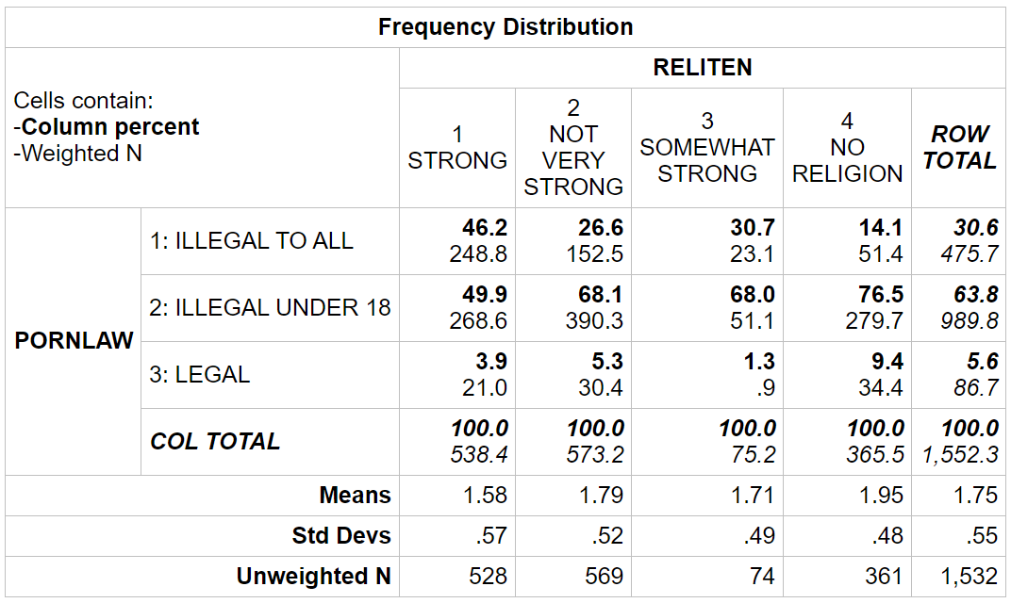

All that is left is to interpret the table. Since the independent variable is the column variable, we had SDA compute the column percents. It’s important to compare the percents straight across. It’s clear that the more religious people are, the more likely they are to think that pornography ought to illegal to all. But the less religious they are, the more likely they are to think that pornography ought to be illegal only to those under 18. For example, 46.2% of those who are strongly religious think pornography ought to be illegal to all, while only 14.1% of those who have no religion think that it should be illegal to everyone. And 76.5% of those who have no religion think pornography ought to be illegal only to those under 18, while 49.9% of the strongly religious feel this way.

Does this support your hypothesis? Compare the dummy table with the table you got from SDA. The pattern is exactly what you expected to find if the hypothesis was true. So the data support the hypothesis. Remember not to make too much out of small differences. The reason we don’t want to make too much out of small differences is because of sampling error. No sample is a perfect representation of the population from which the sample was selected. There is always some error present. Small differences could just be sampling error. So we don’t want to make too much out of small differences.

We can also use the Chi Square test to determine whether the relationship could be due to sampling error. In the Chi Square test, the null hypothesis that we are testing is that there is no relationship between reliten and pornlaw. In other words, any differences that we see in the table are just due to sampling error. To test the null hypothesis, we click on the Summary Statistics box in Output Options. This produces the table below. You want to look at the Chisq-P statistic. Look at the significance value which in this table is p=0.00. This actually means less than .005 since it is a rounded value. If this value is less than .05, then we reject the null hypothesis and say Chi Square is significant. If it is .05 or larger, then we don’t reject the null hypothesis and say that Chi Square is not significant. In this case, the probability that we would be wrong if we rejected the null hypothesis is less than .005. The Chi Square test tells us there probably is a relationship between reliten and pornlaw in the population.

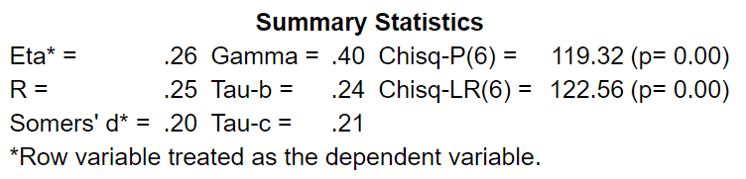

At this point we have only considered two variables. We need to consider other variables. For example, sex is related to both these variables. Women are more likely to feel that they are strong in their religion and women are also more likely to feel that pornography ought to be illegal for all regardless of age. (We’ll run the tables in class to confirm this.) This raises the possibility that the relationship between self-reported strength of religion and how one feels about pornography laws might be due to gender. How are we going to check on the possibility that the relationship between strength of religion and pornography laws is due to the effect of sex on the relationship? What we can do is to separate males and females into two partial tables and look at the relationship between strength of religion and pornography laws separately for men and for women. We can do that in SDA by putting reliten in the Column box (our independent variable), putting pornlaw in the Row box (our dependent variable), and putting sex in the Control box in SDA. In this case, sex is the variable we are holding constant and is often called the control variable. Here’s what you would get.

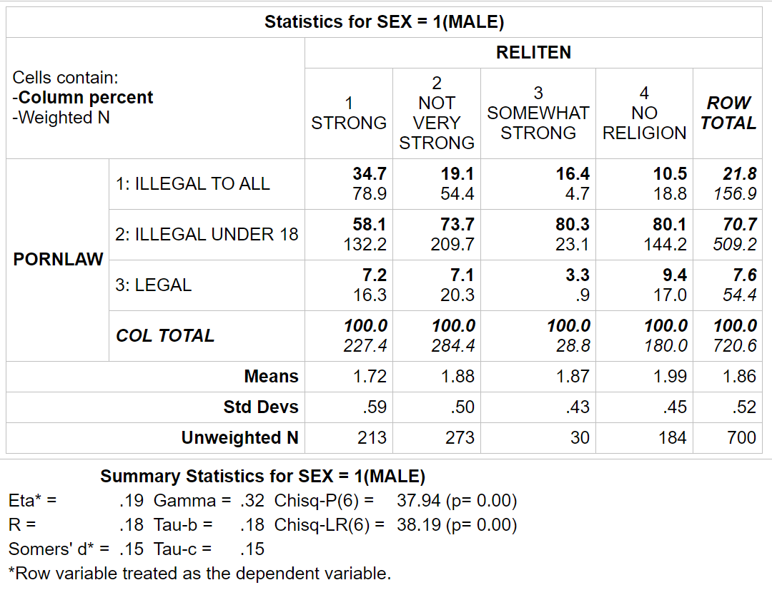

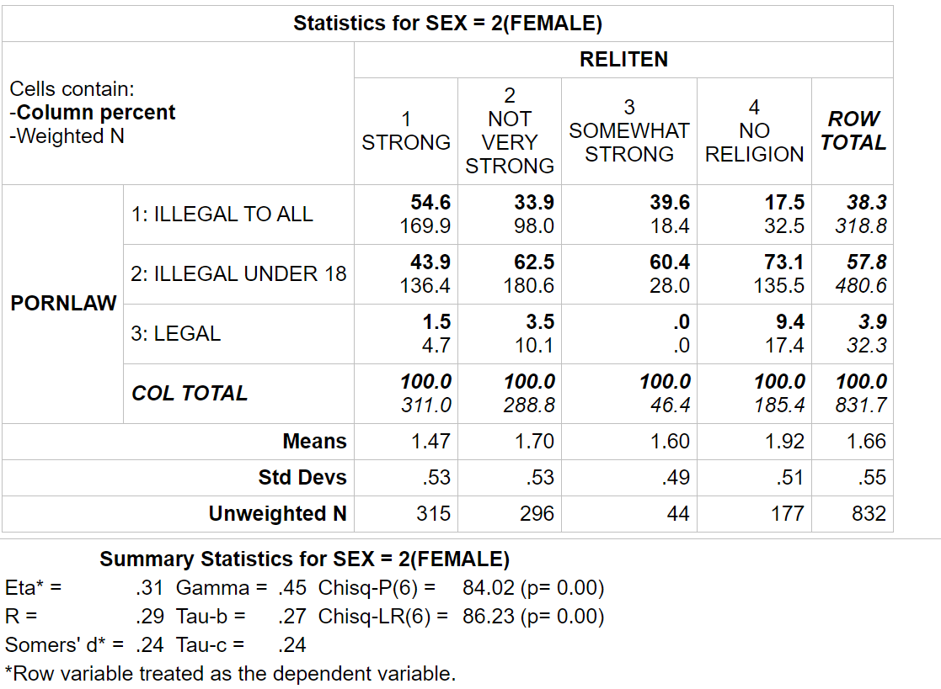

Let’s see what happens to the relationship between strength of religion and opinion on pornography laws when we hold sex constant. We’ll start by looking at only the males (i.e., the top half of the table). The numbers are different from our two-variable table, but the pattern is the same. Men who feel that they are strong in their religion are more likely than men who feel they are less strong in their religion to think that pornography ought to be illegal to everyone regardless of age. The Chi Square value is significant, so you can reject the null hypothesis and conclude that there probably is a relationship between these two variables in the population.

Now we’ll do the same thing for the females (i.e., the next table). Again, the numbers are different from the two-variable table, but the pattern is the same. Women who feel that they are strong in their religion are more likely than women who feel less strong in their religion to think that pornography ought to be illegal to everyone regardless of age. Again, the Chi Square value is significant, so you can reject the null hypothesis and conclude that there probably is a relationship between these two variables in the population.

What does this mean? If the relationship had been due to sex, then the relationship between strength of religion and opinion on pornography laws would have disappeared or decreased when we took out the effect of sex by holding it constant. However, the relationship did not disappear. Therefore, the relationship between strength of religion and opinion about pornography laws is not due to sex. It is not spurious when we hold sex constant. Spurious means that there is a statistical relationship, but not a causal relationship. We know that the relationship is not spurious due to sex, but it might be spurious due to some other variable.

There’s a third table that is labelled "statistics for all valid cases." That’s the two variable table that includes all respondents (i.e., all males and all females.)

