CONSPEND3CS – Exercise Using SPSS to Explore the Relationship Between Confidence in Institutions and Spending Priorities
Author: Ed Nelson
Department of Sociology M/S SS97
California State University, Fresno
Fresno, CA 93740
Email: ednelson@csufresno.edu
Note to the Instructor: The data set used in this exercise is gss14_subset_for_classes_CONFIDENCE_SPENDING.sav which is a subset of the 2014 General Social Survey. Some of the variables in the GSS have been recoded to make them easier to use and some new variables have been created. The data have been weighted according to the instructions from the National Opinion Research Center. This exercise uses CROSSTABS in SPSS to explore the relationship between confidence in the executive branch and whether respondents think we are spending too little, about right, or too much on various spending priorities such as the military, the problems of big cities, the environment, welfare, and assistance to blacks. A good reference on using SPSS is SPSS for Windows Version 23.0 A Basic Tutorial by Linda Fiddler, John Korey, Edward Nelson (Editor), and Elizabeth Nelson. The online version of the book is on the Social Science Research and Instructional Center's Website. You have permission to use this exercise and to revise it to fit your needs. Please send a copy of any revision to the author. Included with this exercise (as separate files) are more detailed notes to the instructors, the SPSS syntax necessary to carry out the exercise (SPSS syntax file), and the SPSS output for the exercise (SPSS output file). Pleas contact the author for additional information.
I'm attaching the following files.
- Data subset (.sav format).
- Extended notes for instructors (MS Word;.docx format).
- SPSS syntax file (.sps format).
- SPSS output file (.spv format).
- This page (MS Word;.docx format).

Goals of Exercise
The goal of this exercise is to determine whether confidence in the executive branch is related to whether respondents think we are spending too little, about right, or too much on various spending priorities such as the military, the problems of big cities, the environment, welfare, and assistance to blacks. The exercise also gives you practice in using FREQUENCIES and CROSSTABS in SPSS.

Part I—Choosing our Dependent Variable
We’re going to use the General Social Survey (GSS) for this exercise. The GSS is a national probability sample of adults in the United States conducted by the National Opinion Research Center (NORC). The GSS started in 1972 and has been an annual or biannual survey ever since. For this exercise we’re going to use a subset of the 2014 GSS. Your instructor will tell you how to access this data set which is called gss14_subset_for_classes_CONFIDENCE_SPENDING.sav.
There are a number of different areas or problems on which the government spends money. Some people think we should be spending more on some of these problems or areas while others think we should be spending less or about the same. The GSS uses the following question to measure spending priorities – “First I would like to talk with you about some things people think about today. We are faced with many problems in this country, none of which can be solved easily or inexpensively. I'm going to name some of these problems, and for each one I'd like you to tell me whether you think we're spending too much money on it, too little money, or about the right amount.” For this exercise were going to focus on whether respondents think we are spending too much, about right, or too little on various issues such as the following.
- the military
  - the military, assistance, and defense (NAT3_NATARMS)
  - national defense (NAT4_NATARMSY)
- big cities
  - solving the problems of big cities (NAT6_NATCITY)
  - assistance to big cities (NAT7_NATCITYY)
- the environment
  - improving and protecting the environment (NAT15_NATENVIR)
  - the environment (NAT16_NATENVIY)
- welfare
  - welfare (NAT17_NATFARE)
  - assistance to the poor (NAT18_NATFAREY)​
- assistance to blacks
  - improving the conditions of blacks (NAT23_NATRACE)
  - assistance to blacks (NAT24_NATRACEY)
The names in all caps are the variable names. Notice that there are two versions of each question. Respondents were randomly assigned to each version. This allows us to see whether question wording affects what people tell us.
These variables will be our dependent variables. Remember that the dependent variable is what we’re trying to explain. We want to explain why some people think we are spending too little on these issues while others think we are spending too much and still others feel we are spending about the right amount of money.
Let starts with spending on the military. Run FREQUENCIES in SPSS for NAT3_NATARMS and NAT4_NATARMSY. (See Frequencies in Chapter 4 of the SPSS online book mentioned on page 1.) Notice that each version of the question produces about the same result. The responses are pretty evenly split. About one-third of respondents think we are spending too little while another third think we are spending too much and the remaining third think we are spending about the right amount of money. Clearly there is disagreement on how much we should be spending on the military.

Part II – Choosing Our Independent Variable
Independent variables are variables that we think might explain why some people feel we are spending too little on the military while others think we are spending too much or about the right amount. There are many possible independent variables. We’re going to focus on the amount of confidence that respondents have in the executive branch of the federal government (CI5_CONFED).
We want to write a hypothesis that specifies the relationship that you expect to find between confidence in the executive branch and how respondents feel about spending on the military. Our hypothesis might be that the more confidence people have in the executive branch of the federal government, the more likely they are to think we are spending too much on the military and the less likely they are to feel we are spending too little.
Now we have a clear hypothesis that specifies the relationship we expect to find between confidence in the executive branch and spending priorities for the military. But why do we expect to find this relationship? We need to provide a clear and convincing argument to support our hypothesis. If we’re asked the why question, how will we respond? We might point out that it’s the president who is the commander-in-chief and who selects the Secretary of Defense (with the consent of Congress). In 2014 when the GSS was carried out the President (Barack Obama) was a Democrat. In recent years the Republican Party has lobbied for more military spending while the Democratic Party tends to focus more on social spending. For these reasons those who have more confidence in the executive branch will feel that we ought to be spending less on the military and more on social issues.
Now it’s your turn. Select one of the other spending priorities listed in Part 1 and write a hypothesis that specifies the relationship that you expect to find between confidence in the executive branch (CI5_CONFED) and spending on that issue. Then write a rationale explaining why you expect to find this relationship.

Part III – Let’s Look at the Data
Now that we have a hypothesis and a rationale for our hypothesis, it’s time to look at the data. First, you need to be clear which is the dependent and independent variable. The dependent variable is what you are trying to explain which is why some people feel we are spending too much on the military and others think we are spending too much or about the right amount. Use NAT4_NATARMSY as your dependent variable. The independent variable is the variable you think might help you explain differences of opinion on spending. Use CI5_CONFED as your independent variable. In this case our hypothesis suggests that confidence in the executive branch influences spending priorities for the military. Run CROSSTABS in SPSS to get the table that shows the relationship between these two variables. Be sure to use both versions of the question on spending for the military. (See Crosstabulation in Chapter 5 of the SPSS online book.) Put the independent variable in the column and the dependent variables in the rows of your table. If you do this, you will always want to tell SPSS to compute the column percents. Also tell SPSS to compute Chi Square and an appropriate measure of association.
Here is the crosstabulation for the question that asks about spending on national defense (NAT4_NATARMSY).
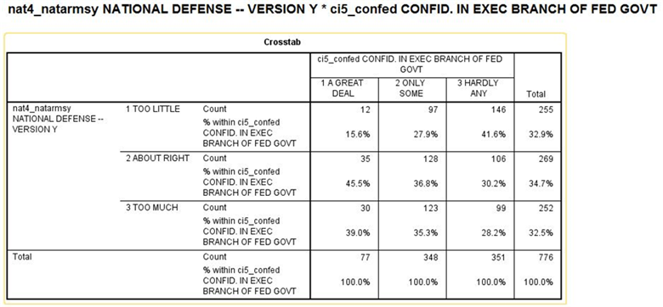

To interpret the crosstabulation always compare the percents in the direction opposite to the way in which they sum to 100%. Since you asked for the column percents, the percents sum down to 100. That means that you want to compare the percents straight across. Look at the first row (i.e., too little). The more confidence people have in the executive branch, the less likely they are to feel that we are spending too little. On the other hand, the more confidence they have in the executive branch, the more likely they are to feel we’re spending too much. For example, 15.6% of those who have a great deal of confidence in the executive branch think we are spending too little on national defense compared to 41.6% of those who have hardly any confidence. On the other hand, 28.2% of those who have hardly any confidence in the executive branch feel we are spending too much on national defense compared to 39.0% of those who have a great deal of confidence.
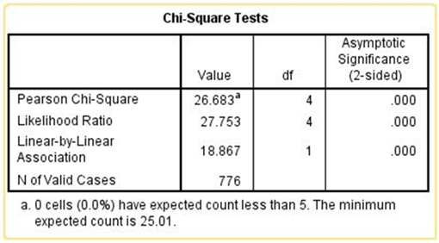
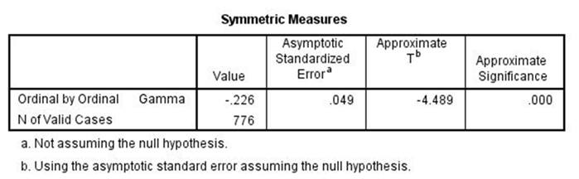
Chi Square is statistically significant and the Gamma value of -0.226 suggests a moderately strong relationship. Clearly the data support our hypothesis.
Run the crosstabulation for the other question that asks about the military, armaments, and defense (NAT3_NATARMS). Did you find the same relationship for both versions of the question on the military?

Part IV – More Analysis
Now repeat this analysis for the hypothesis that you wrote in Part 2. Tell SPSS to get the crosstabulation of the two variables and write a paragraph describing the relationship between your two variables and whether the table supports your hypothesis. Be sure to use both versions of the question and to tell SPSS to compute Chi Square and the appropriate measure of association. Use all this information to interpret the relationship between your two variables.

Part V – Conclusions
Write a paragraph indicating what you learned about the relationship between confidence in the executive branch and spending priorities for the issue that you chose. Be as specific as possible.

