Chapter Eight: Multivariate Analysis

Up until now, we have covered univariate (“one variable”) analysis and bivariate (“two variables”) analysis. We can also measure the simultaneous effects of two or more independent variables on a dependent variable. This allows us to estimate the effects of each independent variable on the dependent variable, while controlling for the effects of one or more other independent variables. This is called multivariate (“multiple variables”) analysis. In this Chapter we review two ways to do that by using techniques that you have already used: crosstabs and regression analysis.

Crosstabs Revisited

Recall from Chapter 5 that the crosstabs procedure is used when variables are nominal (or ordinal). Simple crosstabs, which examine the influence of one variable on another, should be only the first step in the analysis of social science data. We might begin this first step by hypothesizing that women are more strongly religious than men, and that African Americans are more strongly religious than whites.

The 2014 General Social Survey provides data that we can use to test these hypotheses. The measure of sex (or gender) is straightforward. A variable we can use to measure religiosity was obtained by asking respondents about the strength of their religious affiliation (“strong,” “somewhat strong,” “not very strong,” or “no religion”).

The measure of race is a little more complicated. The codes for this measure are 1) white, 2) black, and 3) other. The number of respondents in this last category is relatively small, and lumps together very different groups (Asian Americans, Native Americans, etc.). For this reason, we will limit our analysis of race to blacks and whites. Another problem with the race variable, and one we’ll live with for purposes of this exercise, is that it measures only race and not, as is more common in analysis, race and ethnicity. In particular, it does not distinguish between Hispanic and non-Hispanic white or black respondents.

Open GSS14A.sav and select only white and black respondents for analysis. (Review the procedures described in Chapter 3 for selecting cases.)

Following the instructions in chapter 5, crosstabulate reliten with race and with sex, selecting column percentages for the cells. You’ll obtain the results shown in Figures 8–1 and 8–2. (We’ve left out the “case processing summary.”) 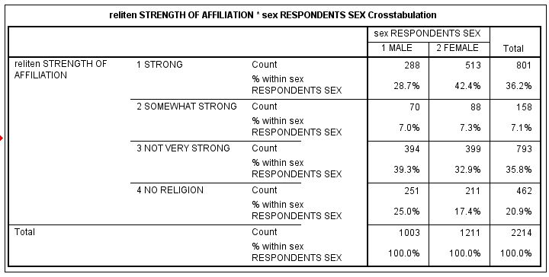
Figure 8-1

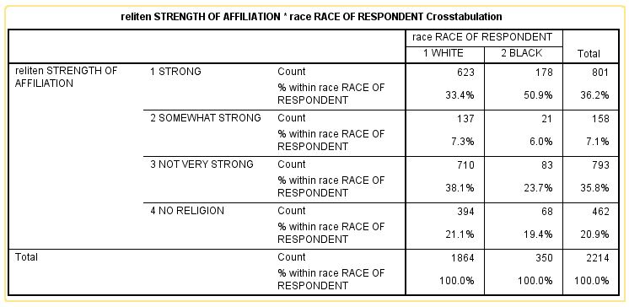
Figure 8-2

As the results show, women are more likely than men to report a strong or somewhat strong religious affiliation, and are less likely to report that their affilation is not very strong or that they have no relious affiliation. Differences between black and white respondents are even greater, with over half of black respondents, but only about a third of whites, reporting a strong religious affiliation, while larger proportions of whites than blacks fall into each of the other categories. (In the interest of conserving space, we haven’t carried out measures of association or statistical significance, but you may wish to do so yourself.)

This one-step method of hypothesis testing is, however, very limited. It does not, for example, tell us whether African American men differ from African American women in religious intensity, whether there are differences in this regard between white men and white women.
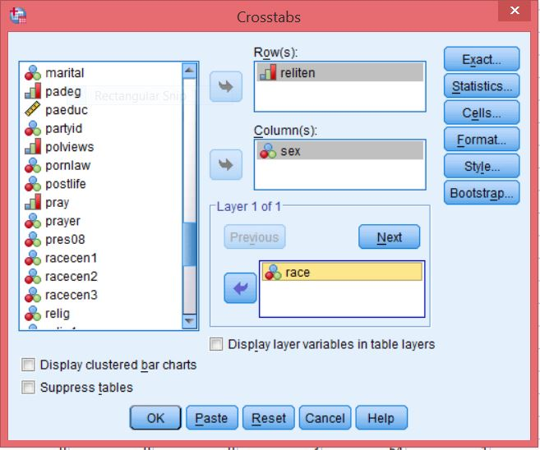
To answer this question, we will do a multivariate cross tabulation, also called an elaboration analysis.

Recall that your original crosstabs procedure produces one contingency table, with as many rows as there are categories (or values) of the dependent variable, and as many columns as there are categories of the independent variable. When you start using control (sometimes called test) variables, you will get as many separate tables as there are categories of the control variable. There are two categories of the race variable; thus, we should expect to get two contingency tables, each one showing the relationship between sex and reliten for whites, the other for African Americans.
Figure 8-3

Open up the crosstabulation dialog box you used for Figures 8–1 and 8–2, but this time adding race in the third box on the right under “Layer 1 of 1.” The dialog box should now look like Figure 8–3. Click OK. Your results should look like the table shown in Figure 8-4.

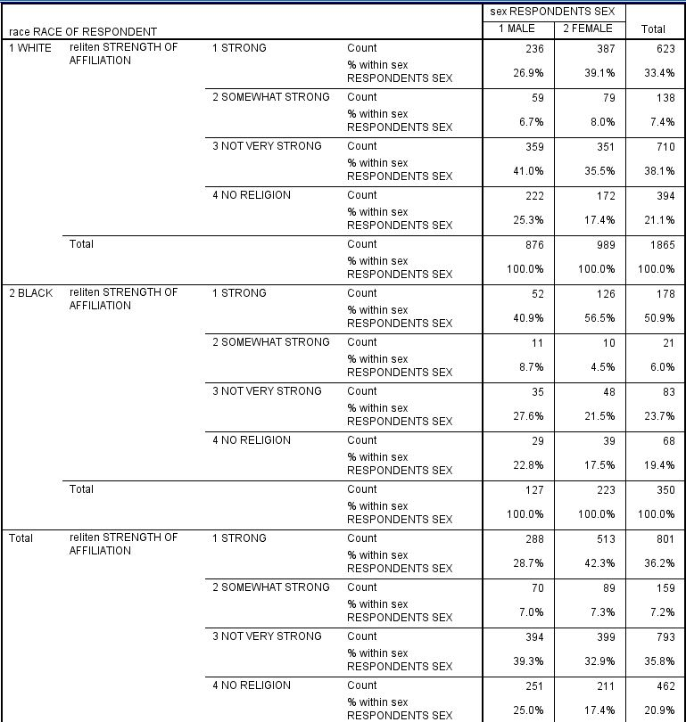
Figure 8-4

Notice that the relationship between reliten and sex is about the same for whites and African Americans.

Try other variables as a control (i.e., in place of race) to see what happens. As a general rule, here is how to interpret what you find from this elaboration analysis:

- If the relationship between the independent and dependent variables shown in the partial tables is similar to that shown in the zero-order (original bivariate) table you have replicated your original findings, which means that in spite of the introduction of a particular control variable, the original relationship persists. This is indeed the case here: the differences between men and women shown in the partial tables of Figure 8–4 are similar to those shown in Figure 8–1.

- If the difference shown in all the partial tables (the separate tables for each category of the control variable) are significantly smaller than those found in the original AND IF your control variable is antecedent (occurs prior in time) to both the other variables, you have found a spurious relationship and explained away the original. In other words, the original relationship was due to the influence of that control variable, not the one you first hypothesized.

- If the differences you see in the partial tables are less than you saw in the original table AND IF your control variable is intervening (that is, the control variable occurs in time after the original independent variable), you have interpreted the relationship. If the time sequence between the independent and control variable is not determinable (or otherwise unclear), then you don't know whether you have explanation or interpretation, but you do know that the control variable is important.

- If one or more of the differences shown in the partial tables is stronger than in the original and one or more is weaker, you have discovered the conditions under which the original relationship is strongest. This is referred to as specification or the interaction effect.

- If the zero order table showed weak association between the variables, you might still find strong associations in the partials (which is a good argument for keeping on with your initial analysis of the data even if you didn’t “find” anything with bivariate analysis). The addition of your control variable showed it to have been acting as a suppressor in the original table.

- Last, if a zero order table shows only a weak or moderate association, the partials might show the opposite relationship, due to the presence of a distorter variable.

Multiple Regression

Another statistical technique estimating the effects of two or more independent variables on a dependent variable is multiple regression analysis. This technique is appropriate when your variables are measured at the interval or ratio level, although researchers sometimes use multiple regression with ordinal variables as well. Multiple regression also assumes that there is a linear relationship between each independent variable and the dependent variable, and that the distribution of values in your variables follows a normal distribution.

Recall from Chapter 7 that we investigated the impact that Internet freedom had on perceived corruption, and found evidence consistent with our hypothesis that high levels of Internet freedom seem to increase people’s sense that they can hold government accountable, thus leading to perceptions of less government corruption. It may be, however, that holding government accountable requires more than the ability to publicize corrupt activities, but also requires the ability to exercise political rights, such as the right to vote in contested elections. In recent years, for example, protesters in some countries have used the Internet to help bring down corrupt regimes, but the absence of effective means to participate in ordinary political institutions has sometimes led to the emergence of new leaders as corrupt as those they replaced.

To test this, open the COUNTRIES.sav file and add the variable polrights to the regression equation we ran in Chapter 7. From the menu, click Analyze, Regression, Linear. Click on corruption and move it into the Dependent box at the top of the dialog box. Click on ifreedom and polrights and move them into the Independent(s) box. The dialog box should look like the one shown in Figure 8-5. Click OK.
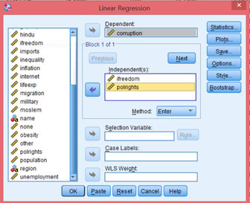
Figure 8-5
Figure 8-6

Your results should look like those shown in Figure 8-6. Looking first at the Model Summary table, you will see that the adjusted R-squared value is .334. As you recall from Chapter 7, this means that 33.4% of the variation in the dependent variable (perceived corruption) is explained by knowing a country’s level of Internet freedom and political rights. The ANOVA table shows that the overall model is highly statistically significant. Next, we need to look at the Coefficients table. If you look at the B coefficient for ifreedom, you will see that it is .076. How do we interpret this coefficient? Recall the discussion in Chapter 7: a one unit change in the independent variable (ifreedom) is associated with a change in the dependent variable (corruption) equal to the value of B. So, if we increase the value of ifreedom by 1, on average, we get a change of .076 units in corruption. Since the higher the level of the corruption variable, the lower the level of perceived corruption, the results are actually in the opposite direction that we had hypothesized. However, the regression coefficient is not statistically significant so we cannot conclude that ifreedom is related to corruption. On the other hand, the value of B for polrights is -5.110, meaning that an increase of one unit on the Political Rights Index is associated with a decrease of 5.11 points on the Perceived Corruption Index. The result is in the hypothesized direction.

However, one problem with interpreting the B coefficients is that the units of measurement we are using are quite different for different variables. Internet freedom and perceived corruption are measured on scales of 0 to 100, whereas political rights are measured on a scale of 1 to 7. We’re comparing apples to oranges.

To address this problem, look at the standardized (Beta) coefficients, which we’ve ignored to this point. Beta coefficients in effect convert all variables to standard scores (with means of 0 and standard deviations of 1). The Beta coefficient for polrights (-.685) has an absolute value almost seven times as large as that for ifreedom (.101). In other words, when each independent variable is controlled for the other, an increase of one standard deviation in polrights has an impact on corruption that is much greater than that of the same increase in the ifreedom measure. Finally, note that the polrights is highly statistically significant (p = .003) while ifreedom is not at all statistically significant (p=.644).

If we convert the information in the Coefficients table to standard algebraic form (but leaving out the error terms) we get, for the unstandardized equation:

Ŷ=58.002+.076*X₁-5.110*X₂ where

X₁=ifreedom and
X₂=polrights.

The standardized equation looks like:

Ŷ=.101*X₁-.685*X₂.

The reason why the constant has dropped out of this equation is that, with variables converted to standard scores, it is equal to zero by definition.

Finally, note that the model as a whole only explains about a third of the variance among countries in perceived corruption. Does the dataset include any other variables that you think might explain some of the rest? Add these variables to the equation and see if they help.

Chapter Eight Exercises

Use GSS14A.sav for exercises 1 through 3.

1, Repeat the crosstabs we ran earlier in this chapter, but this time use race as the independent variable and sex as the control variable.

2. How would you hypothesize the relationship between fear (Afraid to walk at night in neighborhood) and sex?
a. Write out your hypothesis.
b. Run a crosstabs to test your hypothesis and report your results.
c. Now, do a second crosstabs, this time controlling for class. Report your results.
d. Now run fear and sex but control for trust. Report your results.

3. Choose three independent variables from the General Social Survey subset that you think influence the number of hours people watch television (tvhours, the dependent variable).
a. Write up your hypotheses (how and why each independent variable is associated with the dependent variable.
b. Run a multivariate regression to test your hypotheses and report your results.

Use COUNTRIES.sav for exercises 4 and 5.

4. Using the unstandardized regression equation for predicting corruption based on ifreedom and polrights, calculate the residuals for South Africa, the United Kingdom, and Ukraine. You can either do this manually or, when running the regression analysis, save the residuals as an additional variable, then go to DATA VIEW to find the values of RES_1 for these countries. Are the residuals for the United Kingdom and Ukraine less than those we calculated in Chapter 7? Are there other variables that, if added to the equation, might reduce them further?

5. From Appendix B select three variables that you think might help explain inequality of income distribution. Using the COUNTRIES.sav file, run a multiple regression analysis. Which of the three independent variables is the best predictor of inequality? How much of the variance among countries in inequality is explained by the model as a whole?

It’s important to weight the cases so they better represent the population from which the sample is selected. Our data set – GSS14A,sav – has already been weighted so you don’t need to weight it again.

